# SI539 Portfolio Report

Chia-Ming Wang

jaywang@umich.edu

Dec 11, 2020

1. This criterion is linked to a Learning OutcomeSubmit a (minimum four page) site. All of the pages must use a common header, footer, and navigation across all pages. Each page must have a unique titleUsing the browser of your choice, click on each page to show us that it works. As you do, make sure to demo the changes in the navigation and that "Skip To Content" works on EVERY page.  
   Ans: I’ll show the full version for only the main page (since all pages are the same), and ALL “Skip To Content” pages.  
     
   main  
   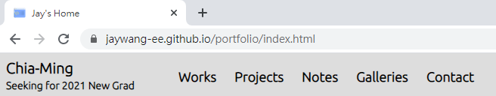  
   main @ wid = 540 (my logo become “Home”)  
     
   main @ width = 500  
   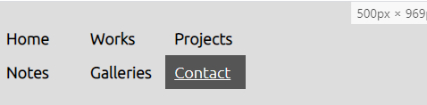  
   main with skip  
   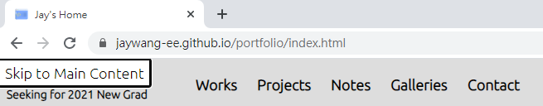  
     
   work  
   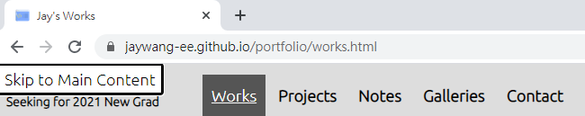  
     
     
   projects  
   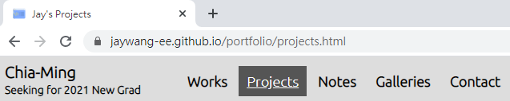  
     
   Notes  
   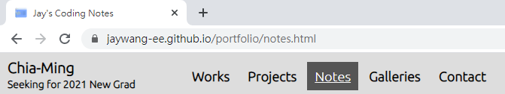  
     
   Galleries  
   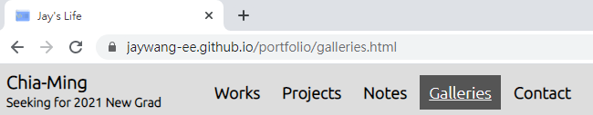  
     
   Contact form  
   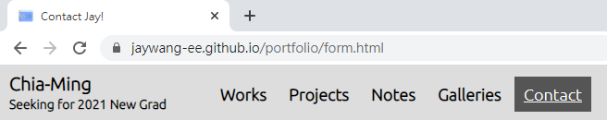
2. This criterion is linked to a Learning OutcomeThe navigation must clearly display the current page within the nav element.As you visit each page, point out how the navigation bar changes to clearly indicate which page you are currently viewing. Don't forget, color alone should never be used to signify important information.  
     
   Ans: As the images in 1, I change the color of the current page, which was inspired by some famous design.
3. This criterion is linked to a Learning OutcomeEach page should contain a main section that can be reached using a Jump to Content option with the first tab on the page. Main must be after the navigation.To demo this, select "Skip to Content" and then hit tab again. Show us where the focus is now.  
   Main  
   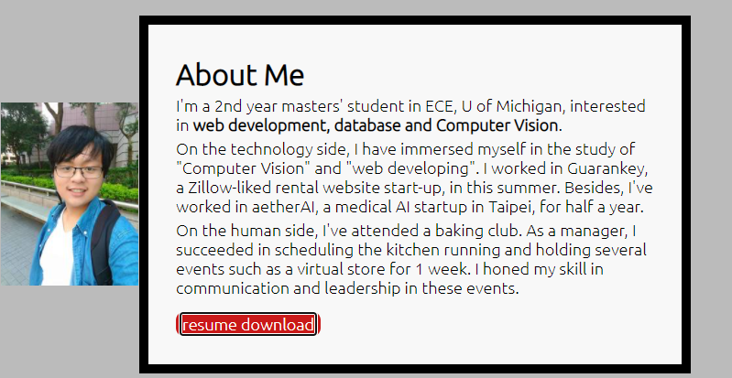  
   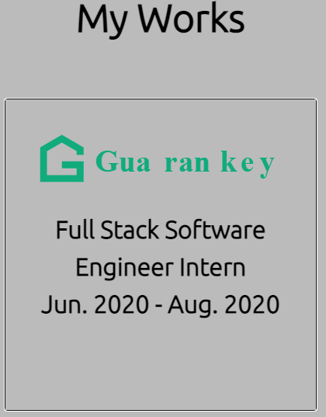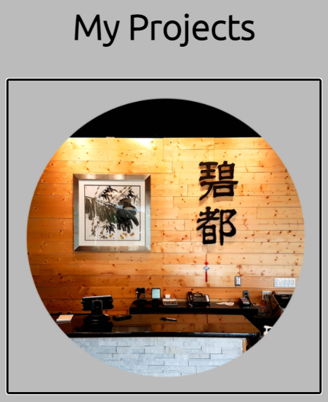  
   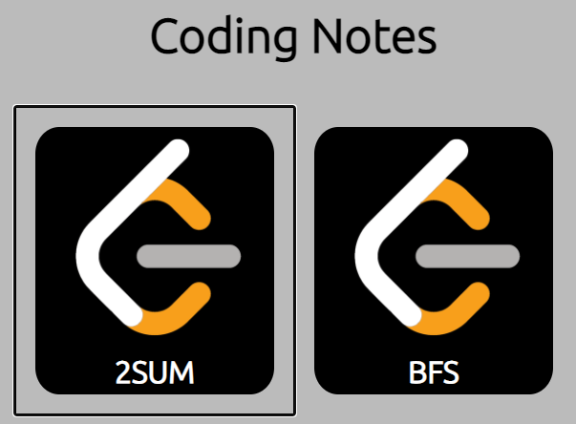  
   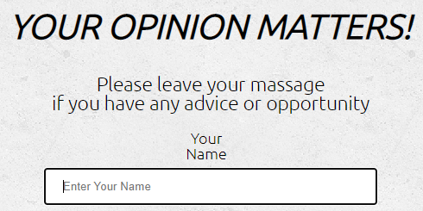
4. This criterion is linked to a Learning OutcomeMinimum content present. This includes a page that has at least nine (9) images.  
     
   Ans: In gallery page (https://jaywang-ee.github.io/portfolio/galleries.html), there are 9 images and the icon image, 10 in total.
5. This criterion is linked to a Learning OutcomeGrid - used more than once, and used effectively.Using the browser of your choice, walk us through the different areas you used grid. Explain how you used them differently than in homework. Show us all of the pages that use them.  
     
   Ans: I showed this in the demo section. I used grid in home and gallery, the css screenshots are:  
   main  
   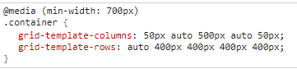  
   gallery  
   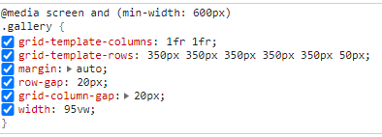  
     
   I really like the design of HW4, so I used the structure of HW4 in homepage and adjust the size to fit the images I used. In gallery, I let my selfie with church occupied 2 rows to make the 9 images into 5 x 2.
6. This criterion is linked to a Learning OutcomeFlex - used more than once, and used effectively.Using the browser of your choice, walk us through the different areas you used flexbox. Explain how you used them differently than in homework. Show us all of the pages that use them.  
     
   Ans: I showed this in the demo section. I used flex in projects and notes, the css screenshots are:  
   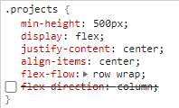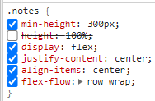  
     
   I use the column-side, center-alignment in both col and row (since I use the flip-image in these pages). In addition to homework, I set a margin change to make sure the 4 project won’t become (3, 1) separate, like this:  
     
   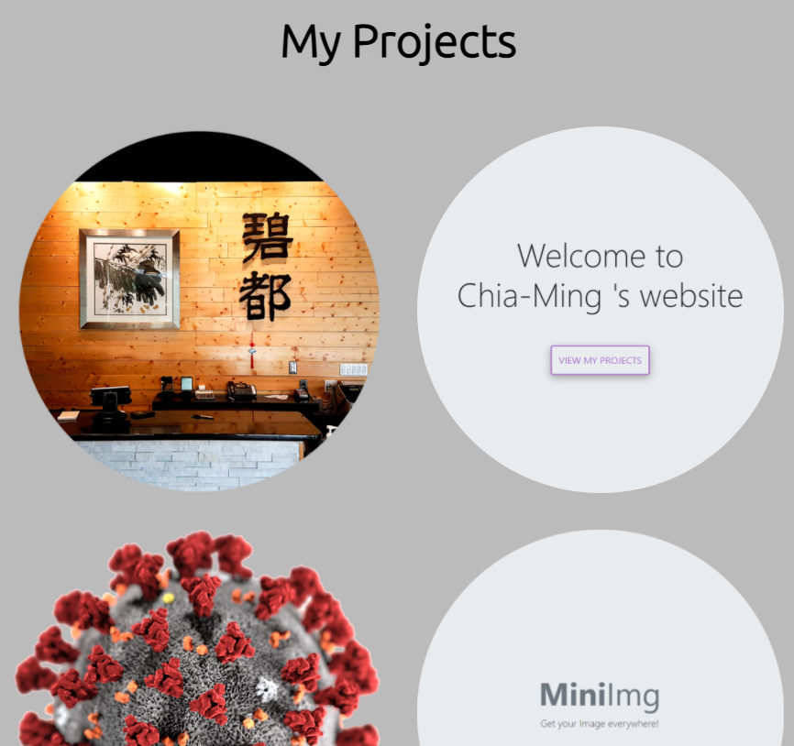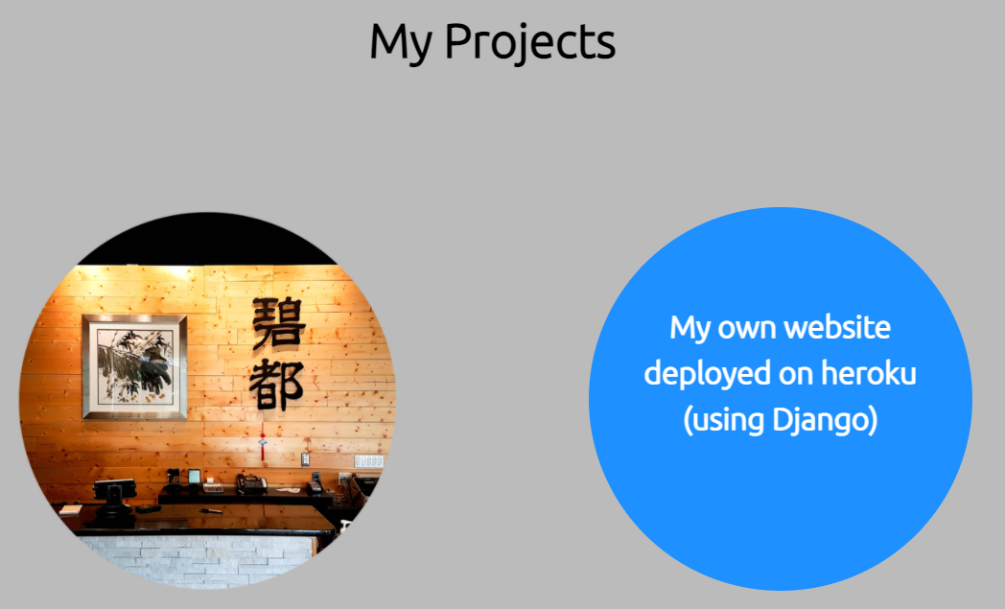
7. This criterion is linked to a Learning OutcomeAt least one CSS generated animation that is NOT part of the gallery.Show us the animation AND the code. Change something in the code to make the animation last twice as long.  
     
   I made a rainbow-color hover nav:  
     
     
     
   I used the flip-card animations in work and project:  
     
   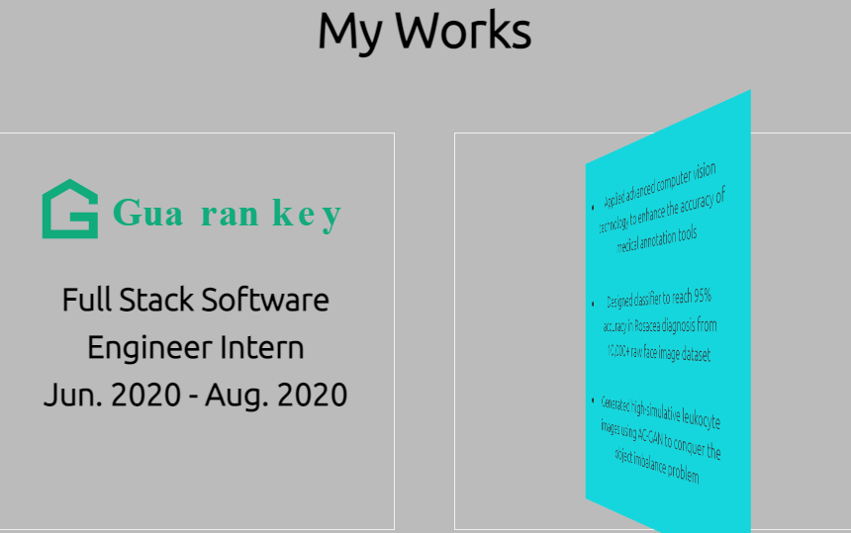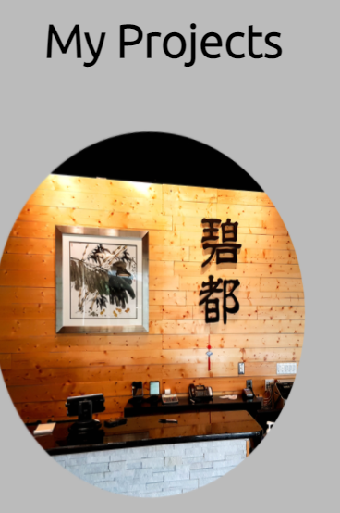  
     
   To change the duration of the animation, just change:  
     
   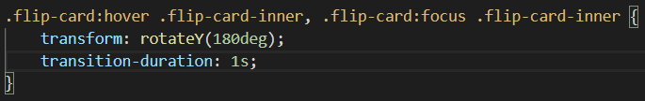  
     
   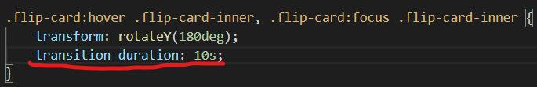
8. This criterion is linked to a Learning OutcomeA working contact form.Show us the email you receive after clicking on the form.  
   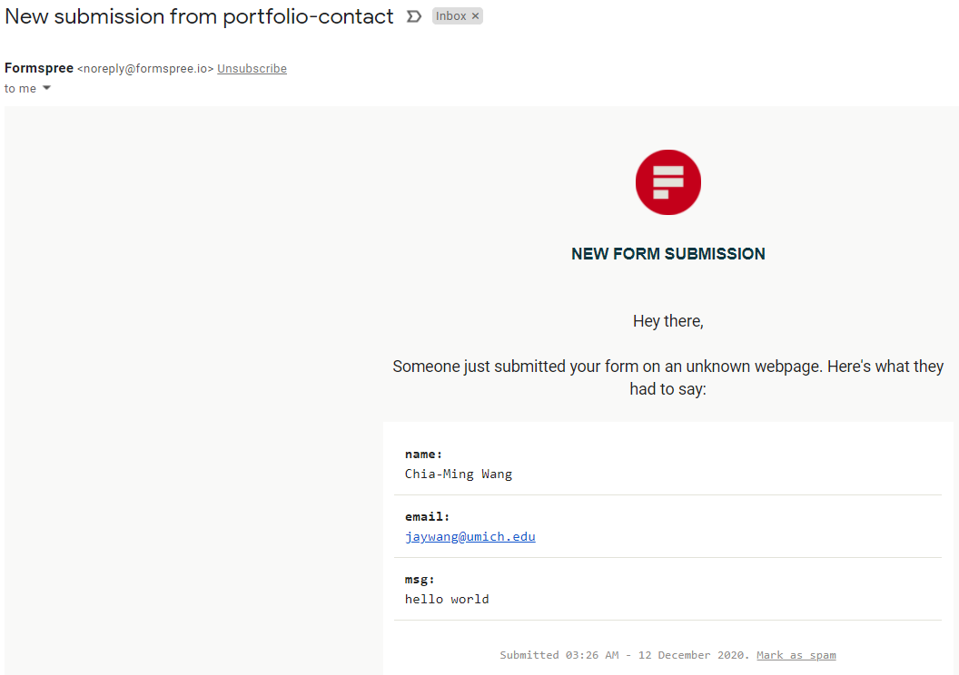
9. This criterion is linked to a Learning OutcomeA parallax image  
     
   Ans: In the homepage, you can see:  
     
     
     
   Also, It’ll be shot down in reduced-motion.
10. This criterion is linked to a Learning OutcomeA keyboard accessible flip card using just CSSDemonstrate that the flipcard works using a mouse AND the keyboard.  
      
    Ans: I’ve showed my flip cards in 7.
11. This criterion is linked to a Learning OutcomeGoogle Analytics on all four pages.In realtime show your Google Analytics dashboard as you enter and leave all four pages of your site. We should be able to see multiple past visitors on each page.  
      
      
    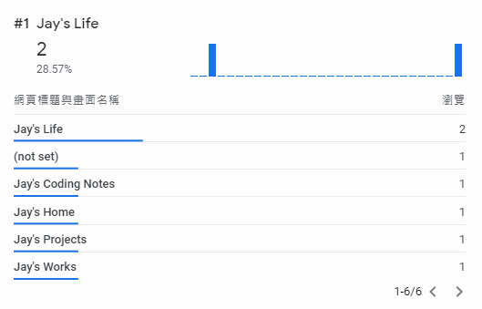  
    
12. This criterion is linked to a Learning OutcomeVisually appealingWhat did you do to make your page particularly appealing? Tell us more about your font choices, image editing, etc. I am sure are things that you did that we can't easily see.  
      
    The most important thing is, I use js to adjust the size to the current height. For some of my pages (works, contacts, notes), the heights are not enough for supporting the footer, and the footer will be in the middle. However, I’ll influence the homepage if we use fixed. Thus, I used the code below to change the size of “body” to the perfect size:  
      
    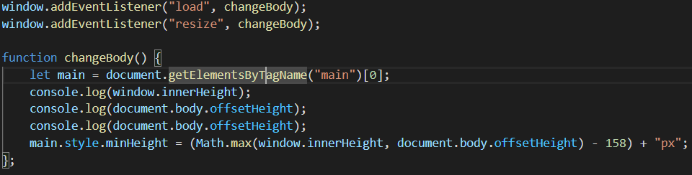  
      
    For the whole design, I want to show my proficiency in programming, so I choose the ubuntu font and the gray background to make my site more formal. And since I’m not a designer, I made my name and my purpose as the logo and the link to homepage. It’s simple and stylish to me:  
      
      
      
    Meanwhile, I also obey this rule in the chosen of the icon and the homepage image. Besides, the image of my publication is the cover of that paper.   
      
    Last but not the least, I want to show my root in the first glance. Thus, I piked the Jade mountain, which is the represent of Taiwan, as my banner and made it parallax.
13. This criterion is linked to a Learning OutcomeMedia Query OneUsing the browser of your choice, walk us through the different responsive design choices you made. Make sure to impress us. The changes should be drastic, obvious, and should improve the look/functionality of the site.  
      
    Ans: Please refer the question 1. I made 3 kinds of nav in responsive design to maximally put all 6 pages in a proper ways.
14. This criterion is linked to a Learning OutcomeMedia Query TwoUsing the browser of your choice, walk us through the different responsive design choices you made. Make sure to impress us. The changes should be drastic, obvious, and should improve the look/functionality of the site.  
      
    Ans: I used responsive design in homepage, gallery and contact. I want to focus on homepage here:  
      
    This is the full-screen version:  
    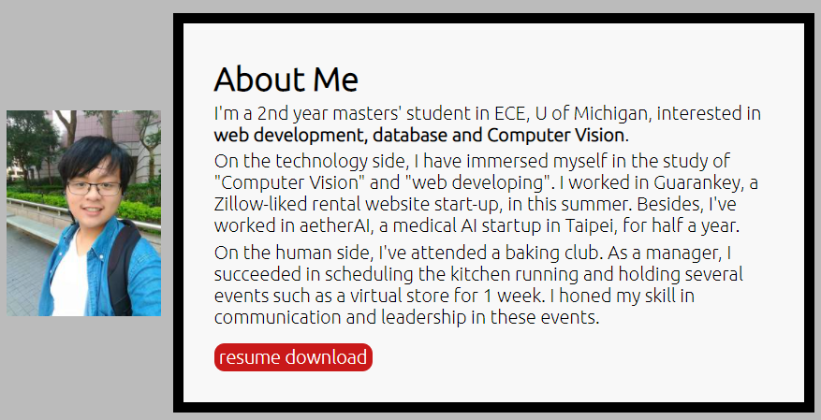  
      
    This is the mobile version:  
    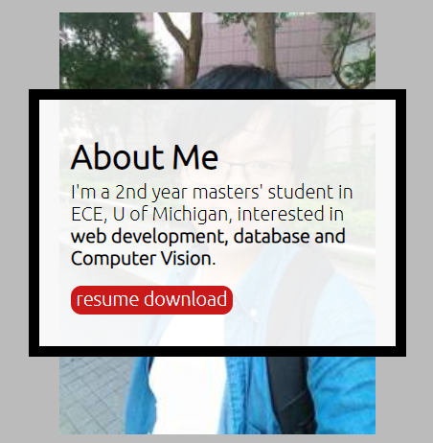  
      
    I didn’t only change the grid structure, but also change the content to focus one my major.
15. This criterion is linked to a Learning OutcomeReduced Motion Media QueryAll animations/motion should be turned off when prefers-reduced motion is selected. (Use Safari when you are demoing this!!!)
16. This criterion is linked to a Learning OutcomeDocumentation/Demonstration - Responsive DesignTalk to us about why your responsive design is great. (You don't need to tell us anything you already told us during the media query demonstration.)  
      
    Ans: I think I’ve described it properly in Q14. But I believe that a good responsive design to me is to present enough information and let the viewer focused on the major part at the same time. Thus, I cut-off all unnecessary paragraphs and realign in the mobile version.
17. This criterion is linked to a Learning OutcomeDocumentation/Demonstration - ValidationValidate all four pages on both aXe and Wave. Demo on your deployed page.  
      
    Caution: there are 2-3 alerts each page, all of them are due to 2 home-page linkes (either of them will be hidden) and usage of underling (required in nav)  
      
    Main  
    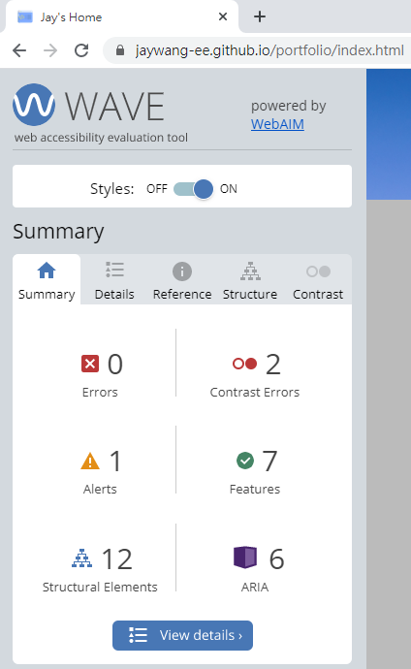  
    The 2 Contrast error is for banner, which will be covered by the parallax image.   
    IN wave  
      
    REAL  
      
      
      
    Work  
    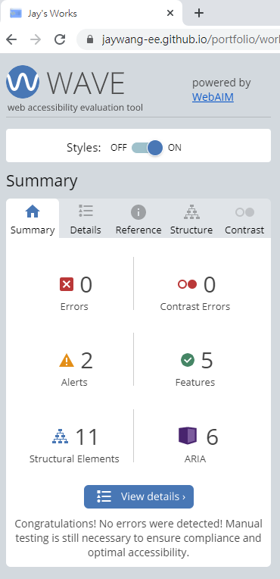
18. This criterion is linked to a Learning OutcomeDocumentation/Demonstration - Accessibility, diversity and inclusionA summary of the steps you took to ensure that your site addresses accessibility, diversity and inclusion.  
      
    For accessibility, I make sure all my reduced-motion is working. Meanwhile, I adjust my width carefully to make sure all viewers will be able to read my page. Last but not the least, the rainbow nav is for my LGBT friends, and for respecting my country, Taiwan, passed the LGBT marriage law last year.
19. "This criterion is linked to a Learning OutcomeExtras - What did you do that was AMAZING??The final 15% of this portion of the assignment requires that you show us the amazing - NOT required - things that you added to the page. What did you go and learn how to do on your own? Where did you learn it? Are you using someone else's code? If so, how did you modify it? Did you use Bootstrap (in addition to the requirements above)? If so, what did you need to do to make it work in the context of your page. Did you do extra accessibility testing? Impress us with what you learned. Only 10% of the class will get the full 21 points here and it would be expected that it is a professional looking site with NO validation errors. (Other than titles on iframes and movie captions. Speaking of which, that could be an extra!)   
    You are welcome to set up a demo to walk us through your extras."  
      
    The parts that I’ve discribed:
    1. Flip-cards in Q7
    2. Auto height adjustment in Q12

The most important extra, as a back-end geek, is the main idea of notes. As I showed in demo, the flex-boxes in NOTES are read from the following GOOGLE SHEET below:

<https://docs.google.com/spreadsheets/d/1X4bGf3xZYMDataNINmnb9wKH-3_Ojdu_mp4aksukB-4/edit#gid=0>

I used google script to avoid CROS issue while reading the data from the google sheet. So I can download the data and load it to the flexboxes via using pure jQuery and JS. It means that I can change the content of my pages in real-time, without changing and re-deploy the webpages.