**Secure C Programming Project**

**Personal Info Manager**

**Model->**

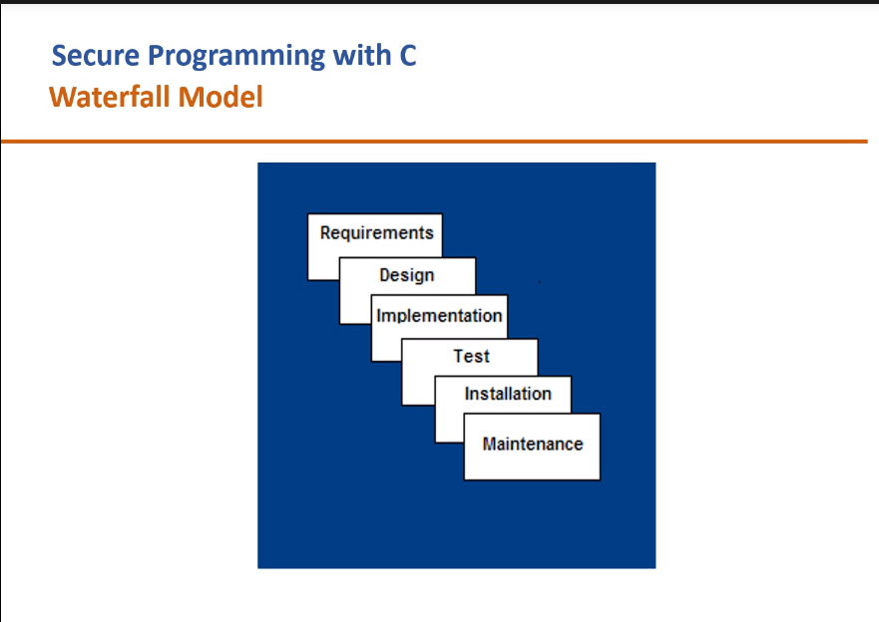

**Software Specifications->** C Programming language with GCC compiler, GDB debugger, splint flawfinder tool

**Data Structures->** Tries and Queues

**SEI CERT C Coding Standard->**

**Did Implement from Text Book->**

1) DCL30-C. Declare objects with appropriate storage durations //keeping local dynamically allocated varb

2) DCL31-C. Declare identifiers before using them

3) DCL37-C. Do not declare or define a reserved identifier //did not do

4)FLP30-C. Do not use floating-point variables as loop counters //in time delay, we have used double since time delay was large, so we had no choice

5) MEM30-C. Do not access freed memory //did not do

6) FIO46-C. Do not access a closed file //did not do

7) MSC37-C. Ensure that control never reaches the end of a non-void function //did not do

8) INT31-C. Ensure that integer conversions do not result in lost or misinterpreted data //fputc used to copy file contents of temp.c to SRNinfo.c, the numbers were not lost or misinterpreted

**Did Implement from class->**

1)Using format specifiers everywhere // %s,%c,%d,..

2) STRO2-C SANITIZE DATA PASSED TO COMPLEX SUBSYSTEMS //We passed the encrypted password to the GetName function and compared it with the encrypted password stored, so that the actual/real password does not get leaked anywhere

3) STR30-C: DO NOT ATTEMPT TO MODIFY STRING LITERALS //did not do

4) STR31-C : Guarantee that storage for strings has sufficient space for character data and the null terminator// kept sizeof(string)+1 for ‘\0’

5) STR32-C: DO NOT PASS A NON-NULL TERMINATOR CHARACTER SEQUENCE TO A LIBRARY FUNCTION THAT EXPECTS A STRING //did not do

6)Using fgets instead of gets. //as told in class

7)Using strncmp instead of strcmp//as told in class

8)Using strncat instead of strcat//as told in class

9) MEM34-C. Only free memory allocated dynamically

//freed tries, queue, and other dynamically allocated memory

10) MEM35-C. Allocate sufficient memory for an object

//tries and q

11) MEM31-C. Free dynamically allocated memory when no longer needed

//Freed all dynamically allocated memory when not needed

12) FIO42-C. Close files when they are no longer needed

//Closed all file pointers pointing to admin.txt, SRNinfo.txt, output.txt, temp.txt

**5 flaws->**

1)If SRNs exhausted,it fails

2)Name with spaces

3)Fgets continuously without flushing stdin, used to not accept data

4)Since Q variable was used, there was memory leak

5)Password>6 and infinite loop for accepting password