1. Pre-requisites for the application is JAVA 11

2. First Start "EurekaServer" Application

3. Subsequently start "FeesManagement" , "ReceiptManagement" , "StudentApplication" application

4. Once applications are up and running - open swagger UI by http://localhost:8761/

5. All the applications listed will be shown on swagger-ui - by clicking on applications url of which swagger to be opened as shown below

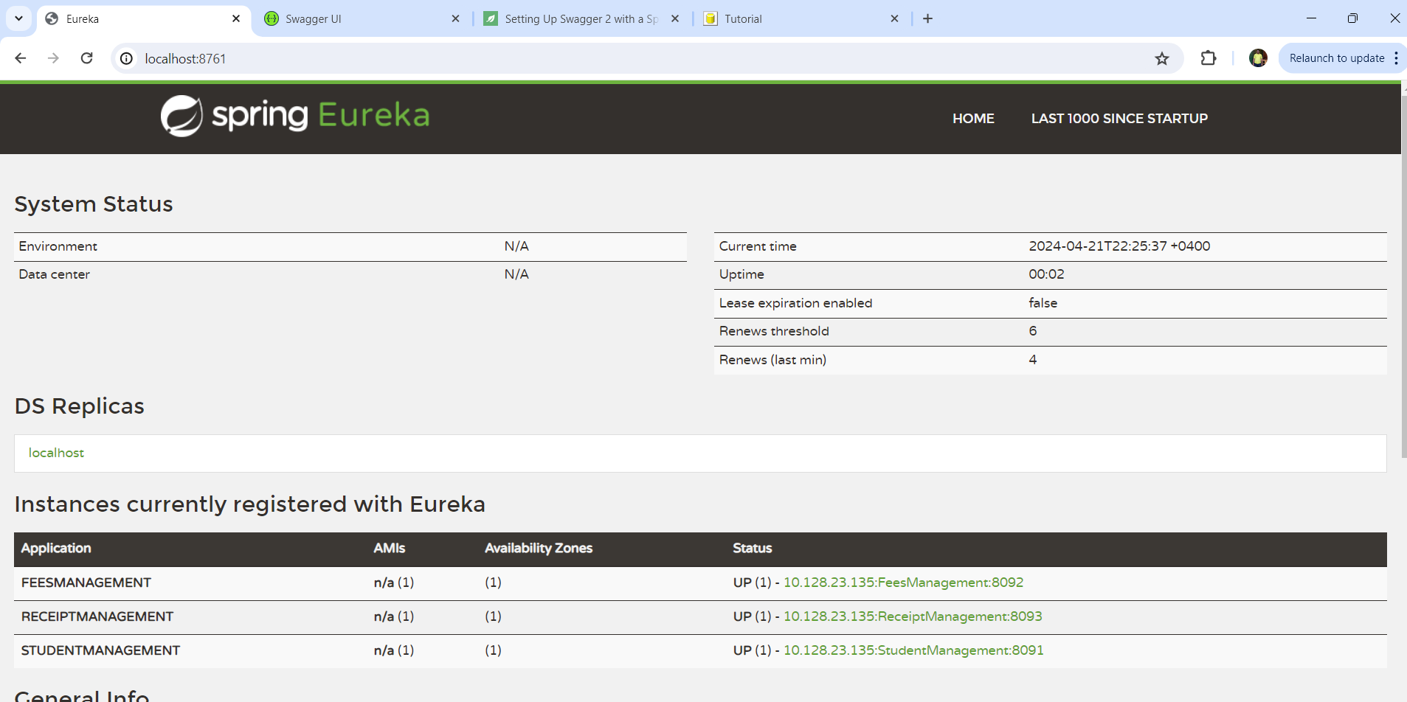

6. Update URL from <http://10.128.23.135:8092/actuator/info> to <http://10.128.23.135:8092/swagger-ui/> update **actuator/info** to **swagger-ui/**

7. test sample data can be created just by updating the existing values