***Cell radius determination***

The microwell measurements function in JEX works by searching each ROI (microwell) for a maximum signal and then drawing a circle with a designated pixel radius around that maximum and measuring the average intensity of that area. In general, I use a radius of 13 for PC3 cells and 9 for BHK cells; however, the right radius might change based on experimental conditions. The radius should be large enough to encompass each cell accounting for variability in cell size, but not so large that cells in neighboring wells are detected in the analysis. The smallest size that surrounds the cells should be chosen for added sensitivity. I choose a size by taking measurements with a range of different designated radii and creating parity plots from the measurements. An example is shown in Figure 2.21

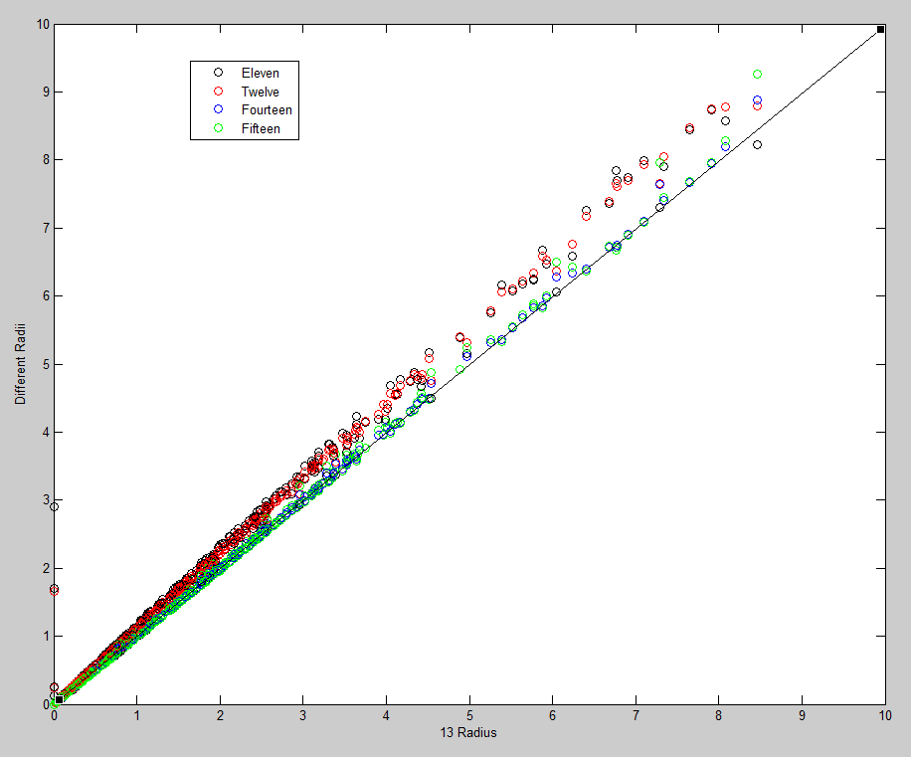

**Figure 2.21: Parity plots of various cell radii compared to a radius of 13.**