Hello

in the latest version the "Documents" tile is missing

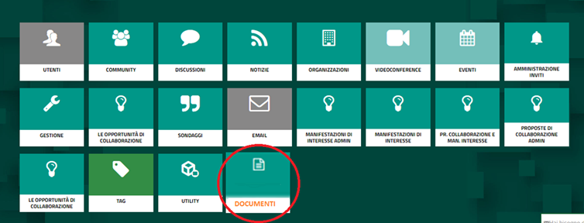

**Developer Comments :-**

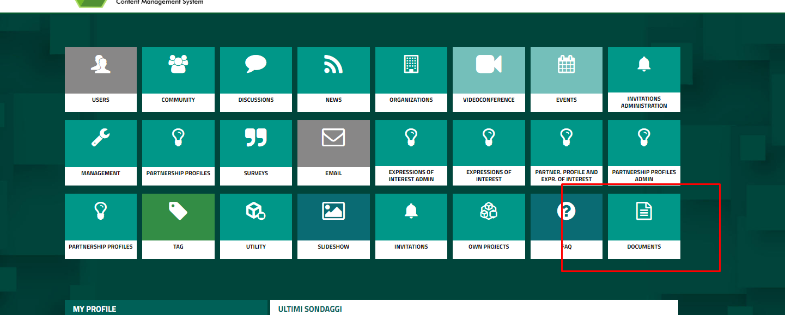

**Document icon is already there**

-----------------------------------------------------------------------------------------------------------------------------------------------

And then, once you have added the aforementioned tile, you have to check the following *bug already reported last time*:

If I try to upload a document:

1)

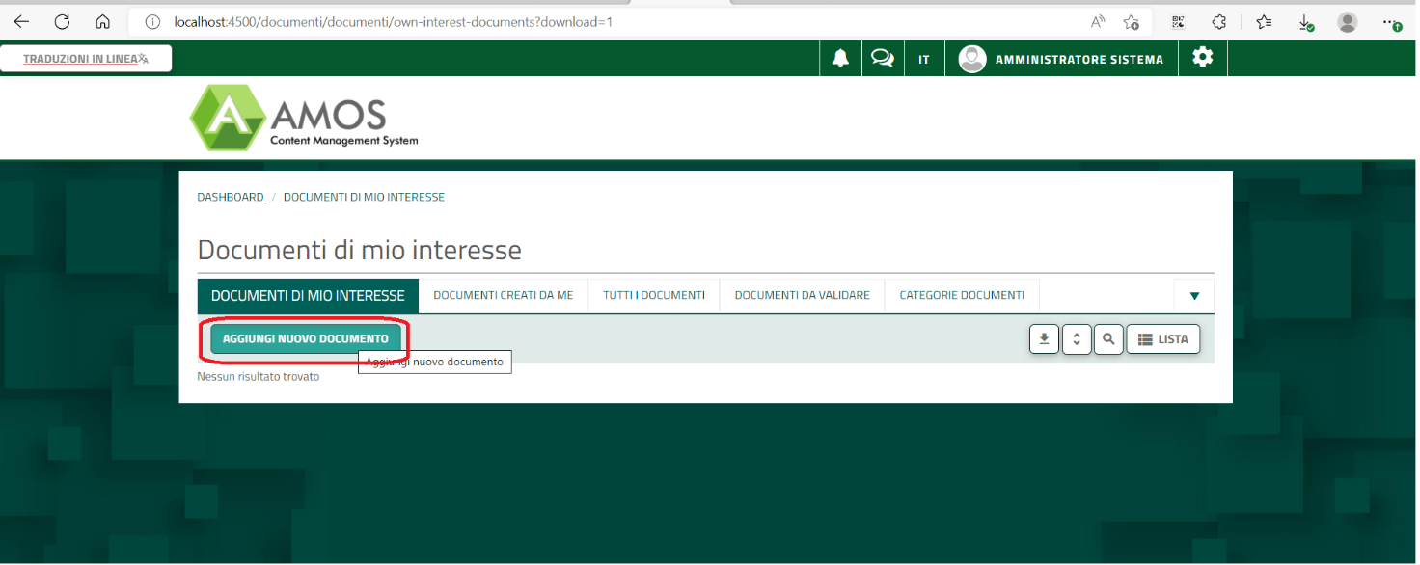

2)

I do NOT select the category (because there are NO values in the combo!!!)

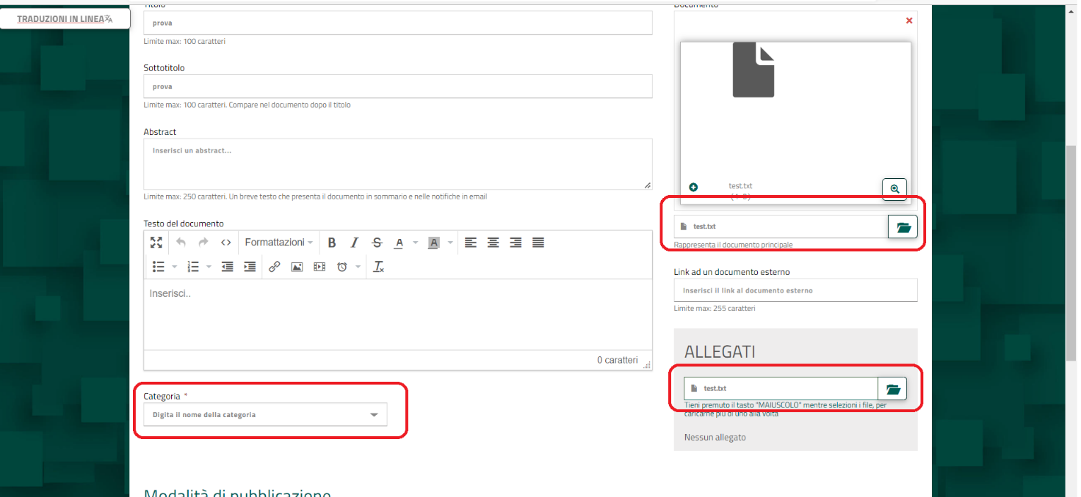

Developer Comments :-

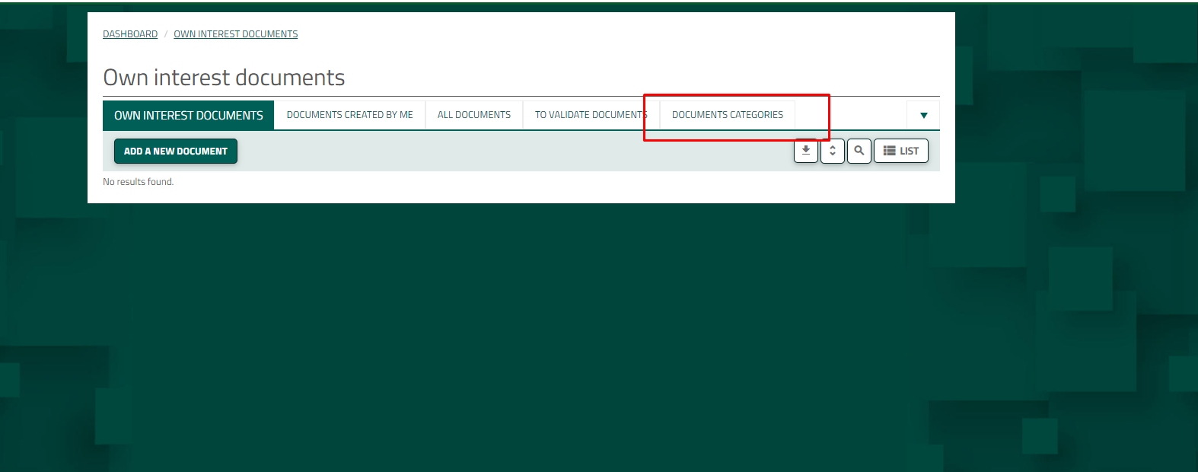

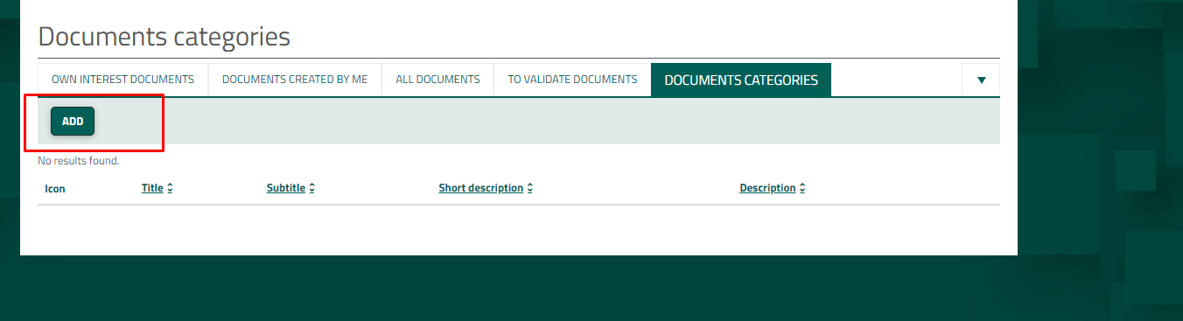

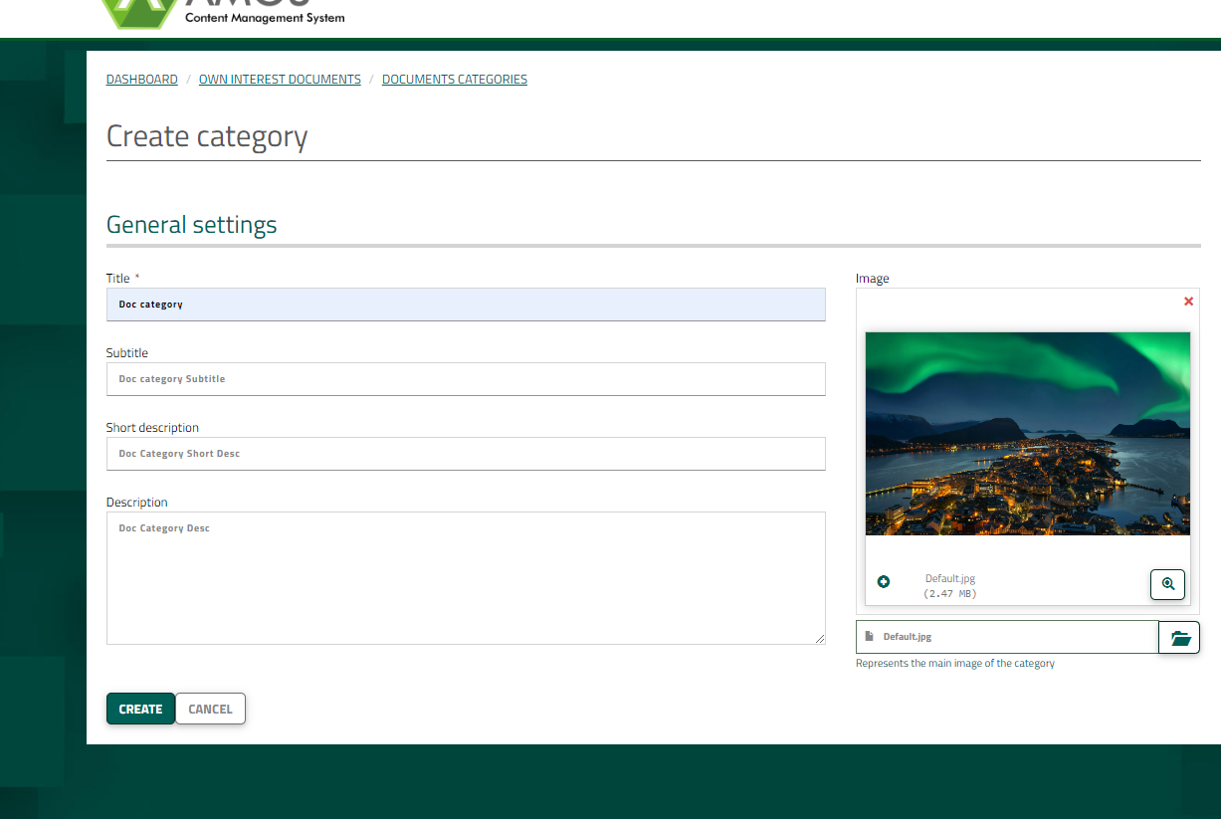

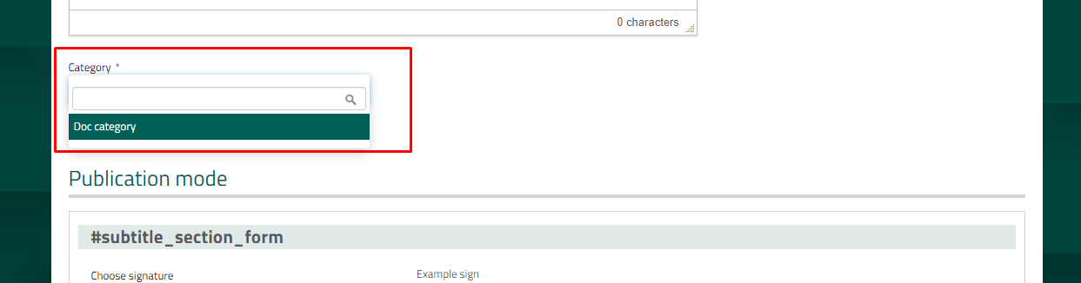

To add categories got to

Document categories -> Add (Categories added in this menu will be shown in dropdown in )

--------------------------------------------------------------------------------------------------------------------------------------------

3)

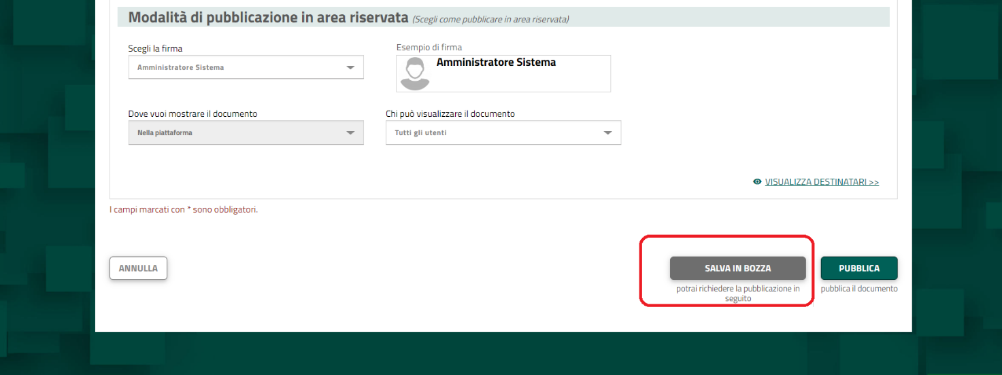

It gives me this error:

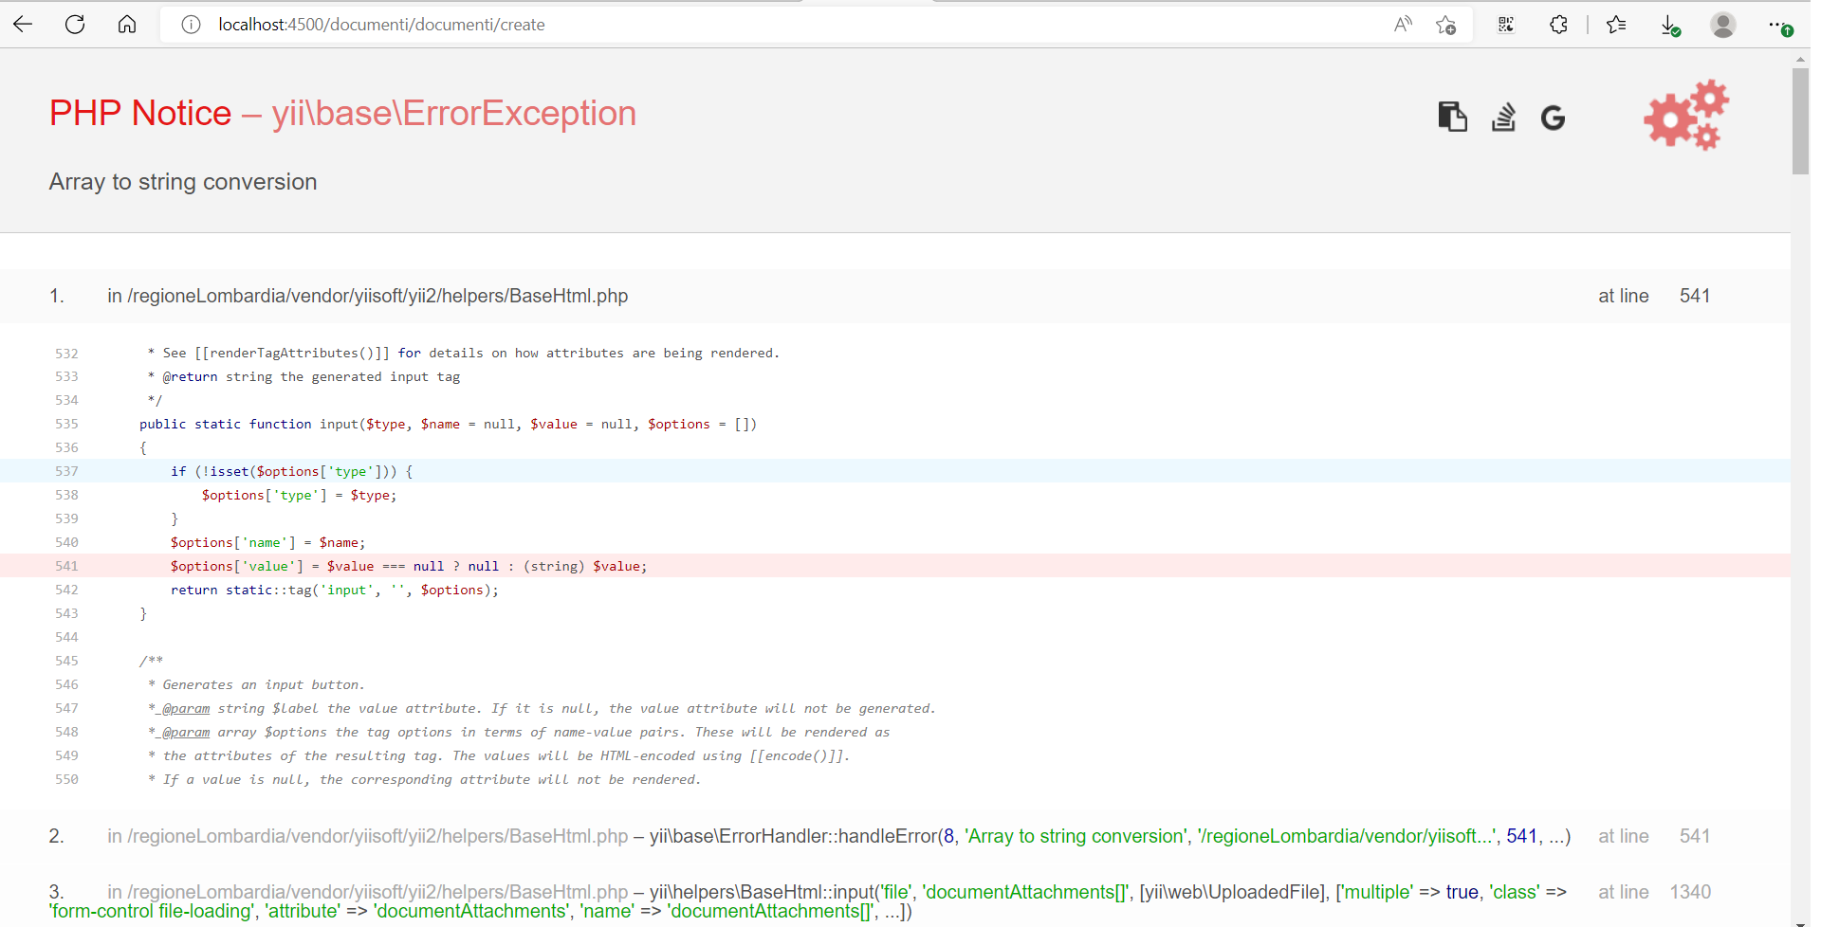

Developer Comments :-

Corrected above error . Note that as category is mandatory please create document category form the menu as shown in the above s.s.

Note above all changes are done in the repo :- https://github.com/jaywebdevpoc/dfp