Hi Kumar, I wanted to point out some things to improve in the installation document:

1)- Clone souce code using below url

https://github.com/RegioneLombardia/Open20

Observation:

Is the url correct? I mean, shouldn't we have a customized version of the application that is separate from that of the Lombardy Region?

Developer Comments :-

-- I have added a new installation instructions in the installation file (doc file in repository) for installing from new repository i.e. <https://github.com/jaywebdevpoc/dfp> .

2) - Run php yii migrate if warning or error shown run again until all migration done

Observation

Highlight well what is the command to execute, and use punctuation to make the meaning of the sentence understand well. Is this perhaps?

Run: php yii migrate. If warning or error shown, run again until all migration done

As you can see, I changed the font to the command to execute, I inserted points and commas for better clarity

Developer Comments :-

-- Yes correct , that’s what the original sentence meant

The same goes for this. Can you fix it in a similar way?

- Run command composer update and read the output, replace all not found version with latest version shown in command output in file {project_dir} \ composer.json and run command again

Developer Comments :-

-- Below is the sentence

Run: composer update

-- Read the output from the terminal, replace all not found version with latest version shown in the terminal as suggestion in the file {project_dir} \ composer.json

-- Once replaced all the versions that are suggested in the terminal , Run: composer update

, again

Note :- If you clone the repo from the new customized repository i i.e. <https://github.com/jaywebdevpoc/dfp> , you do not need to follow this step of composer update

3)

About that:

Change root of our server

sudo nano /etc/apache2/apache2.conf

Add below line

DocumentRoot "/ var / www / html / {your project / backend / web}"

Change below

<Directory / var / www / html / {your project / backend / web}>

Options Indexes FollowSymLinks

AllowOverride All

Require all granted

</Directory>

In the apache2.conf file that runs on docker, if I add the following line it gives me an error.

DocumentRoot "/ var / www / html / {your project / backend / web}"

Here is an excerpt from the apache2.conf file:

# Start added

<Directory / var / www / html / dfp / backend / web>

Options Indexes FollowSymLinks

AllowOverride None

Require all granted

</Directory>

#DocumentRoot "/ var / www / html / dfp / backend / web"

# End added

Developer Comments :-

Instead of above try following :-

In /etc/apache2/apache2.conf , just put below

<Directory /var/www/>

Options Indexes FollowSymLinks

AllowOverride All

Require all granted

</Directory>

Instead of (i.e remove the below lines if you have already added)

<Directory / var / www / html / {your project / backend / web}>

Options Indexes FollowSymLinks

AllowOverride All

Require all granted

</Directory>

==================================================================

Add the following in /etc/apache2/sites-enabled/000-default.conf

DocumentRoot "/ var / www / html / dfp / backend / web"

Following is the s.s just of that file , just change the folder name

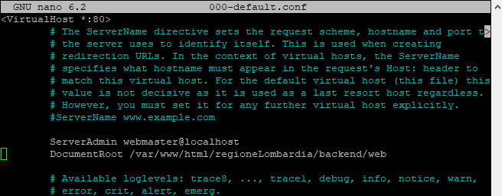

4)- Put a list of users and passwords that correspond to the sql statements to populate the DB.

Otherwise, which utilities do we use to enter?

Developer Comments :-

I have explained it in installation instructions doc

5) The following files must be customized in the application:

/dfp/common/config/main-local.php

/dfp/common/config/params-local.php

Can you highlight it in the document?

And in general you should highlight in a paragraph titled CONFIGURATION (or something like that) all the files to customize (and how to do it).

Developer Comments :-

Done in installation document