**Architecture**

- justify why chose MVC

- controller:

- event based driven

**Model**

- objects (data structures)

- game ID (1)

- game token (1)

- max number of players (2-5)

- current number of players (1-5)

- info tokens (0-8)

- fuse tokens (0-3)

- player hands (2-5)

- cards (4-5)

- colour/number (1/1)

- fireworks pile (5-6)

- height (the piles highest number) (0-5)

- discard pile (0-deck size)

- log

**View**

- check state diagram below

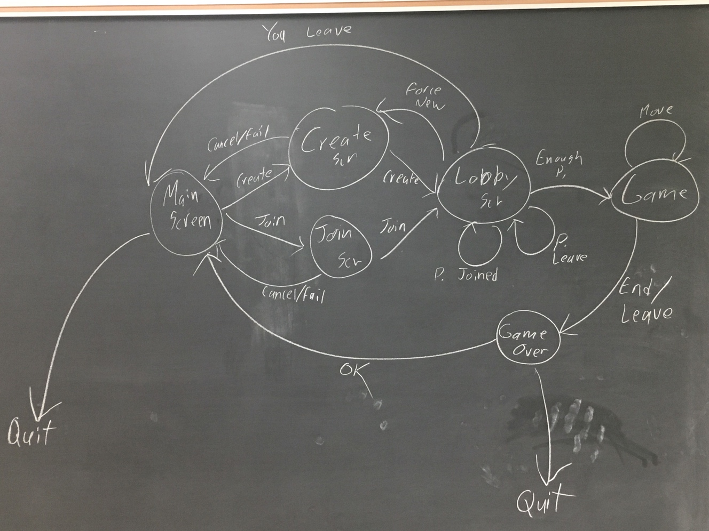

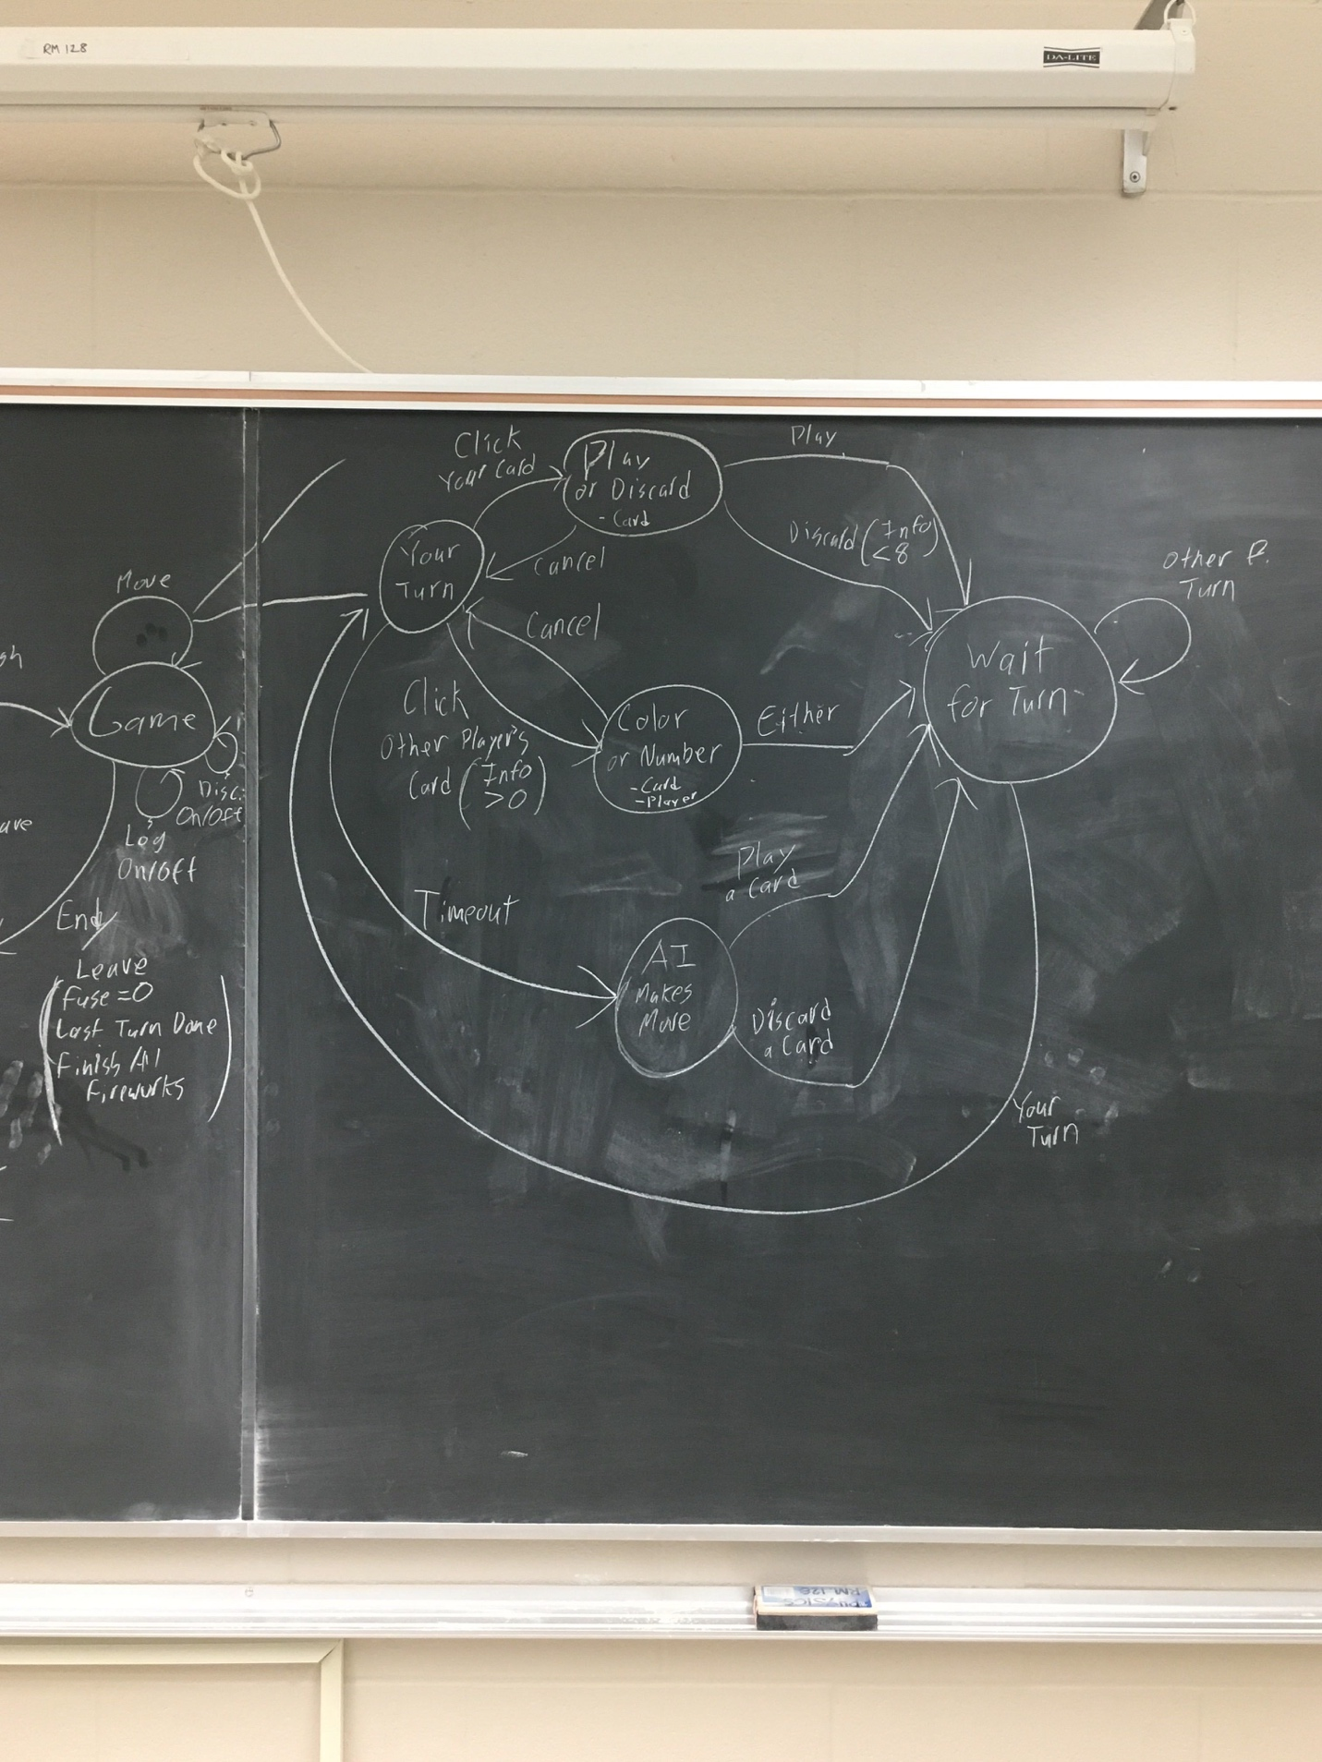

**Controller**

- operations (use-cases) (actions)

- on model

- enter game

- add player

- remove player

- leave game

- start game

- apply/move

- play card

- discard

- give info

- view discard on/off

- view log on/off

- leave game (mid-game)

- on server

- create game

- join game

- add ai

- via CLI

- via lobby button

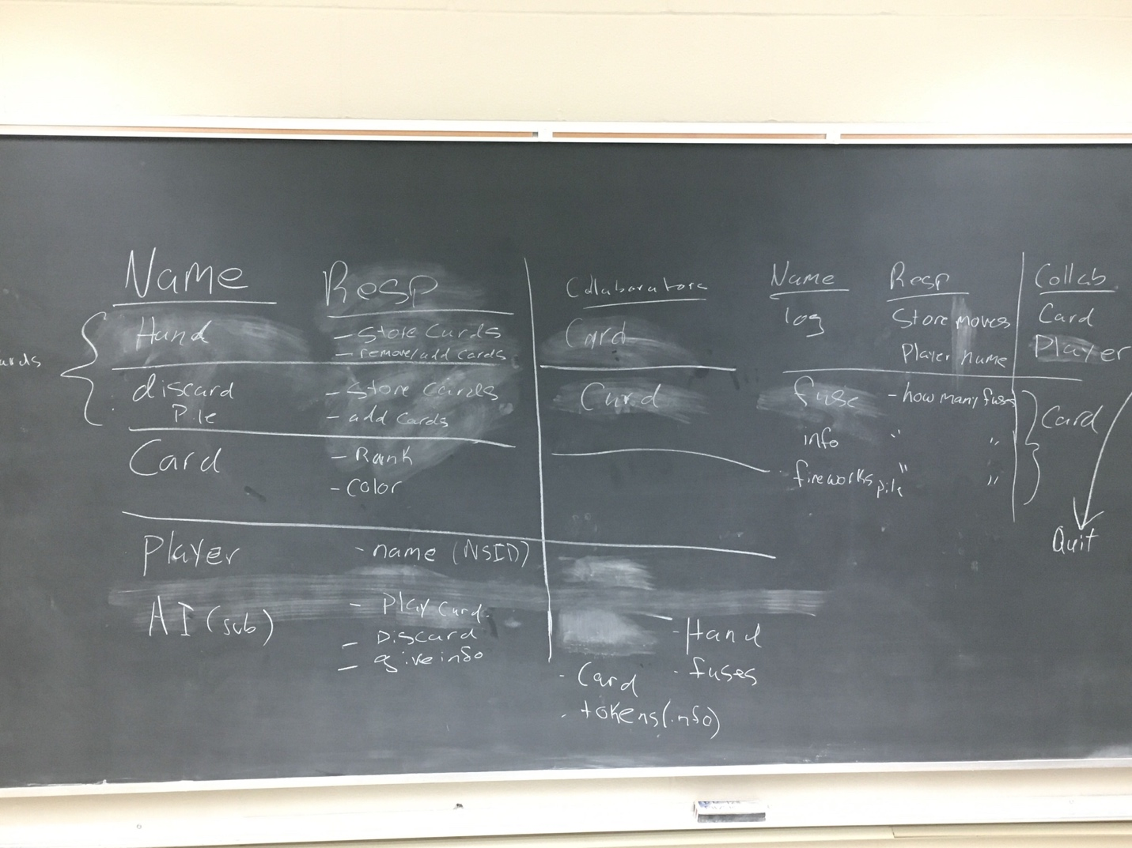

Design doc needs to be detailed on the MVC/event-based for controller