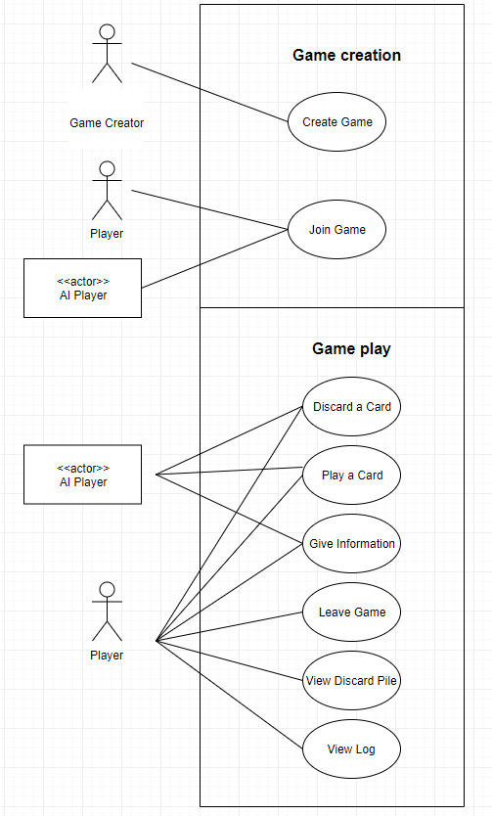

The UML diagram describes the game in two states: game creation and game play. For the first state, the game creator, can start the game with the “Create Game” action. After the connection is established, he will be the first human player in the game. At this point, other players can join game or have the option to add AI players into the table.

At any time during the second state, human players can choose to leave the game, view the pile of discarded cards or view the log. And during a player’s turn, each can choose to discard a card, play a card or give out information appropriately according to the rule.