Router 1 configurations

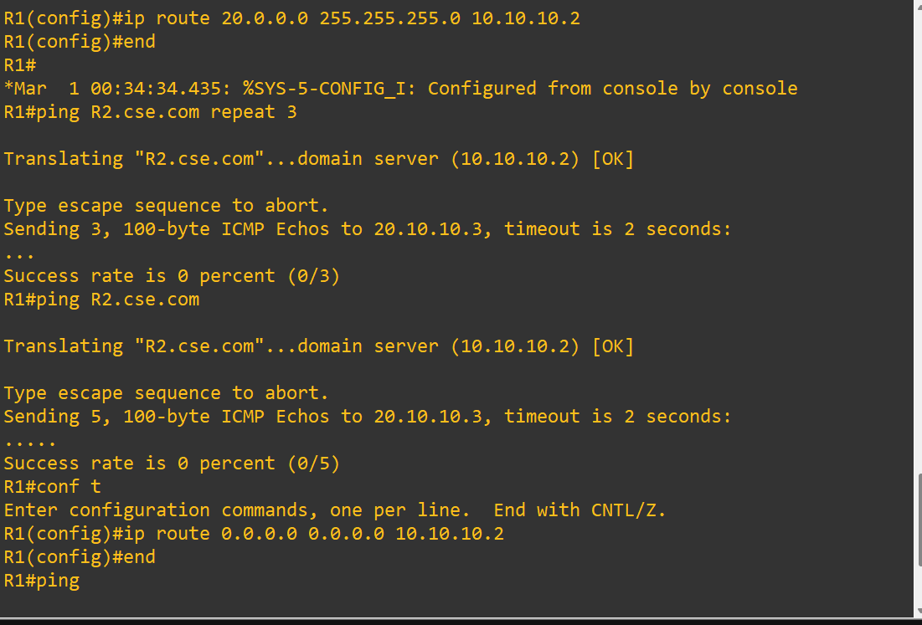

Router 2 configurations

PC configurations

