Week 4

Q1) While tcpdump host your_host is running in one command window, run ping 127.0.0.1 from
another command window. From the ping output, is the 127.0.0.1 interface on? Can you see any
ICMP message sent from your host in the tcpdump output? Why?
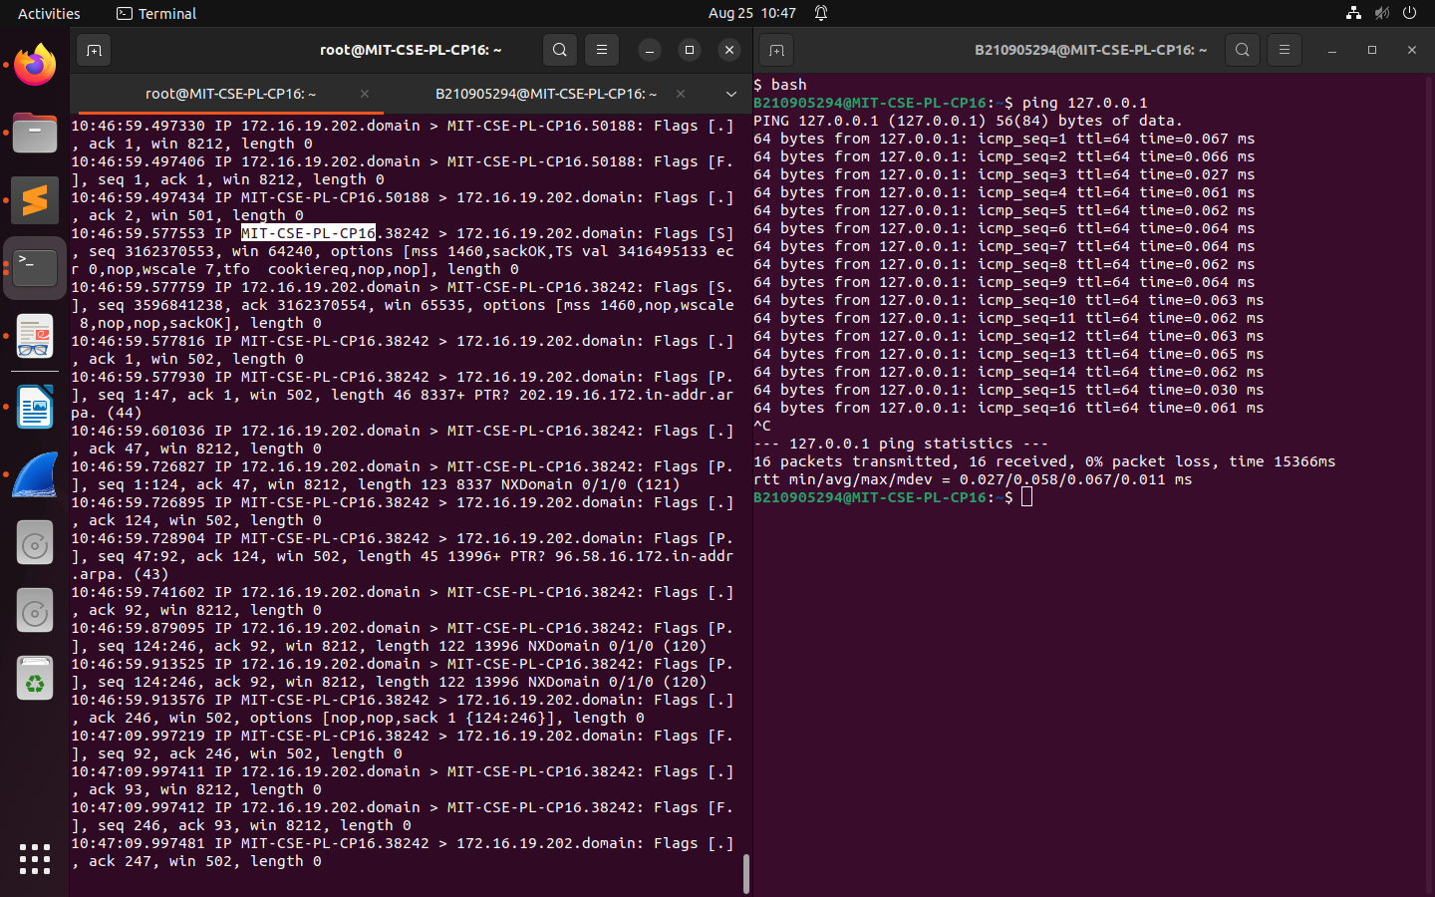
Yes, i can see icmp message sent in the tcpdump output.

Q2)
While tcpdump host your_host is running to capture traffic from your machine, execute telnet
128.238.66.200. Note there is no host with this IP address in the current configuration of the lab
network. Save the tcpdump output of the first few packets for the lab report. After getting the
necessary output, terminate the telnet session. From the saved tcpdump output, describe how the
ARP timeout and retransmission were performed. How many attempts were made to resolve a
non-existing IP address?

$ sudo tcpdump src 172.16.58.96 & dst 128.238.66.200

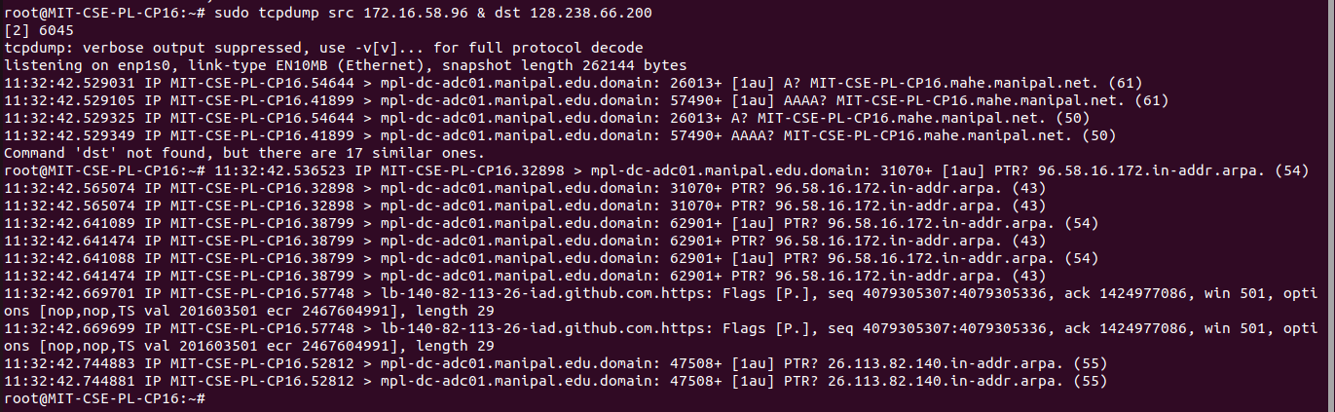

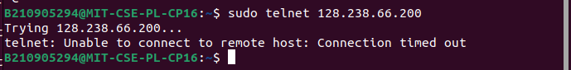

Q3) Briefly explain the purposes of the following tcpdump expressions.

a. tcpdump udp port 520 -
This will track all udp protocol packets where either the source or destination port is 520 which is reserved for Route Info Protocol (RIP)

b. tcpdump -x -s 120 ip proto 89 -
This will show packet contents in hex and ascii format. The size of the capture will be at most 120 bytes. Only packets with ip protocol 89 (Open Shortest Path First (OSPF))

c. tcpdump -x -s 70 host ip addr1 and (ip addr2 or ip addr3) -
This will show packet contents in hex and ascii format. The size of the capture will be at most 70 bytes. Only communication between addr1 and addr2 or addr1 and addr3 will be shown.

d. tcpdump -x -s 70 host ip addr1 and not ip addr2 -
This will show packet contents in hex and ascii format. The size of the capture will be at most 70 bytes. Only communication to and from addr1 excluding communication to addr2 will be shown.

Q4) Basic packet decoding
1) Write a tcpdump command to dump network traffic from an Ethernet connection to the
screen in human readable output format. Perform the following operation and write down
the observations.
a) Capture all the traffic of maximum snap length of 65,535 bytes and provide the
hexadecimal and ASCII decodes of all the traffic in each packet.
b) Find the IP addresses, IP packet length, TCP port numbers, TCP flags, etc. by using
the reference chart to locate those fields on the hexadecimal dump.

$ root@MIT-CSE-PL-CP16:~# tcpdump -i enp1s0 -XX -s 65535

