EG.1)
Network Topology
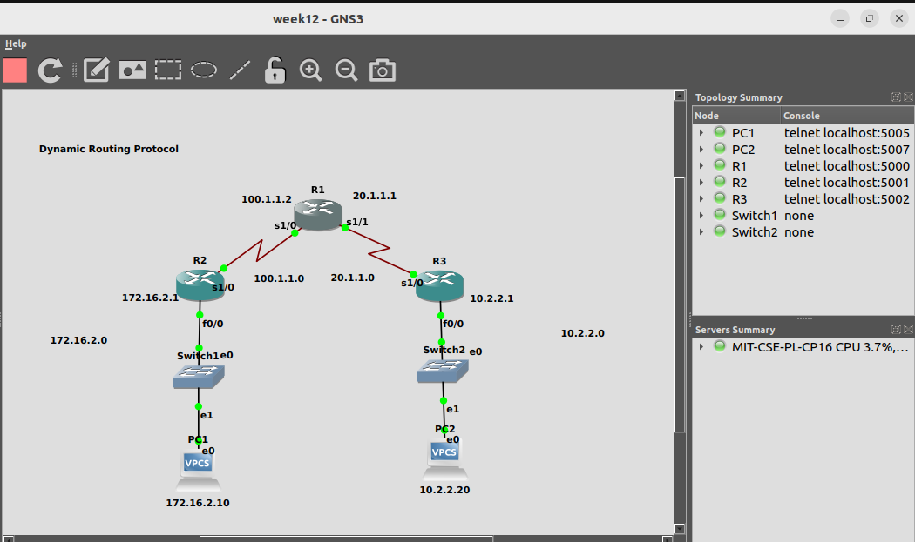

PC1
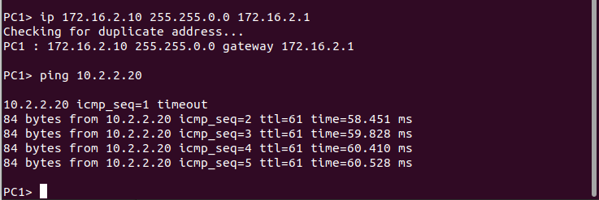
sd

PC2
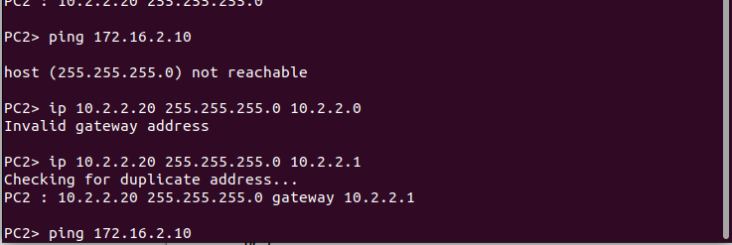
sd

R1
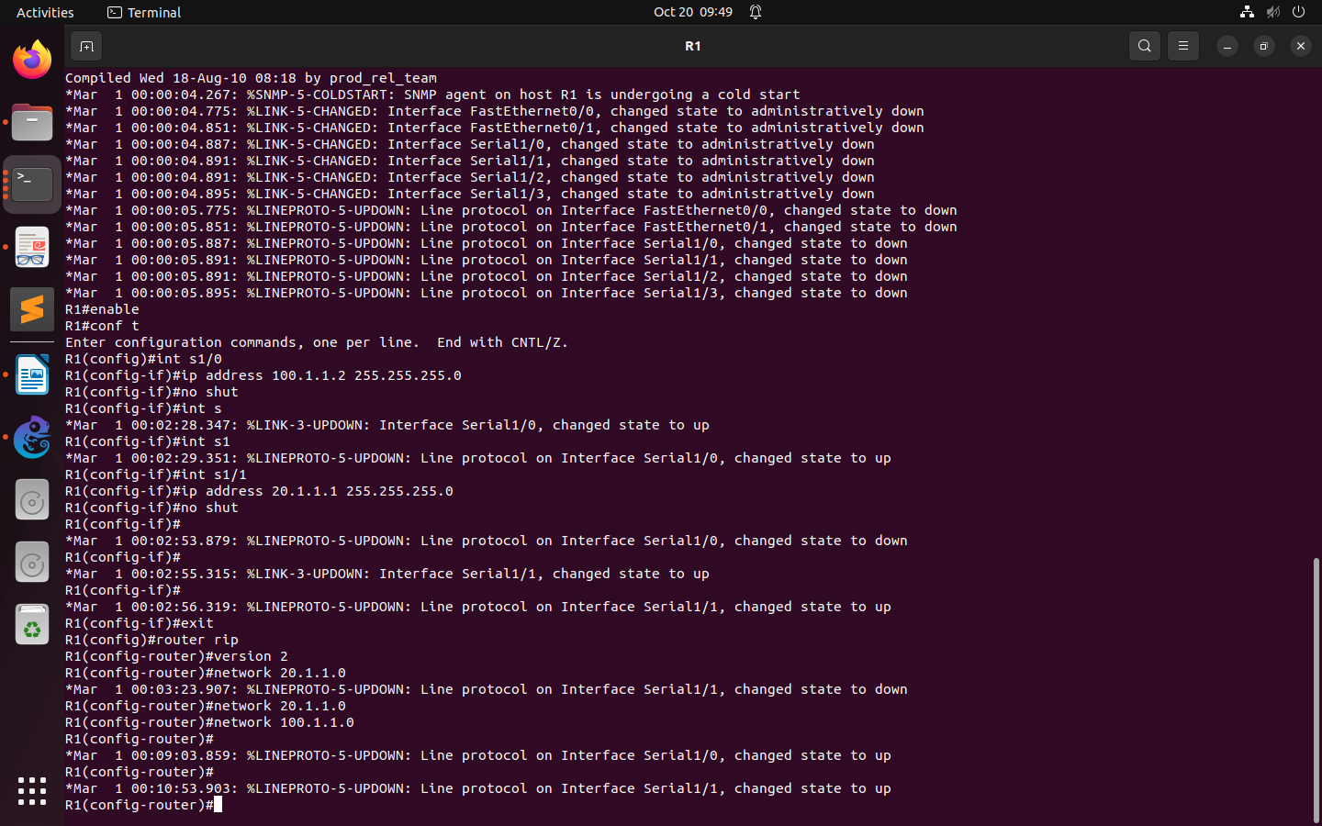
sd

R2
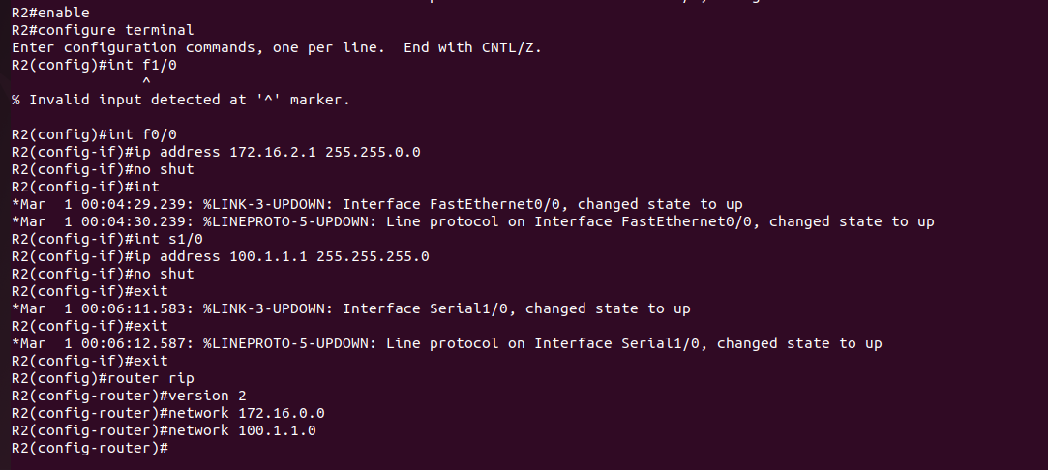
sd

R3
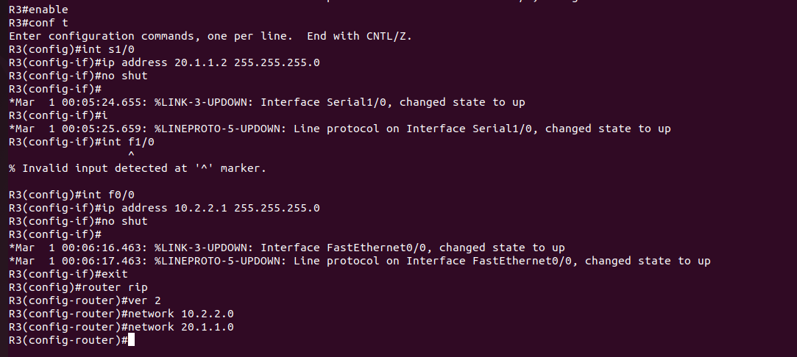
sd

NOTE-
show ip route command should display all RIP networks and end to end ping should be
successful.
show ip protocol command should display if necessary, ports are active.
show ip rip database command should displays the contents of RIP database inside the router.
debug ip rip command shows RIP updates occurring in the system undebug all Once you turn on
debug ip rip router will keep showing RIP updates. The command undebug all will stop such RIP
updates.
show running-config command is used to get the current configuration from the Router.

Q1)
Network Topology
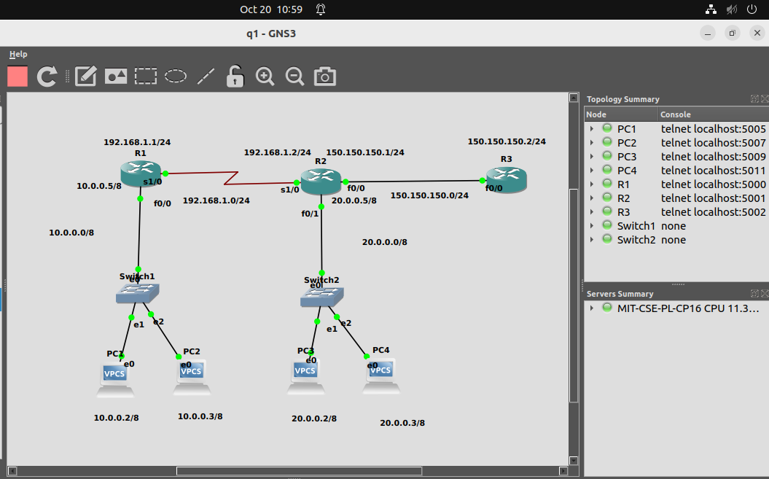
sd

R1
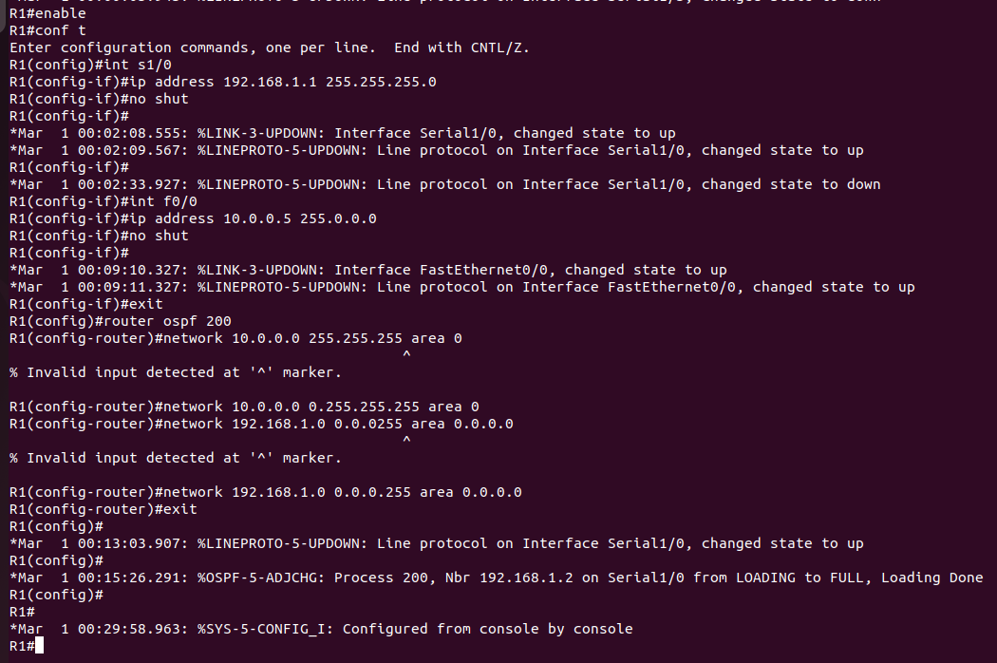
sd
NOTE - In OSPF we use wild mask.

R2
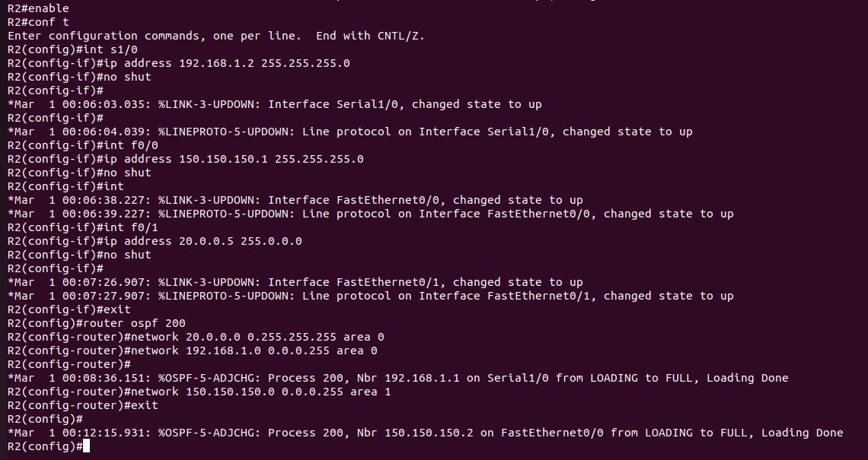
sd

R3
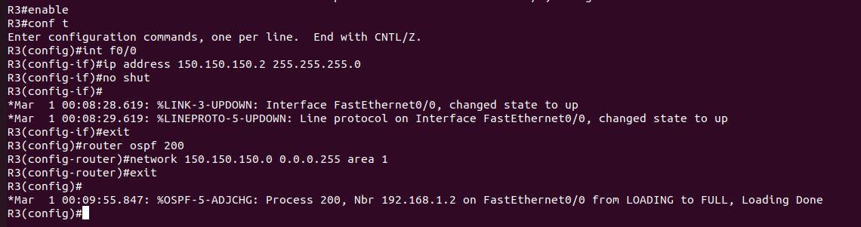
sd

PC1
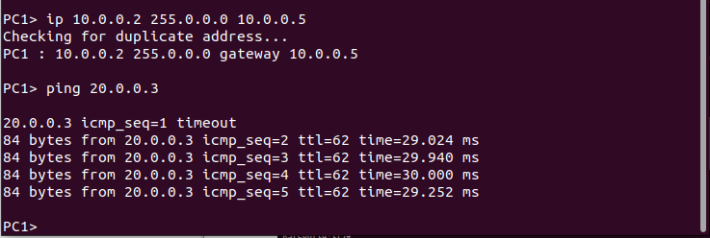
sd

PC2
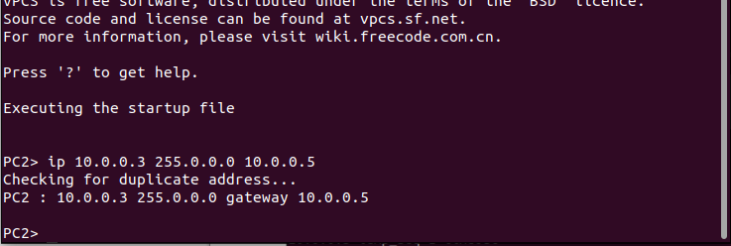
sd

PC4
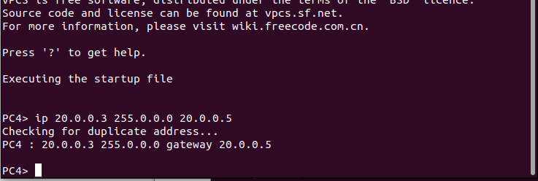
sd

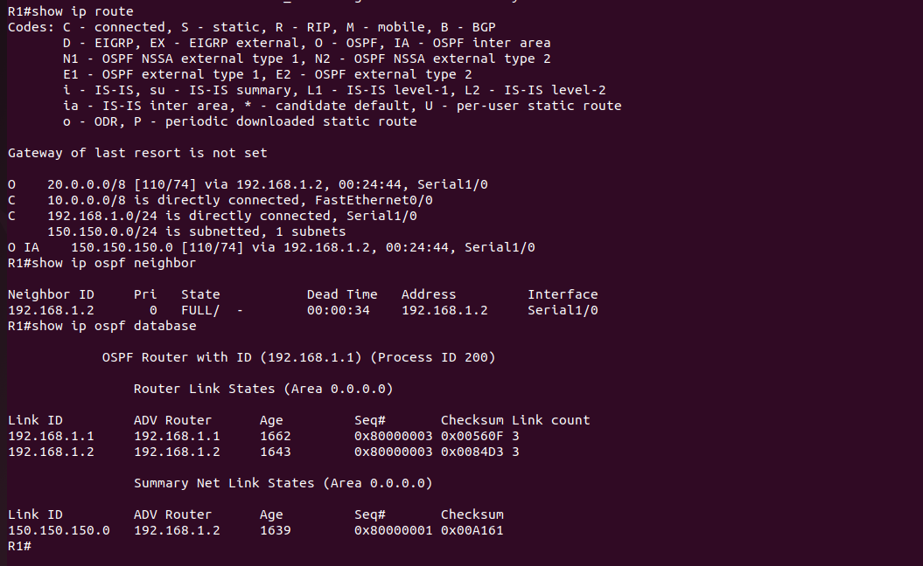
sd

NOTE- OSPF Verification:
show ip route
show ip ospf neighbor
show ip ospf database

