1.

a.
b.
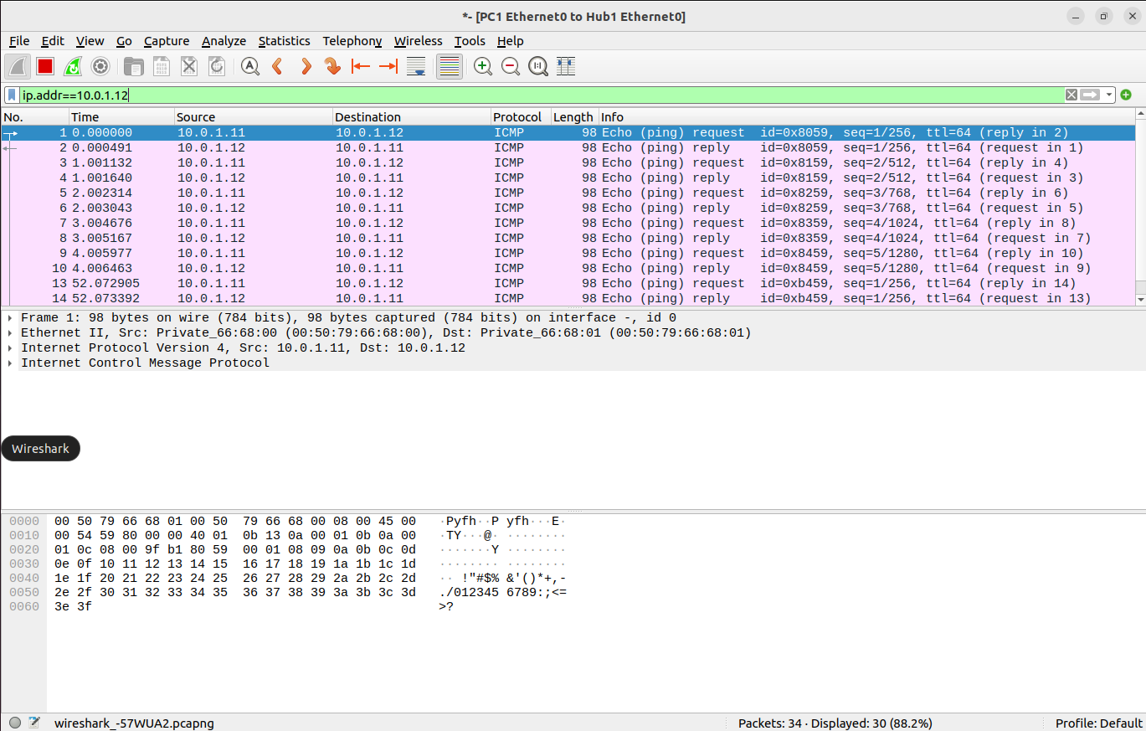
c.
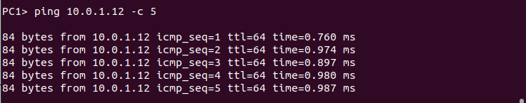
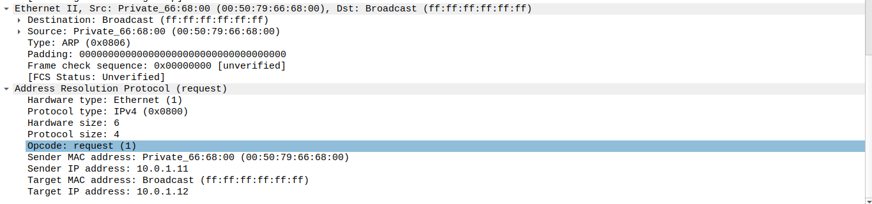
d.

2.
a.

b.
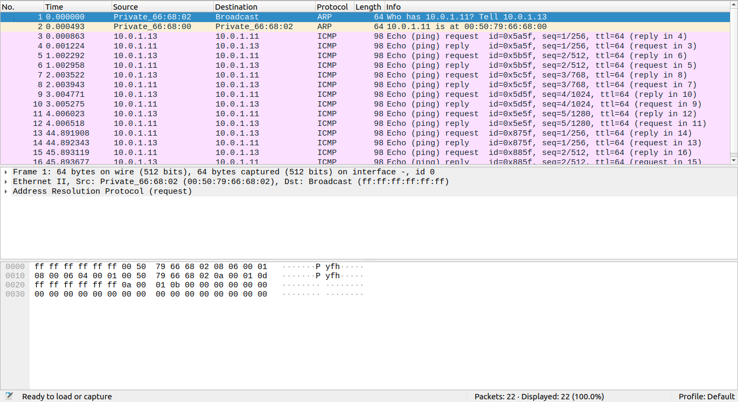
c.
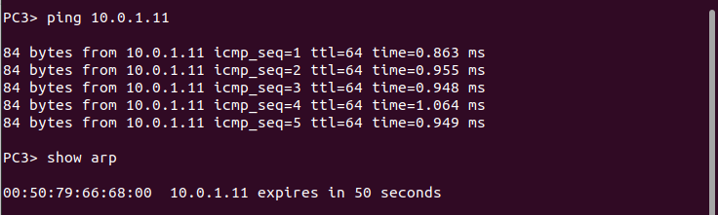
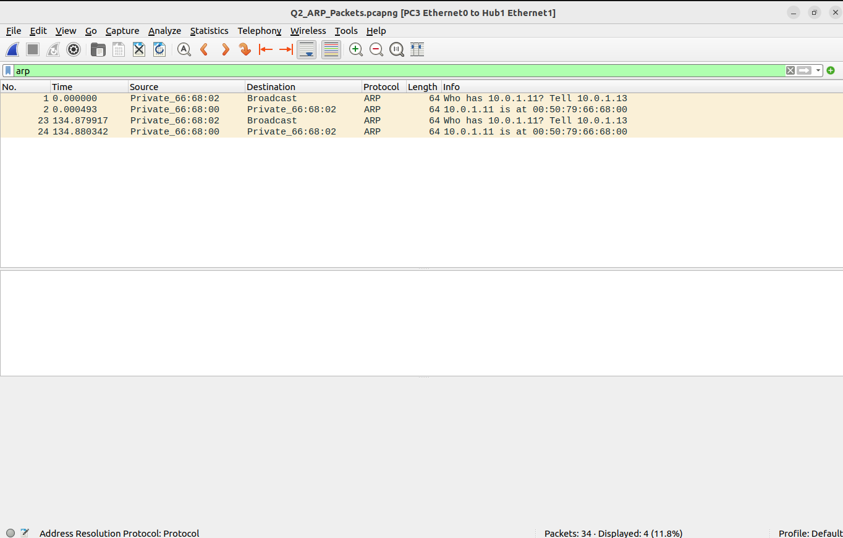
d.


e.
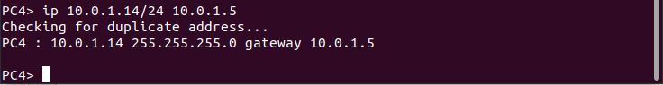
3.
a.

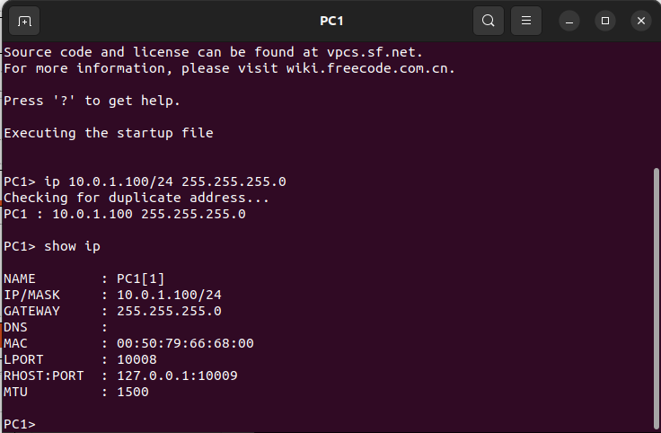
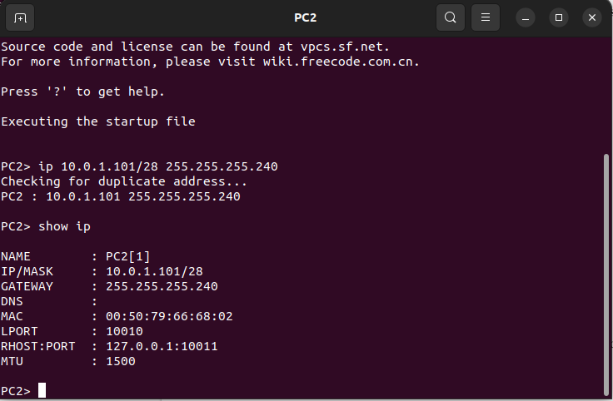
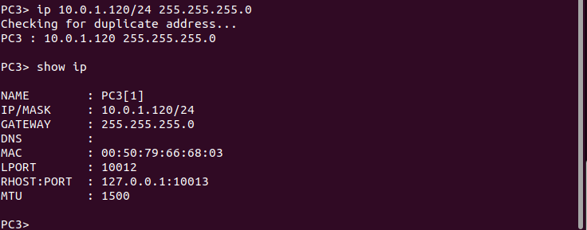

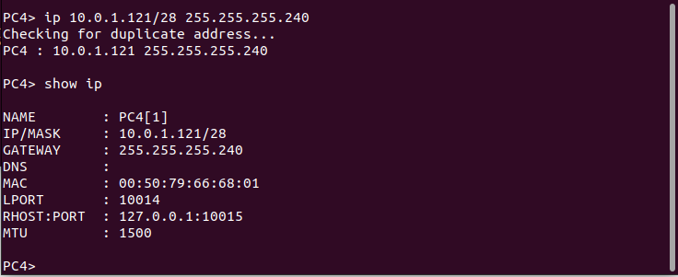
b.
i.
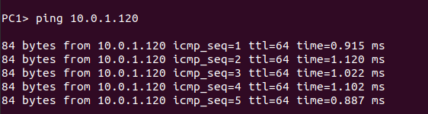
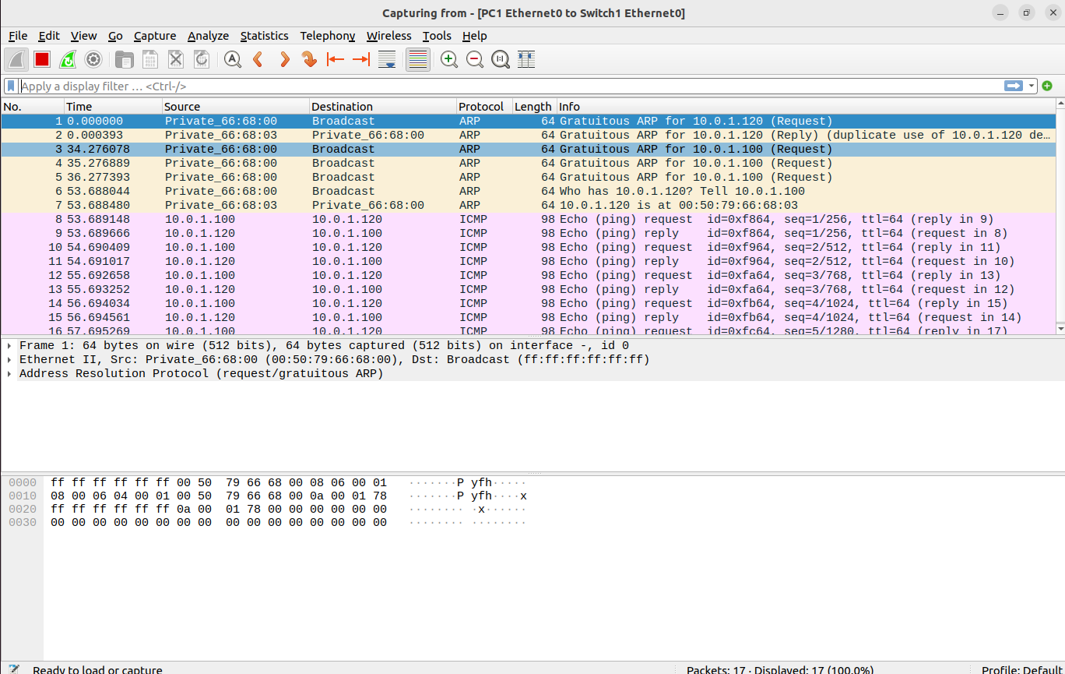
ii.
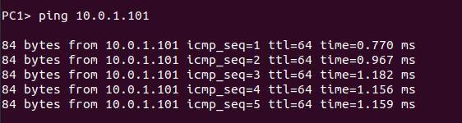
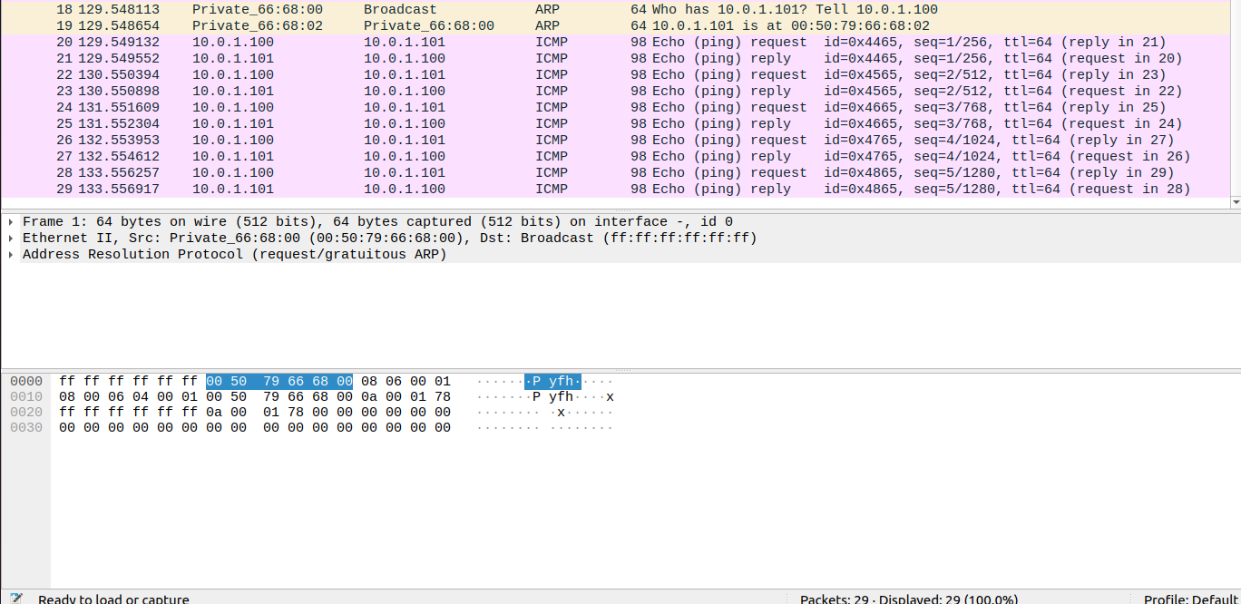
iii.

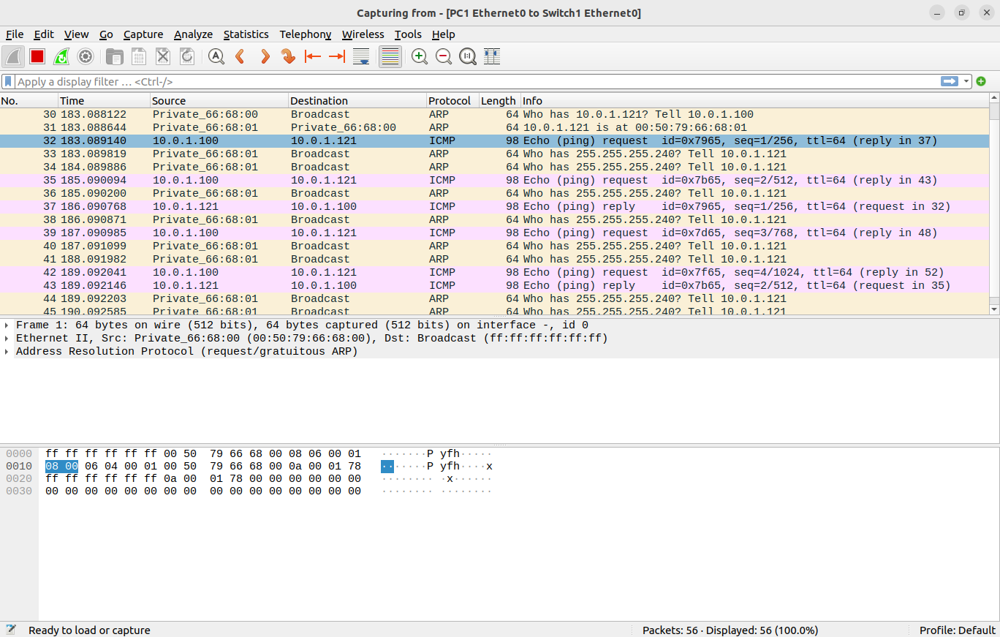
iv.

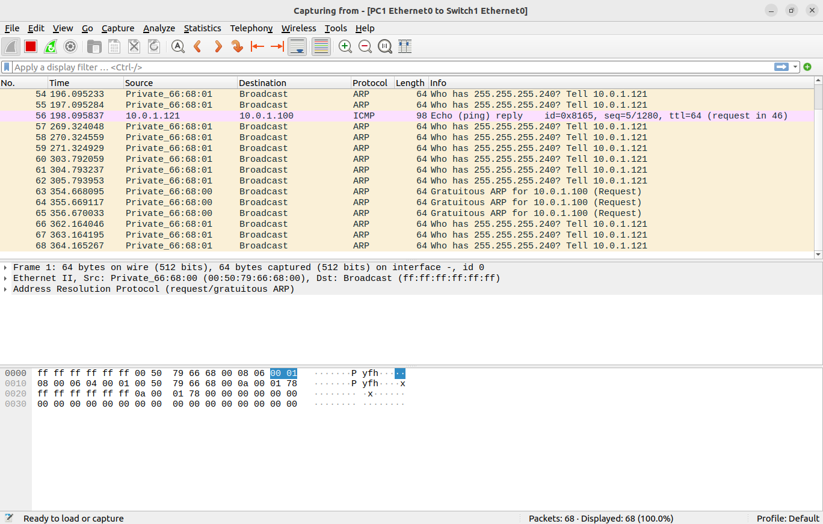
v.

vi.

d.



Based On Lab Question 1
• What is the destination MAC address of an ARP Request packet?
Ans- Private_66:68:00 (00:50:79:66:68:00)

• What are the different Type Field values in the Ethernet headers that you observed?
Ans - ARP (0x0806)

• Use the captured data to analyze the process in which ARP acquires the MAC address for IP
address 10.0.1.12.

Based On Lab Question 2
• Explain how the ping packets were issued by the hosts with duplicate addresses.
Ans – Ping packets weren’t able to transfer and the duplicated PC4 wasn’t able to connect to as the same IP address as of PC1.

• Did the ping command result in error messages?
Ans – Following ping messages weren’t reachable:
PC4 -> PC1
PC2 -> PC4
PC2 -> PC 3
• How can duplicate IP addresses be used to compromise the data security?
Ans - Duplicate IP addresses can compromise data security by enabling:
- Man-in-the-Middle Attacks: Attackers intercept and capture data between devices sharing the same IP.
- Denial of Service (DoS): Conflicts disrupt communication, causing downtime.
- Eavesdropping: Malicious devices capture sensitive, unencrypted data.
- Spoofing: Attackers impersonate legitimate devices, launching attacks.
Based On Lab Question 3
• Use your output data and ping results to explain what happened in each of the ping commands.
Ans – An attempt for transfering packets from one PC to the other was made, however because of differece in IP addresses and subnet masks some PC weren’t able to establish a connection.

• Which ping operations were successful and which were unsuccessful? Why?
Ans - i. From PC1 ping PC3.
Ping was successful, all the packets were able to transfer properly.

ii. From PC1 ping PC2.
Ping was successful, all the packets were able to transfer properly.
iii. From PC1 ping PC4.
Ping was unsuccessful, The provided IP addresses and subnet masks are not consistent with being on the same network. PC1 and PC4 should have IPs within the same subnet, but they're configured with different subnet masks. This likely leads to communication issues.

iv. From PC4 ping PC1.

Ping was unsuccessful, same reason as for PC1 -> PC4 connection.
v. From PC2 ping PC4.
Ping was unsuccessful, same reason as for PC1 -> PC4 connection.

