WEEK-5

Q1)
a.
b.
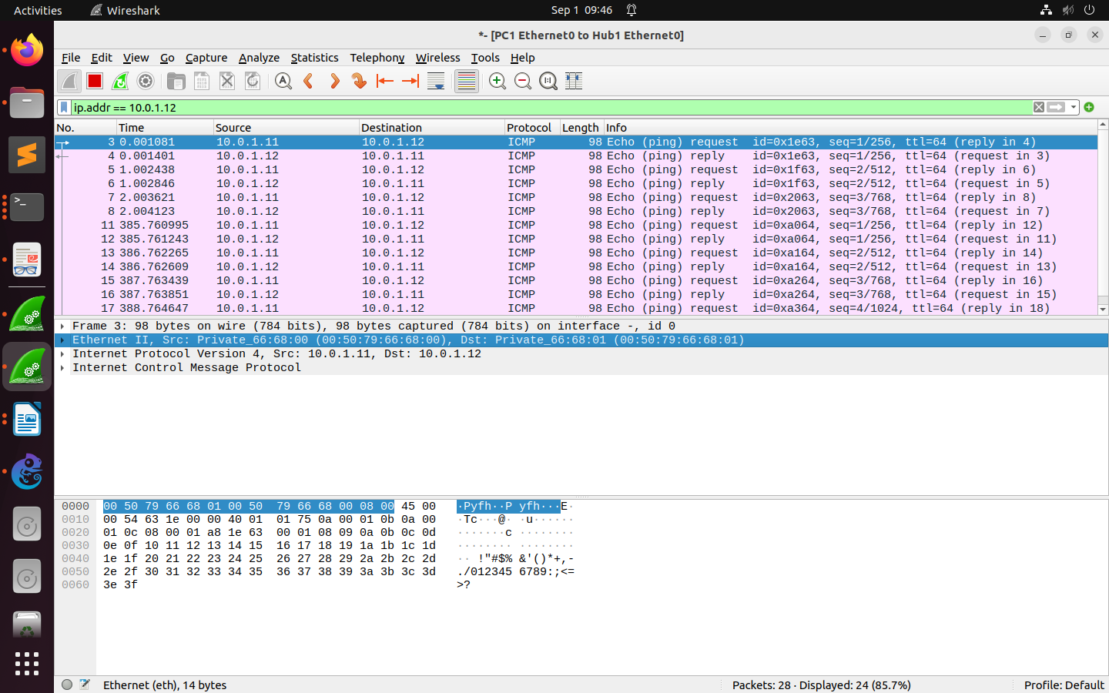

c.
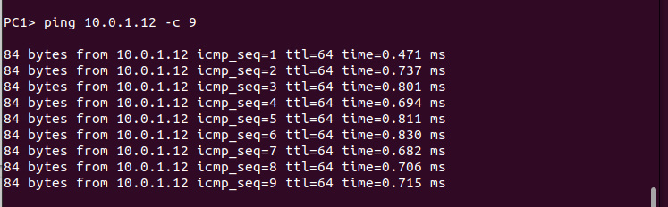
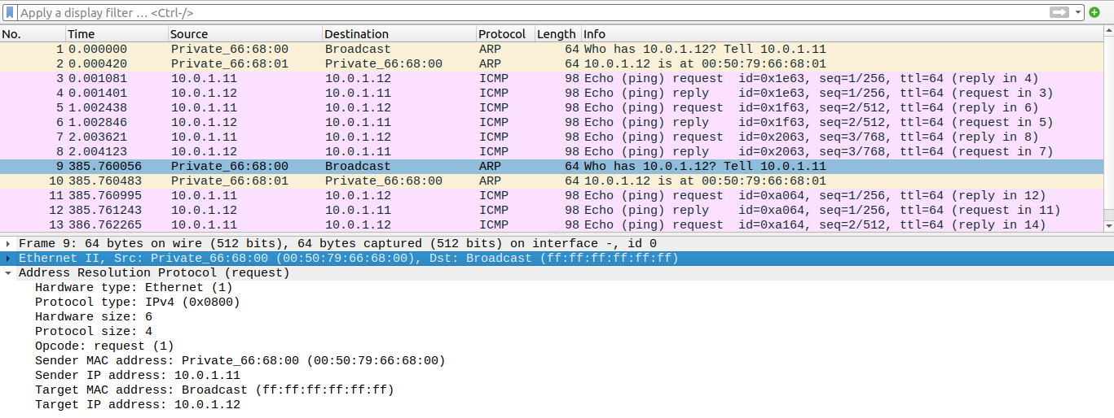
For the arp requests that are broadcasted the traget mac address is (ff:ff:ff:ff:ff:ff)

d.
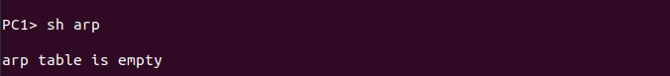

Q2)
a.
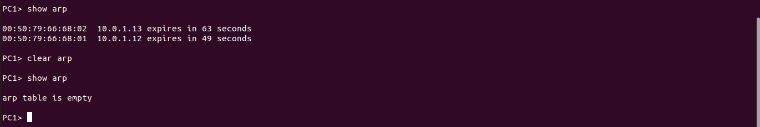
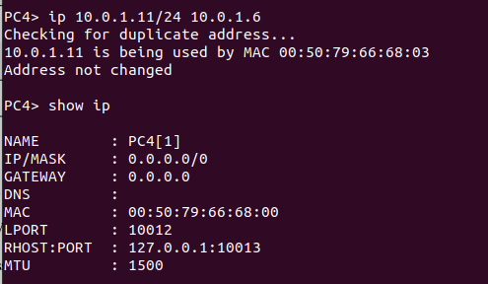
Cannot create duplicate ip address for PC4. Giving error.

b.
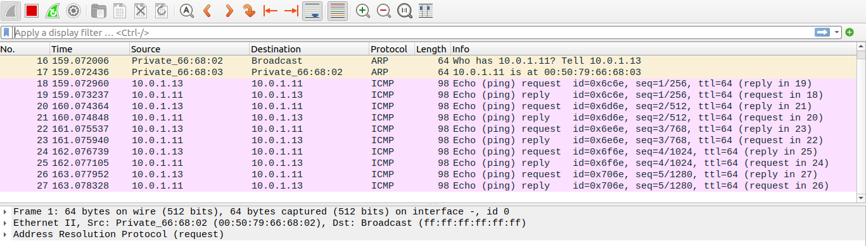
After pinging - PC3% ping 10.0.1.11 –c 5

c.
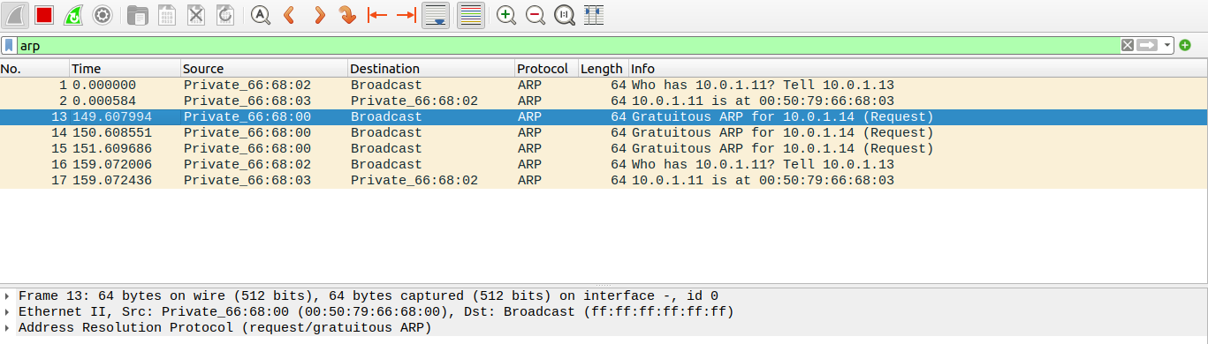
Have not created a duplicate address for PC4.

d.
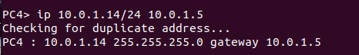

Q3)
a.
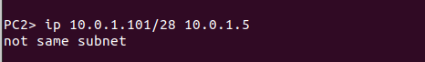

b.
i. From PC1 ping PC3.
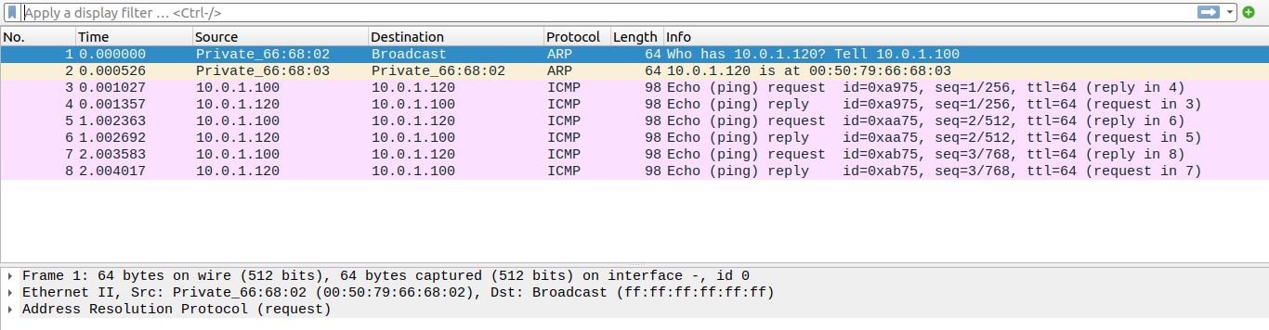
ii. From PC1 ping PC2.
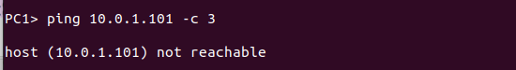
iii. From PC1 ping PC4.
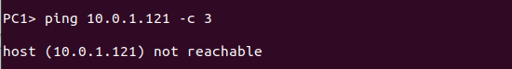
iv. From PC4 ping PC1.
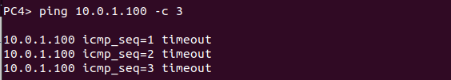
v. From PC2 ping PC4.
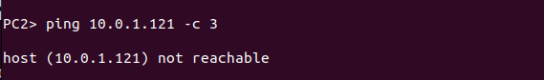
vi. From PC2 ping PC3.
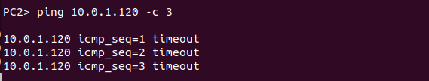
c.
No. Time Source Destination Protocol Length Info
1 0.000000 Private_66:68:02 Broadcast ARP 64 Who has 10.0.1.120? Tell 10.0.1.100

Frame 1: 64 bytes on wire (512 bits), 64 bytes captured (512 bits) on interface -, id 0
Ethernet II, Src: Private_66:68:02 (00:50:79:66:68:02), Dst: Broadcast (ff:ff:ff:ff:ff:ff)
Address Resolution Protocol (request)

No. Time Source Destination Protocol Length Info
2 0.000526 Private_66:68:03 Private_66:68:02 ARP 64 10.0.1.120 is at 00:50:79:66:68:03

Frame 2: 64 bytes on wire (512 bits), 64 bytes captured (512 bits) on interface -, id 0
Ethernet II, Src: Private_66:68:03 (00:50:79:66:68:03), Dst: Private_66:68:02 (00:50:79:66:68:02)
Address Resolution Protocol (reply)

No. Time Source Destination Protocol Length Info
3 0.001027 10.0.1.100 10.0.1.120 ICMP 98 Echo (ping) request id=0xa975, seq=1/256, ttl=64 (reply in 4)

Frame 3: 98 bytes on wire (784 bits), 98 bytes captured (784 bits) on interface -, id 0
Ethernet II, Src: Private_66:68:02 (00:50:79:66:68:02), Dst: Private_66:68:03 (00:50:79:66:68:03)
Internet Protocol Version 4, Src: 10.0.1.100, Dst: 10.0.1.120
Internet Control Message Protocol

No. Time Source Destination Protocol Length Info
4 0.001357 10.0.1.120 10.0.1.100 ICMP 98 Echo (ping) reply id=0xa975, seq=1/256, ttl=64 (request in 3)

Frame 4: 98 bytes on wire (784 bits), 98 bytes captured (784 bits) on interface -, id 0
Ethernet II, Src: Private_66:68:03 (00:50:79:66:68:03), Dst: Private_66:68:02 (00:50:79:66:68:02)
Internet Protocol Version 4, Src: 10.0.1.120, Dst: 10.0.1.100
Internet Control Message Protocol

No. Time Source Destination Protocol Length Info
5 1.002363 10.0.1.100 10.0.1.120 ICMP 98 Echo (ping) request id=0xaa75, seq=2/512, ttl=64 (reply in 6)

Frame 5: 98 bytes on wire (784 bits), 98 bytes captured (784 bits) on interface -, id 0
Ethernet II, Src: Private_66:68:02 (00:50:79:66:68:02), Dst: Private_66:68:03 (00:50:79:66:68:03)
Internet Protocol Version 4, Src: 10.0.1.100, Dst: 10.0.1.120
Internet Control Message Protocol

No. Time Source Destination Protocol Length Info
6 1.002692 10.0.1.120 10.0.1.100 ICMP 98 Echo (ping) reply id=0xaa75, seq=2/512, ttl=64 (request in 5)

Frame 6: 98 bytes on wire (784 bits), 98 bytes captured (784 bits) on interface -, id 0
Ethernet II, Src: Private_66:68:03 (00:50:79:66:68:03), Dst: Private_66:68:02 (00:50:79:66:68:02)
Internet Protocol Version 4, Src: 10.0.1.120, Dst: 10.0.1.100
Internet Control Message Protocol

No. Time Source Destination Protocol Length Info
7 2.003583 10.0.1.100 10.0.1.120 ICMP 98 Echo (ping) request id=0xab75, seq=3/768, ttl=64 (reply in 8)

Frame 7: 98 bytes on wire (784 bits), 98 bytes captured (784 bits) on interface -, id 0
Ethernet II, Src: Private_66:68:02 (00:50:79:66:68:02), Dst: Private_66:68:03 (00:50:79:66:68:03)
Internet Protocol Version 4, Src: 10.0.1.100, Dst: 10.0.1.120
Internet Control Message Protocol

No. Time Source Destination Protocol Length Info
8 2.004017 10.0.1.120 10.0.1.100 ICMP 98 Echo (ping) reply id=0xab75, seq=3/768, ttl=64 (request in 7)

Frame 8: 98 bytes on wire (784 bits), 98 bytes captured (784 bits) on interface -, id 0
Ethernet II, Src: Private_66:68:03 (00:50:79:66:68:03), Dst: Private_66:68:02 (00:50:79:66:68:02)
Internet Protocol Version 4, Src: 10.0.1.120, Dst: 10.0.1.100
Internet Control Message Protocol

No. Time Source Destination Protocol Length Info
9 95.651941 Private_66:68:02 Broadcast ARP 64 Who has 10.0.1.101? Tell 10.0.1.100

Frame 9: 64 bytes on wire (512 bits), 64 bytes captured (512 bits) on interface -, id 0
Ethernet II, Src: Private_66:68:02 (00:50:79:66:68:02), Dst: Broadcast (ff:ff:ff:ff:ff:ff)
Address Resolution Protocol (request)

No. Time Source Destination Protocol Length Info
10 96.653057 Private_66:68:02 Broadcast ARP 64 Who has 10.0.1.101? Tell 10.0.1.100

Frame 10: 64 bytes on wire (512 bits), 64 bytes captured (512 bits) on interface -, id 0
Ethernet II, Src: Private_66:68:02 (00:50:79:66:68:02), Dst: Broadcast (ff:ff:ff:ff:ff:ff)
Address Resolution Protocol (request)

No. Time Source Destination Protocol Length Info
11 97.653535 Private_66:68:02 Broadcast ARP 64 Who has 10.0.1.101? Tell 10.0.1.100

Frame 11: 64 bytes on wire (512 bits), 64 bytes captured (512 bits) on interface -, id 0
Ethernet II, Src: Private_66:68:02 (00:50:79:66:68:02), Dst: Broadcast (ff:ff:ff:ff:ff:ff)
Address Resolution Protocol (request)

No. Time Source Destination Protocol Length Info
12 129.560032 Private_66:68:02 Broadcast ARP 64 Who has 10.0.1.121? Tell 10.0.1.100

Frame 12: 64 bytes on wire (512 bits), 64 bytes captured (512 bits) on interface -, id 0
Ethernet II, Src: Private_66:68:02 (00:50:79:66:68:02), Dst: Broadcast (ff:ff:ff:ff:ff:ff)
Address Resolution Protocol (request)

No. Time Source Destination Protocol Length Info
13 130.560109 Private_66:68:02 Broadcast ARP 64 Who has 10.0.1.121? Tell 10.0.1.100

Frame 13: 64 bytes on wire (512 bits), 64 bytes captured (512 bits) on interface -, id 0
Ethernet II, Src: Private_66:68:02 (00:50:79:66:68:02), Dst: Broadcast (ff:ff:ff:ff:ff:ff)
Address Resolution Protocol (request)

No. Time Source Destination Protocol Length Info
14 131.560533 Private_66:68:02 Broadcast ARP 64 Who has 10.0.1.121? Tell 10.0.1.100

Frame 14: 64 bytes on wire (512 bits), 64 bytes captured (512 bits) on interface -, id 0
Ethernet II, Src: Private_66:68:02 (00:50:79:66:68:02), Dst: Broadcast (ff:ff:ff:ff:ff:ff)
Address Resolution Protocol (request)

No. Time Source Destination Protocol Length Info
15 167.756048 Private_66:68:00 Broadcast ARP 64 Who has 10.0.1.100? Tell 0.0.0.0

Frame 15: 64 bytes on wire (512 bits), 64 bytes captured (512 bits) on interface -, id 0
Ethernet II, Src: Private_66:68:00 (00:50:79:66:68:00), Dst: Broadcast (ff:ff:ff:ff:ff:ff)
Address Resolution Protocol (request)

No. Time Source Destination Protocol Length Info
16 167.756462 Private_66:68:02 Private_66:68:00 ARP 64 10.0.1.100 is at 00:50:79:66:68:02

Frame 16: 64 bytes on wire (512 bits), 64 bytes captured (512 bits) on interface -, id 0
Ethernet II, Src: Private_66:68:02 (00:50:79:66:68:02), Dst: Private_66:68:00 (00:50:79:66:68:00)
Address Resolution Protocol (reply)

No. Time Source Destination Protocol Length Info
17 167.757171 0.0.0.0 10.0.1.100 ICMP 98 Echo (ping) request id=0x5176, seq=1/256, ttl=64 (reply in 22)

Frame 17: 98 bytes on wire (784 bits), 98 bytes captured (784 bits) on interface -, id 0
Ethernet II, Src: Private_66:68:00 (00:50:79:66:68:00), Dst: Private_66:68:02 (00:50:79:66:68:02)
Internet Protocol Version 4, Src: 0.0.0.0, Dst: 10.0.1.100
Internet Control Message Protocol

No. Time Source Destination Protocol Length Info
18 167.757653 Private_66:68:02 Broadcast ARP 64 Who has 10.0.1.5? Tell 10.0.1.100

Frame 18: 64 bytes on wire (512 bits), 64 bytes captured (512 bits) on interface -, id 0
Ethernet II, Src: Private_66:68:02 (00:50:79:66:68:02), Dst: Broadcast (ff:ff:ff:ff:ff:ff)
Address Resolution Protocol (request)

No. Time Source Destination Protocol Length Info
19 168.758695 Private_66:68:02 Broadcast ARP 64 Who has 10.0.1.5? Tell 10.0.1.100

Frame 19: 64 bytes on wire (512 bits), 64 bytes captured (512 bits) on interface -, id 0
Ethernet II, Src: Private_66:68:02 (00:50:79:66:68:02), Dst: Broadcast (ff:ff:ff:ff:ff:ff)
Address Resolution Protocol (request)

No. Time Source Destination Protocol Length Info
20 169.757752 0.0.0.0 10.0.1.100 ICMP 98 Echo (ping) request id=0x5376, seq=2/512, ttl=64 (reply in 27)

Frame 20: 98 bytes on wire (784 bits), 98 bytes captured (784 bits) on interface -, id 0
Ethernet II, Src: Private_66:68:00 (00:50:79:66:68:00), Dst: Private_66:68:02 (00:50:79:66:68:02)
Internet Protocol Version 4, Src: 0.0.0.0, Dst: 10.0.1.100
Internet Control Message Protocol

No. Time Source Destination Protocol Length Info
21 169.758935 Private_66:68:02 Broadcast ARP 64 Who has 10.0.1.5? Tell 10.0.1.100

Frame 21: 64 bytes on wire (512 bits), 64 bytes captured (512 bits) on interface -, id 0
Ethernet II, Src: Private_66:68:02 (00:50:79:66:68:02), Dst: Broadcast (ff:ff:ff:ff:ff:ff)
Address Resolution Protocol (request)

No. Time Source Destination Protocol Length Info
22 170.759893 10.0.1.100 0.0.0.0 ICMP 98 Echo (ping) reply id=0x5176, seq=1/256, ttl=64 (request in 17)

Frame 22: 98 bytes on wire (784 bits), 98 bytes captured (784 bits) on interface -, id 0
Ethernet II, Src: Private_66:68:02 (00:50:79:66:68:02), Dst: Private_66:68:00 (00:50:79:66:68:00)
Internet Protocol Version 4, Src: 10.0.1.100, Dst: 0.0.0.0
Internet Control Message Protocol

No. Time Source Destination Protocol Length Info
23 170.759978 Private_66:68:02 Broadcast ARP 64 Who has 10.0.1.5? Tell 10.0.1.100

Frame 23: 64 bytes on wire (512 bits), 64 bytes captured (512 bits) on interface -, id 0
Ethernet II, Src: Private_66:68:02 (00:50:79:66:68:02), Dst: Broadcast (ff:ff:ff:ff:ff:ff)
Address Resolution Protocol (request)

No. Time Source Destination Protocol Length Info
24 171.758964 0.0.0.0 10.0.1.100 ICMP 98 Echo (ping) request id=0x5576, seq=3/768, ttl=64 (reply in 31)

Frame 24: 98 bytes on wire (784 bits), 98 bytes captured (784 bits) on interface -, id 0
Ethernet II, Src: Private_66:68:00 (00:50:79:66:68:00), Dst: Private_66:68:02 (00:50:79:66:68:02)
Internet Protocol Version 4, Src: 0.0.0.0, Dst: 10.0.1.100
Internet Control Message Protocol

No. Time Source Destination Protocol Length Info
25 171.760701 Private_66:68:02 Broadcast ARP 64 Who has 10.0.1.5? Tell 10.0.1.100

Frame 25: 64 bytes on wire (512 bits), 64 bytes captured (512 bits) on interface -, id 0
Ethernet II, Src: Private_66:68:02 (00:50:79:66:68:02), Dst: Broadcast (ff:ff:ff:ff:ff:ff)
Address Resolution Protocol (request)

No. Time Source Destination Protocol Length Info
26 172.761123 Private_66:68:02 Broadcast ARP 64 Who has 10.0.1.5? Tell 10.0.1.100

Frame 26: 64 bytes on wire (512 bits), 64 bytes captured (512 bits) on interface -, id 0
Ethernet II, Src: Private_66:68:02 (00:50:79:66:68:02), Dst: Broadcast (ff:ff:ff:ff:ff:ff)
Address Resolution Protocol (request)

No. Time Source Destination Protocol Length Info
27 173.761447 10.0.1.100 0.0.0.0 ICMP 98 Echo (ping) reply id=0x5376, seq=2/512, ttl=64 (request in 20)

Frame 27: 98 bytes on wire (784 bits), 98 bytes captured (784 bits) on interface -, id 0
Ethernet II, Src: Private_66:68:02 (00:50:79:66:68:02), Dst: Private_66:68:00 (00:50:79:66:68:00)
Internet Protocol Version 4, Src: 10.0.1.100, Dst: 0.0.0.0
Internet Control Message Protocol

No. Time Source Destination Protocol Length Info
28 173.761539 Private_66:68:02 Broadcast ARP 64 Who has 10.0.1.5? Tell 10.0.1.100

Frame 28: 64 bytes on wire (512 bits), 64 bytes captured (512 bits) on interface -, id 0
Ethernet II, Src: Private_66:68:02 (00:50:79:66:68:02), Dst: Broadcast (ff:ff:ff:ff:ff:ff)
Address Resolution Protocol (request)

No. Time Source Destination Protocol Length Info
29 174.762397 Private_66:68:02 Broadcast ARP 64 Who has 10.0.1.5? Tell 10.0.1.100

Frame 29: 64 bytes on wire (512 bits), 64 bytes captured (512 bits) on interface -, id 0
Ethernet II, Src: Private_66:68:02 (00:50:79:66:68:02), Dst: Broadcast (ff:ff:ff:ff:ff:ff)
Address Resolution Protocol (request)

No. Time Source Destination Protocol Length Info
30 175.763283 Private_66:68:02 Broadcast ARP 64 Who has 10.0.1.5? Tell 10.0.1.100

Frame 30: 64 bytes on wire (512 bits), 64 bytes captured (512 bits) on interface -, id 0
Ethernet II, Src: Private_66:68:02 (00:50:79:66:68:02), Dst: Broadcast (ff:ff:ff:ff:ff:ff)
Address Resolution Protocol (request)

No. Time Source Destination Protocol Length Info
31 176.764112 10.0.1.100 0.0.0.0 ICMP 98 Echo (ping) reply id=0x5576, seq=3/768, ttl=64 (request in 24)

Frame 31: 98 bytes on wire (784 bits), 98 bytes captured (784 bits) on interface -, id 0
Ethernet II, Src: Private_66:68:02 (00:50:79:66:68:02), Dst: Private_66:68:00 (00:50:79:66:68:00)
Internet Protocol Version 4, Src: 10.0.1.100, Dst: 0.0.0.0
Internet Control Message Protocol

No. Time Source Destination Protocol Length Info
32 220.752020 Private_66:68:01 Broadcast ARP 64 Who has 10.0.1.121? Tell 0.0.0.0

Frame 32: 64 bytes on wire (512 bits), 64 bytes captured (512 bits) on interface -, id 0
Ethernet II, Src: Private_66:68:01 (00:50:79:66:68:01), Dst: Broadcast (ff:ff:ff:ff:ff:ff)
Address Resolution Protocol (request)

No. Time Source Destination Protocol Length Info
33 221.752933 Private_66:68:01 Broadcast ARP 64 Who has 10.0.1.121? Tell 0.0.0.0

Frame 33: 64 bytes on wire (512 bits), 64 bytes captured (512 bits) on interface -, id 0
Ethernet II, Src: Private_66:68:01 (00:50:79:66:68:01), Dst: Broadcast (ff:ff:ff:ff:ff:ff)
Address Resolution Protocol (request)

No. Time Source Destination Protocol Length Info
34 222.753056 Private_66:68:01 Broadcast ARP 64 Who has 10.0.1.121? Tell 0.0.0.0

Frame 34: 64 bytes on wire (512 bits), 64 bytes captured (512 bits) on interface -, id 0
Ethernet II, Src: Private_66:68:01 (00:50:79:66:68:01), Dst: Broadcast (ff:ff:ff:ff:ff:ff)
Address Resolution Protocol (request)

No. Time Source Destination Protocol Length Info
35 234.911996 Private_66:68:01 Broadcast ARP 64 Who has 10.0.1.120? Tell 0.0.0.0

Frame 35: 64 bytes on wire (512 bits), 64 bytes captured (512 bits) on interface -, id 0
Ethernet II, Src: Private_66:68:01 (00:50:79:66:68:01), Dst: Broadcast (ff:ff:ff:ff:ff:ff)
Address Resolution Protocol (request)

No. Time Source Destination Protocol Length Info
36 234.913429 Private_66:68:03 Broadcast ARP 64 Who has 10.0.1.5? Tell 10.0.1.120

Frame 36: 64 bytes on wire (512 bits), 64 bytes captured (512 bits) on interface -, id 0
Ethernet II, Src: Private_66:68:03 (00:50:79:66:68:03), Dst: Broadcast (ff:ff:ff:ff:ff:ff)
Address Resolution Protocol (request)

No. Time Source Destination Protocol Length Info
37 235.913671 Private_66:68:03 Broadcast ARP 64 Who has 10.0.1.5? Tell 10.0.1.120

Frame 37: 64 bytes on wire (512 bits), 64 bytes captured (512 bits) on interface -, id 0
Ethernet II, Src: Private_66:68:03 (00:50:79:66:68:03), Dst: Broadcast (ff:ff:ff:ff:ff:ff)
Address Resolution Protocol (request)

No. Time Source Destination Protocol Length Info
38 236.914088 Private_66:68:03 Broadcast ARP 64 Who has 10.0.1.5? Tell 10.0.1.120

Frame 38: 64 bytes on wire (512 bits), 64 bytes captured (512 bits) on interface -, id 0
Ethernet II, Src: Private_66:68:03 (00:50:79:66:68:03), Dst: Broadcast (ff:ff:ff:ff:ff:ff)
Address Resolution Protocol (request)

No. Time Source Destination Protocol Length Info
39 237.914223 Private_66:68:03 Broadcast ARP 64 Who has 10.0.1.5? Tell 10.0.1.120

Frame 39: 64 bytes on wire (512 bits), 64 bytes captured (512 bits) on interface -, id 0
Ethernet II, Src: Private_66:68:03 (00:50:79:66:68:03), Dst: Broadcast (ff:ff:ff:ff:ff:ff)
Address Resolution Protocol (request)

No. Time Source Destination Protocol Length Info
40 238.915179 Private_66:68:03 Broadcast ARP 64 Who has 10.0.1.5? Tell 10.0.1.120

Frame 40: 64 bytes on wire (512 bits), 64 bytes captured (512 bits) on interface -, id 0
Ethernet II, Src: Private_66:68:03 (00:50:79:66:68:03), Dst: Broadcast (ff:ff:ff:ff:ff:ff)
Address Resolution Protocol (request)

No. Time Source Destination Protocol Length Info
41 239.916312 Private_66:68:03 Broadcast ARP 64 Who has 10.0.1.5? Tell 10.0.1.120

Frame 41: 64 bytes on wire (512 bits), 64 bytes captured (512 bits) on interface -, id 0
Ethernet II, Src: Private_66:68:03 (00:50:79:66:68:03), Dst: Broadcast (ff:ff:ff:ff:ff:ff)
Address Resolution Protocol (request)

No. Time Source Destination Protocol Length Info
42 240.917150 Private_66:68:03 Broadcast ARP 64 Who has 10.0.1.5? Tell 10.0.1.120

Frame 42: 64 bytes on wire (512 bits), 64 bytes captured (512 bits) on interface -, id 0
Ethernet II, Src: Private_66:68:03 (00:50:79:66:68:03), Dst: Broadcast (ff:ff:ff:ff:ff:ff)
Address Resolution Protocol (request)

No. Time Source Destination Protocol Length Info
43 241.918202 Private_66:68:03 Broadcast ARP 64 Who has 10.0.1.5? Tell 10.0.1.120

Frame 43: 64 bytes on wire (512 bits), 64 bytes captured (512 bits) on interface -, id 0
Ethernet II, Src: Private_66:68:03 (00:50:79:66:68:03), Dst: Broadcast (ff:ff:ff:ff:ff:ff)
Address Resolution Protocol (request)

No. Time Source Destination Protocol Length Info
44 242.918369 Private_66:68:03 Broadcast ARP 64 Who has 10.0.1.5? Tell 10.0.1.120

Frame 44: 64 bytes on wire (512 bits), 64 bytes captured (512 bits) on interface -, id 0
Ethernet II, Src: Private_66:68:03 (00:50:79:66:68:03), Dst: Broadcast (ff:ff:ff:ff:ff:ff)
Address Resolution Protocol (request)

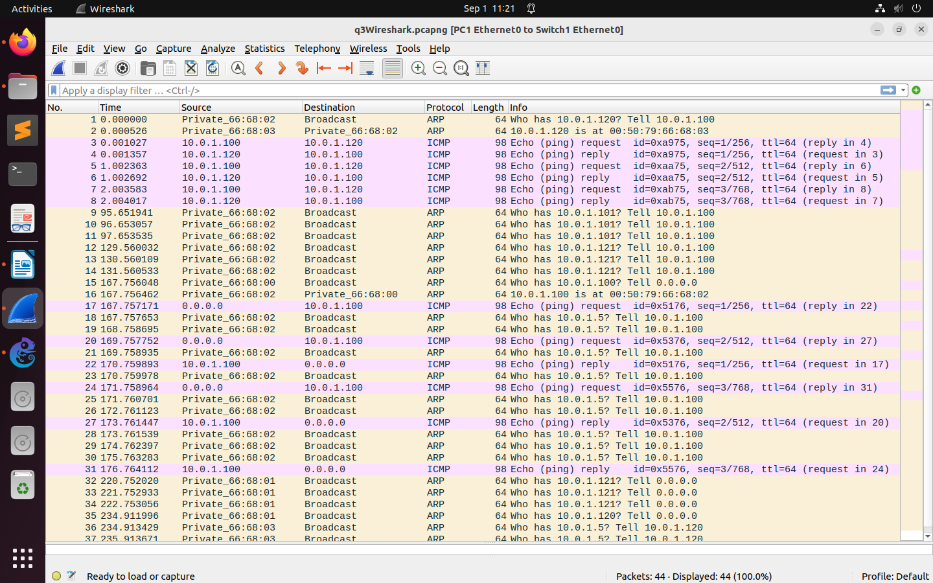

THIS WAS THE ENTIRE PACKETS I RECIEVED IN WIRESHARK BY PINGING DIFFERENT Pcs

d.
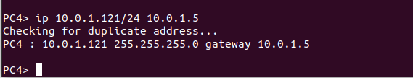
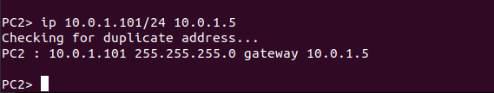
Based On Lab Question 1
• What is the destination MAC address of an ARP Request packet?
Ans- Private_66:68:00 (00:50:79:66:68:00)

• What are the different Type Field values in the Ethernet headers that you observed?
Ans - ARP (0x0806)

• Use the captured data to analyze the process in which ARP acquires the MAC address for IP
address 10.0.1.12.
Ans – Snippet above

Based On Lab Question 2
• Explain how the ping packets were issued by the hosts with duplicate addresses.
Ans – Ping packets weren’t able to transfer and the duplicated PC4 wasn’t able to connect to as the same IP address as of PC1.

• Did the ping command result in error messages?
Ans – Following ping messages weren’t reachable:
PC4 -> PC1
PC2 -> PC4
PC2 -> PC 3
• How can duplicate IP addresses be used to compromise the data security?
Ans - Duplicate IP addresses can compromise data security by enabling:
- Man-in-the-Middle Attacks: Attackers intercept and capture data between devices sharing the same IP.
- Denial of Service (DoS): Conflicts disrupt communication, causing downtime.
- Eavesdropping: Malicious devices capture sensitive, unencrypted data.
- Spoofing: Attackers impersonate legitimate devices, launching attacks.
Based On Lab Question 3
• Use your output data and ping results to explain what happened in each of the ping commands.
Ans – An attempt for transfering packets from one PC to the other was made, however because of differece in IP addresses and subnet masks some PC weren’t able to establish a connection.

• Which ping operations were successful and which were unsuccessful? Why?
Ans - i. From PC1 ping PC3.
Ping was successful, all the packets were able to transfer properly.

ii. From PC1 ping PC2.
Ping was successful, all the packets were able to transfer properly.
iii. From PC1 ping PC4.
Ping was unsuccessful, The provided IP addresses and subnet masks are not consistent with being on the same network. PC1 and PC4 should have IPs within the same subnet, but they're configured with different subnet masks. This likely leads to communication issues.

iv. From PC4 ping PC1.

Ping was unsuccessful, same reason as for PC1 -> PC4 connection.
v. From PC2 ping PC4.
Ping was unsuccessful, same reason as for PC1 -> PC4 connection.

