Q1)
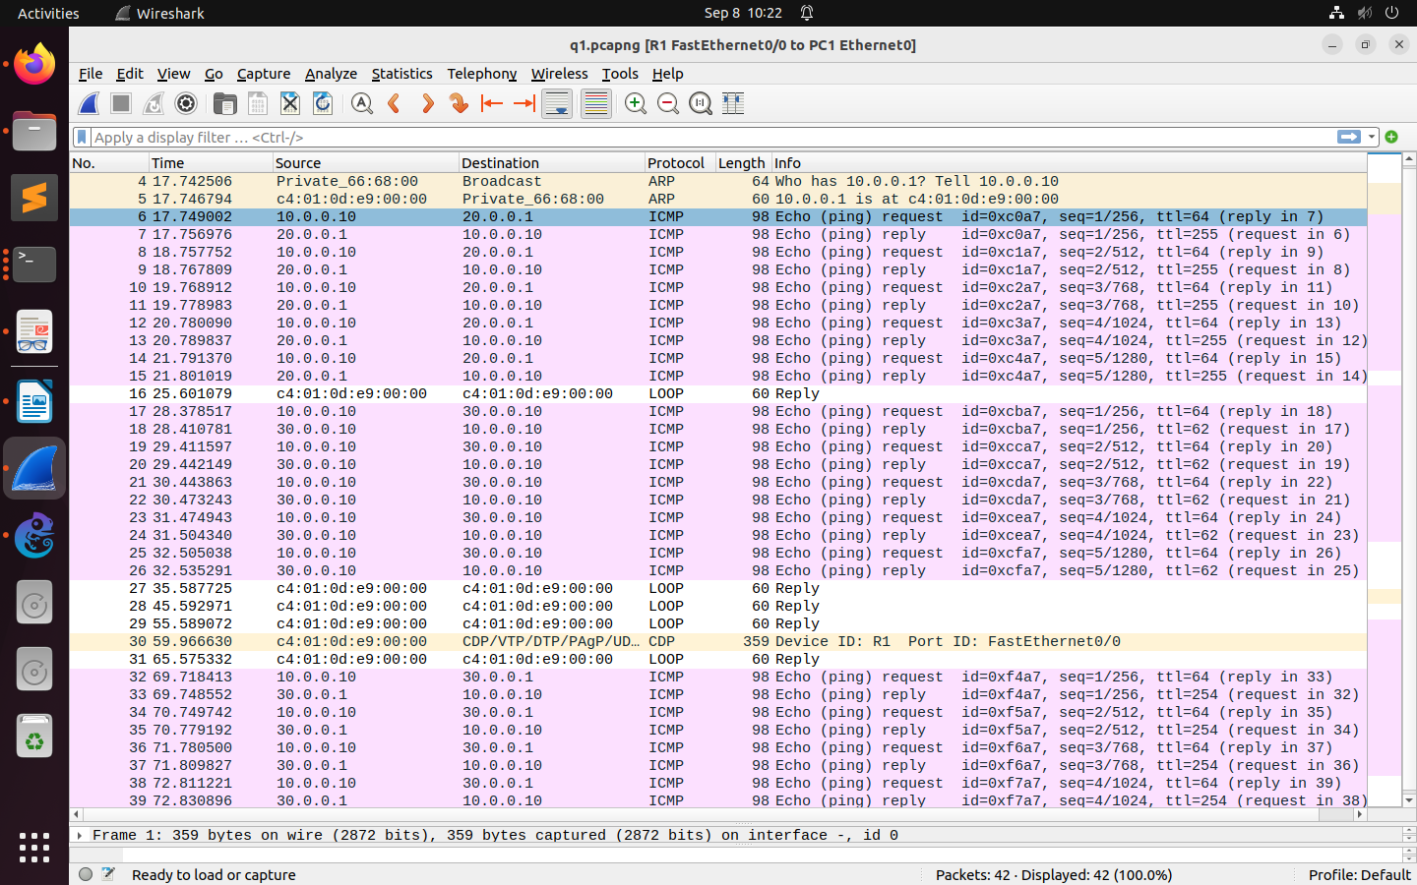
1. CCCode snippets below.
2. ICMP packets and ARP packets.
3. Yes ARP packets are there when connection is established. Broadcast.

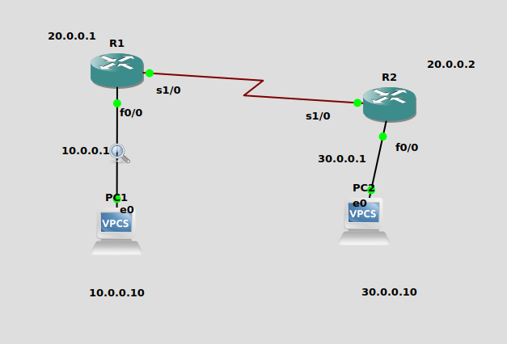
jk
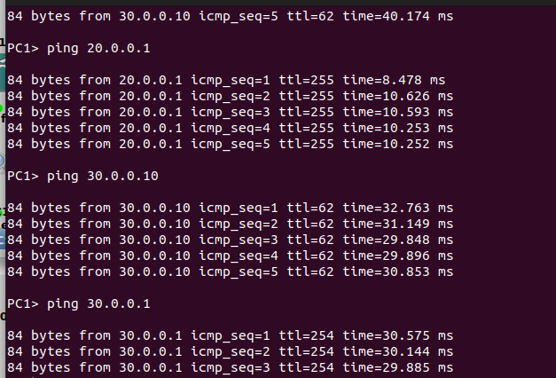
ping sucessfull. From PC1->R1 and PC1->PC2

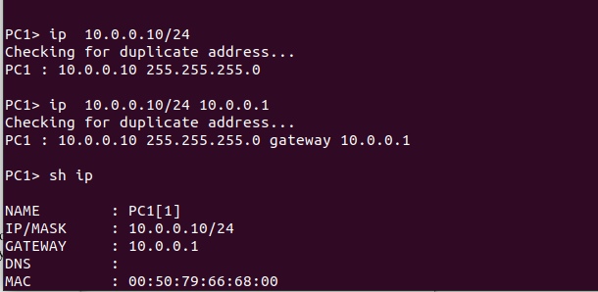
configuring ip of PC1

Q2) ALWAYS DO THIS WHILE PC CONFIGURATION:
PC1: IP MASK GATEWAY

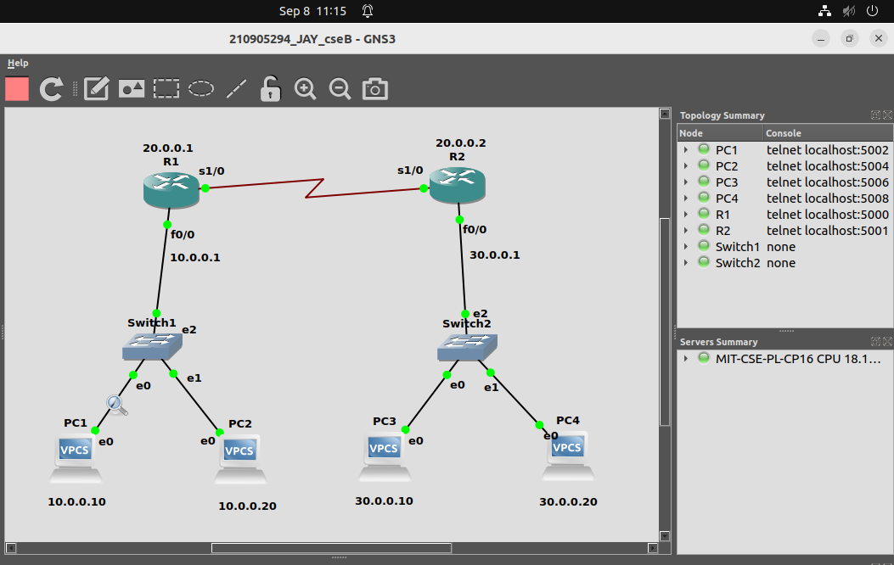
How the connections were made.

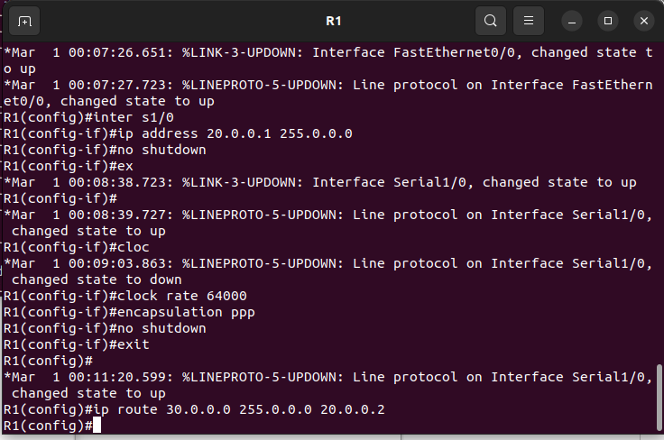
R1 configurations

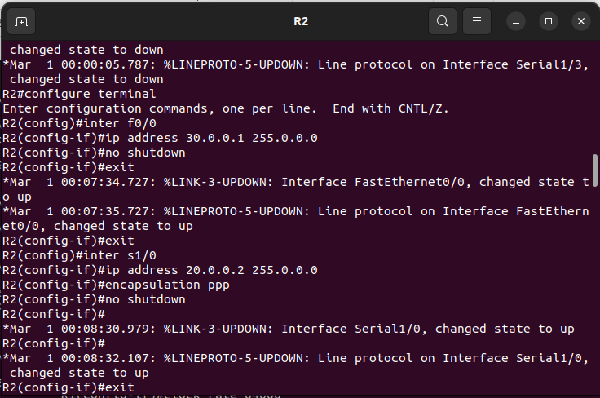
R2 configurations

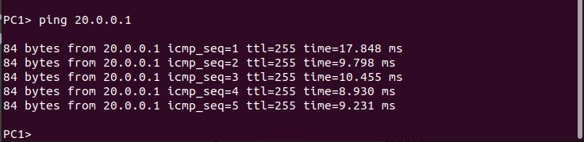
This shows we can ping from PC1 to R1.

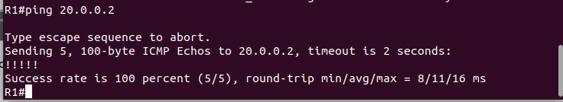
This shows that connection between R1 and R2 is good and successful.

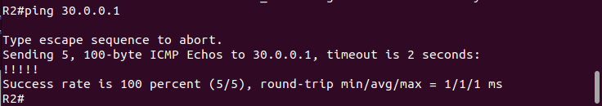
This shows that connection between R2 and PC3 is successfull.

Can we ping from PC1 to PC3?
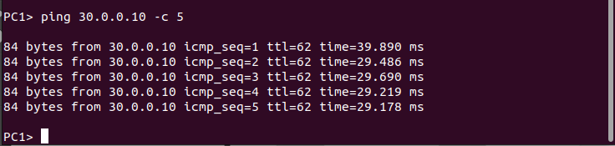
Yes.
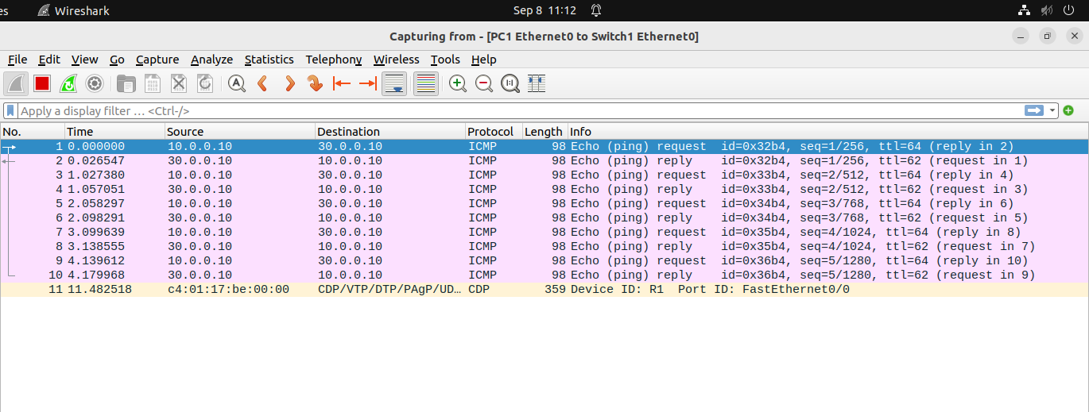
Proof.

