WEEK 1 – Jay Patel 210905294

Looping & Conditional Branches in Python

# Eg.1
num=float(input('Enter a number:'))
if num>0:
print('pos number')
elif num==0:
print('zero')
else:
print('Neg number')
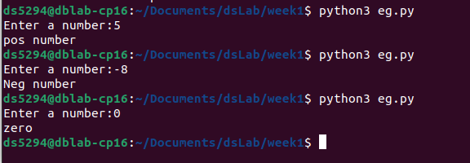
# Eg.2
x=float(input('Enter a number:'))
if x<10:
print('smaller')
if x>20:
print('bigger')
print('Finished')
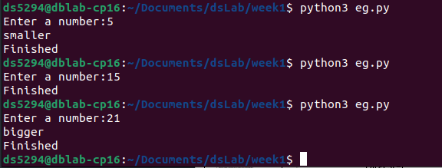
# Eg.3
x=5
print("Before 5")
if x==5:
print ("this is 5")
print("still 5")
print("After 5")
print("Before 6")
if x==6:
print("this is 6")
print ("After 6")
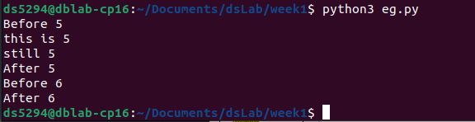
# Eg.4: which will never print?
x=float(input("Enter a number:"))
if x<20:
print("Below 20")
elif x<10:
print("Below 10")
else:
print("something else")
# Ans: Below 10
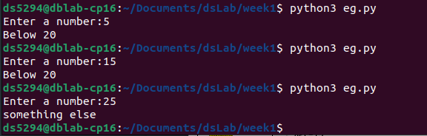
Ans: Below 10

# Eg.5: Nested Decisions
x=42
if x>1:
print("above one")
if x<100:
print("less than 100")
print("All done")
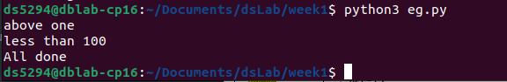
# Eg.6: Ternary operator
age=15
b=("kid" if age<18 else "adult")
print(b)
#this will print "kid"
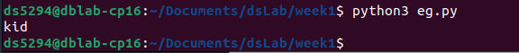

# Usage of For-loop
# Eg.1
for val in [5,4,3,2,1]:
print(val)
print ("Done")
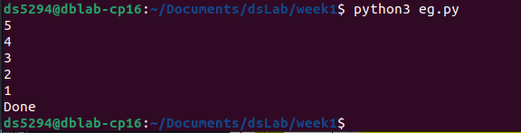
# Eg.2
stud=["Ram","Vijay","Nithya","Anu","Ramesh","suja"]
for k in stud:
print("Hello:", k)
print("done")
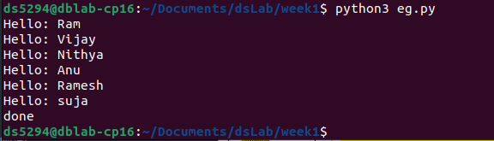
# Eg.3
for i in range(5):
print(i)
if i>2:
print("Bigger than 2")
print("Done with i",i)
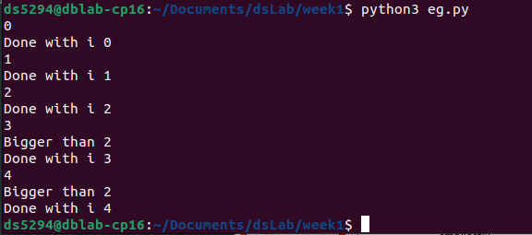
# Eg.4: Calculate factors of a number
x=int(input("Enter a number:"))
for i in range(1,x+1):
if x%i ==0:
print(i)

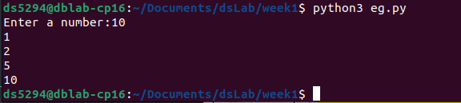
# Eg.5: Calculate largest number in an array
from math import *
x= [9, 41, 12, 3, 74, 15]
Largest=-inf
for i in x:
if i>Largest:
Largest=i
print(Largest)
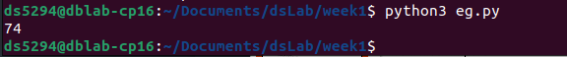
# Eg.6: Calculate smallest number in an array
from math import *
x= [9, 41, 12, 3, 74, 15]
smallest=inf
for i in x:
if i<smallest:
smallest=i
print(smallest)
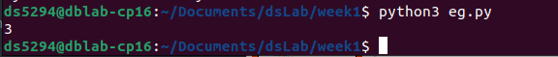
# Eg.7: Calculate the count, sum and average of numerical array
x= [9, 41, 12, 3, 74, 15]
count=sum=avg=0
for i in x:
count=count+1
sum=sum+1
avg=sum/count
print(count)
print(sum)
print(avg)
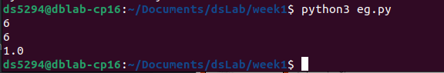
# Eg.8: Filtering in a loop (print all numbers >20)
x= [9, 41, 12, 3, 74, 15]
for i in x:
if i>20:
print (i)
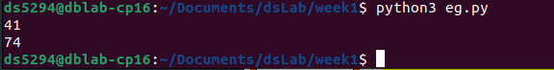
eg9
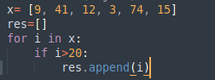

# Eg.10: For the above x, replace all elements <20 into zero. Store the result in different
# variable (object)
import numpy as np
y=np.zeros(len(x))
for i in range(len(x)):
if x[i]>20:
y[i]=x[i]
print(y)
# Eg. 11: Program using elif to check more than one condition.
price = 100
if price > 100:
print("price is greater than 100")
elif price == 100:
print("price is 100")
elif price < 100:
print("price is less than 100")
# Eg. 12: Program using while loop -
program to display numbers from 1 to 5
# initialize the variable
i=1
n=5
# while loop from i = 1 to 5
while i <= n:
print(i)
i=i+1
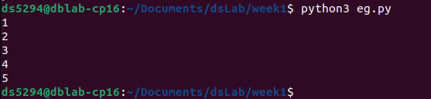
# Eg. 13:Take input from user , until user enters zero and calculate the sum of entered numbers.
total = 0
number = int(input('Enter a number: '))
# add numbers until number is zero
while number != 0:
total += number # total = total + number
# take integer input again
number = int(input('Enter a number: '))
print('total =', total)
