# **System Design Document**

# **Intelligent Document Extraction using Agentic AI**

## **Document Control**

| **Document Information** |  |
| --- | --- |
| Title | System Design Document |
| Project | TSP04 - Intelligent Document Extraction |
| Date | May 29, 2025 |
| Status | Draft |
| Version | 1.0 |
| Prepared by | Ayyanar Jeyakrishnan |

System Design Document

Intelligent Document Extraction using Agentic AI

Document Control

1. Introduction

1.1 Purpose

1.2 Scope

1.3 Definitions, Acronyms, and Abbreviations

1.4 References

2. System Overview

2.1 System Context

2.2 System Functions

2.3 User Characteristics

2.4 Constraints and Assumptions

3. Architecture

3.1 Architectural Overview

3.2 Architectural Principles

3.3 Technology Stack

3.3.1 Infrastructure

3.3.2 Application Layer

3.3.3 Data Layer

3.3.4 AI/ML Layer

3.4 System Topology

4. System Components

4.1 Frontend Component

4.1.1 Purpose

4.1.2 Functions

4.1.3 Interfaces

4.2 Backend Component

4.2.1 Purpose

4.2.2 Functions

4.2.3 Interfaces

4.3 Data Layer Component

4.3.1 Purpose

4.3.2 Functions

4.3.3 Interfaces

4.4 LLM Engine Component

4.4.1 Purpose

4.4.2 Functions

4.4.3 Interfaces

4.5 Consumption Layer Component

4.5.1 Purpose

4.5.2 Functions

4.5.3 Interfaces

4.6 Batch Processing Component

4.6.1 Purpose

4.6.2 Functions

4.6.3 Interfaces

4.7 Ingestion API Component

4.7.1 Purpose

4.7.2 Functions

4.7.3 Interfaces

5. Data Architecture

5.1 Data Model

5.1.1 Document Collection

5.1.2 User Collection

5.1.3 Extraction Template Collection

5.2 Data Flow

5.3 Data Retention and Archiving

6. Interface Design

6.1 User Interfaces

6.1.1 Document Upload Interface

6.1.2 Extraction Review Interface

6.1.3 Dashboard Interface

6.2 API Interfaces

6.2.1 Ingestion API

6.2.2 Extraction API

6.2.3 Consumption API

6.3 Internal Interfaces

6.3.1 Backend to LLM Engine Interface

6.3.2 Backend to Batch Processing Interface

7. Non-Functional Requirements

7.1 Performance

7.2 Scalability

7.3 Availability

7.4 Reliability

7.5 Maintainability

7.6 Security

8. Security Architecture

8.1 Authentication and Authorization

8.2 Data Security

8.3 API Security

8.4 Audit and Compliance

9. Deployment Architecture

9.1 Deployment Model

9.2 Container Strategy

9.3 CI/CD Pipeline

9.4 Monitoring and Logging

10. Appendices

10.1 Glossary

10.2 References

10.3 Revision History

## **1. Introduction**

### **1.1 Purpose**

This System Design Document (SDD) provides a comprehensive architectural overview of the Intelligent Document Extraction system using Agentic AI. It presents the high-level design and architecture of the system to be implemented for global operations.

### **1.2 Scope**

The document covers the system architecture, components, data models, interfaces, and deployment strategy for the Intelligent Document Extraction platform. It serves as a blueprint for the development teams and stakeholders.

### **1.3 Definitions, Acronyms, and Abbreviations**

| **Term/Acronym** | **Definition** |
| --- | --- |
| OCP | OpenShift Container Platform |
| LLM | Large Language Model |
| API | Application Programming Interface |
| UI | User Interface |
| HITL | Human-in-the-Loop |

### **1.4 References**

- TSP04 Architecture and Project Plan

- OpenShift Container Platform Documentation

- MongoDB Documentation

- Langchain Framework Documentation

## **2. System Overview**

### **2.1 System Context**

The Intelligent Document Extraction system is designed to provide automated extraction of structured information from unstructured documents using Agentic AI technologies. The system will be deployed g to support document processing operations across multiple usecases.

### **2.2 System Functions**

The primary functions of the system include:

1. Document ingestion from various sources

2. Intelligent extraction of data using LLM and Langgraph

3. Storage of extraction results with complete lineage

4. Human-in-the-loop review and correction

5. API-based consumption of extraction results by downstream systems

### **2.3 User Characteristics**

The system will be used by:

1. **Document Processors**: Users onboard to the Platform by providing ICMP document as source

2. **System Administrators**: Users who manage the system configuration and monitor performance

3. **API Consumers**: Downstream systems that consume extraction results via APIs

4. **Data Analysts**: Users who analyze extraction performance and quality metrics

### **2.4 Constraints and Assumptions**

**Constraints:**

- The system must be deployed on OpenShift Container Platform

- The system must use MongoDB as the data store

- The system must use Langchain as the LLM framework

- The system must be delivered within 4 months

**Assumptions:**

- Adequate infrastructure resources will be available in OCP

- Required LLM models will be accessible for document extraction

- Downstream systems will be able to consume REST APIs

## **3. Architecture**

### **3.1 Architectural Overview**

The system follows a modular, microservices-based architecture with clear separation of concerns. It is designed to be scalable, resilient, and extensible.

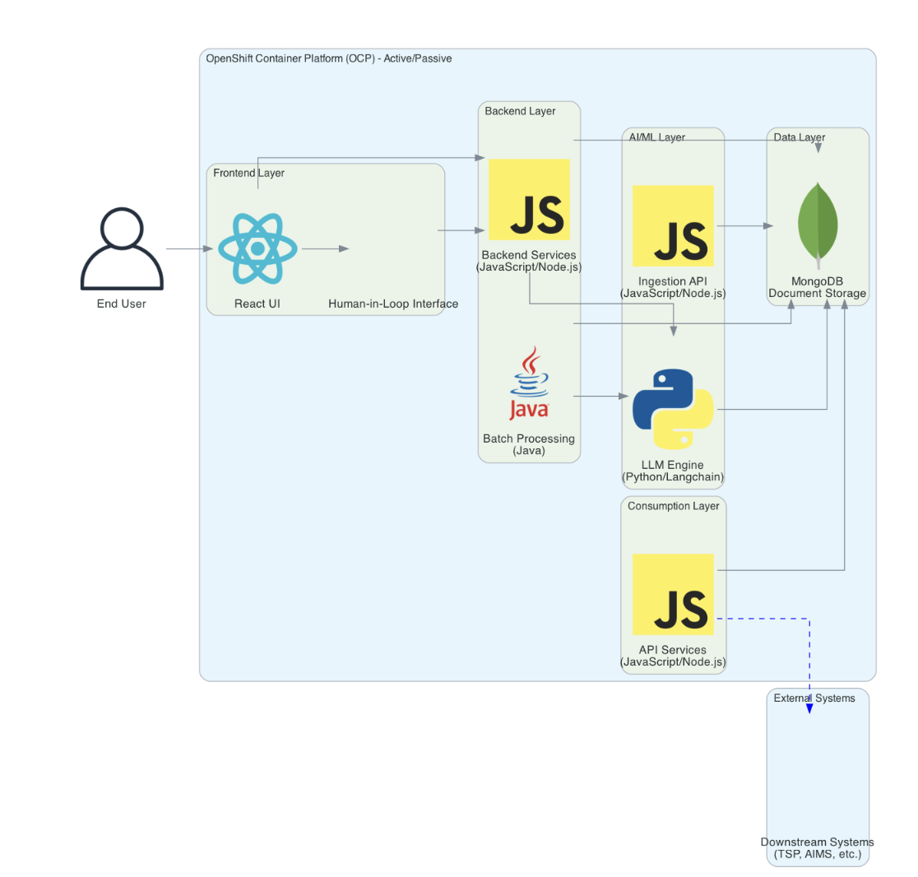

### **3.2 Architectural Principles**

1. **Separation of Concerns**: Clear boundaries between system components

2. **API-First Design**: All components interact through well-defined APIs

3. **Stateless Services**: Application services are stateless for scalability

4. **Data Lineage**: Complete tracking of document processing history

5. **Extensibility**: Modular design allowing for future enhancements

### **3.3 Technology Stack**

#### **3.3.1 Infrastructure**

- **Hosting Environment**: OpenShift Container Platform (OCP)

- **Deployment Model**: Active-Passive configuration for high availability

- **Container Orchestration**: Kubernetes (via OCP)

- **CI/CD**: OpenShift Pipelines (Tekton)

#### **3.3.2 Application Layer**

1. **Frontend**

- **Framework**: React

- **State Management**: Redux

- **UI Components**: Material-UI

- **Build Tool**: Webpack

2. **Backend**

- **Runtime**: Node.js

- **Framework**: Express.js

- **API Documentation**: Swagger/OpenAPI

- **Authentication**: OAuth 2.0 / JWT

3. **Consumption Layer**

- **Runtime**: Node.js

- **Framework**: Express.js

- **API Gateway**: APIGEE

4. **Batch Processing**

- **Runtime**: Java

- **Framework**: Spring boot

- **Build Tool**: Maven

#### **3.3.3 Data Layer**

- **Database**: MongoDB

- **Caching**: Redis (optional)

- **Data Migration**: MongoDB Migration Tools

#### **3.3.4 AI/ML Layer**

1. **LLM Engine**

- **Language**: Python

- **Framework**: Langgraph

- **Models**: Compatible with various LLM providers

2. **Ingestion API**

- **Runtime**: Node.js

- **Framework**: Express.js

- **File Processing**: Multer

### **3.4 System Topology**

The system will be deployed in an active-passive configuration across two OCP clusters for high availability. Each component will be containerized and orchestrated by Kubernetes within OCP.

## **4. System Components**

### **4.1 Frontend Component**

#### **4.1.1 Purpose**

Provides the user interface for document upload, extraction review, and human-in-the-loop corrections.

#### **4.1.2 Functions**

- Document upload interface

- Extraction result visualization

- Human-in-the-loop correction interface

- User authentication and authorization

- Dashboard for extraction metrics

#### **4.1.3 Interfaces**

- **Inbound**: User interactions via web browser

- **Outbound**: REST API calls to Backend Component

### **4.2 Backend Component**

#### **4.2.1 Purpose**

Provides API services, business logic, and orchestration for the document extraction process.

#### **4.2.2 Functions**

- Document processing orchestration

- Business logic implementation

- Authentication and authorization

- Integration with LLM Engine

- Data validation and transformation

#### **4.2.3 Interfaces**

- **Inbound**: REST API calls from Frontend Component

- **Outbound**:

- Database operations to MongoDB

- API calls to LLM Engine

- Event publishing for batch processing

### **4.3 Data Layer Component**

#### **4.3.1 Purpose**

Stores extraction results, metadata, and document lineage in MongoDB.

#### **4.3.2 Functions**

- Document storage and retrieval

- Metadata management

- Lineage tracking

- Query optimization

- Data backup and recovery

#### **4.3.3 Interfaces**

- **Inbound**: Database operations from Backend Component

- **Outbound**: Data provision to Consumption Layer

### **4.4 LLM Engine Component**

#### **4.4.1 Purpose**

Performs document understanding, extraction, and processing using Langchain framework.

#### **4.4.2 Functions**

- Document text extraction

- Entity recognition

- Relationship extraction

- Document classification

- Confidence scoring

#### **4.4.3 Interfaces**

- **Inbound**: API calls from Backend Component

- **Outbound**: Extraction results to Backend Component

### **4.5 Consumption Layer Component**

#### **4.5.1 Purpose**

Provides API endpoints for downstream systems to consume extraction results.

#### **4.5.2 Functions**

- API endpoint provision

- Data filtering and transformation

- Rate limiting and throttling

- API versioning

- Usage metrics collection

#### **4.5.3 Interfaces**

- **Inbound**: API calls from downstream systems

- **Outbound**: Data retrieval from MongoDB

### **4.6 Batch Processing Component**

#### **4.6.1 Purpose**

Handles batch processing tasks and scheduled operations.

#### **4.6.2 Functions**

- Scheduled document processing

- Bulk extraction operations

- Data export and reporting

- System maintenance tasks

- Performance optimization

#### **4.6.3 Interfaces**

- **Inbound**: Scheduled triggers or event-based triggers

- **Outbound**:

- Database operations to MongoDB

- API calls to LLM Engine

### **4.7 Ingestion API Component**

#### **4.7.1 Purpose**

Provides lightweight API for document ingestion.

#### **4.7.2 Functions**

- Document reception and validation

- Initial metadata extraction

- Document storage in MongoDB

- Extraction job queuing

- Input validation

#### **4.7.3 Interfaces**

- **Inbound**: API calls from document sources

- **Outbound**: Document storage to MongoDB

## **5. Data Architecture**

### **5.1 Data Model**

The system uses MongoDB's document-based schema to store extraction data with complete lineage.

#### **5.1.1 Document Collection**

{  
 "_id": "ObjectId",  
 "documentId": "string",  
 "fileName": "string",  
 "fileType": "string",  
 "uploadDate": "date",  
 "status": "string",  
 "metadata": {  
 "source": "string",  
 "uploadedBy": "string",  
 "tags": ["string"]  
 },  
 "content": {  
 "raw": "string",  
 "processed": "string"  
 },  
 "extractionResults": [  
 {  
 "extractionId": "string",  
 "extractionDate": "date",  
 "extractionInstructions": "string",  
 "rawResults": "object",  
 "processedResults": "object",  
 "confidence": "number",  
 "humanCorrections": [  
 {  
 "correctionId": "string",  
 "correctionDate": "date",  
 "correctedBy": "string",  
 "originalValue": "string",  
 "correctedValue": "string",  
 "fieldPath": "string"  
 }  
 ]  
 }  
 ]  
}

#### **5.1.2 User Collection**

{  
 "_id": "ObjectId",  
 "username": "string",  
 "email": "string",  
 "role": "string",  
 "permissions": ["string"],  
 "lastLogin": "date"  
}

#### **5.1.3 Extraction Template Collection**

{  
 "_id": "ObjectId",  
 "templateName": "string",  
 "description": "string",  
 "documentTypes": ["string"],  
 "extractionFields": [  
 {  
 "fieldName": "string",  
 "fieldType": "string",  
 "required": "boolean",  
 "extractionPrompt": "string"  
 }  
 ],  
 "createdBy": "string",  
 "createdDate": "date",  
 "version": "number"  
}

### **5.2 Data Flow**

1. **Ingestion Flow**:

- Documents are submitted through the Ingestion API

- Documents are stored in MongoDB with metadata

- Extraction jobs are queued for processing

2. **Extraction Flow**:

- LLM Engine retrieves documents from MongoDB

- Langchain-based extraction processes the documents

- Extraction results are stored back in MongoDB with full lineage

3. **Human-in-the-Loop Flow**:

- UI displays extraction results

- Human reviewers can correct/validate extractions

- Corrections are stored in MongoDB with lineage

4. **Consumption Flow**:

- Downstream systems access extraction results via Consumption Layer APIs

- Results can be filtered by extraction ID or other metadata

### **5.3 Data Retention and Archiving**

- Active documents will be retained in the primary MongoDB collection

- Processed documents older than a configurable period will be archived to a separate collection

- Document retention policies will be configurable per document type

- Archiving jobs will run as scheduled batch processes

## **6. Interface Design**

### **6.1 User Interfaces**

#### **6.1.1 Document Upload Interface**

- Onboarding ICMP for file upload

- Batch upload capability

- Document type selection

- Initial metadata input

- Upload progress indication

#### **6.1.2 Extraction Review Interface**

- Side-by-side view of original document and extracted data

- Highlighting of extracted entities in the original document

- Confidence score visualization (Optional)

- Correction capability for extracted fields

- Approval/rejection workflow

#### **6.1.3 Dashboard Interface**

- Extraction metrics and KPIs

- Processing queue status

- System health indicators

- User activity logs

- Performance trends

### **6.2 API Interfaces**

#### **6.2.1 Ingestion API**

POST /api/v1/documents  
- Request: multipart/form-data with document file and metadata  
- Response: Document ID and status  
  
GET /api/v1/documents/{documentId}  
- Response: Document metadata and status

#### **6.2.2 Extraction API**

POST /api/v1/documents/{documentId}/extract  
- Request: Extraction parameters and template ID  
- Response: Extraction job ID and status  
  
GET /api/v1/extractions/{extractionId}  
- Response: Extraction results and status

#### **6.2.3 Consumption API**

GET /api/v1/extractions  
- Query Parameters: filters, pagination, sorting  
- Response: List of extraction results matching criteria  
  
GET /api/v1/extractions/{extractionId}/results  
- Response: Detailed extraction results with lineage

### **6.3 Internal Interfaces**

#### **6.3.1 Backend to LLM Engine Interface**

POST /internal/extract  
- Request: Document content, extraction parameters  
- Response: Extraction results with confidence scores

#### **6.3.2 Backend to Batch Processing Interface**

POST /internal/batch/schedule  
- Request: Batch job parameters  
- Response: Batch job ID and status

## **7. Non-Functional Requirements**

### **7.1 Performance**

- API response times under 2 seconds for standard operations

- Document processing throughput of at least 100 documents per minute

- Support for concurrent processing of multiple documents

- Scalable to handle peak loads with minimal performance degradation

### **7.2 Scalability**

- Horizontal scaling of all components

- Auto-scaling based on load metrics

- Support for distributed processing

- Efficient resource utilization

### **7.3 Availability**

- 99.9% uptime for the overall system

- Active-passive deployment for high availability

- Graceful degradation under load

- Automated failover mechanisms

### **7.4 Reliability**

- Complete document lineage for auditability

- Data consistency across system components

- Transactional integrity for critical operations

- Comprehensive error handling and recovery

### **7.5 Maintainability**

- Modular architecture for component-level updates

- Comprehensive logging and monitoring

- Automated testing for all components

- Clear documentation for maintenance procedures

### **7.6 Security**

- Role-based access control

- Data encryption at rest and in transit

- Secure API authentication and authorization

- Audit logging for security events

- Compliance with relevant security standards

## **8. Security Architecture**

### **8.1 Authentication and Authorization**

- OAuth 2.0 / JWT for API authentication

- Role-based access control for UI and API access

- Fine-grained permissions for document operations

- Integration with enterprise identity providers (optional)

### **8.2 Data Security**

- Encryption of sensitive data at rest

- TLS/SSL for all data in transit

- Secure handling of document content

- Data masking for sensitive information in logs

### **8.3 API Security**

- Rate limiting and throttling

- Input validation and sanitization

- Protection against common API attacks

- API keys and secrets management

### **8.4 Audit and Compliance**

- Comprehensive audit logging

- User activity tracking

- Security event monitoring

- Compliance reporting capabilities

## **9. Deployment Architecture**

### **9.1 Deployment Model**

The system will be deployed in an active-passive configuration across two OCP clusters for high availability.

### **9.2 Container Strategy**

- Each component will be containerized using Docker

- Container images will be stored in a private container registry

- Container health checks and readiness probes will be implemented

- Resource limits and requests will be defined for each container

### **9.3 CI/CD Pipeline**

- Source code management in Git

- Automated builds triggered by code commits

- Automated testing (unit, integration, system)

- Deployment automation using OpenShift Pipelines

- Environment promotion workflow (Dev → Test → Staging → Production)

### **9.4 Monitoring and Logging**

- Centralized logging using ELK stack or similar

- Metrics collection using Prometheus

- Visualization using Grafana

- Alerting based on predefined thresholds

- Distributed tracing for request flows

## **10. Appendices**

### **10.1 Glossary**

| **Term** | **Definition** |
| --- | --- |
| Document Extraction | The process of identifying and extracting structured information from unstructured documents |
| Agentic AI | AI systems that can act autonomously to achieve specific goals |
| Lineage | The complete history and provenance of data throughout its lifecycle |
| Human-in-the-Loop | A model that requires human interaction for decision making or validation |

### **10.2 References**

1. OpenShift Container Platform Documentation

2. MongoDB Documentation

3. Langchain Framework Documentation

4. React Documentation

5. Node.js Documentation

6. TIDE Architecture and Project Plan

### **10.3 Revision History**

| **Version** | **Date** | **Description** | **Author** |
| --- | --- | --- | --- |
| 1.0 | May 29, 2025 | Initial draft | TIDE Team |