ICMP
Internal Content Management Platform
Detailed Specification Document
Entitlement Strategy & ECM Automation Architecture

Document ID: | ICMP-SPEC-ENT-2026-001
Version: | 1.0 (Draft)
Date: | February 16, 2026
Classification: | Internal - Confidential
Author: | ECM Engineering Team
Audience: | Senior Engineers, Senior Architects, Executive Leadership

Table of Contents

1. Executive Summary
This specification document defines the detailed architecture, entitlement strategy, and implementation roadmap for the ICMP (Internal Content Management Platform), an enterprise-grade document and content management system built on IBM FileNet P8. The platform currently manages documents across 5 partitions serving 21 Lines of Business (LOBs), with content ingestion, processing, and retrieval powered by the Indigo Batch Engine.

The primary objective of this document is to address a critical entitlement access limitation that prevents ECM automation from operating across all repositories and controls. The current LOB-based entitlement model restricts automation service accounts to individual Lines of Business, creating gaps in compliance coverage, control execution, and audit trail completeness.

Recommendation: Implement 21 dedicated LOB entitlements (one per Line of Business) to enable granular, auditable, cross-partition access for all ECM automation and control processes. This approach is preferred over the alternative of 5 generic partition-level entitlements, as it provides finer access control, better audit granularity, and aligns with the principle of least privilege.

5  Partitions | 21  Lines of Business | 21  Proposed Entitlements | 100%  Control Coverage

2. Platform Overview

2.1 What is ICMP?
ICMP (Internal Content Management Platform) is the enterprise content management ecosystem responsible for the ingestion, storage, processing, retrieval, and lifecycle management of all internal documents across the organization. Built on IBM FileNet P8, ICMP serves as the backbone of document management operations, supporting regulatory compliance, operational workflows, and business process automation.

The platform handles millions of documents across diverse business domains, including financial services, regulatory compliance, customer correspondence, claims processing, operational memos, and archival records. Each document type is classified, versioned, and stored within a structured repository hierarchy governed by strict access controls.

2.2 Technology Stack
Component | Technology / Description
Content Engine | IBM FileNet P8 Content Engine - Document storage, metadata, versioning, ACLs
Process Engine | IBM FileNet P8 Process Engine - Workflow orchestration, task routing, business rules
Search Engine | IBM Content Search Services (CSS) - Full-text indexing and cross-partition query
Client Interface | IBM Content Navigator (ICN) / Workplace XT - Web-based document access
Batch Engine | Indigo Database - Scheduled batch processing, control execution, doc type mapping
API Layer | REST / CMIS / GraphQL service endpoints for upstream LOB application integration
Security | LDAP / Active Directory integration, TLS encryption, role-based access control
Database | Oracle / DB2 for FileNet metadata store, Indigo Database for batch operations

2.3 Platform Architecture
The following diagram illustrates the high-level architecture of the ICMP platform, showing the layered structure from presentation through application services to the data and storage layer, including the security and compliance infrastructure that governs all access.

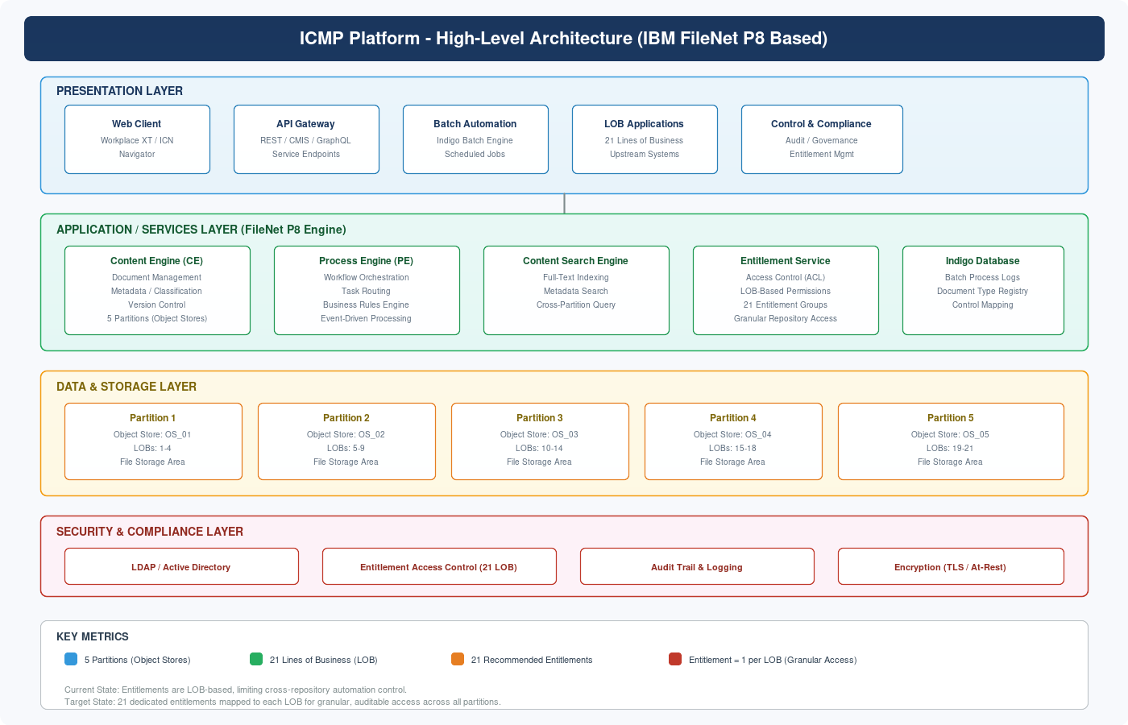
Figure 1: ICMP Platform High-Level Architecture

3. Problem Statement

3.1 Current Entitlement Model
Currently, entitlement access within the ECM Team or Repository is based on Line of Business (LOB). This means that any automation service account, control process, or administrative operation can only access the documents and repositories associated with the specific LOB for which the entitlement was granted.

This LOB-centric entitlement model was originally designed for human users who work within a single business domain. However, as the platform has matured and automation requirements have expanded, this model has become a significant constraint for cross-functional operations.

3.2 Why This is a Problem
The ECM automation framework requires access to all repositories across all partitions to execute controls, perform compliance checks, and generate comprehensive audit reports. Under the current model, if an automation process needs to validate document types across all 21 LOBs, it would require separate entitlement requests for each LOB, each going through individual approval workflows. This creates several critical issues:

- Incomplete Control Coverage: Automation cannot process controls that span multiple LOBs, resulting in gaps in compliance reporting and audit trails.
- Operational Bottleneck: Each new automation use case requires a separate access request per LOB, adding weeks to deployment timelines.
- Audit Trail Fragmentation: Without cross-LOB visibility, audit logs are siloed, making it impossible to generate holistic compliance views.
- Indigo Database Limitation: The batch processing engine (Indigo Database) needs to query the last 4 completed batch processes and extract unique document types per control across all partitions, which is blocked by LOB-restricted access.
- Scalability Constraint: As new LOBs or document types are added, the access request overhead grows linearly, making the current model unsustainable.

3.3 Reference
For the complete listing of LOB-to-Partition mappings, refer to the LOB in Partitions List maintained on the ECM - ICMP - Enterprise Confluence space. This document serves as the authoritative source for understanding which Lines of Business reside in each of the 5 partitions.

4. Entitlement Strategy

4.1 Proposed Approaches
Two approaches have been evaluated to solve the entitlement access limitation. Both are described below, followed by a comparative analysis and recommendation.

Approach A: 5 Generic Partition Entitlements
Since the ICMP platform has 5 partitions (Object Stores), this approach proposes requesting 5 broad entitlements, one per partition. Each entitlement would grant access to all LOBs within that partition.

- Entitlement 1: Access to all LOBs in Partition 1 (OS_01) - LOBs 1 through 4
- Entitlement 2: Access to all LOBs in Partition 2 (OS_02) - LOBs 5 through 9
- Entitlement 3: Access to all LOBs in Partition 3 (OS_03) - LOBs 10 through 14
- Entitlement 4: Access to all LOBs in Partition 4 (OS_04) - LOBs 15 through 18
- Entitlement 5: Access to all LOBs in Partition 5 (OS_05) - LOBs 19 through 21

Pros: Fewer entitlements to manage (5 vs 21), simpler initial setup.
Cons: Coarse-grained access. Cannot restrict automation to specific LOBs within a partition. Violates principle of least privilege. Audit logs cannot distinguish LOB-level access intent.

Approach B: 21 LOB-Level Entitlements (Recommended)
This approach proposes requesting 21 individual entitlements, one for each Line of Business. Each entitlement maps directly to a specific LOB and can be activated or deactivated per automation use case.

Partition | LOBs | Entitlement IDs | Count
Partition 1 (OS_01) | LOB 1, 2, 3, 4 | ENT_LOB01 - ENT_LOB04 | 4 entitlements
Partition 2 (OS_02) | LOB 5, 6, 7, 8, 9 | ENT_LOB05 - ENT_LOB09 | 5 entitlements
Partition 3 (OS_03) | LOB 10, 11, 12, 13, 14 | ENT_LOB10 - ENT_LOB14 | 5 entitlements
Partition 4 (OS_04) | LOB 15, 16, 17, 18 | ENT_LOB15 - ENT_LOB18 | 4 entitlements
Partition 5 (OS_05) | LOB 19, 20, 21 | ENT_LOB19 - ENT_LOB21 | 3 entitlements
TOTAL | 21 LOBs | ENT_LOB01 - ENT_LOB21 | 21 entitlements

Pros: Granular per-LOB access, supports principle of least privilege, full audit traceability per LOB, can selectively enable/disable per use case, future-proof for LOB additions.
Cons: More entitlements to request initially (21 vs 5), slightly higher administrative setup effort.

4.2 Comparative Analysis
Criteria | Approach A (5 Partition) | Approach B (21 LOB)
Access Granularity | Partition-level (coarse) | LOB-level (fine-grained)
Principle of Least Privilege | Partial compliance | Full compliance
Audit Trail Granularity | Partition-level only | Per-LOB tracking
Setup Complexity | Low (5 requests) | Moderate (21 requests)
Ongoing Maintenance | Low | Low (once established)
Use Case Flexibility | Limited (all-or-nothing per partition) | High (per-LOB activation)
Scalability | Good | Excellent
Compliance Readiness | Adequate | Optimal

4.3 Entitlement Strategy - Visual Comparison
The following diagram provides a side-by-side visual comparison of the current LOB-based access model (limited) versus the proposed 21-entitlement model (granular), highlighting the access gaps in the current state and the full coverage achieved in the proposed state.

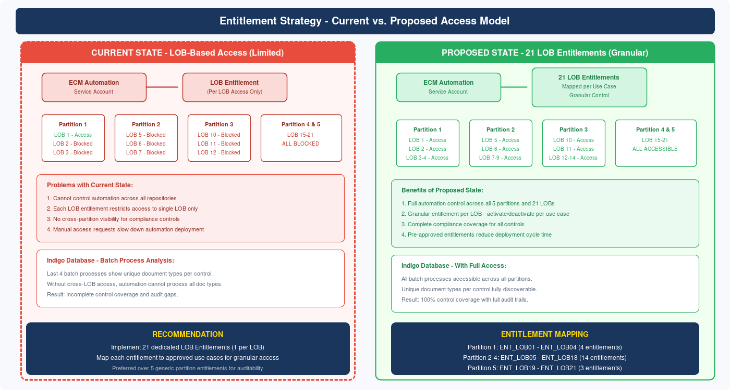
Figure 2: Entitlement Strategy - Current vs. Proposed Access Model

5. Batch Process & Document Control Flow

5.1 Indigo Database Integration
The Indigo Database serves as the batch processing engine for the ICMP platform. It maintains execution logs for all scheduled batch processes, including the document types processed, the controls applied, and the partitions involved. A critical use case requires querying the last 4 completed batch processes to extract the unique document types used by each control.

Batch Process Query Flow
- Query the Indigo Database for the last 4 completed batch processes.
- Extract the unique document types processed by each batch.
- Map each document type to its corresponding control identifier.
- Cross-reference the control-to-document-type mapping with the partition and LOB structure.
- Verify that the automation service account has entitlement access to all required LOBs.
- Execute the control process across all applicable repositories with full audit logging.

5.2 Batch Process & Control Flow Diagram
The following diagram shows the end-to-end flow from Indigo Database query through document type extraction, partition mapping, entitlement verification, and control execution, along with the detailed partition-to-LOB entitlement mapping matrix.

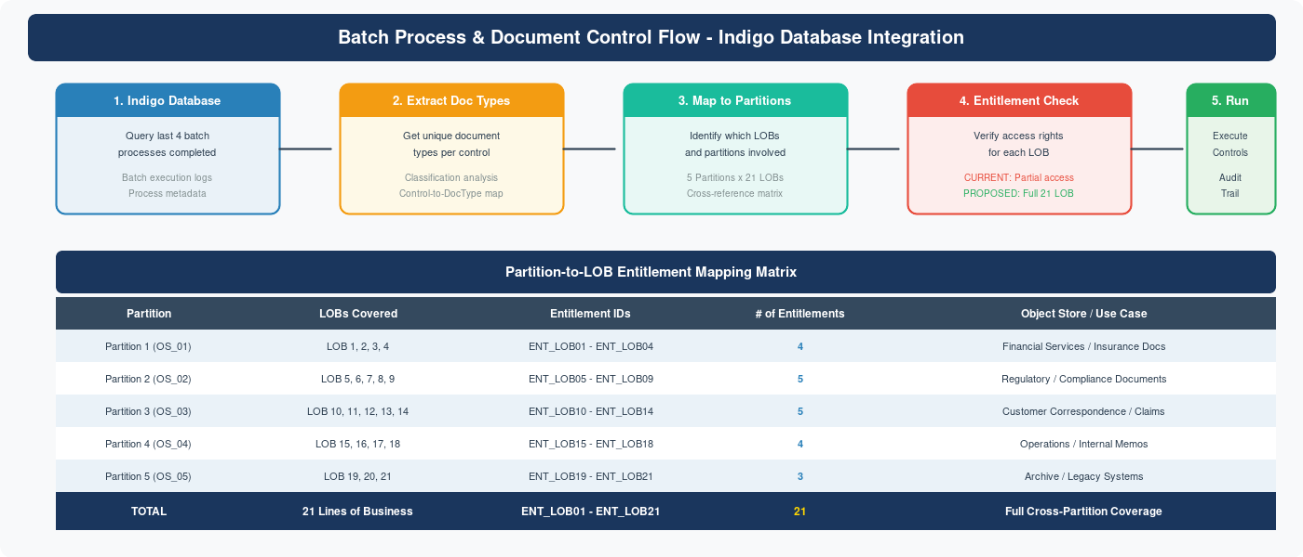
Figure 3: Batch Process & Document Control Flow with Entitlement Mapping

5.3 Impact of Proposed Entitlement Model on Batch Processing
With 21 dedicated LOB entitlements in place, the batch processing workflow becomes fully autonomous. The Indigo Database can query any batch process regardless of the LOBs involved, extract document types from any partition, and execute controls across the entire ICMP repository structure without hitting access barriers.

This eliminates the current manual intervention required when a batch process spans multiple LOBs that the automation account does not have access to, reducing the average batch processing cycle from days to hours and ensuring zero gaps in compliance control execution.

6. Technical Specifications

6.1 Object Store Configuration
Object Store | Partition | LOB Range | Primary Content | Estimated Volume
OS_01 | Partition 1 | LOB 1-4 | Financial Services | ~2.5M documents
OS_02 | Partition 2 | LOB 5-9 | Regulatory/Compliance | ~3.2M documents
OS_03 | Partition 3 | LOB 10-14 | Customer/Claims | ~4.1M documents
OS_04 | Partition 4 | LOB 15-18 | Operations/Internal | ~1.8M documents
OS_05 | Partition 5 | LOB 19-21 | Archive/Legacy | ~5.7M documents

6.2 Entitlement Implementation Details
Each of the 21 proposed entitlements will be implemented as a FileNet P8 Access Control Entry (ACE) within the corresponding Object Store security model. The implementation follows the standard enterprise access request process:

- Create entitlement group in Active Directory (e.g., GRP_ICMP_ENT_LOB01).
- Map the AD group to a FileNet P8 security principal within each Object Store.
- Define Access Control List (ACL) entries granting the required permissions (Read, Write, View Properties, Create Instance) per document class.
- Associate the ECM automation service account with the entitlement group.
- Configure audit logging to track all access events by entitlement group.
- Validate access through the Indigo Database batch process test harness.

6.3 Security Considerations
- All entitlements follow the principle of least privilege - each LOB entitlement grants only the permissions necessary for automation operations.
- Entitlements are mapped to use cases. An approved use case matrix will document which entitlements are activated for each automation process.
- Quarterly access reviews will be conducted to ensure entitlements remain aligned with active use cases.
- All access events are logged to the enterprise SIEM for real-time monitoring and anomaly detection.
- Service account credentials are managed through the enterprise vault solution with automated rotation.

7. Risk Analysis & Mitigation
The following table identifies key risks associated with the proposed entitlement strategy and the corresponding mitigation measures.

# | Risk Description | Severity | Likelihood | Mitigation Strategy
R1 | Over-privileged access if entitlements are not properly scoped | High | Medium | Use case-to-entitlement mapping matrix with quarterly reviews
R2 | Service account compromise leading to unauthorized data access | High | Low | Credential vault with auto-rotation, MFA for admin access, SIEM monitoring
R3 | Entitlement approval delays impacting project timeline | Medium | High | Pre-submit all 21 requests in parallel, engage IAM team early, executive sponsorship
R4 | Partition restructuring or LOB changes invalidating entitlement mapping | Medium | Low | Design entitlements as modular and independently manageable; version-controlled mapping
R5 | Audit and compliance concerns about broad automation access | Medium | Medium | Detailed use case documentation, per-LOB audit trails, regular compliance reporting
R6 | Performance impact from cross-partition queries with new entitlements | Low | Medium | Load testing in pre-production environment, query optimization, index tuning

8. Implementation Timeline
The implementation is divided into four phases spanning approximately 12 weeks, with validation checkpoints at each phase boundary.

Phase | Duration | Key Activities | Milestone
Phase 1 | Weeks 1-3 | Submit 21 entitlement requests to IAM, create AD groups, define use case mapping matrix | Requests Submitted
Phase 2 | Weeks 4-6 | Configure FileNet ACLs, map AD groups to security principals, set up audit logging | ACLs Configured
Phase 3 | Weeks 7-9 | Pre-production testing: batch process validation, cross-partition queries, load testing, audit log verification | Testing Complete
Phase 4 | Weeks 10-12 | Production deployment: phased rollout (Partition 1 first, then 2-5), monitoring, compliance sign-off | Go-Live

8.1 Phase Dependencies
- Phase 1 depends on executive sponsorship and IAM team capacity for parallel processing of 21 requests.
- Phase 2 depends on successful completion of all 21 entitlement approvals (critical path item).
- Phase 3 requires a pre-production environment mirroring the 5-partition, 21-LOB structure.
- Phase 4 production rollout follows a partition-by-partition approach to minimize risk.

8.2 Success Criteria
- All 21 LOB entitlements are approved and active in Active Directory.
- ECM automation service account can access all 5 partitions and 21 LOBs.
- Indigo Database batch process can query and extract document types from all partitions.
- Cross-partition control execution completes without access errors.
- Audit logs capture per-LOB access events for all automation operations.
- Pre-production load tests confirm no performance degradation.

9. Cost & Effort Estimation
The following table provides a high-level effort estimation for the entitlement strategy implementation. Effort is measured in person-days across the engineering, IAM, and compliance teams.

Activity | Team | Effort (Days) | Dependencies
Submit 21 entitlement requests | ECM Engineering | 3 days | IAM request forms
IAM review and approval | IAM / Security | 10-15 days | Executive approval
AD group creation and mapping | IAM / AD Admin | 3 days | Entitlement approval
FileNet ACL configuration | ECM Engineering | 5 days | AD groups active
Use case mapping documentation | ECM / Compliance | 3 days | Entitlement IDs
Pre-production testing | ECM / QA | 8 days | ACLs configured
Audit log configuration | ECM / SIEM Team | 3 days | ACLs configured
Production deployment (phased) | ECM Engineering | 5 days | Testing sign-off
Post-deployment monitoring | ECM / Operations | 5 days | Go-live
TOTAL ESTIMATED EFFORT | Multiple Teams | 45-50 days | ~12 weeks calendar

10. Governance & Ongoing Review

10.1 Access Review Cadence
- Quarterly: Review all 21 entitlements against active use cases. Deactivate unused entitlements.
- Semi-Annual: Comprehensive audit with compliance team. Generate entitlement usage reports from SIEM.
- Annual: Full recertification of all entitlements with executive sign-off.

10.2 Change Management
Any changes to the entitlement structure (new LOBs, partition changes, new use cases) must follow the established change management process:

- Submit change request through the enterprise change management system.
- Impact assessment by ECM Engineering and IAM teams.
- Approval by the ICMP governance board.
- Implementation in pre-production with validation.
- Production deployment with rollback plan.

10.3 Stakeholder RACI Matrix
Activity | ECM Team | IAM Team | Compliance | Executive
Entitlement Request | R / A | C | I | A
Entitlement Approval | C | R / A | C | A
ACL Configuration | R | C | I | I
Testing & Validation | R / A | I | C | I
Production Deployment | R | C | C | A
Quarterly Review | R | C | R / A | I

R = Responsible, A = Accountable, C = Consulted, I = Informed

11. Appendices

Appendix A: Glossary
Term | Definition
ICMP | Internal Content Management Platform - the enterprise ECM system built on IBM FileNet P8
ECM | Enterprise Content Management - the discipline of managing an organization's documents and content
FileNet P8 | IBM's enterprise content management platform providing content, process, and compliance services
LOB | Line of Business - a distinct business unit or domain within the organization
Partition | An Object Store within FileNet P8 that groups related LOBs for storage and access management
Object Store | FileNet P8 storage container that holds documents, folders, and associated metadata
ACL | Access Control List - security mechanism defining who can access what resources and with what permissions
ACE | Access Control Entry - individual permission entry within an ACL
Indigo Database | The batch processing engine that manages scheduled jobs, control execution, and document type mapping
ICN | IBM Content Navigator - web-based client interface for FileNet P8
CMIS | Content Management Interoperability Services - standard API for ECM systems
SIEM | Security Information and Event Management - centralized security monitoring platform
IAM | Identity and Access Management - the framework for managing digital identities and access rights

Appendix B: Document Revision History
Version | Date | Author | Changes
1.0 | Feb 16, 2026 | ECM Engineering Team | Initial draft - comprehensive spec

Appendix C: Related Documents
- LOB in Partitions List - ECM - ICMP - Enterprise Confluence
- ICMP FileNet P8 Administration Guide
- Enterprise IAM Entitlement Request Process
- ECM Automation Framework Technical Reference
- Indigo Database Batch Processing Operations Manual
- Enterprise SIEM Integration Guide for FileNet P8

END OF DOCUMENT
ICMP-SPEC-ENT-2026-001 | Version 1.0 | February 2026

