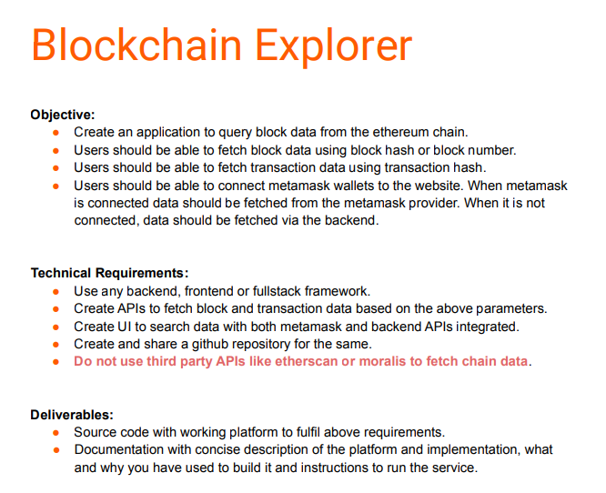

Blockchain Explorer
Creating an web application and API to query/fetch Block Data from Ethereum chain using block number, block hash also to fetch Transaction Data using transaction hash. Created UI to search data with both meta-mask and backend APIs integrated.

To Complete and fulfill above objectives and the technical requirements we’ve used the following tools and their library:
- MetaMask
- Frontend - React JS, Ether ,Web3
- Backend - Python, Flask, Web3

- Flask Server :Create a Flask server using the Flask library in Python.Use the web3 library to connect to an Ethereum node.Define API endpoints to handle requests for block and transaction data.Implement functions to fetch block and transaction data from the Ethereum network using web3.Return data as JSON responses to API requests.

React Frontend;
Create a ReactJS project using the create-react-app command.Design UI elements to allow users to input block or transaction data.Implement functions to handle user input and make API requests to the Flask server.Display responses from the Flask server to the user in a user-friendly format.MetaMask Integration :Add the MetaMask browser extension to your project.Implement functions to interact with the MetaMask API to sign transactions and interact with smart contracts.

Flask Server Code :
This code initializes a Flask application and sets up two routes, one for fetching block data and the other for fetching transaction data. It uses the web3.py library to interact with the Ethereum blockchain and fetches data using either block number or block hash.
from flask import Flask, jsonify, request
from web3 import Web3

app = Flask(__name__)
w3 = Web3(Web3.HTTPProvider("https://mainnet.infura.io/v3/8365b38a49eb4cb899edfe72b3ddc252"))

@app.route('/block/<block_number>', methods=['GET'])
def get_block(block_number):
block = w3.eth.get_block(block_number)
return jsonify(block)

@app.route('/block/hash/<block_hash>', methods=['GET'])
def get_block_by_hash(block_hash):
block = w3.eth.get_block(block_hash)
return jsonify(block)

@app.route('/tx/<tx_hash>', methods=['GET'])
def get_transaction(tx_hash):
tx = w3.eth.get_transaction(tx_hash)
return jsonify(tx)

if __name__ == '__main__':
app.run()

OUTPUT :
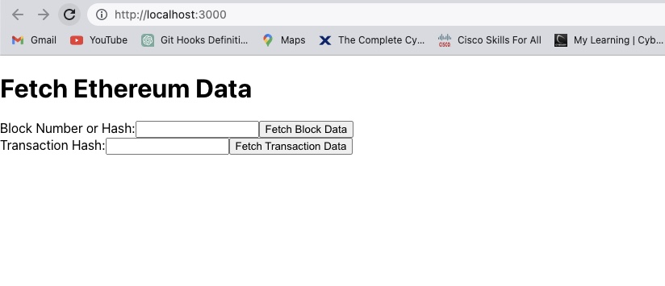
In this senerio the MetaMask Wallet is disconnected and the block data and transeaction data is fetched by Backed API.

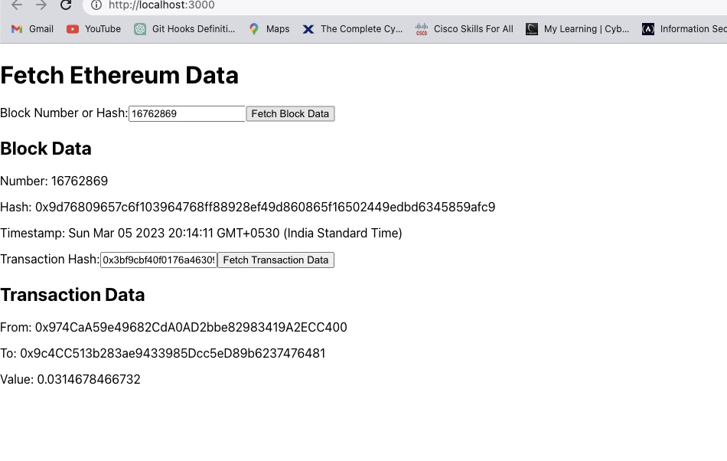

Frontend React Code : React.js app and form for users to enter block number or hash, and transaction hash. Use Web3.js library to connect to Metamask and fetch data from it. If Metamask is not connected, send a request to the backend to fetch data.
import React, { useState, useEffect } from 'react';
import { ethers } from 'ethers';

function App() {
const [provider, setProvider] = useState(null);
const [connectedAddress, setConnectedAddress] = useState('');
const [blockNumber, setBlockNumber] = useState(0);
const [blockHash, setBlockHash] = useState('');
const [blockData, setBlockData] = useState(null);
const [error, setError] = useState(null);

useEffect(() => {
async function loadProvider() {
if (window.ethereum) {
const provider = new ethers.providers.Web3Provider(window.ethereum);
try {
await window.ethereum.enable();
setProvider(provider);
const signer = provider.getSigner();
const address = await signer.getAddress();
setConnectedAddress(address);
} catch (error) {
console.error(error);
}
} else {
try {
const response = await fetch('http://localhost:3000/api/block/123'); // Replace with the actual endpoint
const data = await response.json();
setBlockData(data);
} catch (error) {
console.error(error);
setError('Failed to fetch data from the backend');
}
}
}
loadProvider();
}, []);

const handleBlockNumberChange = (event) => {
setBlockNumber(event.target.value);
};

const handleBlockHashChange = (event) => {
setBlockHash(event.target.value);
};

const handleBlockNumberSubmit = async (event) => {
event.preventDefault();
const blockNumber = parseInt(event.target.elements.blockNumber.value);
const block = await provider.getBlock(blockNumber);
setBlockData(block);
};

const handleBlockHashSubmit = async (event) => {
event.preventDefault();
const blockHash = event.target.elements.blockHash.value;
const block = await provider.getBlock(blockHash);
setBlockData(block);
};

const handleTransactionSubmit = async (event) => {
event.preventDefault();
const txHash = event.target.elements.transactionHash.value;
const tx = await provider.getTransaction(txHash);
console.log(tx);
};

return (
<div>
<h1>Ethereum Data Fetcher</h1>
{error ? (
<p>{error}</p>
) : (
<div>
{provider ? (
<div>
<p>Connected Address: {connectedAddress}</p>
<form onSubmit={handleBlockNumberSubmit}>
<label htmlFor="blockNumber">Block Number:</label>
<input
type
="number"
id="blockNumber"
name="blockNumber"
onChange={handleBlockNumberChange}
/>
<button type="submit">Fetch Block</button>
</form>
<form onSubmit={handleBlockHashSubmit}>
<label htmlFor="blockHash">Block Hash:</label>
<input
type="text"
id="blockHash"
name="blockHash"
onChange={handleBlockHashChange}
/>
<button type="submit">Fetch Block</button>
</form>
<form onSubmit={handleTransactionSubmit}>
<label htmlFor="transactionHash">Transaction Hash:</label>
<input type="text" id="transactionHash" name="transactionHash" />
<button type="submit">Fetch Transaction</button>
</form>
{blockData && (
<div>
<h2>Block Data:</h2>
<p>Number: {blockData.number}</p>
<p>Hash: {blockData.hash}</p>
<p>Timestamp: {new Date(blockData.timestamp * 1000).toLocaleString()}</p>
<p>Transactions: {blockData.transactions.length}</p>
</div>
)}
</div>
) : (
<p>Please connect to MetaMask</p>
)}
</div>
)}
</div>
);
}
export default App;

} catch (error) {
console.error(error);
}
} else {
try {
const response = await fetch('http://localhost:3000/api/block/123'); // Replace with the actual endpoint
const data = await response.json();
setBlockData(data);
} catch (error) {
console.error(error);
setError('Failed to fetch data from the backend');
}
}
}
loadProvider();
}, []);

const handleBlockNumberChange = (event) => {
setBlockNumber(event.target.value);
};

const handleBlockHashChange = (event) => {
setBlockHash(event.target.value);
};
const handleBlockNumberSubmit = async (event) => {
event.preventDefault();
const blockNumber = parseInt(event.target.elements.blockNumber.value);
const block = await provider.getBlock(blockNumber);
setBlockData(block);
};

const handleBlockHashSubmit = async (event) => {
event.preventDefault();
const blockHash = event.target.elements.blockHash.value;
const block = await provider.getBlock(blockHash);
setBlockData(block);
};

const handleTransactionSubmit = async (event) => {
event.preventDefault();
const txHash = event.target.elements.transactionHash.value;
const tx = await provider.getTransaction(txHash);
console.log(tx);
};

return (
<div>
<h1>Ethereum Data Fetcher</h1>
{error ? (
<p>{error}</p>
) : (
<div>
{provider ? (
<div>
<p>Connected Address: {connectedAddress}</p>
<form onSubmit={handleBlockNumberSubmit}>
<label htmlFor="blockNumber">Block Number:</label>
<input
type
="number"
id="blockNumber"
name="blockNumber"
onChange={handleBlockNumberChange}
/>
<button type="submit">Fetch Block</button>
</form>
<form onSubmit={handleBlockHashSubmit}>
<label htmlFor="blockHash">Block Hash:</label>
<input
type="text"
id="blockHash"
name="blockHash"
onChange={handleBlockHashChange}
/>
<button type="submit">Fetch Block</button>
</form>
<form onSubmit={handleTransactionSubmit}>

{blockData && (
<div>
<h2>Block Data:</h2>
<p>Number: {blockData.number}</p>
<p>Hash: {blockData.hash}</p>
<p>Timestamp: {new Date(blockData.timestamp * 1000).toLocaleString()}</p>
<p>Transactions: {blockData.transactions.length}</p>
</div>
)}
</div>
) : (
<p>Please connect to MetaMask</p>
)}
</div>
)}
</div>
);
}
export default App;

<label htmlFor="transactionHash">Transaction Hash:</label>
<input type="text" id="transactionHash" name="transactionHash" />
<button type="submit">Fetch Transaction</button>
</form>
{blockData && (
<div>
<h2>Block Data:</h2>
<p>Number: {blockData.number}</p>
<p>Hash: {blockData.hash}</p>
<p>Timestamp: {new Date(blockData.timestamp * 1000).toLocaleString()}</p>
<p>Transactions: {blockData.transactions.length}</p>
</div>
)}
</div>
) : (
<p>Please connect to MetaMask</p>
)}
</div>
)}
</div>
);
}
export default App;

OUTPUT :
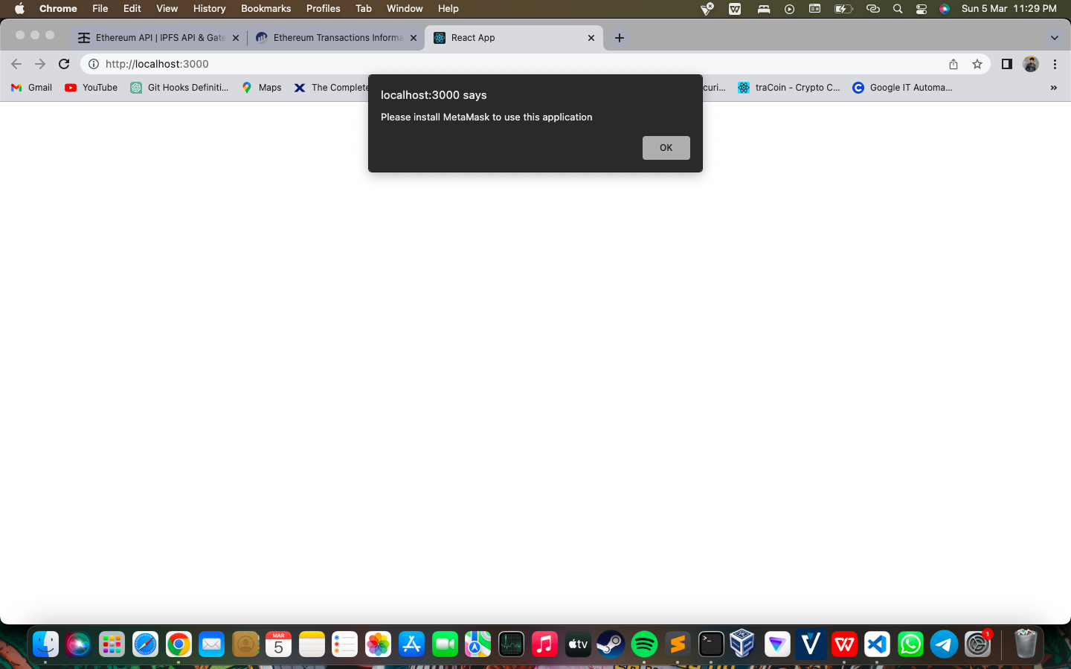
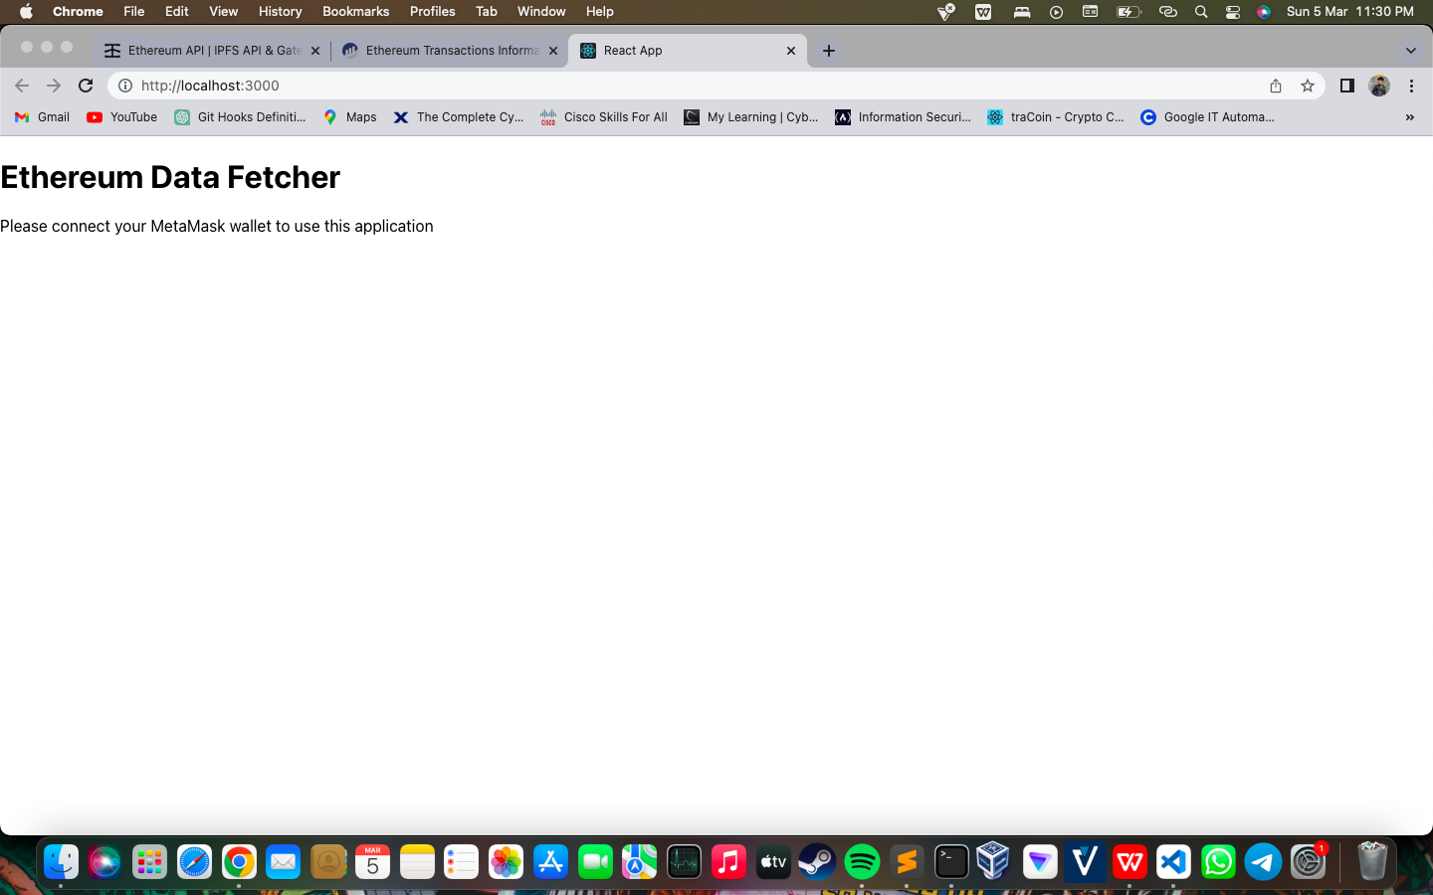
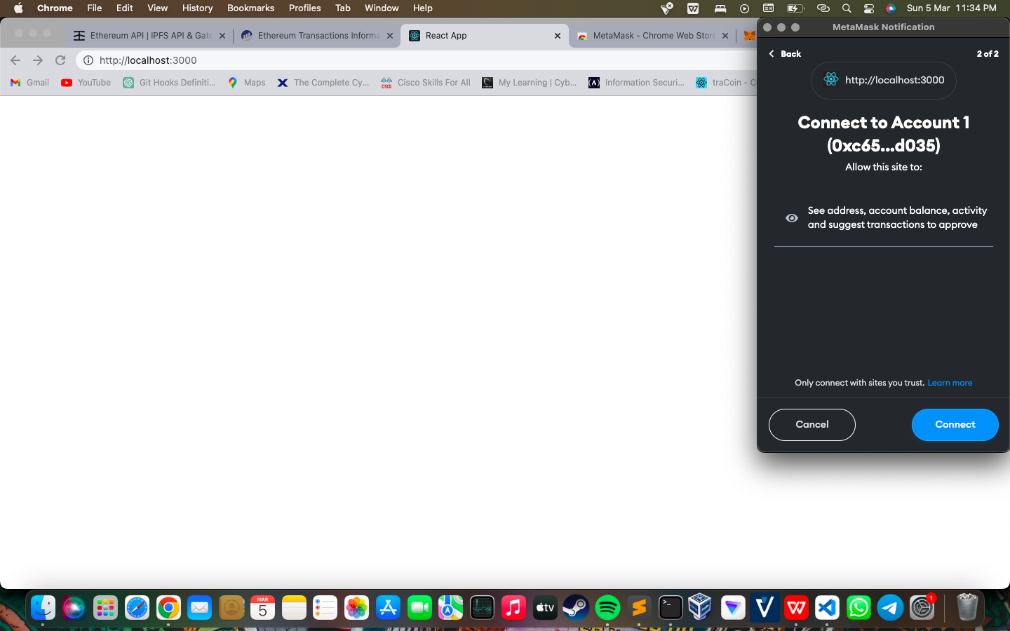
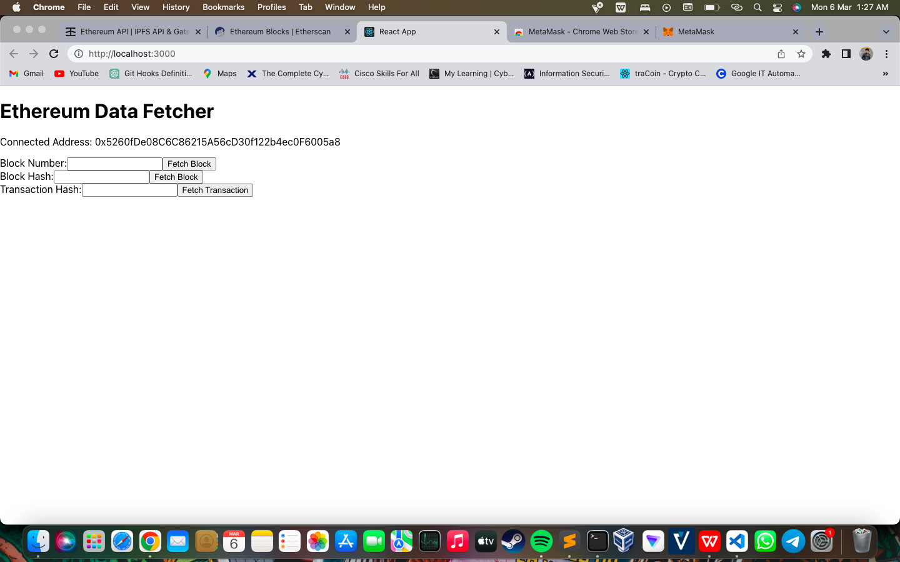
TECHNICAL DETAILS:
Technical Details for Creating an Ethereum Blockchain Explorer Application using Reac,t Python, Web3, Flask, and ReactJS :
Setting up the Development EnvironmentInstall Python, Flask, ReactJS, and Web3 libraries in the development environment.Create a new Flask project using the Flask CLI command, "flask new [project-name]".
- Building the BackendCreate a Python module for querying Ethereum blockchain data using Web3.Define API endpoints for fetching Block Data using Block Number and Block Hash, and Transaction Data using Transaction Hash.Use Flask to implement the API endpoints and handle incoming requests.Use the Web3 library to query the Ethereum blockchain for the requested data.If the user has a Metamask wallet connected, the data should be fetched from the Metamask provider, otherwise, data should be fetched via the backend.
- Building the FrontendCreate a ReactJS application using the create-react-app CLI command.Implement a user interface to allow users to enter Block Number, Block Hash, or Transaction Hash.Use the fetch() function to send requests to the Flask API endpoints and display the fetched data on the user interface.Integrate the Metamask provider using the Web3 and Ether library.Check if the Metamask provider is available and connect to it if possible to fetch data directly from it..

GitHub:
- Created and shared a GitHub repository for the same
https://github.com/jayyeshh55/Blockchain-Deqode.git
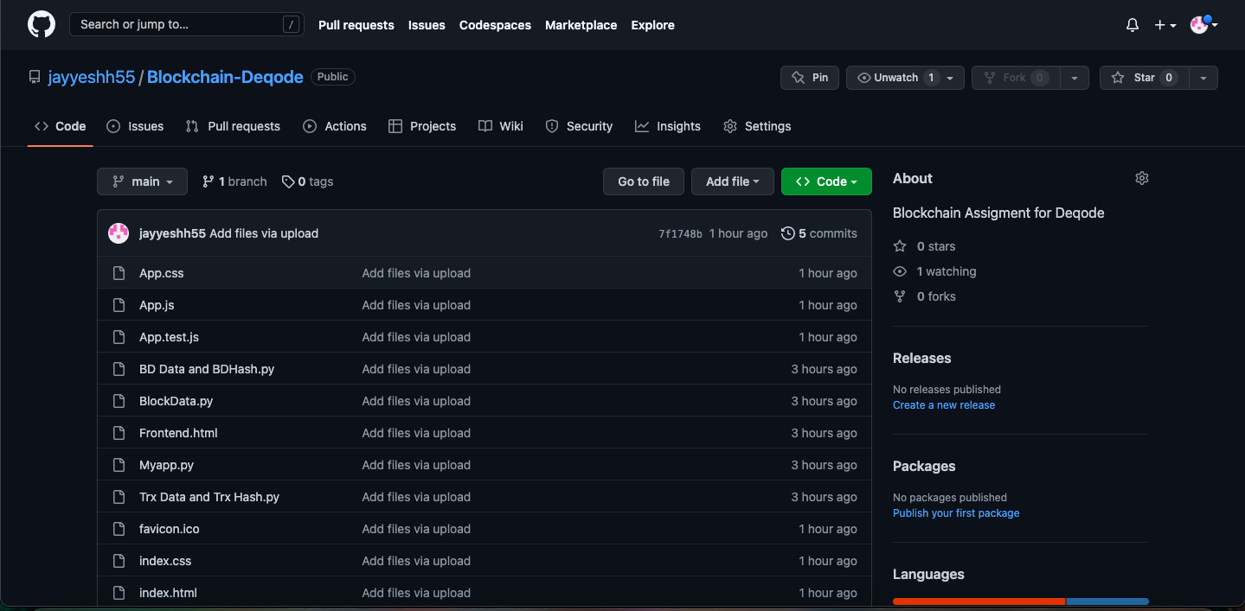

Thank You

