**PROJECT MANAGEMENT PLAN**

***IWS Culinary Tool***

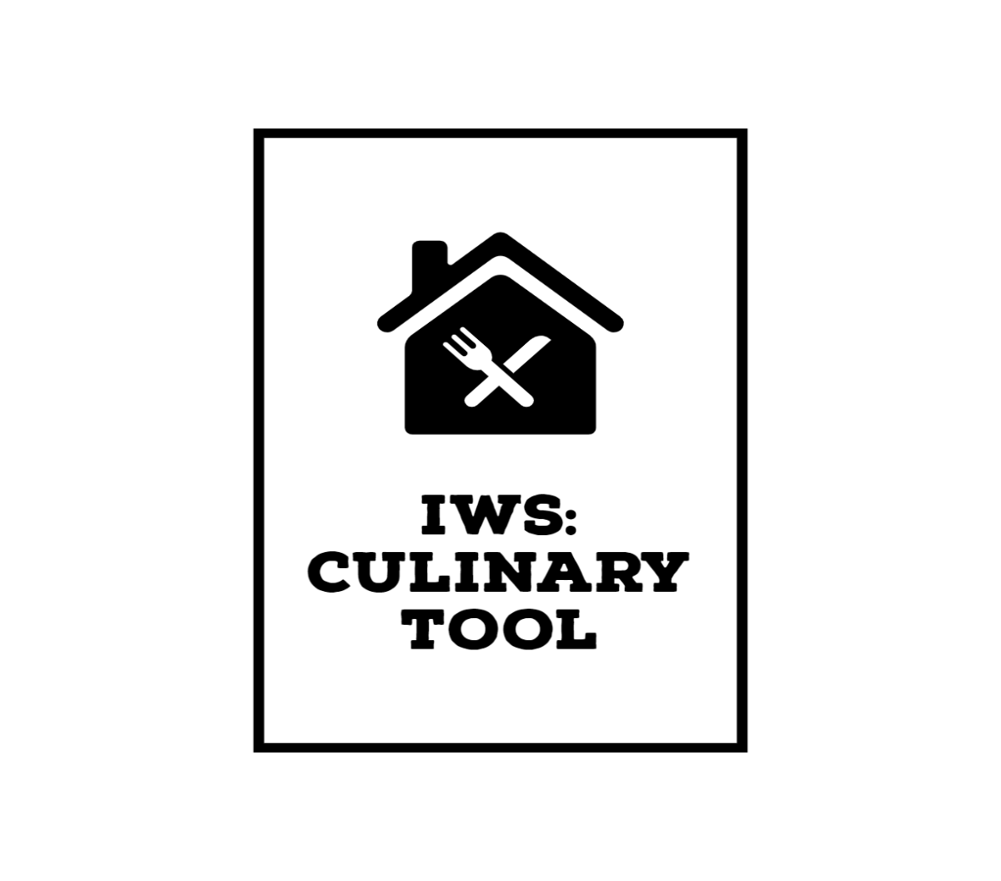

**Revision History**

| Version Number | Description | Date Modified | Author |
| --- | --- | --- | --- |
| 1.0 | Created Full Project Plan | 2022/11/29 | [redacted] |
|  |  |  |  |
|  |  |  |  |
|  |  |  |  |
|  |  |  |  |
|  |  |  |  |

**Authority Signatures**

The Project Lead (Business Side) and the Project Manager agree to deliver the Delivery Stage of this project in accordance with this Project Management Plan and amend it periodically as project parameters change.

|  |  |  |  |
| --- | --- | --- | --- |
| Prepared by: | | | |
| (PWGSC) | Signature | | |
| Please print: | |  |  |
|  | Name | Position | Date |

|  |  |  |  |
| --- | --- | --- | --- |
| Prepared by: | | | |
| (PWGSC) | Signature | | |
| Please print: | |  |  |
|  | Name | Project Analyst | Date |

|  |  |  |  |
| --- | --- | --- | --- |
| Recommended by: | | | |
| (PWGSC) | | Signature | |
| Please print: |  |  |  |
|  | Name | Title | Date |

|  |  |  |  |
| --- | --- | --- | --- |
| Approved by:  (See NPMS procedures for approval Body) | | | |
| (PWGSC) | | Signature | |
| Please print: |  |  |  |
|  | Name | Title | Date |

Table of Contents

1 Executive Summary 6

2 Integration Management 6

2.1 Project Governance and Project Team Structure 6

2.2 Roles and Responsibilities 7

2.3 Change Management 7

2.3.1 Change Control 7

2.3.2 Issue Management 7

2.4 Project Close Out 8

3 Scope Management 8

3.1 Scope Statement 9

3.2 Requirements Management 9

3.3 Project Deliverables 9

3.3.1 Work Activities 9

3.3.2 Requirements Control 9

3.3.3 Constraints 10

3.3.4 Assumptions 10

3.3.5 Stakeholders 10

4 Schedule Management 10

4.1 Milestones 10

4.2 Schedule Control 10

5 Cost Management 11

5.1.1 Estimation 12

5.1.2 Budget Allocation 12

5.1.3 Budget Control 12

6 Quality Management 12

6.1 Quality Assurance 12

6.2 Quality Control 13

7 Human Resource Management 13

7.1 Human Resources Acquisition 13

7.2 Human Resources Development 13

8 Communications Management 13

8.1 Stakeholder Analysis 13

8.2 Project Reporting and Communication 14

8.3 Metrics Collection 14

9 Risk Management 14

10 Procurement Management 14

11 Stakeholder Management 15

12 Team Contribution Composition 15

13 Description of Revisions 15

14 References 16

# Executive Summary

The food waste occurring in the restaurants of Canada has been exorbitant and our project team in collaboration with the Restaurants of Canada will introduce a tool called the IWS Culinary Tool that can help restaurants manage their food waste, keep track of inventory, and lower operating costs to create a more streamlined restaurants management environment.

According to our initial research about the project this endeavour is estimated to cost around $300,000, it is scheduled to take 5 months following the project's critical path, and according to the financial analysis the project is expected to break even.

The project sponsors do expect the project team to understand certain assumptions, constraints, and preliminary requirements that must be adhered to consider the project successful. The information waste management system will be assumed to have a warning displayed when food items are close to their inputted expiry dates, the system must be able to anticipate and generate a list of needed inventories after being given sufficient data, and it must use a FIFO (First in First out) model, and all food products must be classified into major food groups to allow for easy categorizing and search. Constraints that are vital to consider are the possibility that people may have trouble interacting with the system with dirty hands requiring the need for voice-based input, the system may not be economically viable for every restaurant setup, and user error whether by forgetting to input an item or doing it incorrectly may hurt the effectiveness of the system.

The preliminary system requirements that are high priority are the ability to add/remove/edit items, search items by name or id, the ability to input the amount of waste per business day, and the function to predict food cost savings per week. The important risk considerations that the IWS Culinary Tool may undergo during operation is the input of bad data and unexpected power outage, both of which are related to the control of product waste data. Taking into account these risk considerations, the project research indicates that the worth of controlling these risks is not greater than the risk of missing out on the benefits that this tool would provide to restaurants.

# Integration Management

The IWS Culinary Tool project charter will accomplish the task of unifying all of the project elements until completion. This document states the success criteria and the approaches toward that success for the project in question giving a clear goal that both the project team and its primary stakeholders can both measure and evaluate giving the project unity in all its other knowledge areas.

## Project Governance and Project Team Structure

The project team has a set of processes in place in which a strong organizational matrix is used in order to delegate the processes of information between project and external entities. The project manager will handle all primary stakeholder inquiries and be the liaison between primary stakeholders and the senior management and development staff. The sales manager will handle all information pertaining to procurement, sales, purchasing, marketing, and project financials. The chief information officer is responsible for all data communication needs in the project including installation, technical support, and validation.

￼

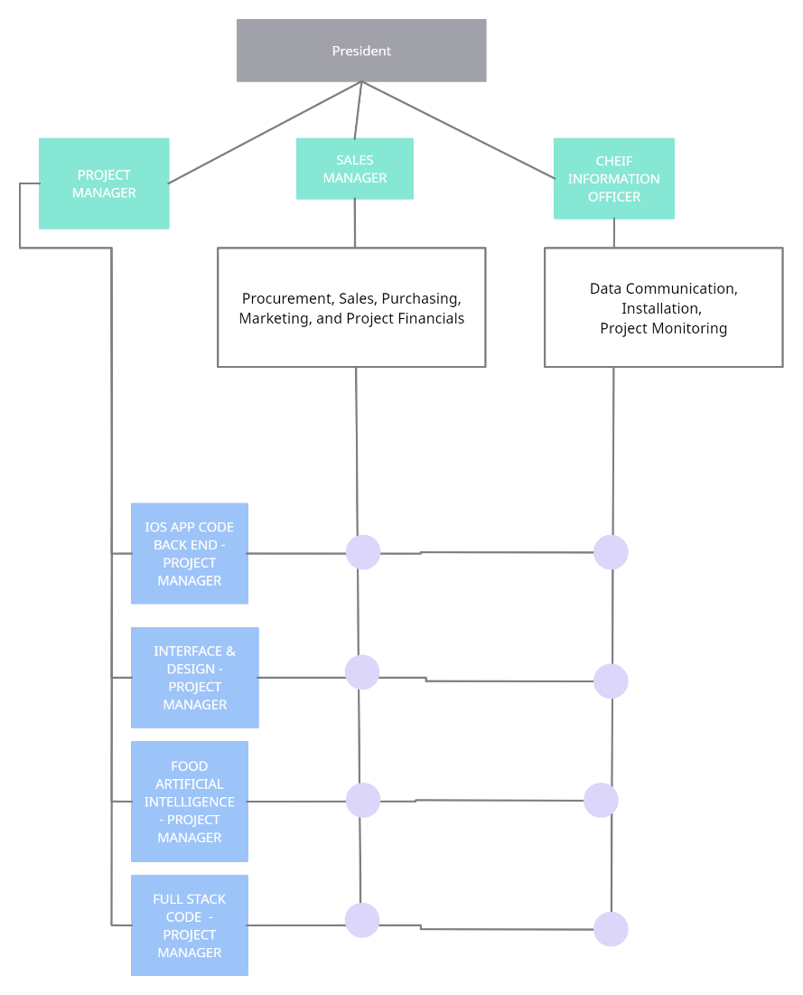

## Roles and Responsibilities

* Project Manager: Main indiviual that coordinates between the president, development team, and project sponsor
* Sales Manager: Responsible for marketing, the supply chain, and project financial proposals
* Chief Information Officer: Handles all information that is given to the IWS culinary system and the issues that may occur during project planning and development phase
* President: Gives authority to project employees to enact decisions for the project that are given
* Alan Howie: Primary project sponsor that provides seed funding and insight into project planning to incorporate this technology representing restaurants of Canada
* Jeremy Bonia: Primary project sponsor that provides seed funding and insight into project planning to incorporate this technology representing restaurants of Canada
* Full Stack Developer: Responsible for all technical project staff in the planning phase and the development phase coordinates with the project manager

## Change Management

Change will be managed in the delivery stage by an appointed change control board (CCB), who will track changes, perform impact analysis, govern the changes being made, and accepting, denying, or revising changes that were formally proposed. Changes will be tracked

### Change Control

Describe the Change Control process that will be used including:

* The CCB will be established that will oversee change control
* All changes will be tracked by assigning change ids and priority leveling by how much the change may affect the project
* Low level changes will be handled by employees in charge of the low-level changes
* All completed changes will be followed by an impact analysis
* CCB will handle approval for all changes from medium to high level, and low-level change approval is handled by the project manager

### Issue Management

There will be a process called an issue log where issues are described, assigned to the appropriate employee, and given a date to complete by. These issues will also be given priority levels spanning low, medium, high, and critical. These levels will be issued by the project lead overseeing that department where the issue stemmed from, and then signed by the president to approve these issue levels. Issue logs then will be periodically reviewed in order to ensure that the most important issues are resolved and their level categorized correctly in order to ensure that project issues do not delay the project.

## Project Close Out

In order to close the project, each phase of the project must perform a post-mortem analysis that indicates the problems that occurred during that phase and their solutions, employee efficiency, and use of materials. After the post-mortem is complete all relevant project documents will be given over to the project manager and will be signed off by the president to transfer them to the relevant next phases departments. An employee reassignment plan is then discussed with all department heads and then is signed off by the project manager.

A final report is then made by analyzing all the post-mortem reports and then that information is used to construct a lesson learned analysis and a project objectives achieved.

# Scope Management

The scope will be managed through reviewing the project charter and requirements documents leading to the creation of the scope statement to facilitate the project deliverables. Using the scope statement, a work breakdown structure will be created that will be then be validated and controlled through the use of the change control board.

## Scope Statement

The IWS Culinary Tool needs the requirements and the work completion of having an intuitive user interface, voice activation in case dirty hands prevent use of system, the ability to scan and record products in the system, IOS app to support system functions and combability between more restaurant systems, to have predictive product order estimation in order to lower costs, and have a reliable waste management database. These activities are vital to the completion of the project and to facilitate its completion the following activities can be removed, if necessary, website advertising of IWS Culinary Tool, enhanced voice activation features, and product images.

| Activities In Scope | Activities Out of Scope |
| --- | --- |
| Voice activation | Website advertising IWS Culinary Tool |
| IWS culinary tool interface | Voice client supporting more than basic functions |
| Waste Management Database | Product Images |
| Product scanning capability |  |
| Predictive product order estimation |  |
| IOS app |  |

## Requirements Management

There are a few mechanisms in place in order to gather and control requirements, a few of which are interviewing the stakeholders, holding focus group with the kitchens in the Restaurants of Canada, and benchmarking to gauge how similarly implemented requirements were effective in similar products.

BarCharts and a requirements traceability matrix will be used to map collected requirements data.

## Project Deliverables

| Deliverable | Recipients | Delivery Date | Delivery Method |
| --- | --- | --- | --- |
| Unit testing complete | Project Sponsor | 16/03/23 | Email |
| Integration testing complete | Project Sponsor | 03/04/23 | Email |
| Secure required resources | Development Team | 30/11/22 | Contracts |
| Develop preliminary budget | Project Sponsors, Investors | 23/11/22 | In-person meeting |
| Finished Prototype | All stakeholders | 12/22/22 | In-person meeting |

### Work Activities

**1.0 Scope**

1.1 Determine project scope

1.2 Secure project sponsorship

1.3 Define preliminary resources

1.4 Secure core resources

1.5 Kick-Off Meeting

1.6 Risk Consultation

**2.0 Analysis/Software Requirements**

2.1 Conduct needs analysis

2.2 Draft preliminary software requirements specifications and hardware design specifications

2.3 Develop preliminary budget

2.4 Review software requirement specifications and hardware design specifications /budget with team

2.5 Finalize software requirement specifications and hardware design specifications

2.6 Develop delivery timeline

2.7 Obtain approvals to proceed (concept, timeline, budget)

2.8 Secure required resources

2.9.1 Risk Management Consultation

**3.0 Design**

3.1 Review preliminary software specifications

3.2 Develop functional specifications

3.3 Develop prototype based on functional specifications

3.4 Incorporate feedback into functional specifications

3.5 Review functional specifications

3.6 Obtain approval to proceed

3.7 Risk Management Consultation

**4.0 Development**

4.1 Assign Development Staff

4.2 Identify modular/tiered design parameters

4.3 Develop IOS App code

4.4 Developer testing (primary debugging)

4.5 Risk Management Consultation

**5.0 Testing**

5.1 Develop unit test plans using product specifications

5.2 Develop integration test plans using product specifications

5.3 Risk Management Consultation

**6.0 Closing**

6.1 Deployment Training

6.2 Closing-Out Meeting

### Requirements Control

The process that is being used for the project requirements control will be the same system that is used in change control in which project requirements are given a priority level from low-high and are governed by a change control board.

### Constraints

* Some chefs may be averse to switching to a digital inventory manager
* Smaller restaurants may struggle to afford our product
* Hands are usually dirty in a kitchen environment so interacting with the system will probably have to be mainly voice based
* Foreign foods might have to be manually inserted into our system
* Individual products like eggs in a carton may be easier to mix up
* Chefs forgetting to log an item could mess up the inventory
* Sending out a food inventory invoice should require manager sign off for financial safety reasons, this could possibly slow down operations
* our main application will be deployed on screens of smart fridges, but obviously not all restaurants have that so that an iPad app will be created too, and the constraints of a smaller screen will make operations more difficult
* Project prototype must be fully developed and approved before the end of December so we don’t time and money once contractors are hired
* Some restaurants may have concerns about cameras inside their kitchen tracking the ingredients to their recipes
* Frost build up on product packaging / other contaminants may affect the cameras functionality
* We are a small company so we need to prepare for server overload around holidays and major calendar events when our products will be seeing more usage
* Kitchens are loud environments so they voice detection will have to be able to tune out background noise
* Clients may have security concerns over constant voice detection

### Assumptions

* Food will be classified into major categories based such as meat, fruits, and vegetables, dairy and liquids.
* Employees will be tasked with inputting food into the inventory system
* Model that the system will incorporate is FIFO (First in First Out), this model is a

standard in restaurant businesses and entails that any food that is entered into the system will be promoted to be used as quickly as possible so that it doesn’t go bad.

* The system will also display caution/warning prompts informing the user that food has been in the system for too long and might expire soon.
* The system will generate the anticipated number of inventories that is needed based on the inventory demand throughout the week and as a result, recommend the number of inventories needed based on its usage throughout the week. This ensures no extra food is ordered and potentially wasted.
* The system will order food automatically if the amount of food drops below a certain amount
* Clients will semi regularly clean the camera part to prevent dust buildup
* At least one employee working will have the companion app downloaded and connected
* Clients will specify the contents of unidentifiable packages

### Stakeholders

* Alan Howie
* Jeremy Bonia
* Jeffrey Knoll
* Duncan Fulton
* Mike Yasinki
* Bill Pratt
* Restaurants of Canada
* [Redacted]
* [Redacted]
* [Redacted]
* [Redacted]

# Schedule Management

## Milestones

|  |  |  |
| --- | --- | --- |
| **Description** | **Forecast Date** | **Gate / Approval** |
| Project initiation/ Scope | Start-31/10/22 Finish-11/11/22 | Project Manager |
| Analysis/ Software Requirement | Start-14/11/22 Finish- 05/12/22 | Chief Information Officer, Project Manager |
| Design | Start-05/12/22 Finish- 27/12/22 | Chief Information Officer, Project Manager |
| Development | Start- 28/12/22 Finish- 13/02/23 | Back End Developer & Full Stack Developer |
| Testing/ Building a prototype | Start- 14/02/23 Finish- 03/04/23 | Chief Information Officer & Back End Developer |
| Closing/ Application release and distribution | Start- 04/04/23 Finish- 19/04/23 | Sales Manager, Project Manager |

## Schedule Control

*Gantt Chart Milestones*

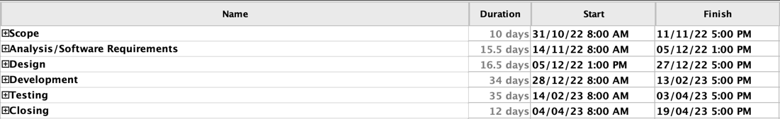

FULL Gantt Chart Milestones

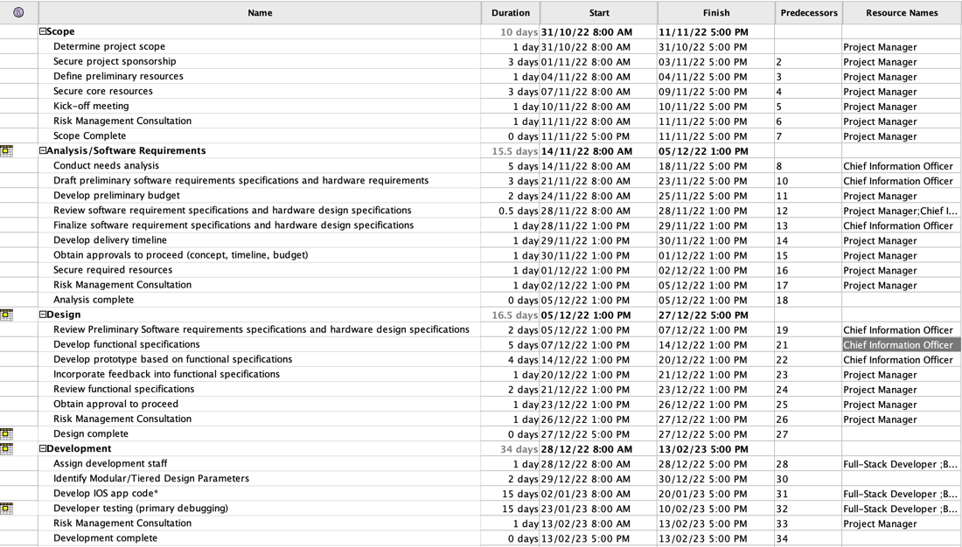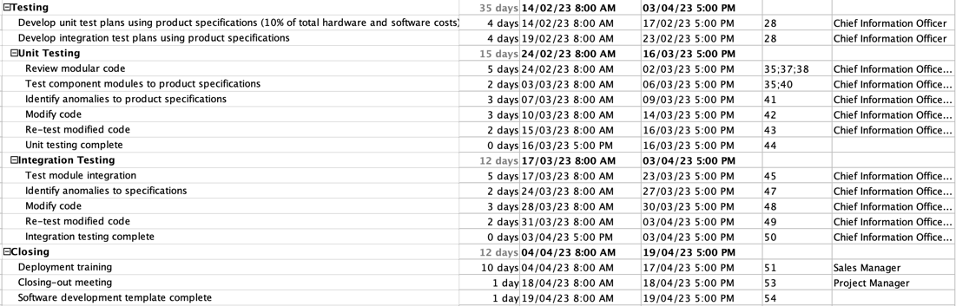

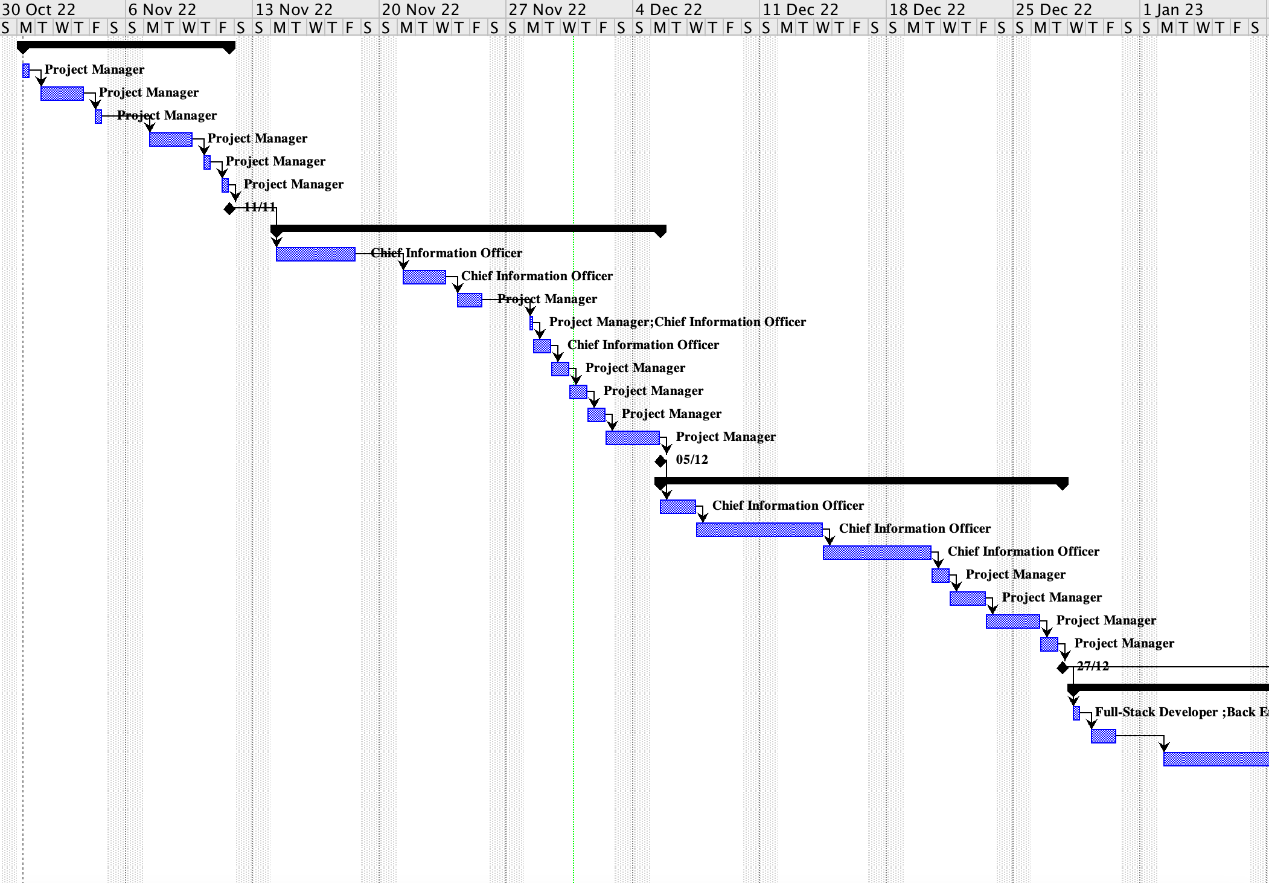

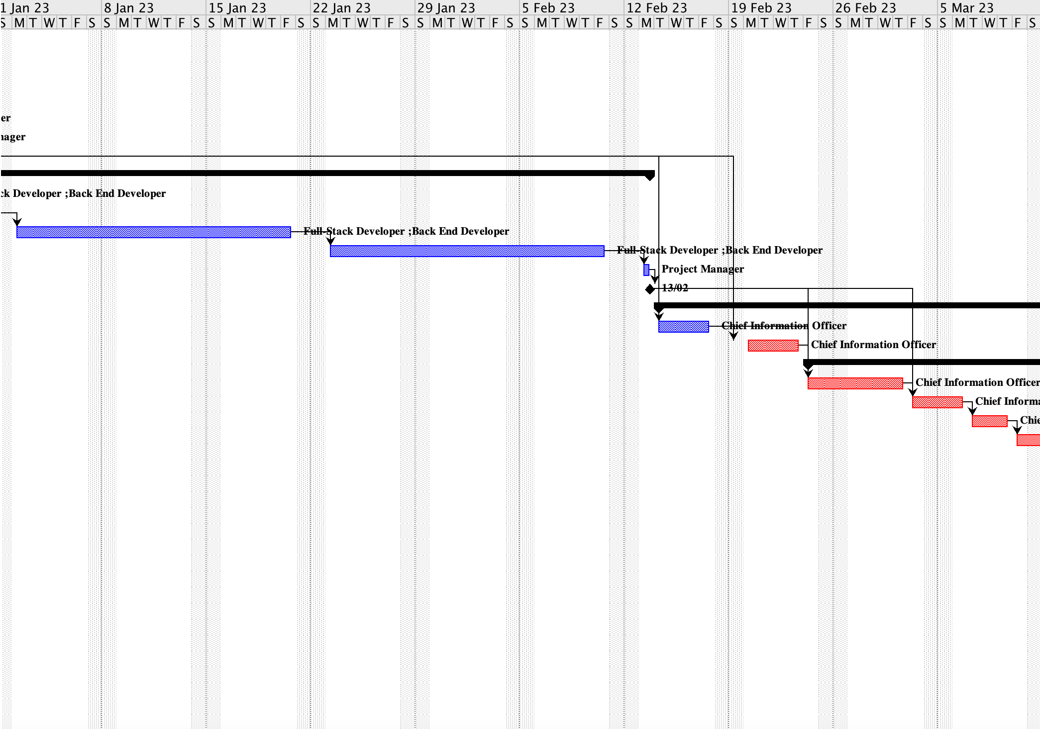

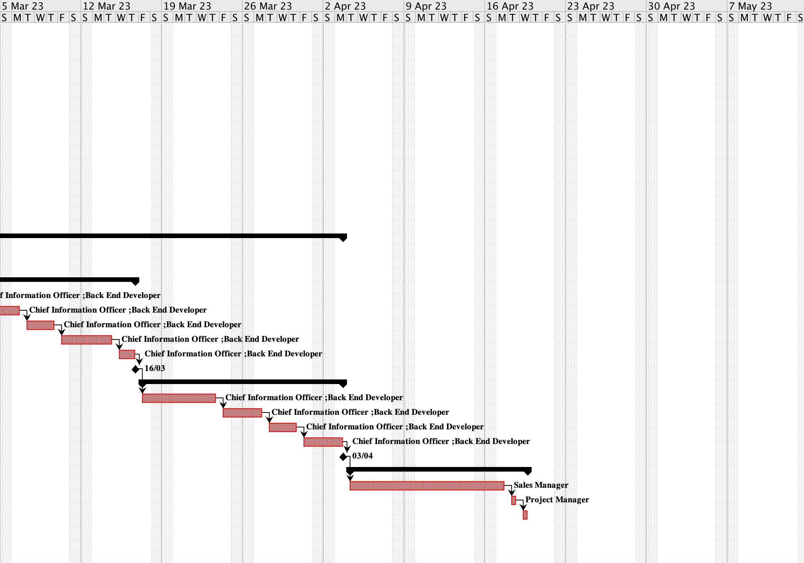

# Cost Management

In the delivery stage costs will be managed by strictly following our resource allocation chart, we will minimize unnecessary expenses as much as possible and we will always encourage efficiency.

Budgets will be developed by analyzing the cost estimate we created using the bottom-up estimate technique and will be adjusted if necessary. We created this estimate by calculating the delivery cost of individual work items in our WBS, and then we summed the total to get an accurate projection of the budget required. For flexible items such as software development labour estimates we will monitor our team performance for a testing period under different conditions and factors, and then we will use that data to create pessimistic and optimistic estimates to accompany the most likely estimate we developed initially, thus fulfilling completion of the three-point estimate technique.

The project manager will monitor the budget and costs as they incur, as they have the most authority and oversight. Any unexpected expenses will have to be approved by the project manager before completion and must be recorded. The chief information officer will monitor any flexible expenses and use his judgment and data analytics to develop optimistic and pessimistic cost estimates, to be shared with the project manager.

### Estimation

Project estimates have been prepared using the bottom-up technique and the corresponding schedule component is documented in our gantt chart. Effort has been estimated in our software development labour estimate and will be revaluated as time proceeds. Critical computer resource requirements were completed in table 5-2 of our project proposal. All core founders were involved in the estimation process and all resulting data has been documented and reviewed in our cost estimate and earned value analysis spreadsheet.

Cost estimates:

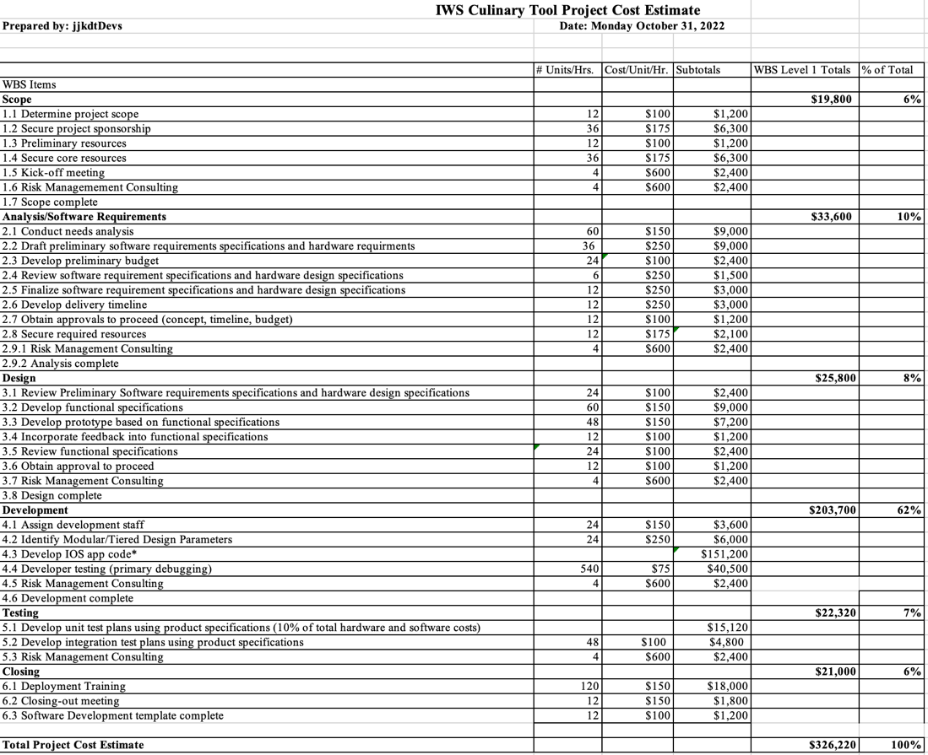

Estimation method used: Bottom-up technique

Assumptions made:

* Assumptions made on how long each task will take, (calculated and well thought out assessments)
* Assuming no major “hiccups” or errors
* Assuming we can find compatible and capable software developers willing to work for the hourly budget we can afford

Confidence level for the estimate: Medium to high, we recognize that there are assumptions we’ve made that could possibly not work out, but we are prepared to revaluate our budget at every step of the process going forward. We also intend to stick to this budget, and we were very thorough and spent a lot of time brainstorming and working together to ensure this estimate is as accurate and helpful as possible. The chief information officer will use data analytics and expert judgment to periodically to re-estimate the cost, time, and resources required to complete the project with the approval of the project manager.

### Budget Allocation

Detailed Budget allocation breakdown by each stage of development:

SCOPE (ACTIVITY):

|  |  |  |  |  |  |
| --- | --- | --- | --- | --- | --- |
| **Scope** |  |  |  | **$19,800** | **6%** |
| 1.1 Determine project scope | 12 | $100 | $1,200 |  |  |
| 1.2 Secure project sponsorship | 36 | $175 | $6,300 |  |  |
| 1.3 Preliminary resources | 12 | $100 | $1,200 |  |  |
| 1.4 Secure core resources | 36 | $175 | $6,300 |  |  |
| 1.5 Kick-off meeting | 4 | $600 | $2,400 |  |  |
| 1.6 Risk Consultation | 4 | $600 | $2,400 |  |  |
| 1.7 Scope complete |  |  |  |  |  |

ANALYSIS:

|  |  |  |  |  |  |
| --- | --- | --- | --- | --- | --- |
| **Analysis/Software Requirements** |  |  |  | **$33,600** | **10%** |
| 2.1 Conduct needs analysis | 60 | $150 | $9,000 |  |  |
| 2.2 Draft preliminary software requirements specifications and hardware requirements | 36 | $250 | $9,000 |  |  |
| 2.3 Develop preliminary budget | 24 | $100 | $2,400 |  |  |
| 2.4 Review software requirement specifications and hardware design specifications | 6 | $250 | $1,500 |  |  |
| 2.5 Finalize software requirement specifications and hardware design specifications | 12 | $250 | $3,000 |  |  |
| 2.6 Develop delivery timeline | 12 | $250 | $3,000 |  |  |
| 2.7 Obtain approvals to proceed (concept, timeline, budget) | 12 | $100 | $1,200 |  |  |
| 2.8 Secure required resources | 12 | $175 | $2,100 |  |  |
| 2.9.1 Risk Management Consultation | 4 | $600 | $2,400 |  |  |
| 2.9.2 Analysis complete |  |  |  |  |  |

DESIGN:

|  |  |  |  |  |  |
| --- | --- | --- | --- | --- | --- |
| **Design** |  |  |  | **$25,800** | **8%** |
| 3.1 Review Preliminary Software requirements specifications and hardware design specifications | 24 | $100 | $2,400 |  |  |
| 3.2 Develop functional specifications | 60 | $150 | $9,000 |  |  |
| 3.3 Develop prototype based on functional specifications | 48 | $150 | $7,200 |  |  |
| 3.4 Incorporate feedback into functional specifications | 12 | $100 | $1,200 |  |  |
| 3.5 Review functional specifications | 24 | $100 | $2,400 |  |  |
| 3.6 Obtain approval to proceed | 12 | $100 | $1,200 |  |  |
| 3.7 Risk Management Consultation | 4 | $600 | $2,400 |  |  |
| 3.8 Design complete |  |  |  |  |  |

DEVELOPMENT (WORK):

|  |  |  |  |  |  |
| --- | --- | --- | --- | --- | --- |
| **Development** |  |  |  | **$203,700** | **63%** |
| 4.1 Assign development staff | 24 | $150 | $3,600 |  |  |
| 4.2 Identify Modular/Tiered Design Parameters | 24 | $250 | $6,000 |  |  |
| 4.3 Develop IOS app code* |  |  | $151,200 |  |  |
| 4.4 Developer testing (primary debugging) | 540 | $75 | $40,500 |  |  |
| 4.5 Risk Management Consultation | 4 | 600 | $2,400 |  |  |
| 4.6 Development complete |  |  |  |  |  |

TESTING:

|  |  |  |  |  |  |
| --- | --- | --- | --- | --- | --- |
| **Testing** |  |  |  | **$19,920** | **6%** |
| 5.1 Develop unit test plans using product specifications (10% of total hardware and software costs) |  |  | $15,120 |  |  |
| 5.2 Develop integration test plans using product specifications | 48 | $100 | $4,800 |  |  |

CLOSING:

|  |  |  |  |  |  |
| --- | --- | --- | --- | --- | --- |
| **Closing** |  |  |  | **$21,000** | **6%** |
| 6.1 Deployment Training | 120 | $150 | $18,000 |  |  |
| 6.2 Closing-out meeting | 12 | $150 | $1,800 |  |  |
| 6.3 Software Development template complete | 12 | $100 | $1,200 |  |  |
| **Total Project Cost Estimate** |  |  |  | **$323,820** | **100%** |

Simplified budget allocation breakdown:

|  |  |  |
| --- | --- | --- |
| SIMPLIFIED BUDGET ALLOCATION BREAKDOWN | | |
| SCOPE (ACTIVITY) | $19,800 | 6% |
| ANALYSIS | $33,600 | 10% |
| DESIGN | $25,800 | 8% |
| DEVELOPMENT (WORK) | $203,700 | 63% |
| TESTING | $19,920 | 6% |
| CLOSING | $21,000 | 6% |
| TOTAL | $323,820 | 100% |

### Budget Control

Some of the control mechanisms we will use to measure the cost of work completed, to compare planned cost to budgeted cost, and to implement corrective action when actual cost does not conform to budgeted cost include using the earned value management system and implementing contingency reserves and management reserves as well doing process adjustments if we fail to conform to the budgeted costs.

First, we will develop milestones and we will reference our earned value analysis spreadsheet to determine what the cumulative planned value should be at a certain milestone;

|  |  |  |
| --- | --- | --- |
| **Milestone** | **Finish Date** | **Cumulative Planned Value at this milestone** |
| Scope (ACTIVITY) | 11/10/22 | $48,600 |
| Analysis | 05/12/22 | $72,000 |
| Design | 27/12/22 | $72,000 |
| Development (WORK) | 13/02/23 | $151,800 |
| Testing | 03/04/23 | $177,600 |
| Closing | 19/04/23 | $177,600 |

Then we will develop an earned value management system with a baseline original plan, and the milestone finish dates will be used to measure earned value completion at different times throughout the product life cycle and progress of scope based on cost and time, starting in October 2022 and ending in April 2023.

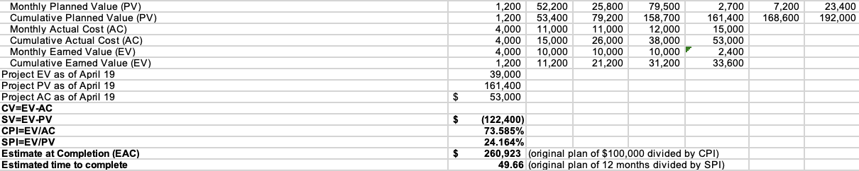

These are our calculations for planned value, actual cost, and earned value, and we’ll use these calculations and Net Present Value analysis, as well as simple cash flow analysis to determine if we’re projected to stay within budget and if not, what adjustment processes need to be made to control the budget. Our chief information officer will also use project Managment information systems and data analysis help control the budget.

# Quality Management

## Quality Assurance

* Everyone in the project aim to prevent the defect
* Quality audit, Benchmarking - [Redacted] [Redacted](Project Manager)
* Cost Effectiveness, Customer Satisfaction - [Redacted](Sales Manager)
* Kaizen process, Charts(control, scatter) - [Redacted](Chief information Officer)
* Change control - [Redacted]
* Review - Everyone

## Quality Control

* Developers are responsible for detecting the bugs
* Control charts - [Redacted] (Full-Stack Developer)
* Software testing and code inspection - [Redacted] [Redacted] (Back-End Developer)
* Technical review - [Redacted] [Redacted], [Redacted]

# Human Resource Management

### 7.1 Human Resources Acquisition

|  |  |  |
| --- | --- | --- |
| Role | HR | Skills |
| Project Manager | [Redacted] [Redacted] | Leadership  Communication  Budgeting  Time Management  Conflict Resolution |
| Sales Manager | [Redacted] | Leadership  Coaching  Recuriting & Selecting |
| Back-End Developer | [Redacted] [Redacted] | Programmings  Server Architecture  Database Administration |
| Full-Stack Developer | [Redacted] | Design skills  Security  Web Architecture |
| Chief Information Officer | [Redacted] | Strategic Planning  Performance&Result based management  Process Improvement |

### 7.2 Human Resources Development

|  |  |
| --- | --- |
| Training | * App development skill * Software programming skill * Leadership skill * Server administration skill * Customer management skill |
| Team-building Activities | * Meetings for develop teamwork * Team field trip * Volunteer activity day |

# Communications Management

|  |  |
| --- | --- |
| Method of Communications | Responsibility |
| Meeting minutes would be used | [Redacted], [Redacted], [Redacted], Talha, [Redacted] |

## Stakeholder Analysis

| Stakeholder Name | How they will impact the project | How they will be impacted by the project | Communication Requirements |
| --- | --- | --- | --- |
| *Alan Howie* | *High* | *High* | *Email, Face to Face, Phone* |
| *Jeremy Bonia* | *High* | *High* | *Email, Face to Face, Phone* |
| *Jeffrey Knoll* | *High* | *Low* | *Email, Face to Face, Phone* |
| *Duncan Fulton* | *High* | *High* | *Email, Face to Face, Phone* |
| *Mike Yasinki* | *High* | *Medium* | *Email, Face to Face, Phone* |
| *Bill Pratt* | *Medium* | *Medium* | *Email, Face to Face, Phone* |
| *Restaurants of Canada* | *High* | *Low* | *Email, Face to Face, Phone* |
| *[Redacted] [Redacted]* | *High* | *High* | *Face-to-Face meeting* |
| *[Redacted]* | *Low* | *Medium* | *Face-to-Face meeting* |
| *[Redacted] [Redacted]* | *High* | *Medium* | *Face-to-Face meeting* |
| *[Redacted]* | *High* | *Medium* | *Face-to-Face meeting* |
| *[Redacted]* | *High* | *Medium* | *Face-to-Face meeting* |

## Project Reporting and Communication

| Type of Communication | Communication Schedule | Communication Mechanism | Initiator | Recipient |
| --- | --- | --- | --- | --- |
| *Monthly status report* | *First of month* | *Internal management meeting* | *Project Manager* | *Project Team* |
| *Monthly status report* | *First of month* | *Customer management meeting* | *Project Manager* | *Project Team* |
| *Monthly status report* | *Frist of month* | *Customer technical staff meeting* | *Project Manager* | *Project Team* |
| *Monthly status report* | *First of month* | *Internal business and technical staff meeting* | *Project Manager* | *Project Team* |
| *Software implementation plan* | *January 2, 2023* | *Software subcontractor* | *Developers* | *Subcontractor* |
| *Training plan* | *April 4, 2023* | *Training subcontractor* | *Sales Manager* | *Subcontractor* |

## Metrics Collection

|  |  |
| --- | --- |
| **Methods, Tools, or Techniques** | Description of task |
| **Windows server 2022** | Used to data mine the effectiveness of the sensors that will be used scan product code, what is the accuracy from other companies that uses these technologies. Also, will generate the report on this. |
| **Project Libre/ Scrum approach** | Used to mock up/ visualize the schedule and delegate responsibilities to the professional of their area of expertise. Scrum approach is used in conjunction with the scheduling program to ensure tasks stay within scope etc. |

# Risk Management

The plan for identifying project risk will be the creation of the SWOT analysis, in doing so will allow team members to breakdown what areas the project is doing well in and where the project is liable to risks. In addition to SWOT analysis, face to face interviews will be conducted with key stakeholders to address any concerns they may have with the project. Once the risk has been identified a risk register will be compiled outlining the risk associated with the project and contingency plans will be made that are applicable to the risk in question. Using the risk register a possibility matrix chart will be made in order to adequately illustrate to the team which risks needs to be prioritized based on the impact they will have and the probability of the risk coming true. The identification of risk will be conducted during the kick off meeting using the SWOT analysis and interviews. Throughout the project life cycle the project manager will identify risks after each project milestone, this will attempt to make the next milestone begin without any risks. The risk management tasks that will be implemented in this project is identifying the risk with the use of SWOT analysis and face to face interviews, analyzing the risk with the use of risk registers, prioritizing the risk using possibility matrix chart, treating the risk which is done by carrying out the possible solutions to remedy the risk and lastly monitoring the risk to ensure that the risk resolved( whether that be mitigated, avoided, accepted, transference or escalation). Based off the budget the percentage number of effort planned for risk management activities is 4%.

# Procurement Management

The procurement will be managed throughout the delivery stage of this project by first identifying the necessary resources for this project. Since project involves creating software it will require the necessary hardware to make the program and hardware that will host the program. Potentially if the project isn't proceeding in timely manner could involve contracting engineers on a temporary basis. Once the necessary resources have been identified its crucial to create guidelines for the creation of contracts. Acquiring hardware relies on contacting vendors and negotiating terms that are in the best interest of the project. The basis for these contracts will be fixed-price contracts as it will involve purchasing a fixed total price for well-define products. The products will include and not limited to monitors, ipads, scanners and etc. For contracting engineers, a technique that will be employed to determine whether acquiring contracted engineers is not only viable for the project but necessary will be evaluated using the make-or-buy analysis if determined necessary, then we will proceed in contracting engineers on a time and material contract. Time and material contract employs a hybrid of fixed price and cost reimbursable contracts, since the work won't necessarily be clearly specified, and the total cost can't be estimated beforehand as it remains to be seen how long the contracted engineers will work and what will they be doing it makes sense to use a time and material contract. Vendors that we plan on employing on this project will be acquired through referral, our stakeholders have referred us to vendors that will be the right partners for this project. The vendors understand that by establishing a contract with us in the initial stages of this project will lead to long term relationships that will benefit both of us. We plan on regularly checking in with our vendors so that both of us can be informed on any developments. To ensure that both parties are responsible for the success and failure of our partnership we intend to make sure that everyone is accountable for their roles. This will be accomplished by establishing evaluation metric which will be used to give insights on areas that the vendor can improve on and areas that they are doing well in. Similarly, we expect our vendors to give us feedback and insight on where we can improve so that we are able to maintain a positive partnership. Regarding contracted employee's they will be incentivized with opportunities to be employed as a full-time work. Contracted employees will also undergo performance evaluation to ensure that they are held accountable for the work they are doing. The performance evaluation will then be used to determine candidates that will be called back to work with us again as well as determine if they are someone who will be a good fit for this project.

# Stakeholder Management

The following engagement plan below is what will allow us to identify and analyze the stakeholders

1. The first step of identifying stakeholders is determining the stakeholders that have the most direct ties to the success of this project.
2. The second step is compiling the stakeholder information by their identification this will include the stakeholder's name, position, roles in project, etc
3. The third step compiling stakeholder by assessment information which includes stakeholder ability to influence the project and the requirements/ expectations the stakeholder has for the project.

Using the above-mentioned engagement plan led to the completion of the stakeholder register which implores step 1 and 2 of the engagement plans, with the use of step 3 lead to the creation of the engagement level chart

In order to properly monitor and manage stakeholders, it is necessary to understand the people who were talking to, the engagement level chart grants us the ability to understand the varying stakeholders and the expectations that they have with this project. The engagement level gives us a glimpse into our stakeholders and the best way to navigate around them. Stakeholders have differing expectations of this project, results in them having different demands and it's important to be able to cater to the demands of the individual stakeholder if we want the project to be successful. For instance, Jeffery Kroll level of interest is low as such he doesn’t need to be bombarded about this project in comparison to Jeremy Bonia whose interest level is quite high and as such wants to be included more in the discussions of the project. As the project progresses the engagement level will differ as certain stakeholders can be more invested in different parts of the project. Stakeholders register and engagement level will be revised after every project milestone, to ensure that the demands of the stakeholders are catered throughout the project life cycle.

**Stakeholder Register**

After analyzing the stakeholders, the following stakeholder register was compiled.

|  |  |  |  |  |
| --- | --- | --- | --- | --- |
| Name | Position | Internal/External | Project Role | Contact Information |
| Jeremy Bonia | Owner of The Merchant Tavern | Internal | Project Sponsor | JeremyBonia12@gmail.com |
| Alan Howie | Vice Chair Northern land Properties | Internal | Project Sponsor | AlanHowie18@gmail.com |
| Jeffrey Kroll | Senior Vice President and Chief Strategy Officer of McDonald | External | Project Sponsor | JeffKroll@gmail.com |
| Duncan Fulton | CEO of Restaurant Brands International | External | Project Sponsor | DFulton@gmail.com |
| Mike Yasinki | Chair Board of Restaurant Canada | External | Project Sponsor | MikeYasinki1@gmail.com |
| Bill Pratt | Chef of the Inspired Group of Restaurants and Food Trucks | External | Project Sponsor | BillPratt@gmail.com |
| [Redacted] | Sales Manager | Internal | Team Member | [Redacted] |
| [Redacted] [Redacted] | Back End Developer | Internal | Team Member | [Redacted] |
| [Redacted] | Full Stack Developer | Internal | Team Member | [Redacted] |
| [Redacted] | Chief Information Officer | Internal | Team Member | [Redacted] |
| [Redacted] [Redacted] | Project Manager | Internal | Project Manager | [Redacted] |

**Engagement Levels**

Engagement levels was made once stakeholders were identified.

|  |  |  |  |
| --- | --- | --- | --- |
| Stakeholder Name | Level Of Interest | Level Of Influence | Potential Management Strategies |
| Jeremy Bonia | High | High | Jeremy has invested a large amount of capital into this project and wants to ensure that it doesn’t go to waste. Keep Jeremy informed as long as he sees progress is being made, we can continue to gain his support. |
| Alan Howie | Medium | High | Alan has invested money into this project but has also invested money into similar projects. He hopes this project is successful however he has other options in case this doesn’t work. Alan is interested in the end goal if he believes this project has a future, we can keep his support. |
| Jeffrey Kroll | Low | Medium | Jeffery is occupied in a lot of revolutionary technology in the food industry. As such showing that there is demand for this project will increase his engagement into the project. |
| Duncan Fulton | High | High | Duncan is meticulous in where he invests and likes to stay well informed. Duncan would appreciate having one on one meetings, he is privy to everything going on is what Duncan expects from us. |
| Mike Yasinki | High | High | Mike has high expectations for this project and genuinely sees this project taking off. Keep Mike well informed by having brief face to face meetings about the project. |
| Bill Pratt | High | Medium | Bill is looking to make money by investing in this project early, with expectations it could yield a big return on investments. Focus on showing him the financial benefits the project could yield. |
| [Redacted] | Medium | High | David enjoys his job and likes making money. As long as David feels his pay reflects the work he puts in he will feel appreciated. |
| [Redacted] [Redacted] | Low | High | [Redacted] has low expectations for this project and is considering looking for other job opportunities if this doesn’t pan out. Show him that the project is feasible. |
| [Redacted] | High | High | Talha is a perfectionist and a hard worker he feels as though his work goes unnoticed. Manage closely and ensure that his work doesn’t go unappreciated. |
| [Redacted] | High | High | [Redacted] is a logical person and prides himself on being well informed. Ask for his advice as needed. |
| [Redacted] [Redacted] | High | High | [Redacted] has a lot riding on making sure that this project is completed. He wants to be informed on everything that concerns this project. |

# Team Contribution Composition

| Team Member Name | Percentage of Contribution | Description of Contribution | |
| --- | --- | --- | --- |
| [Redacted] | 20% | Responsible for Leadership, Coaching, Recruiting and Selection | |
| [Redacted] [Redacted] | 20% | Responsible for Back and Front-end development, Server architecture Data administration |
| [Redacted] | 20% | Responsible for System Design, Network Security, Web architecture | |
| [Redacted] | 20% | Responsible planning, Performance & Result based management, Process improvement. | |
| [Redacted] [Redacted] | 20% | Responsible for Leadership, Communication, Budgeting, Time Management, Conflict resolution | |

# Description of Revisions

No changes to the interim deliverables*.*

# References

The following documents are attached to this Project Plan for immediate reference.

|  |  |  |  |
| --- | --- | --- | --- |
| **Appendix** | **Document Name** | **Version** | **Date** |
| A | Project_01_Proposal_IWS_Culinary_Tool | 1.0.3 | 09/14/2022 |
| B | Project_02_WBS_IWS_Culinary_Tool | 1.1.2 | 09/28/2022 |
| C | Project_03_Gantt and Resources_jjkdtDevs | 2.4.5 | 10/28/2022 |
| D | Project_04_Cost Estimate and Earned Value Analysis _jjkdtDevs | 1.0.9 | 11/02/2022 |