STUDENT INFORMATION

Name | JAY ZALAVADIYA
Student ID | 25CE142
Subject Code | ITUE203
Subject | Web Development Frameworks
Department | CSPIT-CE
University | CHARUSAT

Practical-7:
Aim
Process submitted registration/contact form data using PHP. Validate and sanitize inputs on the server side and store records in CSV or JSON file format. Display success/error messages.
Register.html :
<!doctype html>
<html lang="en">
<head>
<meta charset="UTF-8" />
<meta name="viewport" content="width=device-width, initial-scale=1.0" />
<title>Student Registration | StudentHub</title>
<link rel="stylesheet" href="styles.css" />
</head>
<body>
<header class="site-header">
<div class="brand">
<div class="logo">➵</div>
<div>
<h2>StudentHub</h2>
<p>Student Portal</p>
</div>
</div>

<nav class="site-nav">
<a href="home.html">Home</a>
<a href="timetable.html">Timetable</a>
<a href="results.html">Results</a>
<a href="courses.html">Courses</a>
<a href="register.html" class="active">Register</a>
<a href="about.html">About</a>
<a href="contact.html">Contact</a>
</nav>
</header>

<main class="container">
<div class="card registration-card">
<h1>Student Registration</h1>
<p>Enter your details to complete the registration form.</p>

<!-- CHANGED: Added action and method -->
<form
id="registrationForm" action="register.php" method="POST" novalidate
>
<!-- CHANGED: Added hidden field for PHP to know which form was
submitted -->
<input type="hidden" name="form_type" value="registration" />

<div class="form-group">
<label for="name">Full Name</label>
<input
type="text" id="name" name="name"
placeholder="Enter your full name" required
/>
<small class="error" id="nameError"></small>
</div>

<div class="form-group">
<label for="email">Email Address</label>
<input
type="email" id="email" name="email"
placeholder="student@example.com" required
/>
<small class="error" id="emailError"></small>
</div>

<div class="form-group">
<label for="mobile">Mobile Number</label>
<input
type="tel" id="mobile" name="mobile"
placeholder="Enter 10-digit mobile number"

inputmode="numeric" maxlength="10" required
/>
<small class="error" id="mobileError"></small>
</div>

<div class="form-group">
<label for="password">Password</label>
<input
type="password" id="password" name="password"
placeholder="Create a password" required
/>
<small class="error" id="passwordError"></small>
</div>

<div class="form-group">
<label for="confirmPassword">Confirm Password</label>
<input
type="password" id="confirmPassword" name="confirmPassword" placeholder="Confirm your password" required
/>
<small class="error" id="confirmPasswordError"></small>
</div>

<div class="form-group">
<label for="course">Course</label>
<select id="course" name="course" required>
<option value="">Select your course</option>
<option value="CSE">Computer Science Engineering</option>
<option value="CE">Computer Engineering</option>
<option value="IT">Information Technology</option>
<option value="AIML">
Artificial Intelligence and Machine Learning
</option>
<option value="ECE">
Electronics and Communication Engineering
</option>
<option value="ME">Mechanical Engineering</option>
</select>
<small class="error" id="courseError"></small>
</div>

<div class="form-group">
<label for="year">Academic Year</label>
<select id="year" name="year" required>
<option value="">Select your academic year</option>
<option value="1">First Year</option>
<option value="2">Second Year</option>
<option value="3">Third Year</option>
<option value="4">Fourth Year</option>
</select>
<small class="error" id="yearError"></small>
</div>

<fieldset class="form-group gender-group">
<legend>Gender</legend>
<label
><input type="radio" name="gender" value="Male" /> Male</label
>
<label
><input type="radio" name="gender" value="Female" />
Female</label
>
<label
><input type="radio" name="gender" value="Other" /> Other</label
>
<small class="error" id="genderError"></small>
</fieldset>

<div class="form-group terms-group">
<label for="terms">
<input type="checkbox" id="terms" name="terms" /> I accept the terms and conditions.
</label>
<small class="error" id="termsError"></small>
</div>

<button type="submit">Register</button>
<p id="formMessage" role="status" aria-live="polite"></p>
</form>
</div>
</main>

<footer class="site-footer">
<p>&copy; 2026 StudentHub. All rights reserved.</p>
</footer>

<script src="script.js"></script>
</body>

</html>

Register.php:

<?php
$message = "";
$type = "";

if ($_SERVER["REQUEST_METHOD"] === "POST") {
$formType = $_POST["form_type"] ?? "";

if ($formType === "registration") {
$name = trim($_POST["name"] ?? "");
$email = trim($_POST["email"] ?? "");
$mobile = trim($_POST["mobile"] ?? "");

if ($name === "" || !filter_var($email, FILTER_VALIDATE_EMAIL)
|| !preg_match("/^[0-9]{10}$/", $mobile)) {
$message = "Invalid registration details. Please check your
inputs.";
$type = "error";
} else {
$file = DIR . "/registrations.json";
$records = [];

if (file_exists($file)) {
$data = json_decode(file_get_contents($file), true); if (is_array($data)) {
$records = $data;
}
}

$records[] = [ "name" => $name,
"email" => $email, "mobile" => $mobile,
"submitted_at" => date("Y-m-d H:i:s")
];

$json = json_encode($records, JSON_PRETTY_PRINT);

if ($json !== false &&
file_put_contents($file, $json, LOCK_EX) !== false) {
$message = "Registration submitted successfully!";
$type = "success";
} else {

$message = "Error saving registration data.";
$type = "error";
}
}

} elseif ($formType === "contact") {
$name = trim($_POST["name"] ?? "");
$email = trim($_POST["email"] ?? "");
$messageText = trim($_POST["message"] ?? "");

if ($name === "" || !filter_var($email, FILTER_VALIDATE_EMAIL)
|| $messageText === "") {
$message = "Invalid contact details. Please complete all fields.";
$type = "error";
} else {
$file = DIR . "/contacts.json";
$records = [];

if (file_exists($file)) {
$data = json_decode(file_get_contents($file), true); if (is_array($data)) {
$records = $data;
}
}

$records[] = [ "name" => $name,
"email" => $email, "message" => $messageText,
"submitted_at" => date("Y-m-d H:i:s")
];

$json = json_encode($records, JSON_PRETTY_PRINT);

if ($json !== false &&
file_put_contents($file, $json, LOCK_EX) !== false) {
$message = "Contact message submitted successfully!";
$type = "success";
} else {
$message = "Error saving contact message.";
$type = "error";
}
}
} else {
$message = "Invalid form submission.";
$type = "error";
}
}

function e($value) {
return htmlspecialchars((string)$value, ENT_QUOTES | ENT_SUBSTITUTE, "UTF-
8");
}
?>

<!DOCTYPE html>
<html lang="en">
<head>
<meta charset="UTF-8">
<meta name="viewport" content="width=device-width, initial-scale=1.0">
<title>StudentHub - Form Status</title>
<link rel="stylesheet" href="styles.css">
</head>
<body>
<main class="container">
<section class="card">
<h1>StudentHub</h1>

<?php if ($message !== ""): ?>
<p class="<?= e($type) ?>">
<?= e($message) ?>
</p>
<?php endif; ?>

<a href="register.html">Back to Registration</a>
<br>
<a href="contact.html">Back to Contact</a>
</section>
</main>
</body>
</html>

Output:

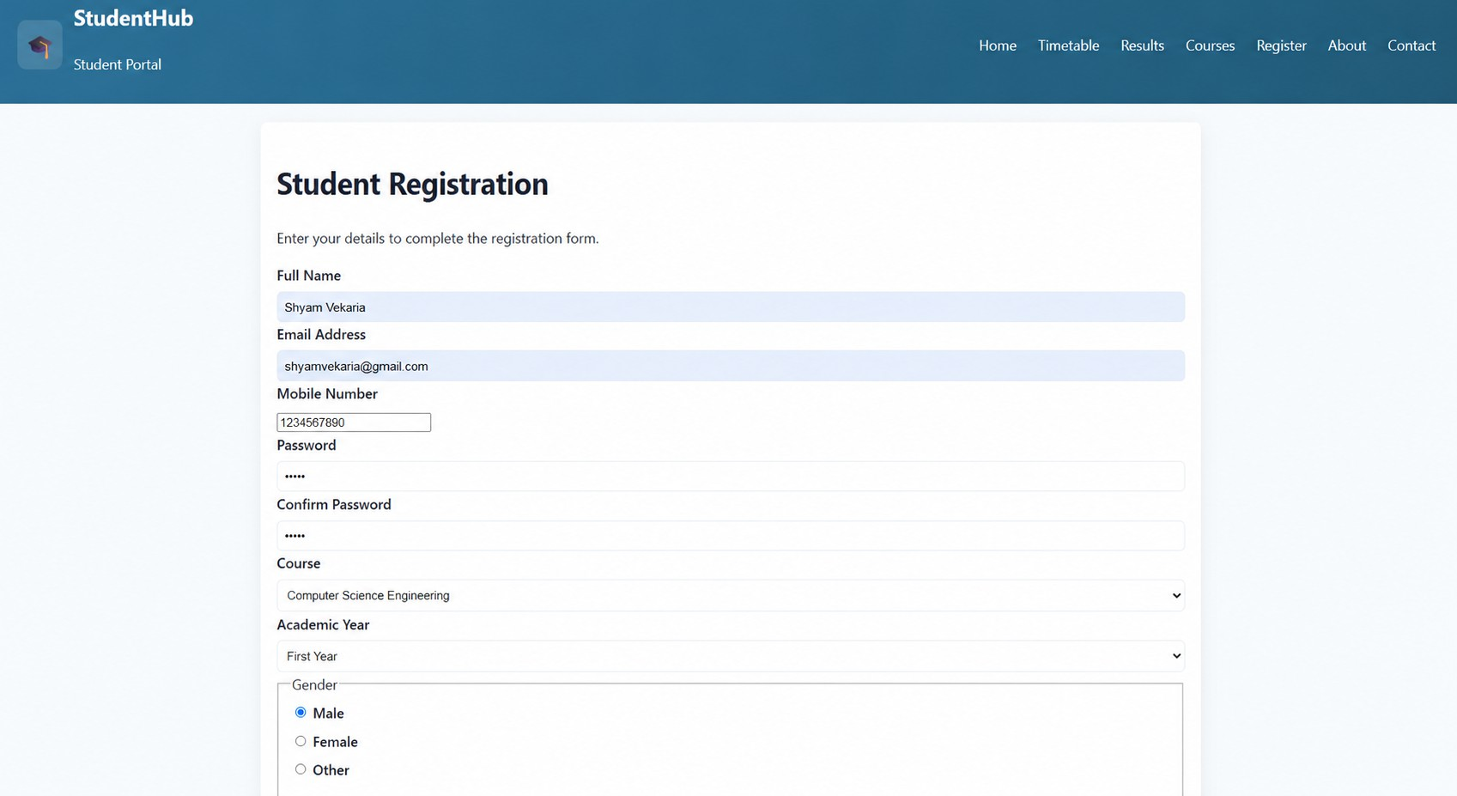
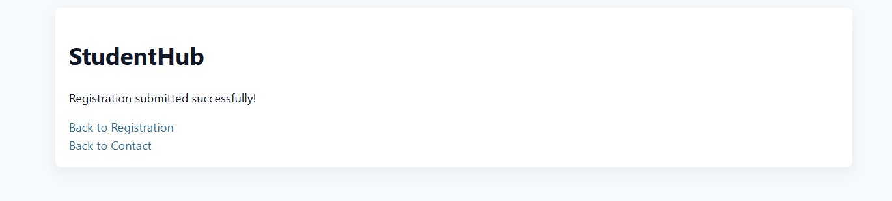

Practical-8:

Aim: Design the database for StudentHub with students, events andregistrations. Create PHP database connection using MYSQL statements.

Db_connect.php :
<?php
$servername = "localhost";
$username = "root";
$password = "";
$dbname = "studenthub_db";
$conn = new mysqli($servername, $username, $password,
$dbname);
if ($conn->connect_error) {
die("Database Connection Failed: " . $conn->connect_error);
}
echo "Connected successfully to the StudentHub database!";
?>

Mysql:
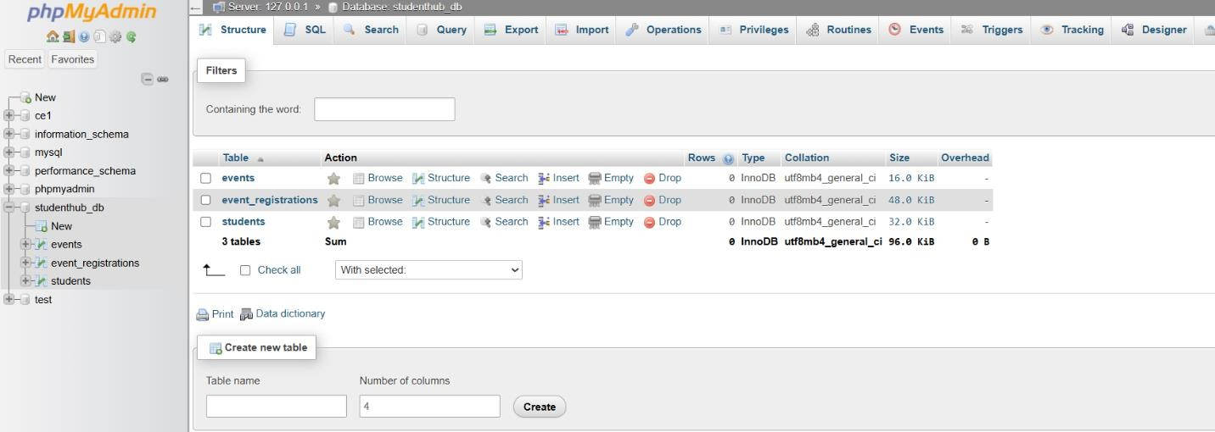

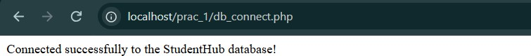

Practical-9: AIM:

Implement secure user registration by inserting user details into MySQL
using MYSQLi. Validate input on frontend and backend, check duplicate
email/username, hash passwords using password_hash(), and display appropriate messages.

Db_connect.php:
<?php
$servername = "localhost";
$username = "root";
$password = "";
$dbname = "studenthub_db";
$conn = new mysqli($servername, $username, $password, $dbname); if ($conn->connect_error) {
die("Database Connection Failed: " . $conn->connect_error);
}
?>

Register.php:
<?php
require_once 'db_connect.php';

$message = "";
$type = "";

if ($_SERVER["REQUEST_METHOD"] === "POST") {
$formType = $_POST["form_type"] ?? ""; if ($formType === "registration") {
$name = htmlspecialchars(trim($_POST["name"] ?? ""));
$email = filter_var(trim($_POST["email"] ?? ""), FILTER_SANITIZE_EMAIL);
$mobile = htmlspecialchars(trim($_POST["mobile"] ?? ""));
$password = $_POST["password"] ?? "";
$course = htmlspecialchars(trim($_POST["course"] ?? ""));
$year = htmlspecialchars(trim($_POST["year"] ?? ""));

$gender = htmlspecialchars(trim($_POST["gender"] ?? ""));

if ($name === "" || !filter_var($email, FILTER_VALIDATE_EMAIL) ||
!preg_match("/^[0-9]{10}$/", $mobile) || $password === "") {
$message = "Invalid registration details. Please check your
inputs.";
$type = "error";
} else {
$stmt = $conn->prepare("SELECT id FROM students WHERE email = ?");
$stmt->bind_param("s", $email);
$stmt->execute();
$stmt->store_result();

if ($stmt->num_rows > 0) {
$message = "Email is already registered. Please login or use another email.";
$type = "error";
} else {
$hashedPassword = password_hash($password, PASSWORD_DEFAULT);

$insertStmt = $conn->prepare("INSERT INTO students (name, email, mobile, password_hash, course, academic_year, gender) VALUES (?, ?, ?,
?, ?, ?, ?)");
$insertStmt->bind_param("sssssss", $name, $email, $mobile,
$hashedPassword, $course, $year, $gender);

if ($insertStmt->execute()) {
$message = "Registration submitted successfully! Welcome,
" . $name . ".";
$type = "success";
} else {
$message = "Error saving registration data.";
$type = "error";
}
$insertStmt->close();
}
$stmt->close();
}

} elseif ($formType === "contact") {

$name = htmlspecialchars(trim($_POST["name"] ?? ""));
$email = filter_var(trim($_POST["email"] ?? ""), FILTER_SANITIZE_EMAIL);
$subject = htmlspecialchars(trim($_POST["subject"] ?? ""));
$messageText = htmlspecialchars(trim($_POST["message"] ?? ""));

if ($name === "" || !filter_var($email, FILTER_VALIDATE_EMAIL) ||
$messageText === "") {
$message = "Invalid contact details. Please complete all required
fields.";
$type = "error";
} else {
$file = DIR . "/contacts.json";
$records = [];

if (file_exists($file)) {
$data = json_decode(file_get_contents($file), true); if (is_array($data)) {
$records = $data;
}
}

$records[] = [ "name" => $name,
"email" => $email, "subject" => $subject, "message" => $messageText,
"submitted_at" => date("Y-m-d H:i:s")
];

$json = json_encode($records, JSON_PRETTY_PRINT);
if ($json !== false && file_put_contents($file, $json, LOCK_EX)
!== false) {
$message = "Contact message submitted successfully! We will get back to you soon.";
$type = "success";
} else {
$message = "Error saving contact message.";
$type = "error";
}
}
} else {
$message = "Invalid form submission.";
$type = "error";
}
}

function e($value) {
return htmlspecialchars((string)$value, ENT_QUOTES | ENT_SUBSTITUTE, "UTF-
8");
}
?>

<!DOCTYPE html>

<html lang="en">
<head>
<meta charset="UTF-8">
<meta name="viewport" content="width=device-width, initial-scale=1.0">
<title>Form Status | StudentHub</title>
<link rel="stylesheet" href="styles.css">
<style>
.status-box {
padding: 20px; border-radius: 8px; margin-bottom: 20px; font-weight: 600;
}
.success { background-color: #d4edda; color: #155724; border: 1px solid #c3e6cb; }
.error { background-color: #f8d7da; color: #721c24; border: 1px solid #f5c6cb; }
</style>
</head>
<body>
<header class="site-header">
<div class="brand">
<div class="logo">➵</div>
<div>
<h1>StudentHub</h1>
<p class="tagline">Your College Student Portal</p>
</div>
</div>
</header>

<main class="container">
<section class="card" style="text-align: center; padding: 40px;">
<h2>Submission Status</h2>

<?php if ($message !== ""): ?>
<div class="status-box <?= e($type) ?>">
<?= e($message) ?>
</div>
<?php endif; ?>

<div style="margin-top: 20px; display: flex; gap: 10px; justify-content: center;">
<a href="register.html" class="btn">Back to Registration</a>
<a href="contact.html" class="btn" style="background: var(--muted);">Back to Contact</a>
</div>
</section>
</main>

</body>
</html>

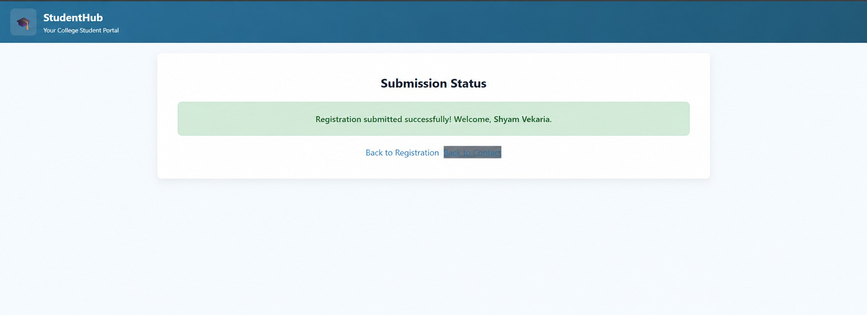
Output:

For same email:
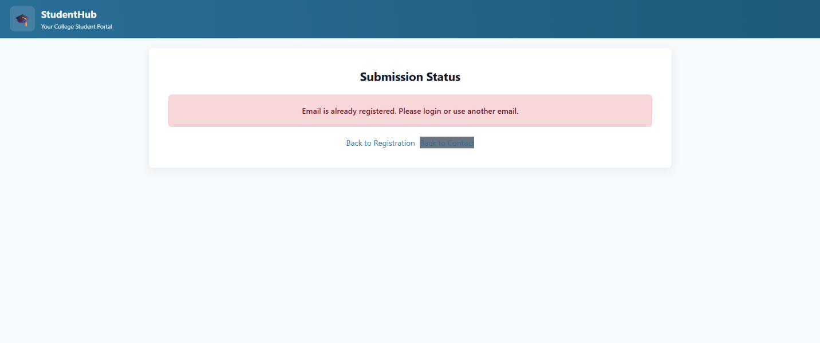

Practical-10:
AIM:
Develop secure login and logout functionality using PHP sessions.
Verify
password using password_verify(), regenerate session ID after login, restrict dashboard access, implement role-based redirection, session timeout, and optional secure remember-me token.

Login.html:
<!DOCTYPE html>
<html lang="en">
<head>
<meta charset="UTF-8">
<meta name="viewport" content="width=device-width, initial-scale=1.0">
<title>StudentHub - Login</title>
<link rel="stylesheet" href="styles.css">
</head>
<body>
<header class="site-header">
<div class="brand">
<div class="logo">➵</div>
<div>
<h1>StudentHub</h1>
<p class="tagline">Student Login Portal</p>
</div>
</div>
<nav class="site-nav">
<ul>
<li><a href="home.php">Home</a></li>
<li><a href="about.html">About</a></li>
<li><a href="portfolio.html">Profile</a></li>
<li><a href="course.html">Courses</a></li>

<li><a href="timetable.html">Timetable</a></li>
<li><a href="result.html">Results</a></li>
<li><a href="notice.html">Notice</a></li>
<li><a href="event.html">Events</a></li>
<li><a href="feedback.html">Feedback</a></li>
<li><a href="contact.html">Contact</a></li>
<li><a href="login.html" class="btn">Login</a></li>
</ul>
</nav>
</header>
<div class="container">
<main class="container">
<div class="card" style="max-width:520px;margin:0 auto">
<h2 class="center">Student Login</h2>
<p class="center">Please login using your registered email address.</p>

<form action="login.php" method="POST">
<label for="email">Email Address</label>
<input type="email" id="email" name="email" placeholder="Enter your email" required>

<label for="password">Password</label>
<input type="password" id="password" name="password" placeholder="Minimum 8 characters" minlength="8" required>

<label style="display:flex;align-items:center;gap:8px">
<input type="checkbox" id="remember" name="remember"> Remember Me
</label>

<div style="display:flex;gap:8px;margin-top:12px">
<input type="submit" value="Login">
<input type="reset" value="Clear">
</div>
</form>

<p style="margin-top:12px" class="center"><a href="#">Forgot Password?</a></p>
<p class="center">Don't have an account? <a href="register.html">Register Here</a></p>
</div>
<footer class="footer">&copy; 2026 StudentHub</footer>
</main>
</div>
</body>
</html>

auth.php:
<?php session_start();

if (!isset($_SESSION["student_id"])) { header("Location: login.html"); exit;
}

$timeout_duration = 1800;

if (isset($_SESSION["last_activity"])) {
if (time() - $_SESSION["last_activity"] > $timeout_duration) { session_unset();
session_destroy(); header("Location: login.html"); exit;
}
}

$_SESSION["last_activity"] = time();
?>

Home.php:
<?php
require_once 'auth.php'; include 'home.html';
?>

Logout.php:
<?php session_start(); session_unset(); session_destroy();
setcookie("remember_me", "", time() - 3600, "/"); header("Location: login.html");
exit;
?>

Output:

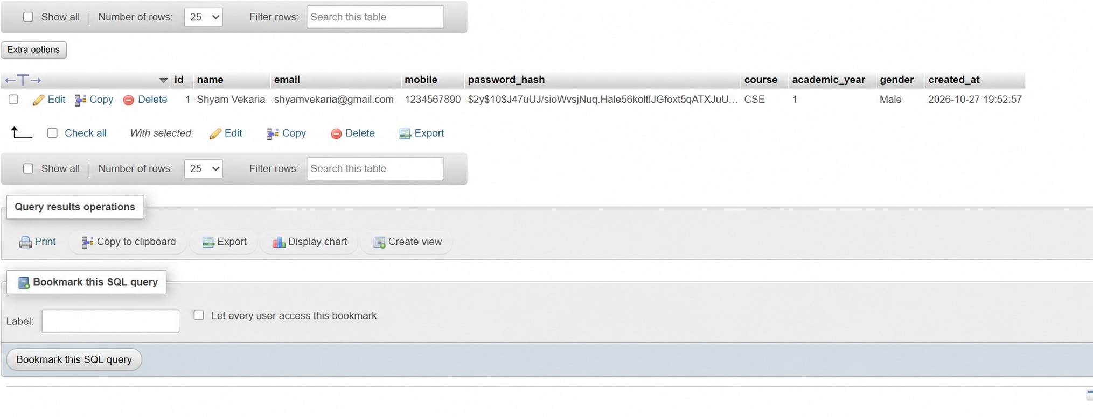

Practical-11:
AIM:
Create a student management module to add, view, edit, delete, search and filter student records. All database operations must use MYSQLi
statements and clear success/failure messages.

manage_students.php:
<?php
require_once 'auth.php';

require_once 'db_connect.php';

$msg = "";
$type = "";

if (isset($_GET['delete_id'])) {
$del_id = $_GET['delete_id'];
$del_stmt = $conn->prepare("DELETE FROM students WHERE id = ?");
$del_stmt->bind_param("i", $del_id); if ($del_stmt->execute()) {
$msg = "Student deleted successfully.";
$type = "success";
} else {
$msg = "Error deleting student.";
$type = "error";
}
$del_stmt->close();
}

$search = $_GET['search'] ?? "";
$course_filter = $_GET['course'] ?? "";

$query = "SELECT id, name, email, mobile, course, academic_year FROM students WHERE 1=1";
$params = [];
$types = "";

if ($search !== "") {
$query .= " AND (name LIKE ? OR email LIKE ?)";
$search_param = "%" . $search . "%";
$params[] = $search_param;
$params[] = $search_param;
$types .= "ss";
}

if ($course_filter !== "") {
$query .= " AND course = ?";
$params[] = $course_filter;
$types .= "s";
}

$query .= " ORDER BY id DESC";

$stmt = $conn->prepare($query); if (!empty($params)) {
$stmt->bind_param($types, ...$params);
}
$stmt->execute();

$result = $stmt->get_result();
?>
<!DOCTYPE html>
<html lang="en">
<head>
<meta charset="UTF-8">
<title>Manage Students | StudentHub</title>
<link rel="stylesheet" href="styles.css">
</head>
<body>
<header class="site-header">
<div class="brand">
<div class="logo">➵</div>
<div>
<h1>StudentHub</h1>
<p class="tagline">Admin Dashboard</p>
</div>
</div>
<nav class="site-nav">
<a href="home.php">Home</a>
<a href="logout.php" class="btn">Logout</a>
</nav>
</header>
<main class="container">
<div class="card">
<h2>Manage Students</h2>

<?php if ($msg !== ""): ?>
<div style="padding:10px; margin-bottom:15px; border-radius:5px; background:<?= $type === 'success' ? '#d4edda' : '#f8d7da' ?>; color:<?= $type === 'success' ? '#155724' : '#721c24' ?>;">
<?= htmlspecialchars($msg) ?>
</div>
<?php endif; ?>

<form method="GET" action="manage_students.php" style="display:flex; gap:10px; margin-bottom:20px;">
<input type="text" name="search" placeholder="Search name or email" value="<?= htmlspecialchars($search) ?>" style="flex:1;">
<select name="course" style="width:200px;">
<option value="">All Courses</option>
<option value="CSE" <?= $course_filter === 'CSE' ? 'selected' : '' ?>>CSE</option>
<option value="CE" <?= $course_filter === 'CE' ? 'selected' : '' ?>>CE</option>
<option value="IT" <?= $course_filter === 'IT' ? 'selected' : '' ?>>IT</option>

<option value="ME" <?= $course_filter === 'ME' ? 'selected' : '' ?>>ME</option>
</select>
<button type="submit">Filter</button>
<a href="add_student.php" class="btn" style="background:#28a745;">+ Add Student</a>
</form>

<table class="table">
<thead>
<tr>
<th>ID</th>
<th>Name</th>
<th>Email</th>
<th>Mobile</th>
<th>Course</th>
<th>Actions</th>
</tr>
</thead>
<tbody>
<?php while ($row = $result->fetch_assoc()): ?>
<tr>
<td><?= htmlspecialchars($row['id']) ?></td>
<td><?= htmlspecialchars($row['name']) ?></td>
<td><?= htmlspecialchars($row['email']) ?></td>
<td><?= htmlspecialchars($row['mobile']) ?></td>
<td><?= htmlspecialchars($row['course']) ?></td>
<td>
<a href="edit_student.php?id=<?= $row['id'] ?>" style="color:#f39c12; margin-right:10px;">Edit</a>
<a href="manage_students.php?delete_id=<?=
$row['id'] ?>" style="color:#e74c3c;" onclick="return confirm('Delete this student?');">Delete</a>
</td>
</tr>
<?php endwhile; ?>
</tbody>
</table>
</div>
</main>
</body>
</html>

Add_student.php:
<?php
require_once 'auth.php'; require_once 'db_connect.php';

$msg = "";
$type = "";

if ($_SERVER["REQUEST_METHOD"] === "POST") {
$name = htmlspecialchars(trim($_POST["name"] ?? ""));
$email = filter_var(trim($_POST["email"] ?? ""), FILTER_SANITIZE_EMAIL);
$mobile = htmlspecialchars(trim($_POST["mobile"] ?? ""));
$course = htmlspecialchars(trim($_POST["course"] ?? ""));
$password = password_hash("default123", PASSWORD_DEFAULT);

if ($name && $email && $mobile && $course) {
$stmt = $conn->prepare("INSERT INTO students (name, email, mobile, password_hash, course) VALUES (?, ?, ?, ?, ?)");
$stmt->bind_param("sssss", $name, $email, $mobile, $password,
$course);

if ($stmt->execute()) {
$msg = "Student added successfully. Default password is 'default123'.";
$type = "success";
} else {
$msg = "Error adding student. Email may already exist.";
$type = "error";
}
$stmt->close();
} else {
$msg = "All fields are required.";
$type = "error";
}
}
?>
<!DOCTYPE html>
<html lang="en">
<head>
<meta charset="UTF-8">
<title>Add Student | StudentHub</title>
<link rel="stylesheet" href="styles.css">
</head>
<body>
<main class="container">
<div class="card" style="max-width:500px; margin:40px auto;">
<h2>Add New Student</h2>

<?php if ($msg !== ""): ?>
<div style="padding:10px; margin-bottom:15px; border-radius:5px; background:<?= $type === 'success' ? '#d4edda' : '#f8d7da' ?>; color:<?= $type === 'success' ? '#155724' : '#721c24' ?>;">

<?= htmlspecialchars($msg) ?>
</div>
<?php endif; ?>

<form method="POST" action="add_student.php">
<label>Name</label>
<input type="text" name="name" required>

<label>Email</label>
<input type="email" name="email" required>

<label>Mobile</label>
<input type="text" name="mobile" required>

<label>Course</label>
<select name="course" required>
<option value="CSE">CSE</option>
<option value="CE">CE</option>
<option value="IT">IT</option>
<option value="ME">ME</option>
</select>

<div style="margin-top:15px; display:flex; gap:10px;">
<button type="submit">Save Student</button>
<a href="manage_students.php" class="btn" style="background:#6c757d;">Back</a>
</div>
</form>
</div>
</main>
</body>
</html>

Edit_student.php:
<?php
require_once 'auth.php'; require_once 'db_connect.php';

$msg = "";
$type = "";
$id = $_GET['id'] ?? 0;

if ($_SERVER["REQUEST_METHOD"] === "POST") {
$id = $_POST['id'];
$name = htmlspecialchars(trim($_POST["name"] ?? ""));
$email = filter_var(trim($_POST["email"] ?? ""), FILTER_SANITIZE_EMAIL);
$mobile = htmlspecialchars(trim($_POST["mobile"] ?? ""));

$course = htmlspecialchars(trim($_POST["course"] ?? ""));

if ($name && $email && $mobile && $course) {
$stmt = $conn->prepare("UPDATE students SET name=?, email=?, mobile=?, course=? WHERE id=?");
$stmt->bind_param("ssssi", $name, $email, $mobile, $course, $id);

if ($stmt->execute()) {
$msg = "Student updated successfully.";
$type = "success";
} else {
$msg = "Error updating student.";
$type = "error";
}
$stmt->close();
}
}

$stmt = $conn->prepare("SELECT id, name, email, mobile, course FROM students WHERE id = ?");
$stmt->bind_param("i", $id);
$stmt->execute();
$result = $stmt->get_result();
$student = $result->fetch_assoc();
$stmt->close();

if (!$student) {
header("Location: manage_students.php"); exit;
}
?>
<!DOCTYPE html>
<html lang="en">
<head>
<meta charset="UTF-8">
<title>Edit Student | StudentHub</title>
<link rel="stylesheet" href="styles.css">
</head>
<body>
<main class="container">
<div class="card" style="max-width:500px; margin:40px auto;">
<h2>Edit Student</h2>

<?php if ($msg !== ""): ?>
<div style="padding:10px; margin-bottom:15px; border-radius:5px; background:<?= $type === 'success' ? '#d4edda' : '#f8d7da' ?>; color:<?= $type === 'success' ? '#155724' : '#721c24' ?>;">
<?= htmlspecialchars($msg) ?>

</div>
<?php endif; ?>

?>">
<form method="POST" action="edit_student.php?id=<?= $student['id']

<input type="hidden" name="id" value="<?=

htmlspecialchars($student['id']) ?>">

<label>Name</label>
<input type="text" name="name" value="<?= htmlspecialchars($student['name']) ?>" required>

<label>Email</label>
<input type="email" name="email" value="<?= htmlspecialchars($student['email']) ?>" required>

<label>Mobile</label>
<input type="text" name="mobile" value="<?= htmlspecialchars($student['mobile']) ?>" required>

<label>Course</label>
<select name="course" required>
<option value="CSE" <?= $student['course'] === 'CSE' ? 'selected' : '' ?>>CSE</option>
'selected' | : | '' | <option value="CE"  ?>>CE</option> | <?= | $student['course'] | === | 'CE' | ?
'selected' | : | '' | <option value="IT"  ?>>IT</option> | <?= | $student['course'] | === | 'IT' | ?
'selected' | : | '' | <option value="ME"  ?>>ME</option>  </select> | <?= | $student['course'] | === | 'ME' | ?

<div style="margin-top:15px; display:flex; gap:10px;">
<button type="submit">Update Student</button>
<a href="manage_students.php" class="btn" style="background:#6c757d;">Back</a>
</div>
</form>
</div>
</main>
</body>
</html>

Output:

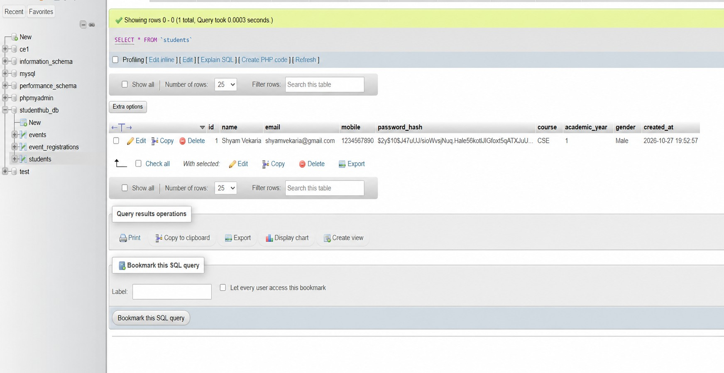

Practical-12: AIM:

Develop event management functionality for admin users. Admin can add, view, update, delete, and upload event posters with file type and file size validation.
add_event.html:
<!doctype html>
<html lang="en">
<head>
<meta charset="UTF-8" />
<title>Add Event</title>
<link rel="stylesheet" href="styles.css" />
</head>
<body>
<main class="container">
<div class="card" style="max-width: 500px; margin: 40px auto">
<h2>Add New Event</h2>
<form
method="POST" action="process_add_event.php" enctype="multipart/form-data"
>
<label>Event Name</label>
<input type="text" name="event_name" required />

<label>Event Date</label>
<input type="date" name="event_date" required />

<label>Venue</label>
<input type="text" name="venue" required />

<label>Event Poster (JPG/PNG, Max 2MB)</label>
<input
type="file" name="poster"
accept="image/png, image/jpeg" required
/>

<div style="margin-top: 15px; display: flex; gap: 10px">
<button type="submit">Save Event</button>
<a href="manage_events.php" class="btn" style="background:
#6c757d"
>Back</a
>
</div>

</form>
</div>
</main>
</body>
</html>

process_add_event.php:
<?php session_start();
include 'db_connect.php';

$event_name = $_POST['event_name'];
$event_date = $_POST['event_date'];
$venue = $_POST['venue'];

$poster = $_FILES['poster']['name'];
$tmp_name = $_FILES['poster']['tmp_name'];
$size = $_FILES['poster']['size'];
$type = $_FILES['poster']['type'];

$allowed_types = array('image/jpeg', 'image/jpg', 'image/png');
$max_size = 2 * 1024 * 1024;

if (in_array($type, $allowed_types) && $size <= $max_size) { if (!is_dir('uploads')) {
mkdir('uploads');
}

$upload_path = 'uploads/' . basename($poster); move_uploaded_file($tmp_name, $upload_path);

$sql = "INSERT INTO events (event_name, event_date, venue, poster) VALUES ('$event_name', '$event_date', '$venue', '$poster')";
mysqli_query($conn, $sql);
}

header("Location: manage_events.php");
?>

Manage_event.php:
<?php session_start();
include 'db_connect.php';

$sql = "SELECT * FROM events";
$result = mysqli_query($conn, $sql);
?>
<!DOCTYPE html>
<html lang="en">
<head>
<meta charset="UTF-8">
<title>Manage Events</title>
<link rel="stylesheet" href="styles.css">
</head>
<body>
<main class="container">
<div class="card">
<h2>Manage Events</h2>
<a href="add_event.html" class="btn" style="background:#28a745; margin-bottom: 20px;">+ Add Event</a>

<table class="table">
<thead>
<tr>
<th>ID</th>
<th>Poster</th>
<th>Event Name</th>
<th>Date</th>
<th>Venue</th>
<th>Actions</th>
</tr>
</thead>
<tbody>
<?php while ($row = mysqli_fetch_assoc($result)) { ?>
<tr>
<td><?php echo $row['id']; ?></td>
<td>
<?php if ($row['poster'] != "") { ?>
<img src="uploads/<?php echo $row['poster'];
?>" width="60" height="60" style="object-fit:cover; border-radius:4px;">
<?php } ?>
</td>
<td><?php echo $row['event_name']; ?></td>
<td><?php echo $row['event_date']; ?></td>
<td><?php echo $row['venue']; ?></td>
<td>
<a href="edit_event.php?id=<?php echo $row['id'];
?>" style="color:#f39c12; margin-right:10px;">Edit</a>
<a href="process_delete_event.php?id=<?php echo
$row['id']; ?>" style="color:red;">Delete</a>
</td>
</tr>

<?php } ?>
</tbody>
</table>
</div>
</main>
</body>
</html>

Edit_event.php:
<?php session_start();
include 'db_connect.php';

$id = $_GET['id'];
$sql = "SELECT * FROM events WHERE id = $id";
$result = mysqli_query($conn, $sql);
$event = mysqli_fetch_assoc($result);
?>
<!DOCTYPE html>
<html lang="en">
<head>
<meta charset="UTF-8">
<title>Edit Event</title>
<link rel="stylesheet" href="styles.css">
</head>
<body>
<main class="container">
<div class="card" style="max-width:500px; margin:40px auto;">
<h2>Edit Event</h2>
<form method="POST" action="process_edit_event.php" enctype="multipart/form-data">
<input type="hidden" name="id" value="<?php echo $event['id'];
?>">

<label>Event Name</label>
<input type="text" name="event_name" value="<?php echo
$event['event_name']; ?>" required>

<label>Event Date</label>
<input type="date" name="event_date" value="<?php echo
$event['event_date']; ?>" required>

<label>Venue</label>
<input type="text" name="venue" value="<?php echo
$event['venue']; ?>" required>

<label>Update Poster (Optional)</label>

<input type="file" name="poster" accept="image/png,
image/jpeg">

<div style="margin-top:15px; display:flex; gap:10px;">
<button type="submit">Update Event</button>
<a href="manage_events.php" class="btn" style="background:#6c757d;">Back</a>
</div>
</form>
</div>
</main>
</body>
</html>

Output:
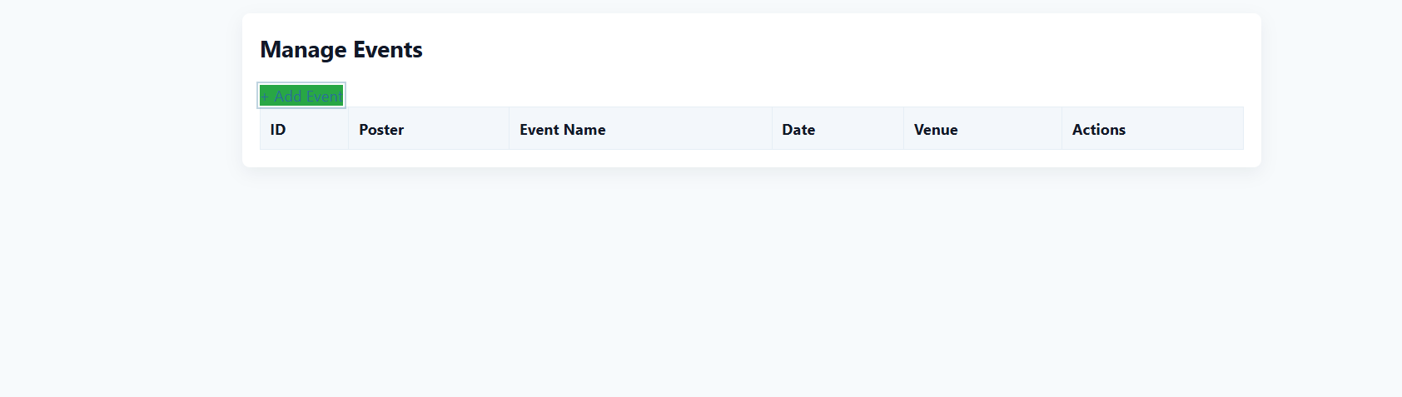

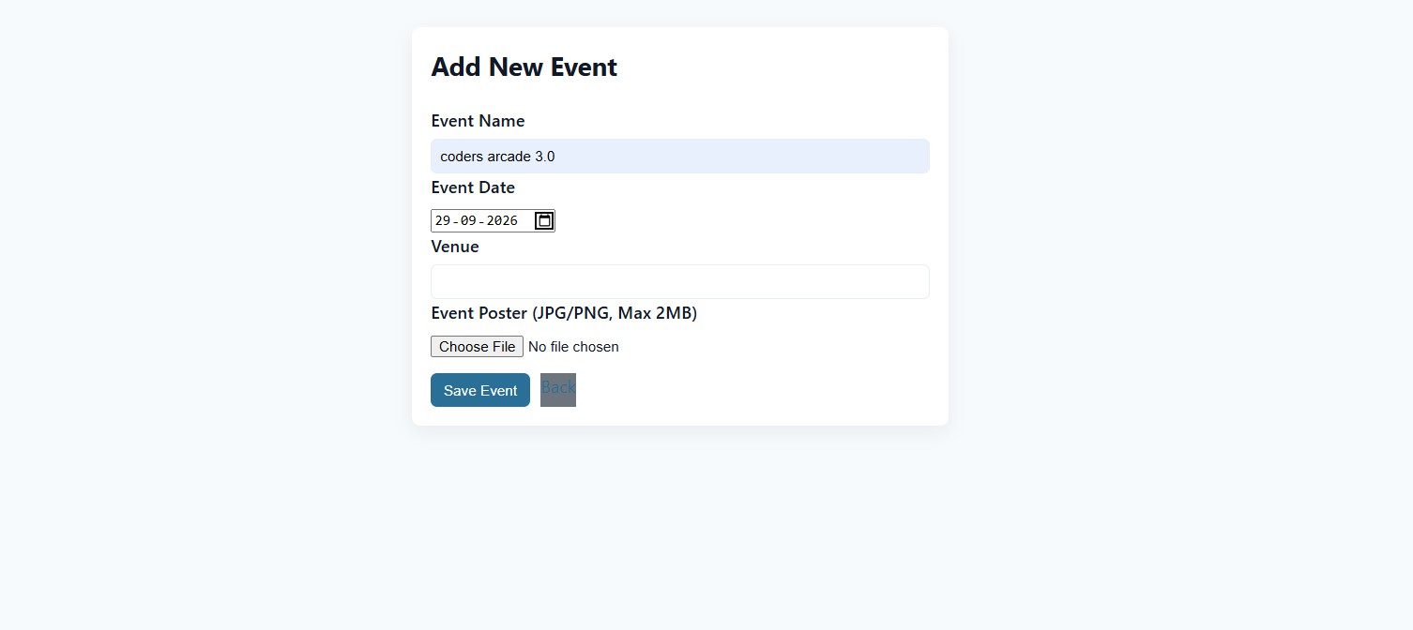

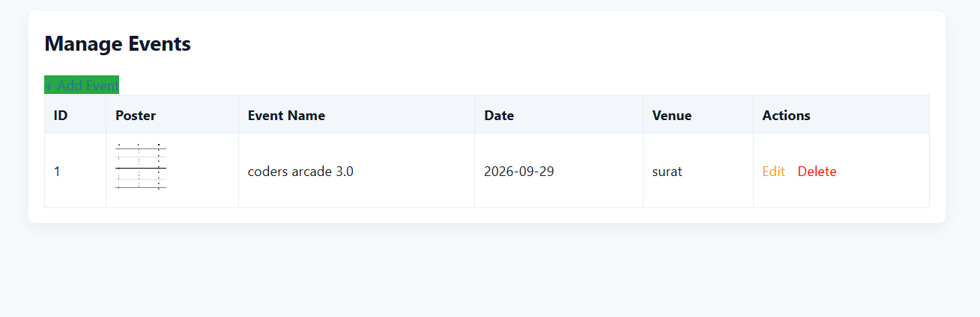

Practical-13:
AIM:
Create simple PHP JSON API endpoints for events or students and consume them using Fetch API. Perform list, add, update, and delete operations asynchronously without full page reload.

Api_events.php:
<?php
header("Content-Type: application/json"); include 'db_connect.php';

$method = $_SERVER['REQUEST_METHOD'];
$input = json_decode(file_get_contents('php://input'), true);

if ($method == 'GET') {
$sql = "SELECT id, event_name, event_date, venue FROM events";

$result = mysqli_query($conn, $sql);
$events = array();
while ($row = mysqli_fetch_assoc($result)) {
$events[] = $row;
}
echo json_encode($events);
}
elseif ($method == 'POST') {
$name = $input['event_name'];
$date = $input['event_date'];
$venue = $input['venue'];

$sql = "INSERT INTO events (event_name, event_date, venue) VALUES ('$name', '$date', '$venue')";
mysqli_query($conn, $sql);
echo json_encode(["status" => "success"]);
}
elseif ($method == 'PUT') {
$id = $input['id'];
$name = $input['event_name'];
$date = $input['event_date'];
$venue = $input['venue'];

$sql = "UPDATE events SET event_name='$name', event_date='$date', venue='$venue' WHERE id=$id";
mysqli_query($conn, $sql);
echo json_encode(["status" => "success"]);
}
elseif ($method == 'DELETE') {
$id = $_GET['id'];

$sql = "DELETE FROM events WHERE id=$id"; mysqli_query($conn, $sql);
echo json_encode(["status" => "success"]);
}
?>

Event_dashboard.html:
<!doctype html>
<html lang="en">
<head>
<meta charset="UTF-8" />
<title>Events API Dashboard | StudentHub</title>
<link rel="stylesheet" href="styles.css" />
</head>
<body>
<header class="site-header">

<div class="brand">
<div class="logo">➵</div>
<div>
<h1>StudentHub</h1>
<p class="tagline">Async Event Dashboard</p>
</div>
</div>
</header>

<main class="container">
<div class="card">
<h2>Manage Events (No Reload)</h2>

wrap"
<form
id="eventForm"
style="margin-bottom: 20px; display: flex; gap: 10px; flex-wrap:

>
<input type="hidden" id="eventId" />
<input type="text" id="eventName" placeholder="Event Name" required
/>
<input type="date" id="eventDate" required />
<input type="text" id="eventVenue" placeholder="Venue" required />
<button type="submit" id="saveBtn">Save Event</button>
</form>

<table class="table">
<thead>
<tr>
<th>ID</th>
<th>Event Name</th>
<th>Date</th>
<th>Venue</th>
<th>Actions</th>
</tr>
</thead>
<tbody id="eventTableBody"></tbody>
</table>
</div>
</main>

<script>
function loadEvents() { fetch("api_events.php")
.then((response) => response.json())
.then((data) => {
let tbody = document.getElementById("eventTableBody"); tbody.innerHTML = "";

data.forEach((event) => { tbody.innerHTML += `
<tr>
<td>${event.id}</td>
<td>${event.event_name}</td>
<td>${event.event_date}</td>
<td>${event.venue}</td>
<td>
<button onclick="editEvent(${event.id}, '${event.event_name}', '${event.event_date}', '${event.venue}')" style="background:#f39c12; border:none; color:white; padding:6px 12px; cursor:pointer; border-radius:4px; margin-right:5px;">Edit</button>
<button onclick="deleteEvent(${event.id})" style="background:#e74c3c; border:none; color:white; padding:6px 12px; cursor:pointer; border-radius:4px;">Delete</button>
</td>
</tr>
`;
});
});
}

document
.getElementById("eventForm")
.addEventListener("submit", function (e) { e.preventDefault();
let id = document.getElementById("eventId").value;
let name = document.getElementById("eventName").value; let date = document.getElementById("eventDate").value; let venue = document.getElementById("eventVenue").value;

let method = id ? "PUT" : "POST";
let payload = { event_name: name, event_date: date, venue: venue }; if (id) payload.id = id;

fetch("api_events.php", { method: method,
headers: { "Content-Type": "application/json" }, body: JSON.stringify(payload),
}).then(() => { document.getElementById("eventForm").reset(); document.getElementById("eventId").value = ""; loadEvents();
});
});

function editEvent(id, name, date, venue) { document.getElementById("eventId").value = id;

document.getElementById("eventName").value = name; document.getElementById("eventDate").value = date; document.getElementById("eventVenue").value = venue;
}

function deleteEvent(id) {
if (confirm("Are you sure you want to delete this event?")) { fetch(`api_events.php?id=${id}`, { method: "DELETE" }).then(() =>
loadEvents(),
);
}
}

loadEvents();
</script>
</body>
</html>

Outout:
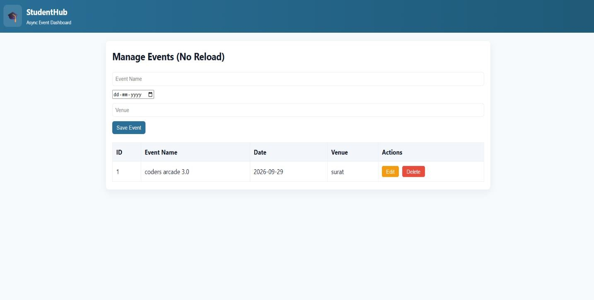

Practical-14:
AIM:
Develop an admin dashboard that displays user statistics, student count, event count and latest registrations. Restrict access to admin users only and show dynamic menu options based on role.

Login.php:
<?php session_start();
include 'db_connect.php';

$email = $_POST['email'];
$password = $_POST['password'];

$sql = "SELECT * FROM students WHERE email='$email'";
$result = mysqli_query($conn, $sql);

if ($row = mysqli_fetch_assoc($result)) {
if (password_verify($password, $row['password_hash'])) {
$_SESSION['student_id'] = $row['id'];
$_SESSION['student_name'] = $row['name'];
$_SESSION['role'] = $row['role'];

if ($_SESSION['role'] == 'admin') { header("Location: admin_dashboard.php");
} else {
header("Location: home.php");
}
exit;
}
}

header("Location: login.html");
?>

Admin_dashboard.php
<?php session_start();
include 'db_connect.php';

if (!isset($_SESSION['student_id']) || $_SESSION['role'] !== 'admin') { header("Location: login.html");
exit;
}

$student_count = 0;
$sql_students = "SELECT COUNT(*) as count FROM students WHERE role='student'";
$res_students = mysqli_query($conn, $sql_students); if ($row = mysqli_fetch_assoc($res_students)) {
$student_count = $row['count'];
}

$event_count = 0;
$sql_events = "SELECT COUNT(*) as count FROM events";
$res_events = mysqli_query($conn, $sql_events); if ($row = mysqli_fetch_assoc($res_events)) {
$event_count = $row['count'];
}

$sql_latest = "SELECT id, name, email, created_at FROM students WHERE role='student' ORDER BY id DESC LIMIT 5";
$latest_students = mysqli_query($conn, $sql_latest);
?>
<!DOCTYPE html>
<html lang="en">
<head>
<meta charset="UTF-8">
<title>Admin Dashboard | StudentHub</title>
<link rel="stylesheet" href="styles.css">
</head>
<body>
<header class="site-header">
<div class="brand">
<div class="logo">➵</div>
<div>
<h1>StudentHub Admin</h1>
<p class="tagline">Welcome, <?php echo
$_SESSION['student_name']; ?></p>
</div>
</div>
<nav class="site-nav">

<?php if ($_SESSION['role'] === 'admin') { ?>
<a href="admin_dashboard.php" class="active">Dashboard</a>
<a href="manage_students.php">Manage Students</a>
<a href="manage_events.php">Manage Events</a>
<?php } else { ?>
<a href="home.php">Home</a>
<a href="course.html">Courses</a>
<?php } ?>
<a href="logout.php" class="btn" style="background: #e74c3c;">Logout</a>
</nav>
</header>

<main class="container">
<div class="grid" style="grid-template-columns: 1fr 1fr; margin-bottom: 20px;">
<div class="card" style="text-align: center;">
<h3>Total Students</h3>
<h1 style="font-size: 48px; color: var(--primary); margin: 10px 0;"><?php echo $student_count; ?></h1>
</div>
<div class="card" style="text-align: center;">
<h3>Total Events</h3>
<h1 style="font-size: 48px; color: var(--accent); margin: 10px 0;"><?php echo $event_count; ?></h1>
</div>
</div>

<div class="card">
<h2>Latest Registrations</h2>
<table class="table">
<thead>
<tr>
<th>ID</th>
<th>Name</th>
<th>Email</th>
<th>Joined Date</th>
</tr>
</thead>
<tbody>
<?php while ($student = mysqli_fetch_assoc($latest_students)) { ?>
<tr>
<td><?php echo $student['id']; ?></td>
<td><?php echo $student['name']; ?></td>
<td><?php echo $student['email']; ?></td>
<td><?php echo $student['created_at']; ?></td>
</tr>

<?php } ?>
</tbody>
</table>
</div>
</main>
</body>
</html>

Output:


