DATA COMMENTARY · APRIL CPI
Inflation rose to 2.8% on higher gasoline prices.
THE TAKE
“Headline inflation wasn’t so bad given that most economists thought high oil prices and the war in Iran would drive it up above 3%. Even with the energy price shock, headline is still within the Bank of Canada’s control band and should allow them to remain on hold.”
— JAY ZHAO-MURRAY · CHIEF ECONOMIST · SIBLEY CREEK
Read the full commentary on the next page →
May 19, 2026

Jay Zhao-Murray
Chief Economist
Khoi Pham
Research Analyst

Inflation prints below expectations
Headline inflation rose to 2.8% in April, a four-tenth increase from the previous month. The rise was driven by higher global prices for energy, which are largely due to the war in Iran. On a monthly basis, the consumer price index rose 0.4% on an unadjusted basis, and 0.3% after accounting for seasonal factors. An economist consensus was looking for 3.1% on the headline and 0.6% on the monthly unadjusted print.
Headline inflation rose to 2.8% on higher gas prices.
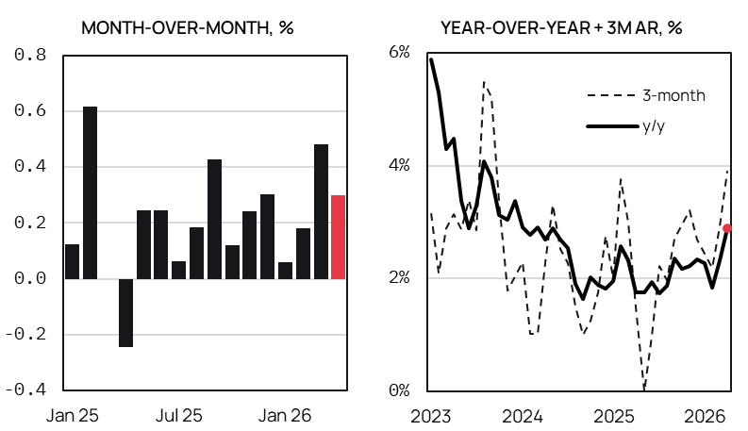
Source: Statistics Canada, Sibley Creek calculations. Seasonally adjusted.
Core inflation measures actually ticked down in April, an encouraging sign for the Bank of Canada. Both core-trim and core-median fell by two-tenths, to 2.0% and 2.1% respectively. With core effectively anchored at the Bank of Canada’s target, there is little reason to expect a change in monetary policy in the near future. The main exception would be if high oil and gasoline prices do not retreat over the next few months and trigger a broad increase in inflation expectations.
Looking ahead to next month, the same energy price dynamic is likely to keep playing out. Data from GasBuddy suggests that national gasoline prices are currently tracking at about C$1.88 per litre, up 11 cents from April. This will continue to add upward pressure to the headline figure, but so long as breadth remains narrow, continued inflation in energy prices shouldn’t be the deciding factor for policy.
Contact
Jay Zhao-Murray
Chief Economist
(613) 883-0774
jayzhaomurray@outlook.com
Khoi Pham
Research Analyst
(506) 897-2466
anhkhoi.pham@unb.ca

`

Disclaimer
©2026 Sibley Creek. Sibley Creek is not a registered investment advisor. This report is for informational and discussion purposes only. Opinions expressed represent the good faith views of the author(s) as of the date of the report and may be subject to change at any time without notice. Opinions about future economic and financial market performance are based on assumptions, risks and uncertainties that may change over time. Sibley Creek does not guarantee the accuracy or completeness of the information contained in this report.
No mention of a particular security, index, derivative, or other instrument in the report constitutes a recommendation to buy, sell, or hold that or any other security, nor does it constitute an opinion on the suitability of any security, index, or derivative. You must determine, on your own behalf or through independent professional advice, the merits, terms, conditions, risks and consequences of any transactions described in this report. The author(s) may have a financial interest in any or all securities and instruments mentioned herein.

