DATA COMMENTARY · MARCH RETAIL SALES  Retail sales jump 0.9%, driven by higher gas prices  THE TAKE  The Canadian consumer showed signs of weakness in March, with both core sales and volumes declining. The jump in the headline number is a reflection of higher prices at the pump, not a genuine increase in consumer demand.  — JAY ZHAO-MURRAY · CHIEF ECONOMIST · SIBLEY CREEK  Read the full commentary on the next page → |  | May 22, 2026  Jay Zhao-Murray  Chief Economist  Thompson Richards  Economist

Headline sales beat expectations, driven by higher gas prices
Retail sales jumped 0.9% to C$ 72.7 billion in March, more than StatCan’s advance estimate of 0.6% had indicated. The gain in sales was largely driven by higher prices for gasoline, which are tied to the global increase in energy costs stemming from the conflict in Iran.
Sales volumes dropped by 0.7%, while core dollar sales edged down a tenth. Breadth was weak—sales only rose in four of nine subsectors. The advance estimate for April indicates a 0.6% increase, but this will likely reflect the same dynamic of higher prices for fuel, which we’ve already seen in the latest CPI.
Retailing volumes dropped in March as total sales rose.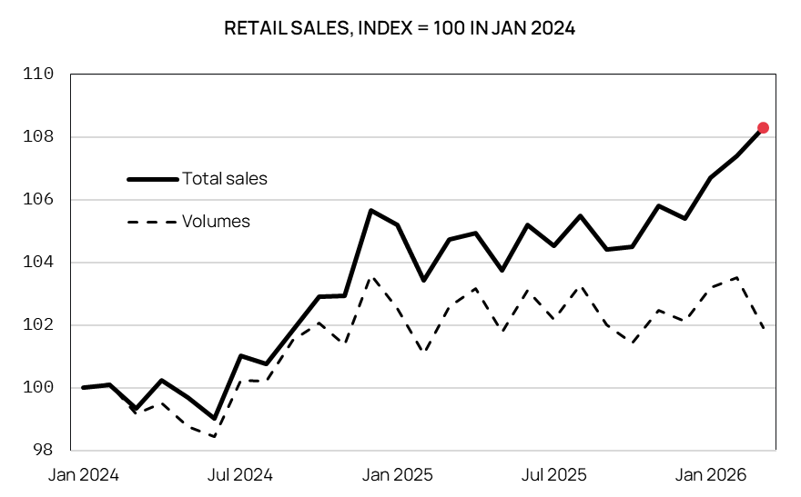
Source: Statistics Canada. Seasonally adjusted.
Total sales at gas stations surged by 12.4% in March, a gain that was entirely driven by price effects. Gas station sales volumes actually fell by 1.9%, while the consumer price report for March released last month showed the price of gasoline had shot up over 20%.
Consumer weakness was not anticipated by economists. Credit card spending data from RBC was pointing to a robust 1% increase in core sales for the month, as opposed to the slight decline we saw. The data reinforces a picture of a gradually softening economy; not a macro environment in which you’d expect monetary policy should be tightened.
Contact
Jay Zhao-Murray  Chief Economist  (613) 883-0774  jayzhaomurray@outlook.com  Khoi Pham  Research Analyst  (506) 897-2466  anhkhoi.pham@unb.ca | Thompson Richards  Economist  (819) 328-2809  thompsonrichards12@gmail.com

Disclaimer
©2026 Sibley Creek. Sibley Creek is not a registered investment advisor. This report is for informational and discussion purposes only. Opinions expressed represent the good faith views of the author(s) as of the date of the report and may be subject to change at any time without notice. Opinions about future economic and financial market performance are based on assumptions, risks and uncertainties that may change over time. Sibley Creek does not guarantee the accuracy or completeness of the information contained in this report.
No mention of a particular security, index, derivative, or other instrument in the report constitutes a recommendation to buy, sell, or hold that or any other security, nor does it constitute an opinion on the suitability of any security, index, or derivative. You must determine, on your own behalf or through independent professional advice, the merits, terms, conditions, risks and consequences of any transactions described in this report. The author(s) may have a financial interest in any or all securities and instruments mentioned herein.

