DATA COMMENTARY · MARCH RETAIL SALES
[Headline: state the conclusion in one sentence.]
THE TAKE
[2 to 4 sentences. The lift-and-quote summary. State the print, what it tells us about the macro story, and the implication for policy or markets. Keep it crisp — this is what a journalist will quote.]
— JAY ZHAO-MURRAY · CHIEF ECONOMIST · SIBLEY CREEK
Read the full commentary on the next page →
May 22, 2026

Jay Zhao-Murray
Chief Economist
Khoi Pham
Research Analyst

The print
[Lede paragraph: state the headline number, the consensus expectation, and the direction of surprise. Two to three sentences.]
- m/m: [headline %]
- m/m ex-autos: [%]
- y/y: [%]
- Volume (real retail), m/m: [%]
- Advance estimate for April: [direction]
[Caption: state the chart's finding in one sentence.]
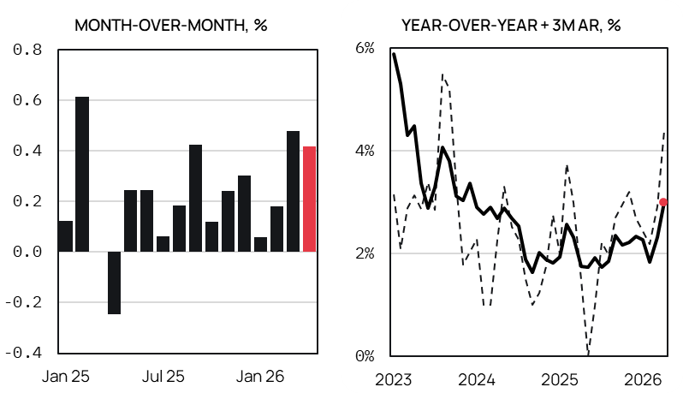
Source: Statistics Canada, Sibley Creek calculations. Seasonally adjusted.
What changed
[Two to four sentences. Decompose the print — what subcomponents drove the move. Use the chart pack as the evidence base.]
What it means
[Three to five sentences. The analytical core. What does this print tell us about the underlying macro question — inflation persistence, policy stance, the consumer.]
What to watch
[One to two sentences. The next data point or policy moment that updates this read.]
Contact
Jay Zhao-Murray
Chief Economist
(613) 883-0774
jayzhaomurray@outlook.com
Khoi Pham
Research Analyst
(506) 897-2466
anhkhoi.pham@unb.ca

Disclaimer
©2026 Sibley Creek. Sibley Creek is not a registered investment advisor. This report is for informational and discussion purposes only. Opinions expressed represent the good faith views of the author(s) as of the date of the report and may be subject to change at any time without notice. Opinions about future economic and financial market performance are based on assumptions, risks and uncertainties that may change over time. Sibley Creek does not guarantee the accuracy or completeness of the information contained in this report.
No mention of a particular security, index, derivative, or other instrument in the report constitutes a recommendation to buy, sell, or hold that or any other security, nor does it constitute an opinion on the suitability of any security, index, or derivative. You must determine, on your own behalf or through independent professional advice, the merits, terms, conditions, risks and consequences of any transactions described in this report. The author(s) may have a financial interest in any or all securities and instruments mentioned herein.

INTERNAL PREP — OVERWRITE BEFORE PUBLISHING
Mar 2026 retail · Fri May 22 8:30 ET · StatCan advance estimate +0.6% m/m. [X%] = drop in the number from the release.
ALWAYS IN THE TAKE — write something for each
▸ HEADLINE m/m (vs +0.6% advance)
+0.4 to +0.8 → "March retail rose [X%] m/m, in line with StatCan’s own +0.6% advance estimate."
below +0.3 → "March retail rose [X%] m/m, undershooting StatCan’s own +0.6% advance estimate — a downward revision in the indicator’s forward signal."
above +0.9 → "March retail rose [X%] m/m, beating the +0.6% advance and marking the first acceleration print of 2026."
negative → "March retail fell [X%] m/m, reversing direction from a +0.6% advance estimate."
▸ CORE RETAIL (ex-autos and ex-gas) — the cleaner consumer pulse
+0.6% or more → "Core retail rose [X%] m/m, the consumer holding up despite tariff news flow."
+0.1 to +0.5 → "Core retail rose [X%] m/m, modest growth consistent with the Bank of Canada’s call for consumption to moderate through mid-2027."
zero or negative → "Core retail [fell/was flat] at [X%] m/m, the first hard data point of the consumer pulling back."
▸ GAS LINK — March is BEFORE April’s gas surge (forward signal)
March gas accelerating → "Gasoline stations were already firming in March, an early read on the surge ahead — April CPI showed gasoline up 28.6% y/y."
March gas roughly flat → "March was before April’s gasoline shock — gas-station retail should show the lift in next month’s release, with April CPI gasoline already up 28.6% y/y."
March gas down → "Gasoline stations softened in March, masking the April surge that will land in next month’s release."
──────────────────────────────────────────────────────────────────────
PICK ONE — only if it’s the mover
▸ Autos (~20% of retail; biggest swing category)
autos +1.5% or more → "Pull-forward auto buying ahead of expected tariff pass-through to vehicle prices."
autos -1% or worse → "Sticker shock landing — tariff drag visible at the dealership."
▸ Volume vs nominal (real vs price)
volume flat or down, nominal up → "The headline was mostly price; the purchasing-power squeeze is landing on schedule, as the Bank of Canada flagged in its April MPR."
volume ≈ nominal → "Growth was real demand, not price."
▸ Building material (housing read-through)
second straight decline → "Housing-linked retail still soft — a second straight monthly decline confirming the housing drag."
bounce after Feb -0.6% → "Housing-linked retail pushed back on the housing-drag narrative with a bounce after February’s -0.6%."
──────────────────────────────────────────────────────────────────────
CONSUMER HEALTH — pick the overall framing for THE TAKE
Strong. headline beats, core +0.5%+, autos positive, volume positive
→ "The Canadian consumer is holding up despite tariff noise."
Holding. headline in line, core modest, sub-sectors mixed
→ "The consumer is moderating on schedule — softer underneath, but not cracking."
Cracking. headline misses, core flat or down, volume negative
→ "The Canadian consumer is cracking. The June 4 Bank of Canada decision risk tilts dovish."
──────────────────────────────────────────────────────────────────────
FACT-CHECK URLS — open at 8:25
• Today’s release (live 8:30 ET): https://www150.statcan.gc.ca/n1/daily-quotidien/260522/dq260522a-eng.htm
• Feb 2026 retail (prior print): https://www150.statcan.gc.ca/n1/daily-quotidien/260424/dq260424a-eng.htm
• April 2026 CPI (gas reference): https://www150.statcan.gc.ca/n1/daily-quotidien/260519/dq260519a-eng.htm
• BoC April 2026 MPR — Canadian outlook: https://www.bankofcanada.ca/publications/mpr/mpr-2026-04-29/canadian-outlook/
• Full watch-list (more detail if needed): editorial/_briefs/retail_2026-03_watchlist.md
──────────────────────────────────────────────────────────────────────
TRAPS
• March is BEFORE April’s gas surge — don’t use April CPI to explain March retail.
• Don’t say "core retail" without specifying "ex-autos and ex-gas".
• No Big-Six bank economist names. Consensus framing only.
• Don’t predict the June 4 BoC. Frame as "tilts the read" or "raises the bar".
• Don’t say "soft" or "weak" without a number alongside.

