CS 1632 - DELIVERABLE 3:

Automated System Testing of a Web Application

Name: Jie Zhou

Git username: jayzhou125

https://github.com/jayzhou125/D3

with Extra Credit 1

**Writeup:**

For D3, the most challenging part for me is to print the table using erb. First of all, I never learned any html before. So I have to learn the syntax and functions at first. What I did is I looked up some quick tutorials online. Then I tried out some things that I learned using the sample that was on the 1632 repo. Especially the table part.   
 I think for beginners like me. The code base of a erb seems way scarier than what it actual does. Once learned the syntax and everything, things becoming natural, and it is fairly easy. Another part that I struggle the most is the interaction between the ruby driver and the actual erb. Things like how pass in a value into the erb and how to get a value from the erb into the ruby file. I spend quite a lot time figuring out the actual means to do so. Once that part is done, the main program itself is not hard to implement, except I spend some time thinking about how to implement the table. I thought about creating a table class and several other solutions like split the table into a static part and a calculation part. But most of them seems complicate the problem. So, in the end, I just implement the table as a 2-D array. Which is a fairly simpler way to implement. For the decision part, I think is quite useful in future references.

S**creen shots:**

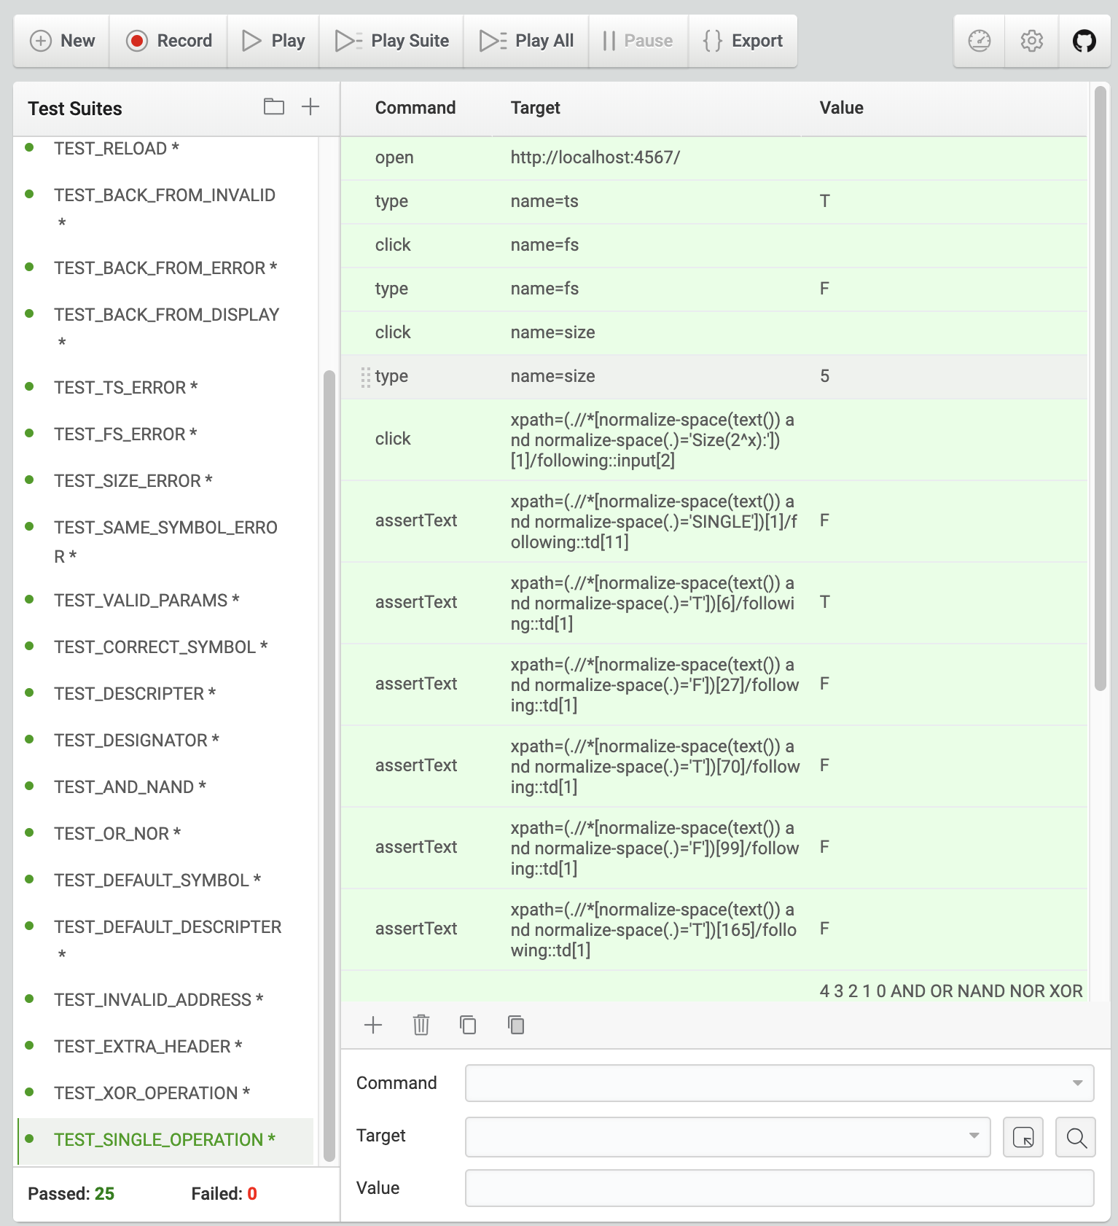

**Traceability table:**

|  |  |
| --- | --- |
| **REQUIREMENTS** | **TEST_CASES** |
| MAIN_PAGE | TEST_TS_LABEL  TEST_FS_LABEL  TEST_SIZE_LABEL  TEST_TEXTBOX  TEST_BUTTON |
| BACK_TO_MAIN | TEST_RELOAD  TEST_BACK_FROM_INVALID  TEST_BACK_FROM_ERROR  TEST_BACK_FROM_DISPLAY |
| ERROR_PAGE | TEST_TS_INVALID  TEST_FS_INVALID  TEST_SIZE_INVALID  TEST_SAME_SYMBOL_ERROR |
| VALID_PARAMS | TEST_VALID_PARAMS |
| DISPLAY_TABLE | TEST_CORRECT_SYMBOL  TEST_DESCRIPTER  TEST_DESIGNATOR |
| OPERATION_CORRECTNESS | TEST_AND_NAND  TEST_OR_NOR |
| DEFAULT_TABLE | TEST_DEFAULT_SYMBOL  TEST_DEFAULT_DESCRIPTER |
| INVALID_ADDRESS | TEST_INVALID_ADDRESS |
| EXTRA_OPRERATION | TEST_EXTRA_HEADER  TEST_XOR_OPERATION  TEST_SINGLE_OPERATION |