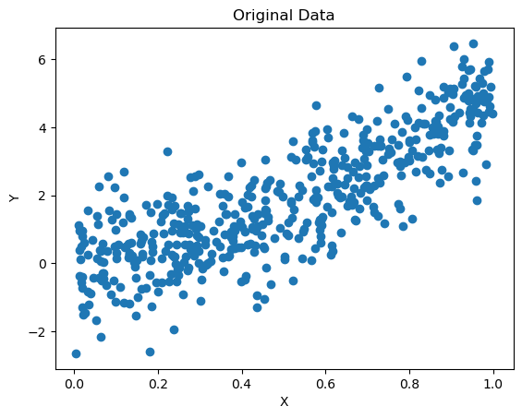
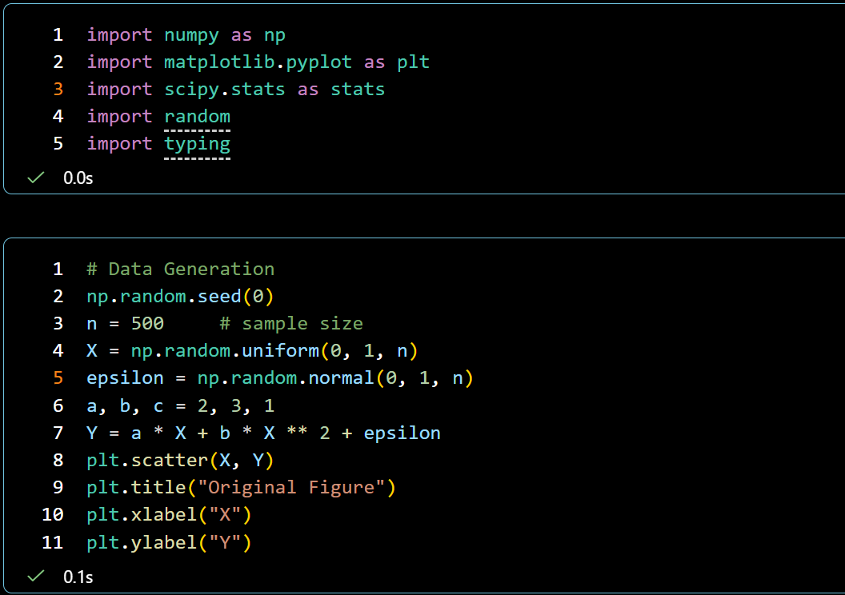
Prerequisite & Data Generation

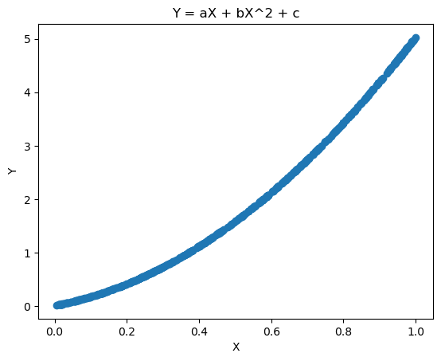
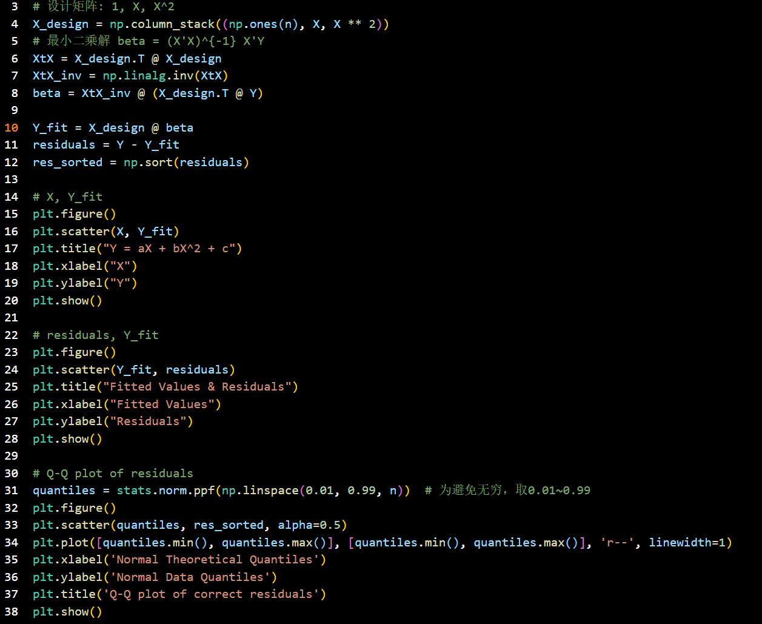
Task 1: Fit a Correct Linear Model
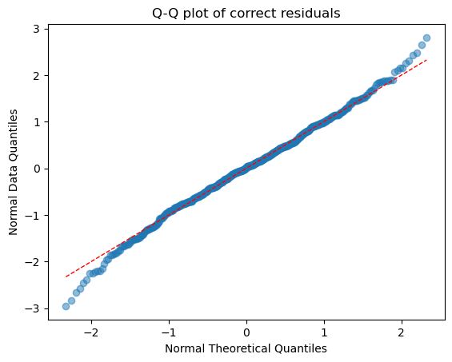
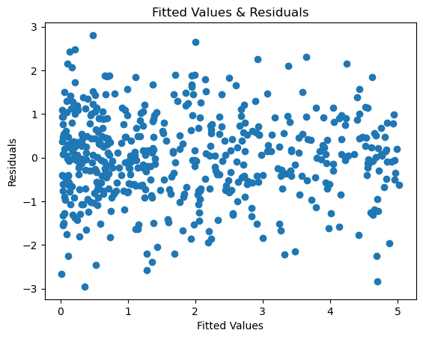
Discussion:
- Pattern in the residual plot. Residuals are randomly distributed around the zero line.
- Normality assumption. The normality assumption appears valid, as it is shown on the Q-Q plot, the points are located near the diagonal.
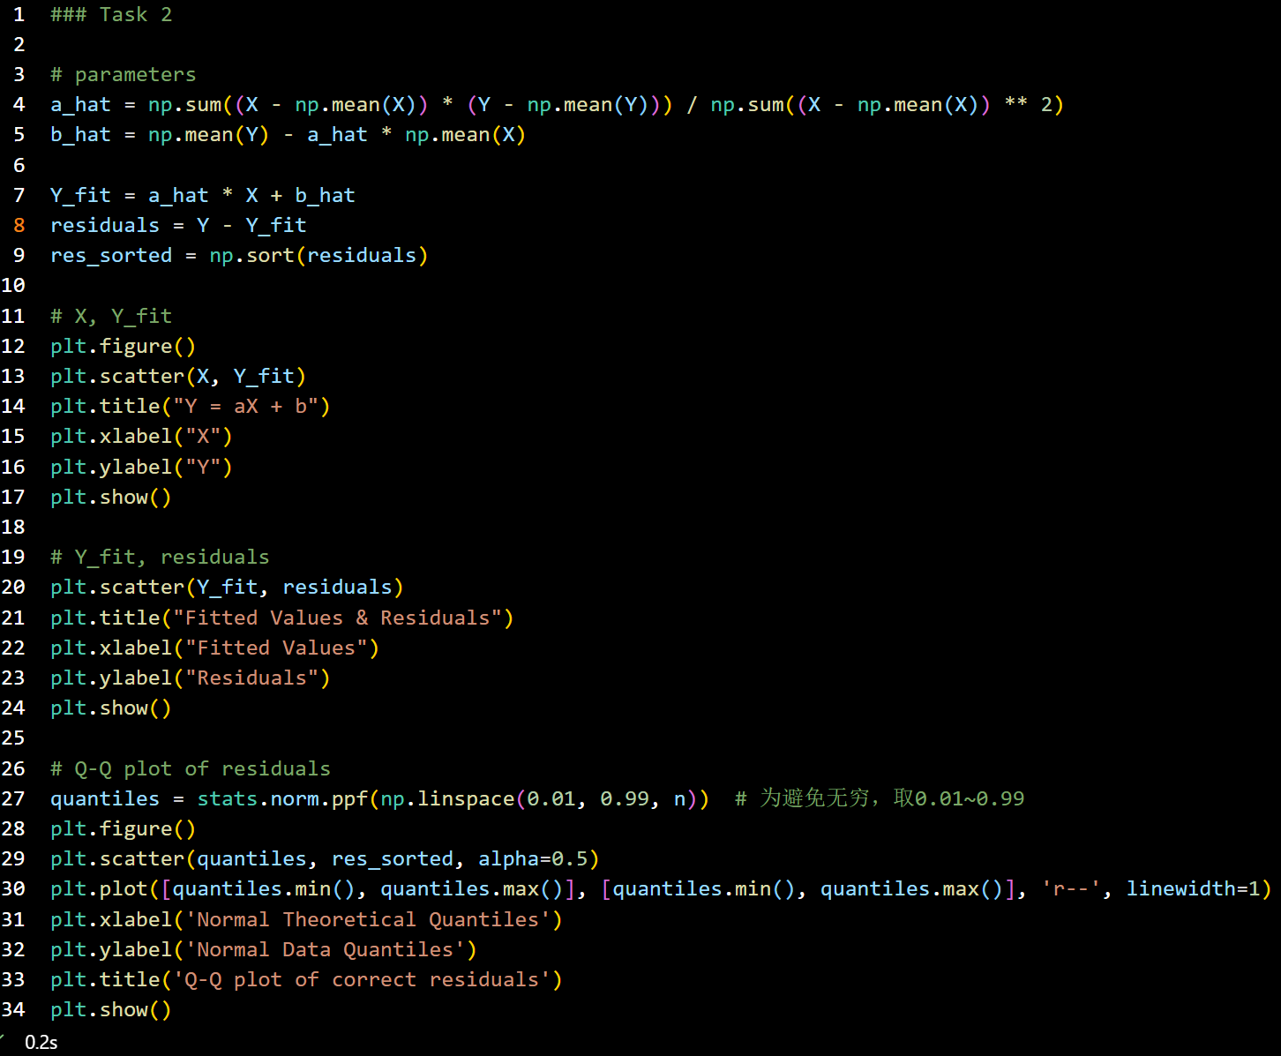
Task 2: Fit A Misspecified Model
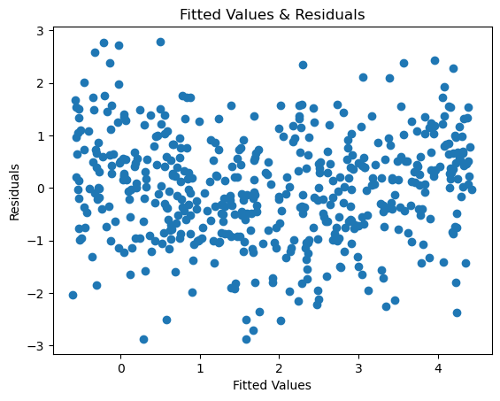
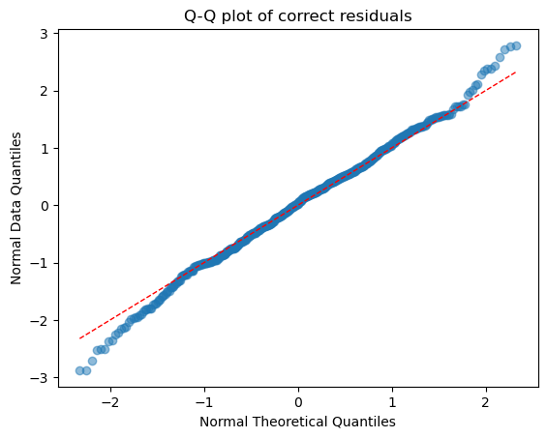
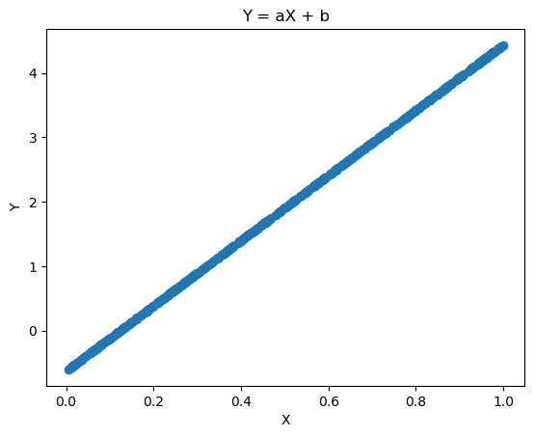
Comparison:
- The model in task 1 fits better.
- The normality assumption of residuals is not valid. It’s obvious that there exists a clear deviation between the data points and the diagonal.
- Pass
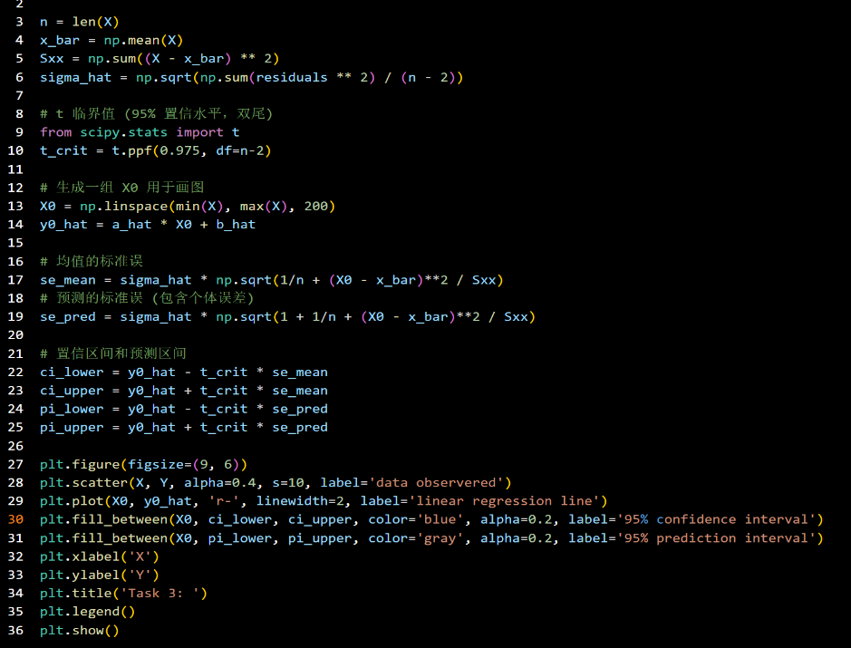
Task 3: Confidence Interval and Prediction Interval
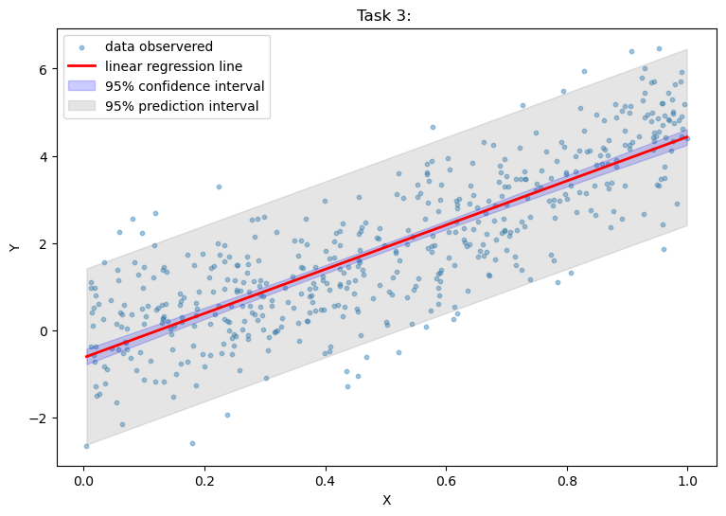
# Task 4: Discussion
- How does model misspecification affect residual behavior?
Model misspecification makes residuals lose its random distribution around zero, and deviate from normality assumption.
- How does it affect inference (confidence intervals)?
The standard error estimates are distorted and parameter point estimates are biased, thus, the confidence intervals have inaccurate width.
- Why is it important to check diagnostic plots in regression?
Diagnostic plots clearly reveal violations of linearity and normality, helping us avoid wrong assumptions and misleading conclusions, and improves model specification.

