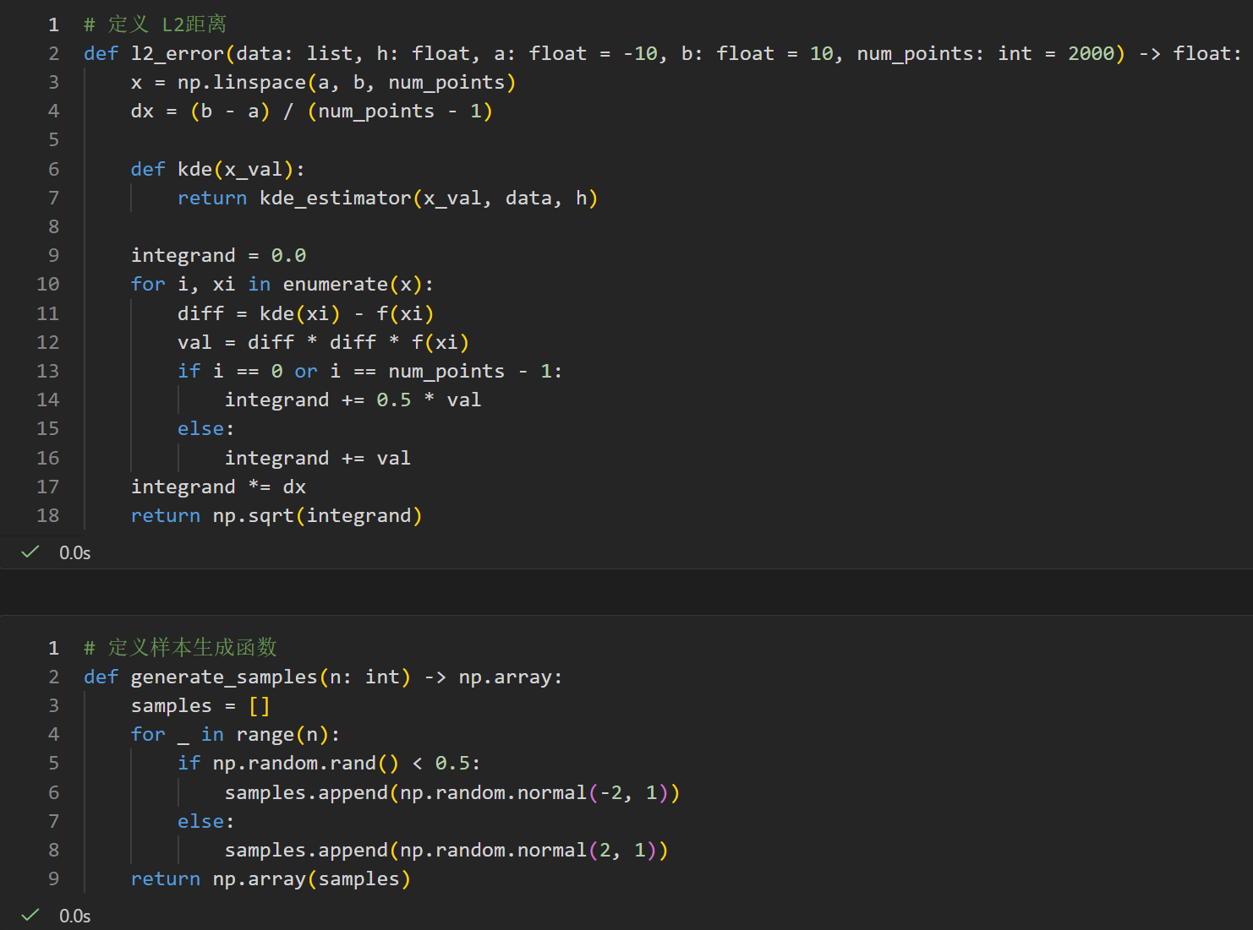
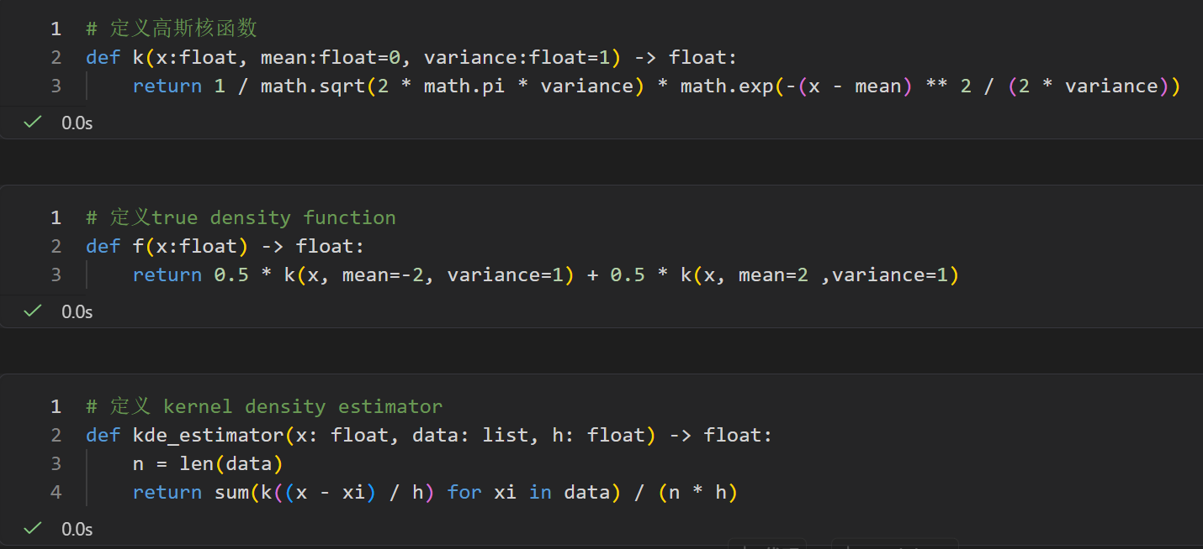
Prerequisite: Definition of necessary functions
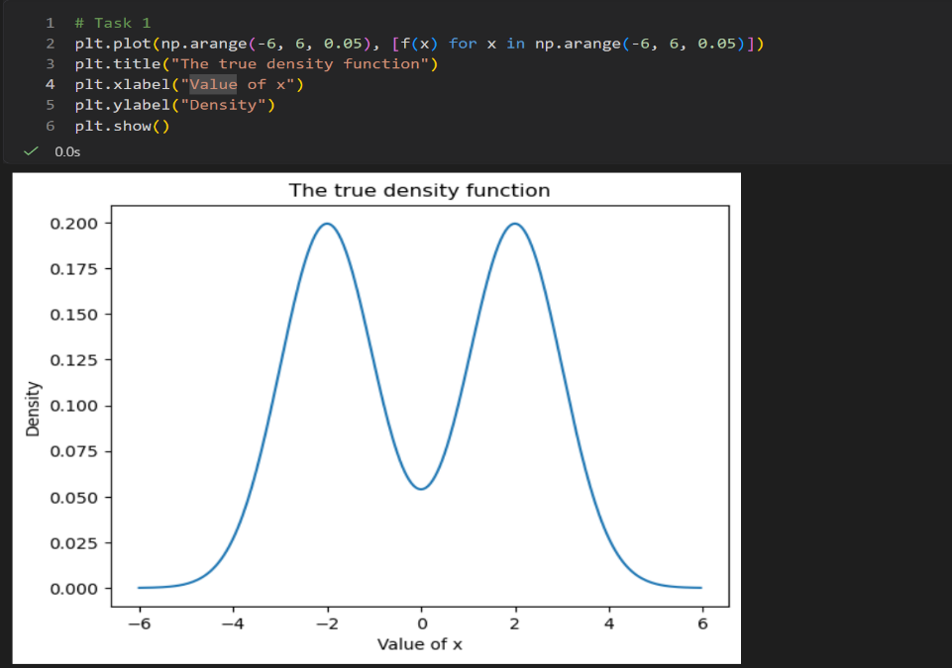
# Task 1
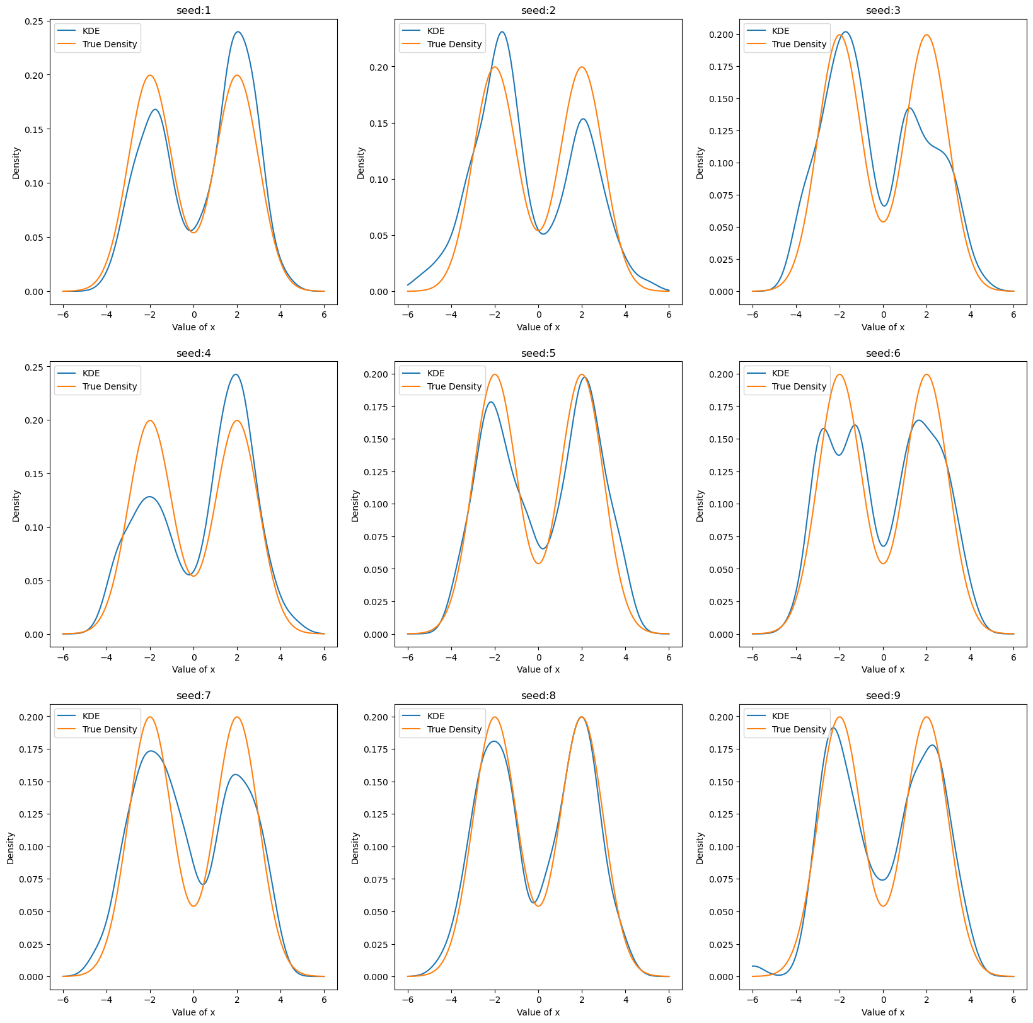
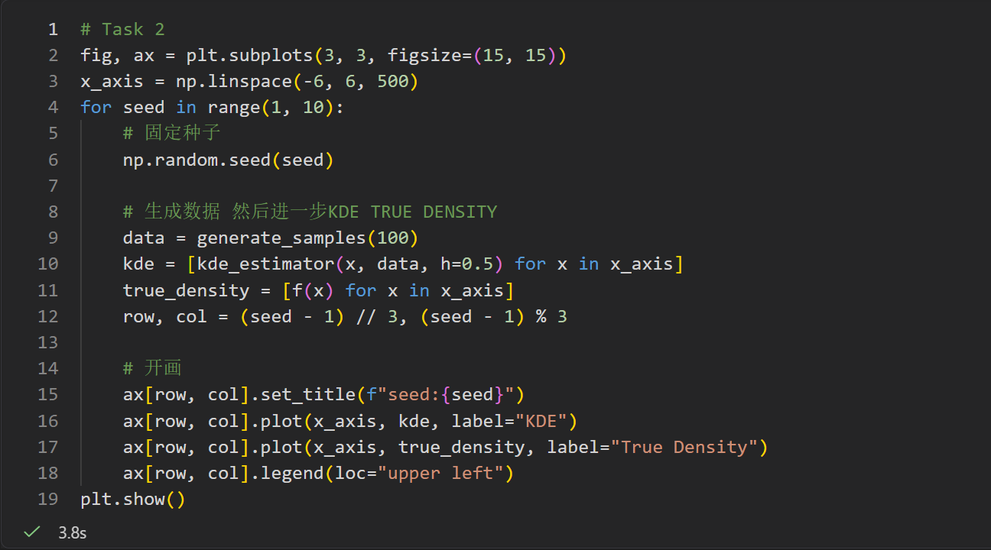
# Task 2
# Task 3
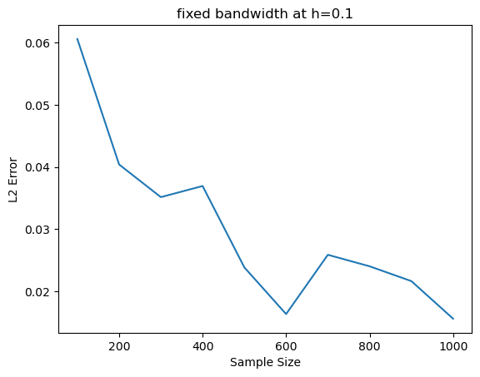
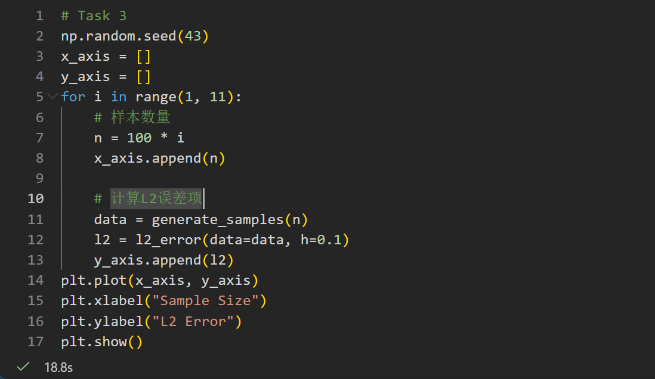
In general, increasing the sample size indeed improves estimation under a fixed bandwidth.

# Task 4
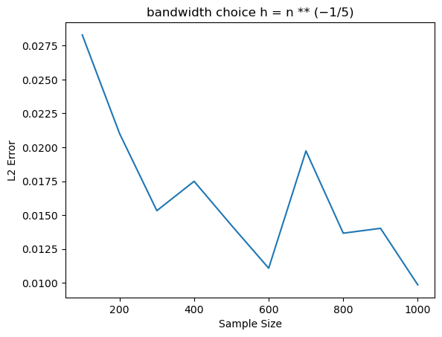
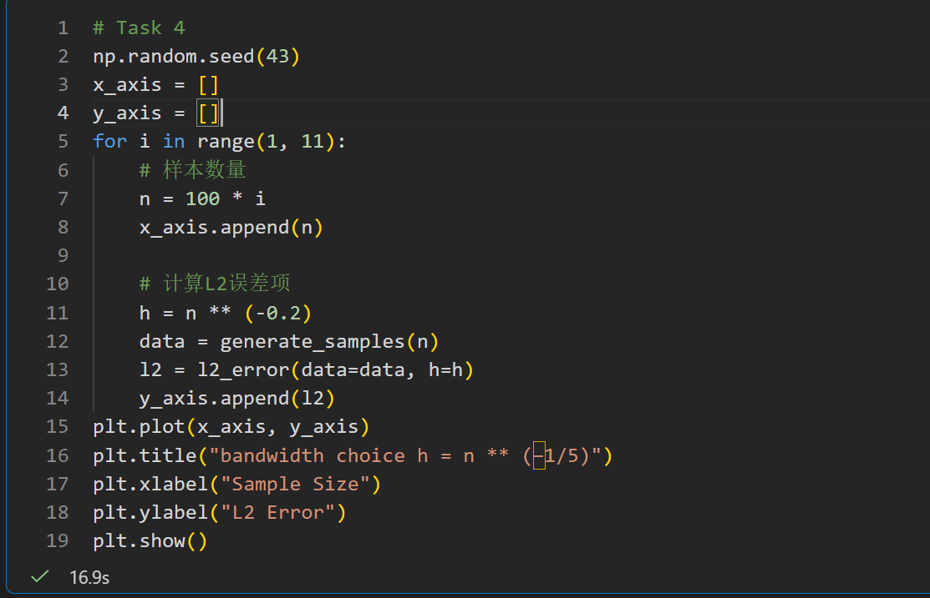
This adaptive bandwidth strategy significantly reduces L2 error, greatly improves estimation accuracy compared with the fixed one.

Brief discussion
The first part is about variability across different random samples. In task 2, we fix all other parameters and manipulate random seed only, which results in different random samples. As it is clearly shown in the graph, KDE curves exhibit noticeable variability with the change of random seeds. But it’s also worth mentioning that though KDE curves are distinct, all of them preserve the bimodal shape that is consistent with the true density function.
Next, we analyze the effect of sample size on estimation accuracy. In task 3, in an effort to measure the estimation accuracy, we construct the L2 distance function. And just as we did in task 2, we hold all other irrelevant parameters constant, and only change sample size varied from 100 to 1000. The result illustrates that the estimation error exhibits a clear decreasing tendency as the sample size increases. This result comes with no surprise, as it’s highly consistent with the Central Limit Theorem.
Lastly, we study the differences between fixed bandwidth and adaptive bandwidth. In task 3, bandwidth is set to be a constant at h=0.1, while in task 4, bandwidth is a formula that depends on sample size n ( h=n**(−1/5) ). Comparing results from these two, we can find that provided the same sample size, the estimation error generated in task 4 is way smaller than that from the previous one. This comparison illustrates that adaptive bandwidth tends to be more accurate in calculating KDE.

