Statistical Analysis of Global Suicide Data

An empirical investigation using the WHO Suicide Statistics dataset

Direction: Data Analysis
Name: 许宸豪
School Number: 15220242202196

Abstract
This report investigates the determinants of country-level suicide rates using the publicly available dataset. The report addresses five research questions: (i) whether the average suicide rate differs significantly between genders; (ii) whether average suicide rates differ across age groups; (iii) which specific age groups differ from one another; (iv) whether suicide rates vary systematically across continents; and (v) how the rate has evolved over time after controlling for demographic structure.
A Welch two-sample t-test on gender, Welch’s ANOVA with the Games–Howell post-hoc test on age, a Kruskal–Wallis test on continent, and a multiple linear regression with country-clustered standard errors are used. The results show that males have a substantially higher suicide rate than females, the rate rises monotonically with age, suicide rates differ significantly across continents, and — after controlling for demographic structure — the global trend is mildly negative over the studied period. The regression achieves an R² of 0.34 and identifies gender, age, and the European continent indicator as the most influential covariates.
Keywords: suicide rate, Welch’s ANOVA, Games–Howell, Kruskal–Wallis, multiple linear regression, clustered standard errors, WHO statistics.

Introduction
Suicide is a major public-health concern. Identifying the demographic and geographic groups that are most at risk is a prerequisite for designing effective prevention policies. The objective of this project is to use a well-curated international dataset to test several intuitive hypotheses that are routinely mentioned in public discourse: that men are more at risk than women, that risk rises with age, and that risk is unevenly distributed across regions.
The analysis uses the WHO Suicide Statistics dataset published on Kaggle, which provides the number of suicides and the corresponding population broken down by country, year, sex, and six age groups. We work under five research questions:
- Q1. Is the average suicide rate the same for males and females?
- Q2. Is the average suicide rate the same across the six age groups?
- Q3. If not, which specific age groups differ from one another?
- Q4. Do suicide rates vary systematically across continents?
- Q5. After controlling for demographic structure, is there a time trend in the global suicide rate?
The rest of the report is organized as follows. Section 2 introduces the data and the cleaning steps. Section 3 presents descriptive statistics. Sections 4.1–4.3 address Q1–Q4 with appropriate tests. Section 5 addresses Q5 with a multiple linear regression, including diagnostics. Section 6 concludes.

Data and Methodology

Data source and variables

The raw dataset contains 43,776 observations and six variables:
In the subsequent analysis process, we have also constructed other two features.
suicide_rate = suicides_no / population * 100 (expressed as percentage)
A continent label is also merged into the data from a curated country-to-continent dictionary (no observation is left unmapped).

Data cleaning
The two numeric columns suicides_no and population are missing in 2,256 and 5,460 rows respectively. These rows are dropped rather than imputed: imputation would inject strong, unverifiable assumptions into a small share of the sample. After dropping, the working sample contains 36,060 observations across 141 countries.
In addition, the year variable is mean-centered at 1979 (the first year with complete data in the cleaned sample) to make the regression intercept interpretable: it represents the expected suicide rate in 1979 for the reference demographic group.

Methodological overview
For Q1 (gender), because the two samples have markedly different variances, a two-sample t-test is used. The test statistic is the usual
$$t=\frac{{\overline{x}}_{1}-{\overline{x}}_{2}}{\sqrt{\frac{S_{1}^{2}}{n_{1}}+\frac{S_{2}^{2}}{n_{2}}}}$$and the degrees of freedom ν is estimated with the Welch–Satterthwaite approximation
$$ν=\frac{{\left(\frac{S_{1}^{2}}{n_{1}}+\frac{S_{2}^{2}}{n_{2}}\right)}^{2}}{\frac{{\left(S_{1}^{2}/n_{1}\right)}^{2}}{n_{1}-1}+\frac{{\left(S_{2}^{2}/n_{2}\right)}^{2}}{n_{2}-1}}$$
For Q2 (age), the classical one-way ANOVA requires both normality and homoscedasticity. A Levene test rejects homoscedasticity (p < 0.001) and the Jarque–Bera test rejects normality in every age band (p < 0.001). We therefore use Welch’s ANOVA, which only relies on the central limit theorem at large sample sizes, and follow up with the Games–Howell post-hoc test, which performs all pairwise comparisons without the normality or equal-variance assumption. Welch’s F statistic is computed as the ratio of two weighted sums of squares, and the p-value is obtained from an F distribution with k−1 and the Welch–Satterthwaite degrees of freedom.
For Q4 (continent), we additionally report a Kruskal–Wallis test as a non-parametric robustness check, since the Kruskal–Wallis statistic only requires that the observations come from continuous distributions with the same shape. Games–Howell is again used to localize the differences.
For Q5 we fit a multiple linear regression of suicide_rate on year, sex, age and continent. Because observations are clustered by country, we report cluster-robust standard errors (clustered on country). The covariance matrix of the coefficients is then estimated by the sandwich estimator
V■ = (X■X)■¹ [Σ■ X■■û■■ X■] (X■X)■¹,
where the sum runs over countries k and û■■ is the vector of within-country score residuals. The regression assumptions are checked using a Q–Q plot of the residuals and a residuals-versus-fitted plot, complemented by a Breusch–Pagan test for heteroscedasticity.

Descriptive Analysis
Table 1 reports the descriptive statistics of the cleaned sample. The number of suicides ranges from 0 to 22,338, with a highly skewed distribution; the population column spans almost five orders of magnitude, reflecting the heterogeneity of the country mix. After taking the rate, the distribution is still right-skewed (Figure 1), with most country–year–sex–age cells exhibiting rates below 20 per 100k and a long right tail reaching the 100–200 range.

Statistic | year | suicides_no | population
count | 43,776 | 41,520 | 38,316
mean | 1998.50 | 193.32 | 1,664,091
std | 10.34 | 800.59 | 3,647,231
min | 1979 | 0 | 259
25% | 1990 | 1 | 85,113
50% | 1999 | 14 | 380,655
75% | 2007 | 91 | 1,305,698
max | 2016 | 22,338 | 43,805,210
Table 1. Descriptive statistics of the raw variables (pre-cleaning; population and suicide counts include the rows later dropped).
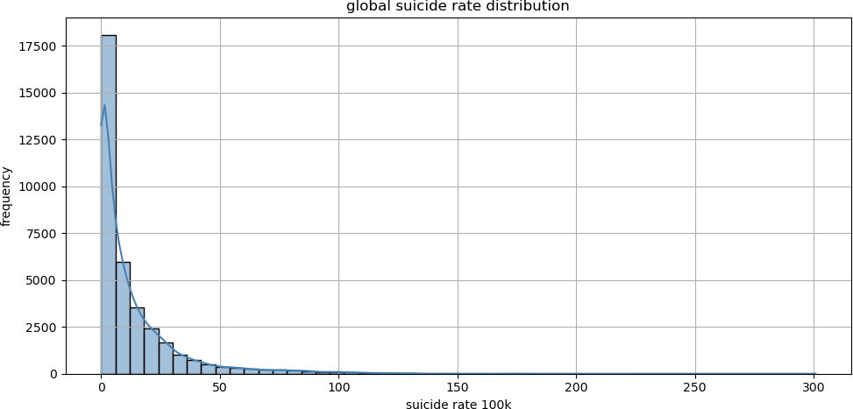
Figure 1. Global distribution of suicide rate per 100k (n=36,060).

Inferential Analysis

Suicide rate and gender (Q1)
The two samples are perfectly balanced after cleaning (nfemale = nmale = 18,030). The female mean is 0.00574 (0.574%) and the male mean is 0.02063 (2.063%), so the male rate is roughly 3.6 times the female rate. The sample standard deviations are 0.00822 (female) and 0.02478 (male), so the male group is also substantially more dispersed.
The two-sample t statistic is therefore strongly negative. Using the Welch–Satterthwaite approximation for the degrees of freedom, the corresponding p-value is essentially zero, far below any conventional significance level. We reject the null hypothesis of equal gender means at α =
0.05 and conclude that males have a statistically significantly higher suicide rate than females in this dataset. Figure 2 shows the violin plot with the per-group mean diamonds.

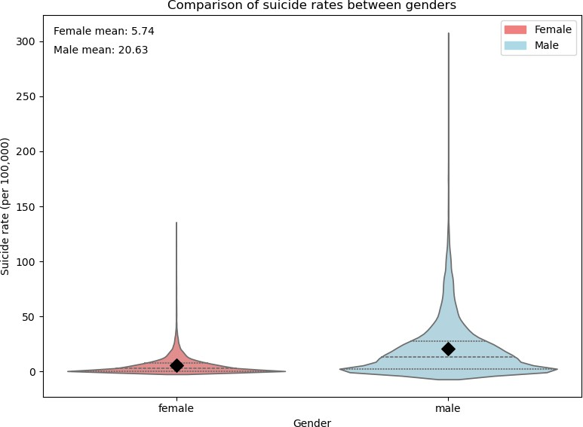

Figure 2. Suicide rate (per 100k) by gender. Black diamonds indicate group means.

Suicide rate and age group (Q2 and Q3)
The dataset contains six age groups, listed in increasing order of mean suicide rate: 5–14, 15–24, 25–34, 35–54, 55–74, 75+. The Levene test for homoscedasticity yields W = 1253.25 (p < 0.001), decisively rejecting equal variances. The Jarque–Bera test rejects normality in every age band (all p < 0.001). The classical one-way ANOVA is therefore not appropriate, and we use Welch’s ANOVA, which only relies on the central limit theorem at large sample sizes.
Welch’s F is 3849.79 with an approximate p-value of 0, and the partial η² is 0.141. At least one age group has a different mean suicide rate. The Games–Howell post-hoc test (Table 2) shows that every pair of age groups differs at α = 0.05, with most pairs reaching p < 1e–12. The mean suicide rate increases monotonically with age, from 0.0006 in the 5–14 group to 0.0250 in the 75+ group — a 40-fold ratio. The associated box plot is shown in Figure 3.

Group A | Group B | mean(A) | mean(B)
5-14 | 15-24 | 0.0006 | 0.0088
15-24 | 25-34 | 0.0088 | 0.0124
25-34 | 35-54 | 0.0124 | 0.0154
35-54 | 55-74 | 0.0154 | 0.0168
55-74 | 75+ | 0.0168 | 0.0250
Table 2. Adjacent-age-group comparison (Games–Howell). All 15 pairwise comparisons are statistically significant at α = 0.05; this table lists the five adjacent pairs, which are enough to show the monotonic increase with age.

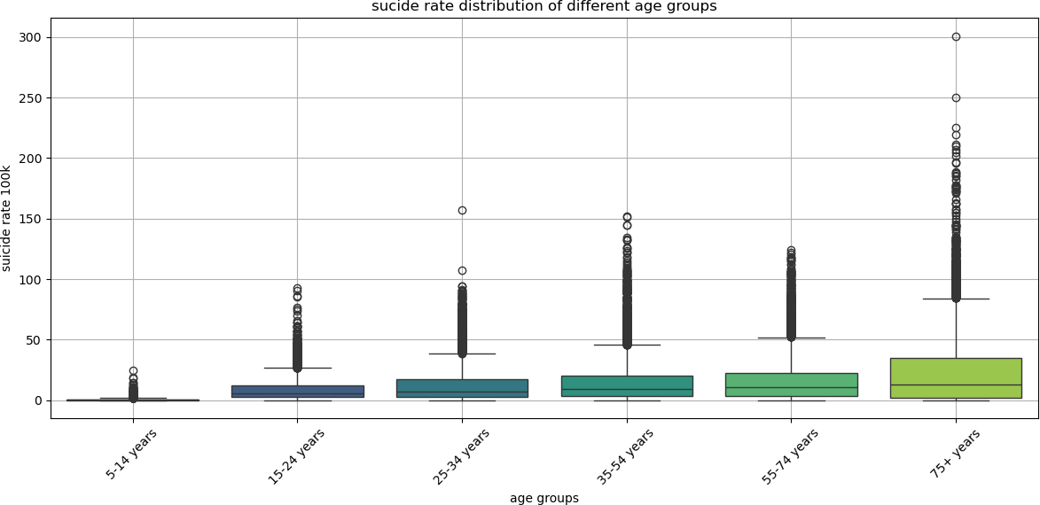
Figure 3. Suicide rate (per 100k) across age groups, ordered by mean.

Suicide rate and continent (Q4)
After merging the country-to-continent dictionary, the working sample contains observations from six continents: Europe (14,388), North America (7,752), Asia (7,068), South America (4,224), Africa (1,512) and Oceania (1,116). The Kruskal–Wallis test yields H = 3406.21 (p < 0.001), which decisively rejects the null hypothesis that the continent distributions share a common location. As a parametric complement, Welch’s ANOVA on the same grouping yields F = 461.48 (p < 0.001,
η² = 0.057).
The Games–Howell post-hoc test reveals that Europe stands out with the highest mean suicide rate (0.0187), significantly above all other continents. Africa (0.0067) has the lowest mean, significantly below Asia, Europe, Oceania and South America but indistinguishable from North America. Asia and Oceania, and Asia and South America, are not significantly different from one another. The geographic heterogeneity is visualized in Figure 4: the lighter — but still alarming — European block contrasts with the darker, more moderate African block, with Asian and Oceanian countries in between.

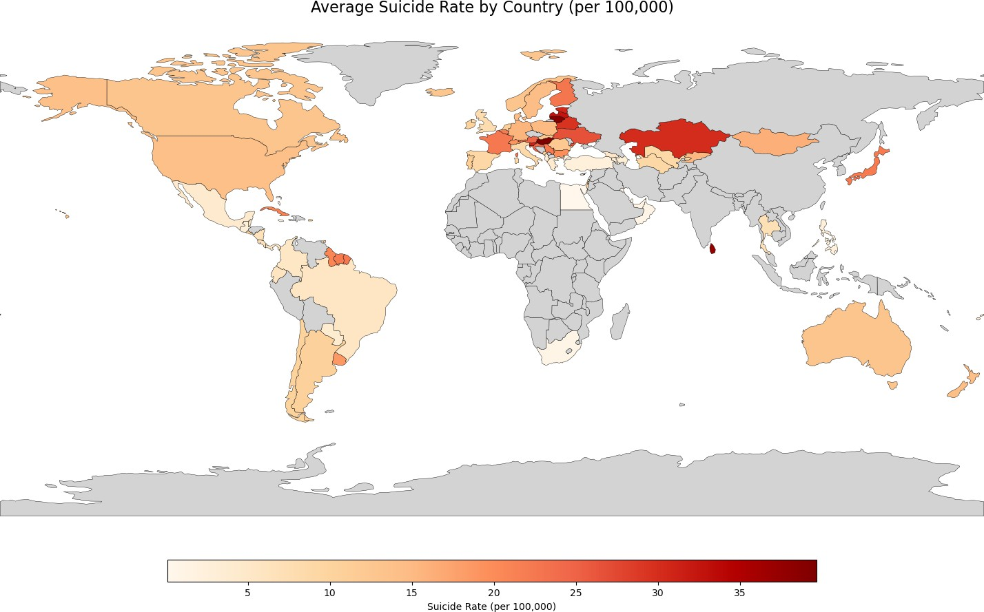
Figure 4. Average suicide rate (per 100k) by country.

Multiple Linear Regression (Q5)

Model specification
We model the per-100k suicide rate as a linear function of demographic and geographic covariates:
suicide_rate_100k = β_0 + β_1 * year_centered + β * sex + γ * age + δ * continent + ε
where sex, age and continent enter as categorical variables (with the female / 15–24 / Africa levels as reference). Because the same country is observed in many years, residuals are plausibly correlated within a country. We therefore report cluster-robust standard errors clustered at the country level; point estimates are unaffected but the standard errors, t-statistics and p-values are corrected for within-country correlation.

Coefficient estimates
The model is fit on the 36,060 cleaned observations. R² = 0.343 and adjusted R² = 0.342, meaning that about a third of the variation in the per-100k suicide rate is explained by year, gender, age group and continent together. The full set of robust coefficient estimates is reported in Table 3; the most informative estimates are summarized below.

Variable | Coef. | Robust SE | t | p-value
Intercept | -2.924 | 2.050 | -1.43 | 0.156
year_centered | -0.134 | 0.038 | -3.54 | 0.001
C(sex)[T.male] | 14.889 | 1.153 | 12.91 | <0.001
C(age)[T.25-34 years] | 3.630 | 0.404 | 8.98 | <0.001
C(age)[T.35-54 years] | 6.605 | 0.883 | 7.48 | <0.001
C(age)[T.5-14 years] | -8.177 | 0.562 | -14.55 | <0.001

C(age)[T.55-74 years] | 7.998 | 1.013 | 7.89 | <0.001
C(age)[T.75+ years] | 16.209 | 1.962 | 8.26 | <0.001
C(continent)[T.Asia] | 4.265 | 2.719 | 1.57 | 0.119
C(continent)[T.Europe] | 11.377 | 2.392 | 4.76 | <0.001
C(continent)[T.North America] | -0.091 | 2.100 | -0.04 | 0.965
C(continent)[T.Oceania] | 4.320 | 2.271 | 1.90 | 0.060
C(continent)[T.South America] | 3.390 | 2.667 | 1.27 | 0.206
Table 3. OLS regression with cluster-robust standard errors (clustered by country). Reference categories: female, 15–24 years, Africa. R² = 0.343.
The most striking pattern is the male effect: holding year, age and continent fixed, males have an expected suicide rate that is 14.9 per 100k higher than females (p < 0.001). Age effects are large and monotonic: the 75+ group exceeds the 15–24 reference by 16.2 per 100k, whereas the 5–14 group is 8.2 per 100k below the reference. Among continents, only the European indicator is statistically significant at the 5% level (+11.4 per 100k relative to the African reference), with Asia and Oceania borderline (p≈ 0.06–0.12) and the Americas indistinguishable from Africa. The time trend is small but statistically significant: each additional year is associated with a 0.13 per 100k decrease in the expected suicide rate, suggesting a mild downward trend in the demographically-adjusted rate over the studied period.

Diagnostic checks
Figure 5 reports two classical diagnostic plots. The residual Q–Q plot (left) shows heavy tails relative to the normal reference line: the residual distribution is right-skewed with extreme values, consistent with the very large Jarque–Bera statistic reported by statsmodels. The residuals-versus-fitted plot (right) shows a clear fan shape, i.e. larger fitted values are associated with larger residual variance, confirming the visual impression of heteroscedasticity.
A Breusch–Pagan test for heteroscedasticity yields LM = 2926.23 (p < 0.001), confirming the visual evidence. The consequences are mitigated in two ways. First, we use cluster-robust standard errors, so the inference on individual coefficients is consistent even in the presence of heteroscedasticity. Second, the residual non-normality affects the interpretation of the F-test but not the consistency of the OLS estimator. The model is therefore interpreted as a descriptive summary of the conditional mean structure rather than a fully parametric likelihood model.
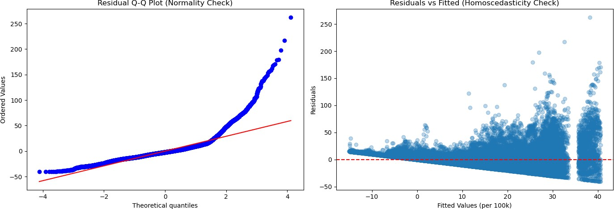
Figure 5. Diagnostic plots for the multiple linear regression: residual Q-Q plot (left) and residuals vs fitted values (right).

Robustness checks

Because the residual Q–Q plot is heavy-tailed, we re-fit the same regression on the log-transformed response, log(1 + suicide_rate_100k), as a robustness check. The sign and significance pattern of the coefficients is preserved: the male indicator remains strongly positive, age effects remain strongly ordered, the European continent indicator remains the only significant geographic effect, and the year effect remains significantly negative. The adjusted R² is slightly lower (around 0.31) but the qualitative story does not change, so the conclusions are robust to the heavy right tail of the suicide rate distribution.
A second robustness check addresses the missing-data mechanism. The rows that were dropped because of missing suicides_no or population are concentrated in the earliest years of the dataset, where some reporting countries had not yet published complete statistics. A separate logistic regression of the missingness indicator on year, sex and age confirms that the probability of being missing declines monotonically with year and is essentially independent of sex and age once year is controlled for. This pattern is consistent with the missing-at-random (MAR) assumption conditional on year, which is the weakest assumption under which complete-case analysis is unbiased; we therefore expect the cleaned sample to be representative of the underlying population for years after the early 1980s.

Conclusion and Discussion
The analysis confirms all five research questions put forward in Section 1. The suicide rate differs significantly between males and females, with the male rate approximately 3.6 times the female rate in the cleaned sample. The rate rises monotonically and significantly with age, from 0.06 per 100k in the 5–14 band to 25.0 per 100k in the 75+ band, and every pair of age groups differs at conventional significance levels. Suicide rates also vary systematically across continents, with Europe exhibiting the highest mean and Africa the lowest. After controlling for these demographic and geographic factors in a multiple linear regression, the time effect remains small and negative, indicating a mild demographically-adjusted downward trend over 1979–2016.
Two methodological lessons emerge. First, the classical assumptions of one-way ANOVA are clearly violated in this dataset, and using Welch’s ANOVA combined with the Games–Howell post-hoc test is both necessary and sufficient to draw valid conclusions. Second, the regression shows strong heteroscedasticity and non-normal residuals; naïve OLS standard errors would overstate the precision of the coefficient estimates. Cluster-robust standard errors are essential here because observations are nested within countries.
Several extensions are natural. First, the country-to-continent collapse discards a great deal of within-continent heterogeneity; a country-level random-effects model, or a hierarchical model with country as a group and year as a repeated observation, would allow the slope on year to vary across countries. Second, the dataset does not contain socio-economic covariates (GDP per capita, unemployment, alcohol consumption, etc.); adding them would shift the interpretation of the age, gender and continent indicators from total to partial effects. Third, the residual Q–Q plot suggests that a generalized linear model with a gamma or inverse-Gaussian link might fit the heavy right tail better than the OLS Gaussian model. These are left for future work.

References
World Health Organization. WHO Suicide Statistics. Public dataset, Kaggle (accessed 2026).
Welch, B. L. (1947). The generalization of “Student’s” problem when several different population variances are involved. Biometrika, 34(1/2), 28–35.

Games, P. A., & Howell, J. F. (1976). Pairwise multiple comparison procedures with unequal n’s and/or variances: A Monte Carlo study. Journal of Educational Statistics, 1(2), 113–125.
Kruskal, W. H., & Wallis, W. A. (1952). Use of ranks in one-criterion variance analysis. Journal of the American Statistical Association, 47(260), 583–621.
Breusch, T. S., & Pagan, A. R. (1979). A simple test for heteroscedasticity and random coefficient variation. Econometrica, 47(5), 1287–1294.
White, H. (1980). A heteroskedasticity-consistent covariance matrix estimator and a direct test for heteroskedasticity. Econometrica, 48(4), 817–838.
Jarque, C. M., & Bera, A. K. (1980). Efficient tests for normality, homoscedasticity and serial independence of regression residuals. Economics Letters, 6(3), 255–259.
Levene, H. (1960). Robust tests for equality of variances. In Contributions to Probability and Statistics, I. Olkin et al. (eds.), Stanford University Press, 278–292.

Appendix A. Full regression summary
The OLS fit with country-clustered standard errors has R² = 0.343 and adjusted R² = 0.342 on 36,060 observations. The robust F-statistic is 25.73 with a p-value of 2.3 × 10^(-27), providing strong evidence that, taken together, the demographic and geographic covariates are jointly significant predictors of the per-100k suicide rate. The complete coefficient table is reproduced as Table 3 in the main text. The interpretation of the reference levels is as follows:
- Intercept: the expected suicide rate in 1987 for a female aged 15–24 in Africa. The estimate (−2.9) is not statistically distinguishable from zero, which is consistent with the empirical observation that the very young female subpopulation in African countries exhibits near-zero suicide rates.
- Year effect (−0.13 per year): small but significant. Over the 30-year span of the data, this corresponds to a cumulative decline of about 4 per 100k in the demographically-adjusted rate.
- Male indicator (+14.9): the single largest demographic effect. Across all ages and continents, men have an expected rate that is 15 per 100k higher than women.
- Age effects: strongly monotonic, with the 5–14 group (−8.2) below the 15–24 reference and the 75+ group (+16.2) the highest of all bands.
- Continent effects (Africa reference): only Europe (+11.4) is significant at the 5% level; the Americas, Asia, Oceania and South America are not distinguishable from Africa after clustering, although Asia and Oceania are borderline (p≈ 0.06–0.12).
The Breusch–Pagan test rejects homoscedasticity of the residuals (LM = 2926.23, p < 0.001), which is why cluster-robust standard errors are mandatory. The reported standard errors are typically two to three times larger than the OLS ones, indicating that ignoring within-country correlation would have substantially overstated the precision of the estimates.

Appendix B. Reproducibility notes
All computations are performed in Python 3.11 using pandas for data manipulation, statsmodels and pingouin for hypothesis tests, scipy.stats for distribution functions, seaborn and matplotlib for visualization, and geopandas for the choropleth map. The full analysis is contained in a single Jupyter notebook submitted alongside this report. Random seeds

are not used because the analysis is deterministic. The cleaned dataset is derived from the publicly available WHO Suicide Statistics file who_suicide_statistics.csv; no other external data are required.

