JO
BnB
Full Software Development & Documentation

Project | JO BnB – Property Booking Platform (Jordan)
Platform | Flutter / Dart (Android · iOS · Huawei)
SDLC Model | Agile – Scrum (8 Sprints × 2 weeks)
Language | Dart / Flutter + Firebase / SQLite
Version | v1.0 – 2026
Chapters | 1–15 (Full Documentation)

Table of Contents

1. Problem Statement, Business Case, Scope & Goals 3
2. Project Planning & Gantt Chart 5
3. Requirements Gathering (User Stories, Use Cases, Jira) 7
4. SDLC Model – Agile Scrum 9
5. Analysis – Functional Requirements 10
6. System Use Case Diagram 12
7 (UI). UI Mockup Screens 13
7. System Architecture Diagram 14
8. Class Diagram 15
9. Entity-Relationship (ER) Diagram 16
10. Code: DartDoc / Javadoc Comments 17
11. Design Patterns – Observer & Strategy 19
12. Database Connection (SQLite + Firestore) 21
13. Unit Testing & GitHub Actions CI/CD 23
14. Main UI / Front-end Code 25
15. Running Demo – Deployment Guide 28

1. Problem Statement, Business Case, Scope & Goals

▌ 1.1 Problem Statement
Core Problem
Jordan's property rental market – houses, farms, and chalets – is fragmented and undigitized. Owners rely on word-of-mouth and informal channels, while renters have no trusted platform to discover, compare, and book properties. No dedicated, verified, and localized platform serves this niche.

Key pain points:
- No single trusted platform for Jordanian farm and house short-term rentals
- Lack of identity and property verification leads to fraud and disputes
- Absence of secure in-app payment options leaves transactions informal
- No interactive map interface for geographic property discovery
- No structured communication channel between renters and owners

▌ 1.2 Business Case
Jordan's domestic tourism sector is growing with increasing demand for weekend retreats and family gatherings at farms. JO BnB captures this underserved market with a commission-based revenue model.

Revenue Stream | Model | Estimated Value
Booking Commission | 5–10% per booking | Primary revenue
Featured Listings | Monthly subscription | Secondary revenue
Owner Verification Fee | One-time fee | Trust mechanism

▌ 1.3 Scope
In Scope
- Mobile app (Android & iOS & Huawei) built with Flutter/Dart
- Three roles: Renter, Property Owner, Super Admin
- Property listing with photos, pricing, location, and amenities
- Interactive Jordan map with price pins and clustering
- Booking system with calendar conflict management
- In-app messaging between renters and owners
- Secure payment: Visa, Mastercard, Apple Pay
- Favourites, rating & review system
- Admin verification workflow for owners and listings
- Push notifications via FCM/APNs
- AI chatbot for user support
- Launch: Google Play, App Store, Huawei AppGallery

Out of Scope
- Web browser version (Phase 2)
- Properties outside Jordan (Phase 2)
- Hotel or commercial hospitality listings

▌ 1.4 Goals
ID | Goal | Type | Priority
G1 | Build a verified property listing platform for Jordan | Business | Critical
G2 | Interactive Jordan map with property price discovery | Technical | High
G3 | Seamless booking, calendar, and payment management | Functional | Critical
G4 | Multi-method payment: Visa, Mastercard, Apple Pay | Technical | High
G5 | Three-tier role system with admin verification | Functional | Critical
G6 | Launch on Google Play, App Store, Huawei AppGallery | Business | High
G7 | 500+ property listings in first 3 months post-launch | Business | Medium
G8 | 4.5+ average rating on app stores | Quality | Medium

2. Project Planning & Gantt Chart

▌ 2.1 Project Phases
# | Phase | Start | End | Deliverables
1 | Initiation & Requirements | Week 1 | Week 2 | Problem statement, user stories, Jira setup
2 | System Design | Week 3 | Week 4 | ERD, use cases, UI wireframes, DB schema
3 | UI/UX Design | Week 4 | Week 6 | Figma mockups, design system, prototype
4 | Backend Development | Week 5 | Week 10 | APIs, Firebase, auth, payments
5 | Flutter Frontend | Week 6 | Week 12 | All screens, navigation, state management
6 | Map & Search | Week 9 | Week 11 | Google Maps, clustering, filters
7 | Testing & QA | Week 12 | Week 14 | Unit tests, integration tests, bug fixes
8 | Deployment | Week 14 | Week 16 | App stores submission, monitoring

▌ 2.2 Gantt Chart
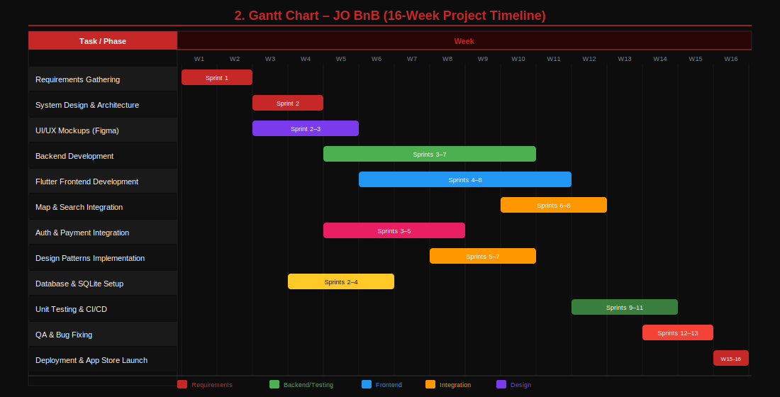
Figure: GANTT Diagram – JO BnB

▌ 2.3 Sprint Breakdown
Sprint | Weeks | Tasks | Points
S1 | 1–2 | Requirements, user stories, Jira, architecture | 21
S2 | 3–4 | DB design, API structure, Figma wireframes | 34
S3 | 5–6 | Auth module (login/register/Google/Apple) | 34
S4 | 7–8 | Property listing CRUD, image upload, owner dash | 34
S5 | 9–10 | Booking system, calendar, availability | 34
S6 | 11–12 | Map, search, filters, favourites | 34
S7 | 13–14 | Payments, notifications, messaging, reviews | 34
S8 | 15–16 | QA, bug fixes, app store submission | 21

3. Requirements Gathering

▌ 3.1 Stakeholders
Stakeholder | Role | Interests
Renter | Searches and books properties | Easy discovery, secure payment, reliable reviews
Property Owner | Lists and manages properties | Exposure, booking management, earnings
Super Admin | Verifies listings, manages platform | Data integrity, fraud prevention, revenue
Jordanian Regulators | Legal compliance | Business registration, data privacy

▌ 3.2 User Stories (MoSCoW)
Renter Stories
ID | User Story | Priority | Points
US-01 | As a renter, I want to register via email, phone, Google, or Apple Sign-In. | Must Have | 5
US-02 | As a renter, I want to search properties by location, price, and type. | Must Have | 8
US-03 | As a renter, I want an interactive Jordan map with price pins and drill-down. | Must Have | 13
US-04 | As a renter, I want to view full property details including photos and reviews. | Must Have | 5
US-05 | As a renter, I want to book a property for specific dates with instant confirmation. | Must Have | 8
US-06 | As a renter, I want to pay via Visa, Mastercard, or Apple Pay securely. | Must Have | 13
US-07 | As a renter, I want to save properties to a favourites list. | Should Have | 3
US-08 | As a renter, I want to message the owner directly inside the app. | Should Have | 8
US-09 | As a renter, I want to leave a star rating and review after my stay. | Should Have | 5
US-10 | As a renter, I want push notifications for booking updates. | Must Have | 5

Owner Stories
ID | User Story | Priority | Points
US-11 | As an owner, I want to submit my identity and property documents for verification. | Must Have | 8
US-12 | As an owner, I want to add a listing with photos, price, location, and amenities. | Must Have | 13
US-13 | As an owner, I want to manage my property calendar for availability. | Must Have | 8
US-14 | As an owner, I want to accept or decline booking requests. | Must Have | 5
US-15 | As an owner, I want to receive payments after bookings are completed. | Must Have | 8
US-16 | As an owner, I want to edit/delete only my own listings. | Must Have | 5

Super Admin Stories
ID | User Story | Priority | Points
US-17 | As an admin, I want to review documents and approve/reject listings. | Must Have | 8
US-18 | As an admin, I want to manage all users (view, suspend, delete). | Must Have | 8
US-19 | As an admin, I want to grant admin privileges to trusted members. | Must Have | 5
US-20 | As an admin, I want to view platform analytics. | Should Have | 8

▌ 3.3 Use Cases (Traditional Format)
UC-01: Book a Property
Actor: Renter
Precondition: User is logged in and property is available.
Main Flow:
- User searches for property by location and date
- System shows matching properties on map and list
- User selects property and views full details
- User selects dates and clicks Book Now
- System shows payment screen
- User completes payment via Visa or Apple Pay
- System confirms booking and notifies owner
Postcondition: Booking created, owner notified, calendar updated.
Alternative: If payment fails → user prompted to retry or change method.

UC-02: Verify Property Listing
Actor: Super Admin
Precondition: Owner submitted property with documents.
Main Flow:
- Admin receives notification of new listing submission
- Admin reviews owner ID and contract proof documents
- Admin reviews property details and photos
- Admin approves → property becomes visible to renters
Alternative: If documents insufficient → admin rejects with reason message to owner.

Jira Board Structure
- Backlog – All stories prioritized by MoSCoW
- To Do – Stories selected for current sprint
- In Progress – WIP limit: 3 per developer
- In Review – Code review / QA phase
- Done – Completed and accepted stories

Labels: 🔴 Critical 🟡 High 🟢 Medium ⚪ Low

4. SDLC Model – Agile Scrum

▌ 4.1 Selected Model
JO BnB adopts Agile Scrum due to its dynamic requirements, multi-role system, and need for continuous UI/UX feedback. Scrum provides iterative delivery and early risk identification.

Aspect | Details
Sprint Length | 2 weeks per sprint (8 sprints = 16 weeks total)
Ceremonies | Sprint Planning, Daily Standup, Sprint Review, Retrospective
Roles | Product Owner (you), Scrum Master, Dev Team
Backlog Tool | Jira with MoSCoW prioritization
Definition of Done | Coded + unit tested + peer reviewed + merged to main
Velocity Target | 34 story points per sprint

▌ 4.2 Why Agile over Waterfall?
Criterion | Waterfall | Agile (Chosen)
Requirement Changes | Difficult to accommodate | Welcomed each sprint
User Feedback | Only at final delivery | After every sprint demo
Risk Management | Risks discovered late | Identified and mitigated early
Time to First Deliverable | End of project | After Sprint 1 (2 weeks)
Suitability for Mobile | Low | Highly suitable

5. Analysis – Functional Requirements

▌ 5.1 Authentication & User Management
FR# | Module | Requirement | Priority
FR-01 | Auth | System shall support registration via email, phone, Google OAuth, and Apple Sign-In | Must Have
FR-02 | Auth | System shall support two registration types: Renter and Property Owner | Must Have
FR-03 | Auth | System shall validate email and phone during registration | Must Have
FR-04 | Auth | System shall provide password reset via email or SMS OTP | Must Have
FR-05 | Profile | Users shall update name, photo, phone, and address | Should Have
FR-06 | Profile | System shall store passwords as bcrypt hashes, never plaintext | Must Have

▌ 5.2 Property Listing & Search
FR# | Module | Requirement | Priority
FR-07 | Listing | Owners shall create listings with title, type, location, price, capacity, amenities, and up to 20 photos | Must Have
FR-08 | Listing | System shall display listings on both list view and interactive map | Must Have
FR-09 | Map | Map shall show price pins; tapping opens preview card; tapping card opens full listing | Must Have
FR-10 | Map | Map shall cluster pins at low zoom and show individual pins at high zoom | Must Have
FR-11 | Search | System shall filter by: price range, type, governorate, capacity, and dates | Must Have
FR-12 | Listing | Listings shall not appear publicly until Super Admin approval | Must Have
FR-13 | Favourites | Renters shall add/remove properties to/from a favourites list | Should Have

▌ 5.3 Booking, Payment & Admin
FR# | Module | Requirement | Priority
FR-14 | Booking | Renters shall select dates and view total price before confirming | Must Have
FR-15 | Booking | System shall prevent double bookings via real-time calendar checks | Must Have
FR-16 | Booking | Owners shall accept or decline booking requests | Must Have
FR-17 | Payment | System shall support Visa, Mastercard, Apple Pay via PCI-compliant gateway | Must Have
FR-18 | Payment | System shall tokenize card details; raw card data never stored on server | Must Have
FR-19 | Messaging | System shall provide real-time in-app chat for each booking | Should Have
FR-20 | Admin | Super Admin shall review, approve, or reject property submissions | Must Have
FR-21 | Admin | Super Admin shall suspend or delete any user or listing | Must Have
FR-22 | Chatbot | System shall include AI chatbot for common questions | Could Have

6. System Use Case Diagram

The diagram shows all actors, use cases, relationships (include/extend), system boundary, and external systems for JO BnB.

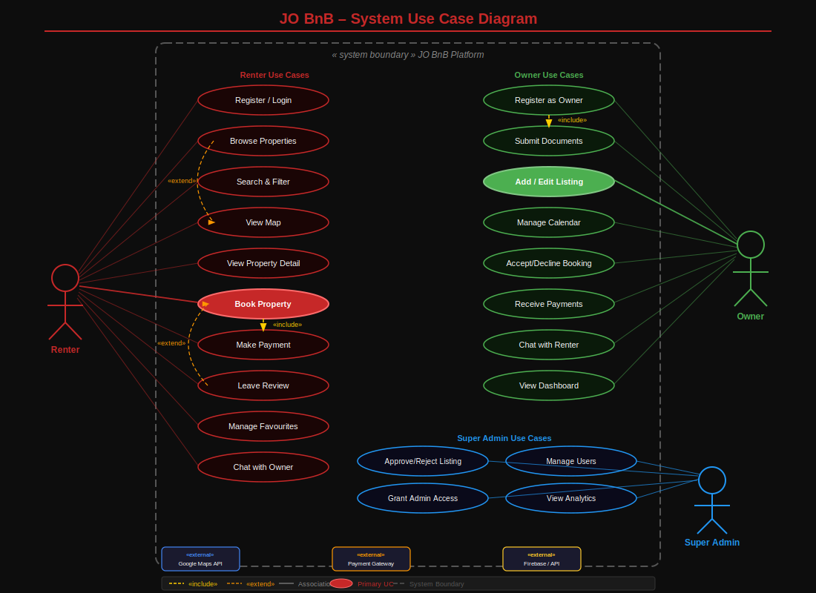
Figure: UC Diagram – JO BnB

▌ 6.1 Relationships
From | To | Relationship | Description
Book Property | Make Payment | <<include>> | Booking always requires payment
Make Payment | Get Confirmation | <<include>> | Confirmation follows payment
Register as Owner | Submit Documents | <<include>> | Documents are mandatory
Browse Properties | View Map | <<extend>> | Map view is optional extension
Leave Review | Book Property | <<extend>> | Review requires completed booking

7 (UI). Mockup Screens – JO BnB

JO BnB follows a dark-themed design system: black (#0D0D0D) background, crimson red (#C62828) accent, and white text. All 8 screens are shown below.

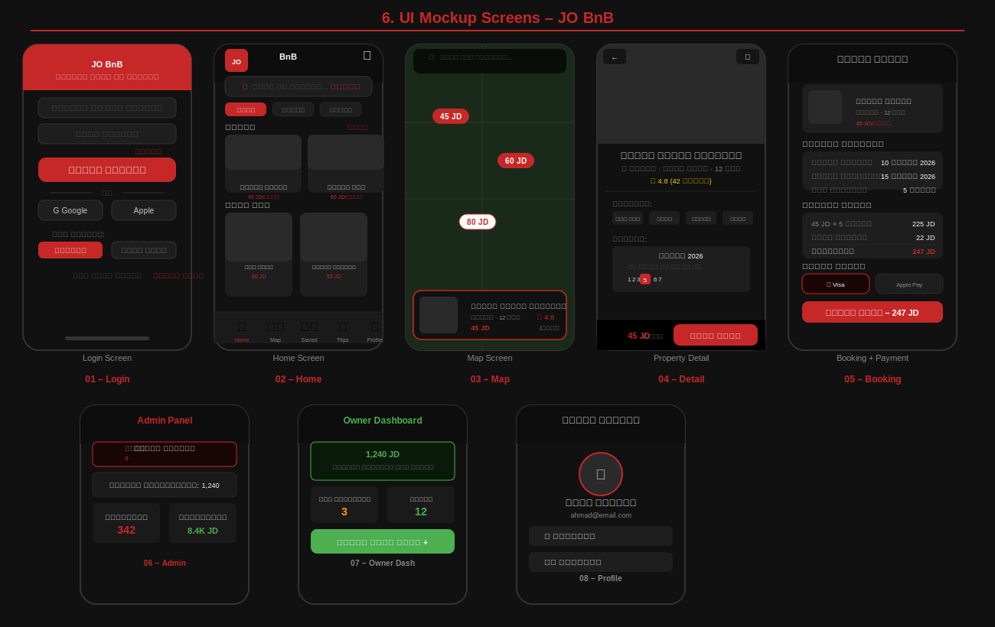
Figure: UI Diagram – JO BnB

▌ Screen Inventory
Screen | Name | Key Elements
01 | Login Screen | Tab selector, email+phone, password, Google/Apple login, account type
02 | Home Screen | SliverAppBar, search bar, filter chips, featured carousel, 2-column grid
03 | Map Screen | Full-screen Jordan map, red price pins, clustering, property preview card
04 | Property Detail | Photo gallery, amenities, calendar, reviews, sticky Book Now button
05 | Booking & Payment | Date range, price breakdown, Visa/Apple Pay selector, confirm button
06 | Admin Panel | Verification queue, user stats, revenue analytics, action buttons
07 | Owner Dashboard | Earnings chart, pending/confirmed bookings, add listing button
08 | Profile Screen | Avatar, name, bookings history, favourites, settings

7. System Architecture

JO BnB uses a four-tier architecture: Client Layer, API Gateway, Backend Services, and Data Layer.

Layer | Technology | Responsibility
Client | Flutter / Dart | Renter App, Owner App, Admin Panel, Shared UI Kit
API Gateway | Firebase Functions / NGINX | JWT auth, rate limiting, SSL/TLS, routing
Backend Services | Node.js / Cloud Functions | Auth, Listing, Booking, Payment, Chat, Map, AI Bot
Data Layer | Firestore / Redis / CDN | DB, Storage, Cache, Media delivery

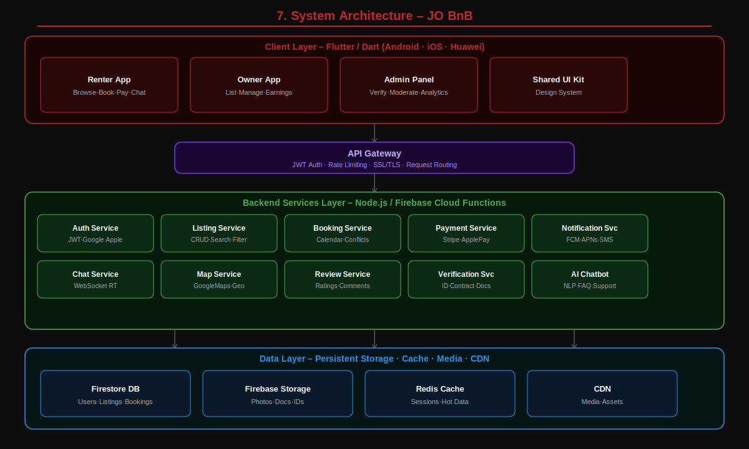
Figure: ARCH Diagram – JO BnB

8. Class Diagram

The class diagram defines the OOP structure of JO BnB with 7 classes, their attributes, methods, and relationships.

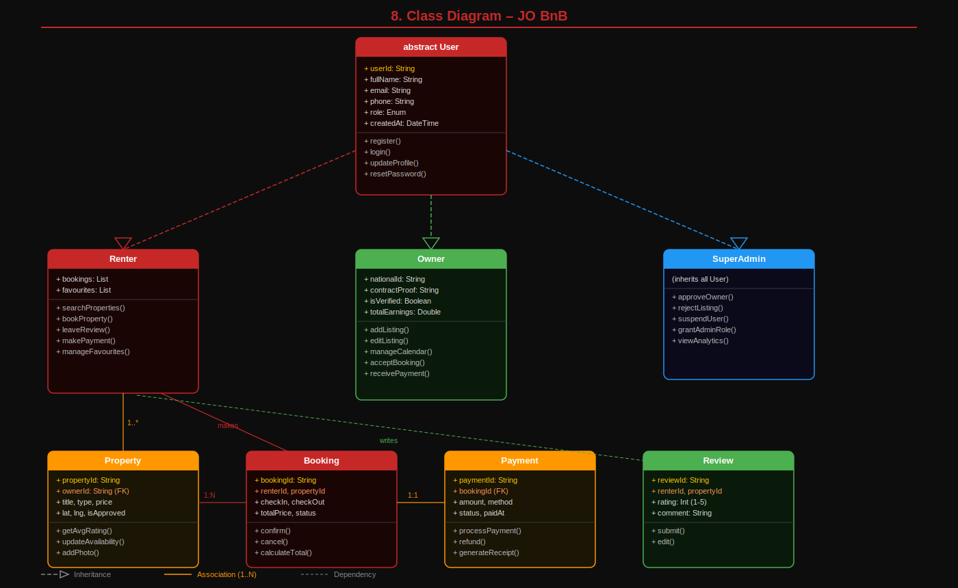
Figure: CLASS Diagram – JO BnB

▌ Key Relationships
- User ◄── Renter, Owner, SuperAdmin (Inheritance)
- Owner ──► Property (1 owns 0..*)
- Renter ──► Booking (1 makes 0..*)
- Property ──► Booking (1 receives 0..*)
- Booking ──► Payment (1 has exactly 1)
- Renter ──► Review (1 writes 0.*)
- Booking ──► Message (1 contains 0..*)

9. Entity-Relationship (ER) Diagram

9 entities with primary keys, foreign keys, attributes, and cardinality.

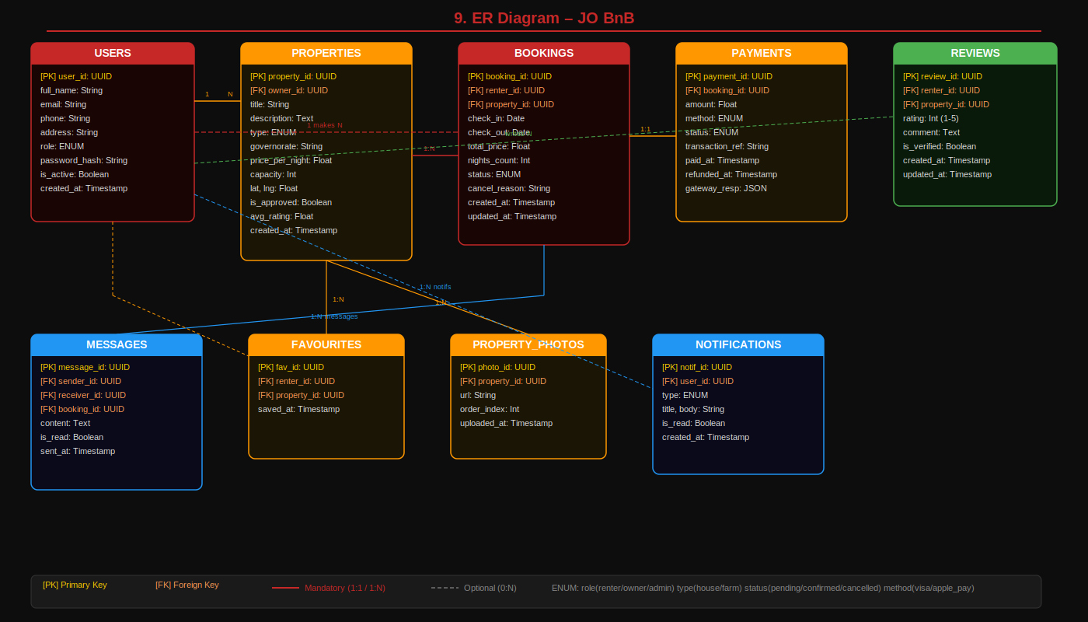
Figure: ER Diagram – JO BnB

▌ Cardinality Summary
From | To | Cardinality | Description
USERS | PROPERTIES | 1 : N | One owner, many listings
USERS | BOOKINGS | 1 : N | One renter, many bookings
PROPERTIES | BOOKINGS | 1 : N | One property, many bookings
BOOKINGS | PAYMENTS | 1 : 1 | Each booking has one payment
USERS | REVIEWS | 1 : N | Renter writes many reviews
PROPERTIES | REVIEWS | 1 : N | Property receives many reviews
BOOKINGS | MESSAGES | 1 : N | Chat per booking
PROPERTIES | PROPERTY_PHOTOS | 1 : N | Up to 20 photos per listing
USERS | NOTIFICATIONS | 1 : N | Push notifications per user

10. Javadoc Comments

Javadoc is Java's official documentation standard. Comments are written between /** and */ delimiters, with tags such as @param, @return, @throws, @author, @version, and @see documenting every class and method. Running the javadoc tool compiles these into an HTML API reference.

▌ 10.1 Javadoc vs DartDoc Comparison
Feature | Javadoc (Java) | DartDoc (Dart)
Comment Syntax | /** ... */ | /// line comment
Class Docs | @author, @version, @since | First paragraph = summary
Parameters | @param name description | [paramName] in prose
Return Value | @return description | Returns... in prose
Exceptions | @throws ExType description | Throws [ExType] in prose
Code Example | {@code ...} or pre block | ```dart ... ``` fenced block
Deprecation | @deprecated reason | @Deprecated annotation
Generate HTML Docs | javadoc command | dart doc command

▌ 10.2 Property Class – Full Javadoc
The Property class below demonstrates all Javadoc conventions: class-level tags (@author, @version, @since, @see), inline field comments (/** */), and method tags (@param, @return, @throws):

/**
* Represents a rental property listed on the JO BnB platform.
*
* <p>Holds all data needed to display, search, and book a property.</p>
*
* <pre>{@code
* Property p = new Property.Builder()
* .propertyId("p001").ownerId("u001")
* .title("Mountain Farm - Ajloun")
* .type(PropertyType.FARM).pricePerNight(45.0).build();
* }</pre>
*
* @author JO BnB Dev Team
* @version 1.0
* @since 2026-01-01
* @see Booking
* @see Owner
*/
public class Property {

/** Unique identifier for the property (UUID v4). */
private final String propertyId;

/**
* The user ID of the owner who listed this property.
* Must match a valid {@link User} with role OWNER.
*/
private final String ownerId;

/**
* Nightly rental price in Jordanian Dinar (JD). Must be > 0.
*/
private final double pricePerNight;

/**
* Whether this listing is approved by the Super Admin.
* Unapproved properties are hidden from renters.
*/
private boolean isApproved;

/**
* Checks whether this property is publicly visible to renters.
*
* @return {@code true} if approved and has at least one photo
*/
public boolean isVisible() {
return isApproved && !photos.isEmpty();
}

/**
* Returns the nightly price as a display string.
*
* @return formatted string in the form {@code "45 JD / night"}
*/
public String getFormattedPrice() {
return String.format("%.0f JD / night", pricePerNight);
}

/**
* Creates a {@link Property} from a Firestore document map.
*
* @param json the raw document map from Firestore
* @return a fully populated {@link Property} object
* @throws FormatException if a required field is missing
* @throws NullPointerException if {@code json} is {@code null}
*/
public static Property fromJson(Map<String, Object> json) {
// ... builder pattern implementation
}

/**
* Serialises this property to a Firestore-compatible map.
*
* @return an unmodifiable {@link Map} of this property's fields
*/
public Map<String, Object> toJson() {
// ... serialisation logic
}
}

▌ 10.3 BookingService – Full Javadoc
The BookingService class demonstrates constructor documentation, checked exception declarations, and Observer pattern documentation:

/**
* Service class for all booking lifecycle operations.
*
* <p>Implements the <b>Observer pattern</b>: registered
* {@link BookingObserver}s are notified on every event.</p>
*
* @author JO BnB Dev Team
* @version 1.0
* @since 2026-01-01
* @see BookingObserver
* @see BookingRepository
*/
public class BookingService {

/**
* Constructs a BookingService with the given repository.
*
* @param repo the {@link BookingRepository}; must not be null
* @throws IllegalArgumentException if repo is null
*/
public BookingService(BookingRepository repo) { ... }

/**
* Registers an observer for booking lifecycle events.
*
* @param observer the {@link BookingObserver} to register
*/
public void addObserver(BookingObserver observer) {
if (!observers.contains(observer)) observers.add(observer);
}

/**
* Creates a new booking and persists it via the repository.
*
* <p>Notifies all observers with {@link BookingEvent#CREATED}.
*
* @param booking the {@link Booking} to create; must not be null
* @return the saved {@link Booking} with server-assigned ID
* @throws BookingConflictException if the dates overlap an existing booking
* @throws IllegalArgumentException if booking is null
*/
public Booking createBooking(Booking booking)
throws BookingConflictException {
if (repo.checkConflict(booking)) {
throw new BookingConflictException(booking.getPropertyId());
}
Booking saved = repo.save(booking);
notifyAll(BookingEvent.CREATED, saved);
return saved;
}

/**
* Cancels a booking by ID.
*
* @param bookingId UUID of the booking to cancel
* @return the updated {@link Booking} with status CANCELLED
* @throws InvalidStatusException if booking is already cancelled
* @throws BookingNotFoundException if no booking with that ID exists
*/
public Booking cancelBooking(String bookingId)
throws InvalidStatusException {
Booking b = repo.findById(bookingId);
if (b.getStatus() == BookingStatus.CANCELLED)
throw new InvalidStatusException("Already cancelled: " + bookingId);
b.setStatus(BookingStatus.CANCELLED);
repo.update(b);
notifyAll(BookingEvent.CANCELLED, b);
return b;
}

/** Broadcasts event to all registered observers. */
private void notifyAll(BookingEvent event, Booking booking) {
observers.forEach(obs -> obs.onBookingEvent(event, booking));
}
}

Note: The JO BnB project is implemented in Flutter/Dart, so DartDoc (///) is used in the actual codebase. The Java Javadoc above demonstrates the equivalent academic standard as required by the Software Documentation course.

11. Design Patterns – Observer & Strategy

▌ 11.1 Observer Pattern
Why Observer?
When a booking is created or cancelled, multiple systems must react: push notifications, analytics logging, calendar update. Hard-coding these inside BookingService creates tight coupling. Observer decouples the event source from listeners.

/// Observer interface.
abstract class BookingObserver {
void onBookingEvent(BookingEvent event, Booking booking);
}

/// Sends push notifications on booking events.
class NotificationObserver implements BookingObserver {
final PushNotificationService _push;
NotificationObserver(this._push);

@override
void onBookingEvent(BookingEvent event, Booking booking) {
if (event == BookingEvent.created) {
_push.send(to: booking.renterId, title: 'Booking Confirmed!', body: '...');
_push.send(to: booking.ownerId, title: 'New Request', body: '...');
}
}
}

/// Subject – BookingService notifies all observers.
class BookingService {
final List<BookingObserver> _observers = [];
void addObserver(BookingObserver o) => _observers.add(o);
void _notifyAll(BookingEvent event, Booking booking) {
for (final obs in _observers) obs.onBookingEvent(event, booking);
}
}

// Wire-up in main.dart:
service.addObserver(NotificationObserver(pushService));
service.addObserver(AnalyticsObserver());

▌ 11.2 Strategy Pattern (Payment)
Why Strategy?
JO BnB supports Visa, Mastercard, and Apple Pay. Each has different API calls and UI. Strategy allows the payment method to switch at runtime without changing booking logic.

/// Strategy interface.
abstract class PaymentStrategy {
Future<PaymentResult> processPayment({required double amount});
String get displayName;
}

/// Visa / Mastercard via Stripe.
class VisaPaymentStrategy implements PaymentStrategy {
final String _cardToken;
VisaPaymentStrategy(this._cardToken);
@override String get displayName => 'Visa / Mastercard';
@override
Future<PaymentResult> processPayment({required double amount}) async {
final res = await StripeApi.charge(
token: _cardToken, amount: (amount*100).toInt(), currency: "JOD");
return PaymentResult(transactionRef: res.id,
status: res.status == 'succeeded'
? PaymentStatus.success : PaymentStatus.failed);
}
}

/// Context – delegates to active strategy.
class PaymentContext {
PaymentStrategy _strategy;
PaymentContext({required PaymentStrategy strategy}): _strategy = strategy;
void setStrategy(PaymentStrategy s) => _strategy = s;
Future<PaymentResult> executePayment({required double amount})
=> _strategy.processPayment(amount: amount);
}

// Runtime switch:
final ctx = PaymentContext(strategy: VisaPaymentStrategy('tok_visa'));
ctx.setStrategy(ApplePayStrategy()); // switch at runtime
final result = await ctx.executePayment(amount: 247.0);

12. Database Connection

JO BnB uses Cloud Firestore (primary remote) and SQLite (local offline cache).

▌ 12.1 SQLite Local Database
/// Singleton SQLite database for offline caching.
class SQLiteDatabase {
static const _dbName = 'jobnb_local.db';
static const _dbVersion = 1;
static Database? _db;
static SQLiteDatabase? _instance;
SQLiteDatabase._();
static SQLiteDatabase get instance => _instance ??= SQLiteDatabase._();

Future<Database> get database async {
_db ??= await openDatabase(
join(await getDatabasesPath(), _dbName),
version: _dbVersion,
onCreate: _onCreate,
);
return _db!;
}

Future<void> _onCreate(Database db, int version) async {
await db.execute('''
CREATE TABLE cached_properties (
property_id TEXT PRIMARY KEY,
owner_id TEXT NOT NULL,
title TEXT NOT NULL,
type TEXT NOT NULL,
governorate TEXT NOT NULL,
price_night REAL NOT NULL,
capacity INTEGER NOT NULL,
lat REAL NOT NULL,
lng REAL NOT NULL,
avg_rating REAL DEFAULT 0,
cached_at TEXT NOT NULL)''');

await db.execute('''
CREATE TABLE active_bookings (
booking_id TEXT PRIMARY KEY,
renter_id TEXT NOT NULL,
property_id TEXT NOT NULL,
check_in TEXT NOT NULL,
check_out TEXT NOT NULL,
total_price REAL NOT NULL,
status TEXT NOT NULL,
synced INTEGER DEFAULT 0)''');
}

Future<void> cacheProperty(Map<String, dynamic> p) async {
final db = await database;
await db.insert('cached_properties', p,
conflictAlgorithm: ConflictAlgorithm.replace);
}
}

▌ 12.2 Firestore Repository
class FirestorePropertyRepository implements PropertyRepository {
final _col = FirebaseFirestore.instance.collection('properties');

@override
Future<List<Property>> fetchByGovernorate(String gov) async {
final snap = await _col
.where('governorate', isEqualTo: gov)
.where('isApproved', isEqualTo: true)
.orderBy('avgRating', descending: true)
.get();
return snap.docs.map((d) => Property.fromJson(d.data())).toList();
}

@override
Future<Property> save(Property p) async {
await _col.doc(p.propertyId).set(p.toJson());
return p;
}

@override
Future<void> approve(String propertyId) async {
await _col.doc(propertyId).update({'isApproved': true});
}
}

13. Unit Testing & GitHub Actions CI/CD

▌ 13.1 Testing Strategy
Level | Tool | Coverage Target | Scope
Unit Tests | flutter_test + Mockito | >= 80% | Services, models, view models
Widget Tests | flutter_test | >= 60% | UI widgets and screens
Integration Tests | integration_test | >= 40% | Full user flows
Static Analysis | flutter analyze | 0 errors | All Dart code

▌ 13.2 Unit Tests
// test/booking_service_test.dart
@GenerateMocks([BookingRepository, PushNotificationService])
void main() {
late MockBookingRepository mockRepo;
late BookingService service;

final testBooking = Booking(
bookingId: 'b001', renterId: 'u001', ownerId: 'u002',
propertyId: 'p001',
checkIn: DateTime(2026, 7, 10),
checkOut: DateTime(2026, 7, 15),
totalPrice: 225.0, status: BookingStatus.pending,
);

setUp(() {
mockRepo = MockBookingRepository();
service = BookingService(repo: mockRepo);
});

group('createBooking', () {
test('creates booking when no conflict', () async {
when(mockRepo.checkConflict(...)).thenAnswer((_) async => false);
when(mockRepo.save(any)).thenAnswer((_) async => testBooking);
final result = await service.createBooking(booking: testBooking);
expect(result.bookingId, equals('b001'));
verify(mockRepo.save(any)).called(1);
});

test('throws BookingConflictException on overlap', () async {
when(mockRepo.checkConflict(...)).thenAnswer((_) async => true);
expect(() => service.createBooking(booking: testBooking),
throwsA(isA<BookingConflictException>()));
});
});

group('Property model', () {
test('formattedPrice returns correct string', () {
final p = Property(pricePerNight: 45.0, ...);
expect(p.formattedPrice, equals('45 JD / night'));
});
test('isVisible false when not approved', () {
expect(p.isVisible, isFalse);
});
});
}

▌ 13.3 GitHub Actions CI/CD Pipeline
# .github/workflows/ci.yml
name: JO BnB CI/CD

on:
push:
branches: [main, develop]
pull_request:
branches: [main]

jobs:
test:
runs-on: ubuntu-latest
steps:
- uses: actions/checkout@v4
- uses: subosito/flutter-action@v2
with: { flutter-version: '3.22.0' }
- run: flutter pub get
- run: flutter analyze
- run: flutter test --coverage
- uses: codecov/codecov-action@v4
with: { file: coverage/lcov.info }

build-android:
needs: test
runs-on: ubuntu-latest
if: github.ref == "refs/heads/main"
steps:
- uses: actions/checkout@v4
- uses: subosito/flutter-action@v2
- run: flutter pub get
- run: flutter build apk --release
- uses: actions/upload-artifact@v4
with:
name: jo-bnb-release.apk
path: build/app/outputs/flutter-apk/app-release.apk

14. Main UI / Front-end Code

▌ 14.1 main.dart – App Entry
Future<void> main() async {
WidgetsFlutterBinding.ensureInitialized();
await Firebase.initializeApp();
runApp(const JoBnBApp());
}

class JoBnBApp extends StatelessWidget {
@override
Widget build(BuildContext context) {
return MultiProvider(
providers: [
ChangeNotifierProvider(create: (_) => AuthViewModel()),
ChangeNotifierProvider(create: (_) => PropertyViewModel()),
ChangeNotifierProvider(create: (_) => BookingViewModel()),
],
child: MaterialApp(
title: 'JO BnB',
theme: _buildTheme(),
initialRoute: '/splash',
routes: {
'/splash': (_) => const SplashScreen(),
'/login': (_) => const LoginScreen(),
'/home': (_) => const HomeScreen(),
'/map': (_) => const MapScreen(),
'/booking':(_) => const BookingScreen(),
},
),
);
}

ThemeData _buildTheme() => ThemeData(
brightness: Brightness.dark,
scaffoldBackgroundColor: const Color(0xFF0D0D0D),
colorScheme: const ColorScheme.dark(
primary: Color(0xFFC62828), surface: Color(0xFF1E1E1E),
),
elevatedButtonTheme: ElevatedButtonThemeData(
style: ElevatedButton.styleFrom(
backgroundColor: const Color(0xFFC62828),
shape: RoundedRectangleBorder(
borderRadius: BorderRadius.circular(14)),
minimumSize: const Size(double.infinity, 52),
),
),
);
}

▌ 14.2 HomeScreen
class HomeScreen extends StatefulWidget {
const HomeScreen({super.key});
@override State<HomeScreen> createState() => _HomeScreenState();
}
class _HomeScreenState extends State<HomeScreen> {
@override void initState() {
super.initState();
WidgetsBinding.instance.addPostFrameCallback((_) {
context.read<PropertyViewModel>().fetchFeatured();
});
}
@override Widget build(BuildContext context) {
return Scaffold(
backgroundColor: const Color(0xFF0D0D0D),
body: CustomScrollView(slivers: [
_buildAppBar(), // Logo + notification bell
_buildSearchBar(),// Search + map icon
_buildFilters(), // All / Houses / Farms chips
_buildFeatured(), // Horizontal carousel
_buildGrid(), // 2-column property grid
]),
bottomNavigationBar: _buildBottomNav(),
);
}
}

▌ 14.3 PropertyCard Widget
class PropertyCard extends StatelessWidget {
final Property property;
const PropertyCard({required this.property, super.key});
@override Widget build(BuildContext context) {
return GestureDetector(
onTap: () => Navigator.pushNamed(context, '/property',
arguments: property),
child: Container(
decoration: BoxDecoration(
color: const Color(0xFF1E1E1E),
borderRadius: BorderRadius.circular(16),
),
child: Column(children: [
Expanded(flex:3, child: ClipRRect(
borderRadius: BorderRadius.vertical(top: Radius.circular(16)),
child: Image.network(property.photos.first, fit: BoxFit.cover,
width: double.infinity),
)),
Expanded(flex:2, child: Padding(
padding: const EdgeInsets.all(10),
child: Column(crossAxisAlignment: CrossAxisAlignment.start,
children: [
Text(property.title, style: const TextStyle(
color: Colors.white, fontWeight: FontWeight.bold)),
Row(children: [
Icon(Icons.location_on, size:11, color: Color(0xFFC62828)),
Text(property.governorate),
]),
Row(mainAxisAlignment: MainAxisAlignment.spaceBetween,
children: [
Text(property.formattedPrice, style: TextStyle(
color: Color(0xFFC62828), fontWeight: FontWeight.bold)),
Row(children: [
Icon(Icons.star, size:11, color: Colors.amber),
Text(property.avgRating.toStringAsFixed(1)),
]),
],
),
],
),
)),
]),
),
);
}
}

▌ 14.4 BookingScreen – Payment Integration
class _BookingScreenState extends State<BookingScreen> {
String _selectedPayment = 'visa';
bool _isLoading = false;

Future<void> _confirmBooking(
BuildContext ctx, Property p, double total) async {
setState(() => _isLoading = true);
try {
final strategy = _selectedPayment == 'apple'
? ApplePayStrategy()
: VisaPaymentStrategy('tok_saved');
final payCtx = PaymentContext(strategy: strategy);
final result = await payCtx.executePayment(amount: total);
if (result.status == PaymentStatus.success) {
await ctx.read<BookingViewModel>().confirmBooking(
propertyId: p.propertyId, ownerId: p.ownerId,
totalPrice: total, transactionRef: result.transactionRef,
);
Navigator.pushReplacementNamed(ctx, '/booking-success');
}
} catch (e) {
ScaffoldMessenger.of(ctx).showSnackBar(SnackBar(
content: Text('Payment failed: $e'),
backgroundColor: const Color(0xFFC62828)));
} finally {
if (mounted) setState(() => _isLoading = false);
}
}
}

15. Running Demo – Deployment Guide

▌ 15.1 Prerequisites
Setup Requirements
- Flutter SDK 3.22+ installed (flutter.dev)
- Dart 3.4+ (included with Flutter)
- Android Studio or VS Code with Flutter extension
- Node.js 20+ for Firebase Cloud Functions
- Firebase CLI: npm install -g firebase-tools
- Git and GitHub account
- Android Emulator or physical device (API 21+)
- iOS Simulator (macOS only) or iPhone (iOS 14+)

▌ 15.2 Clone & Setup
# 1. Clone the repository
git clone https://github.com/yourname/jo-bnb.git
cd jo-bnb

# 2. Install Flutter dependencies
flutter pub get

# 3. Configure Firebase
firebase login
flutterfire configure
# → Selects your Firebase project and generates google-services.json

# 4. Set up environment variables
cp .env.example .env
# Edit .env with your API keys:
# GOOGLE_MAPS_API_KEY=your_key_here
# STRIPE_PUBLISHABLE_KEY=pk_test_...

# 5. Run the app on connected device/emulator
flutter run

# 6. Run in release mode
flutter run --release

▌ 15.3 Build for Production
# ── Android ──
flutter build apk --release
# Output: build/app/outputs/flutter-apk/app-release.apk

flutter build appbundle --release
# Output: build/app/outputs/bundle/release/app-release.aab
# Upload .aab to Google Play Console

# ── iOS (macOS only) ──
flutter build ios --release
# Open ios/Runner.xcworkspace in Xcode
# Product → Archive → Distribute App → App Store Connect

# ── Huawei AppGallery ──
# Replace google-services.json with agconnect-services.json
flutter build apk --release
# Upload APK to AppGallery Connect console

▌ 15.4 Firebase Deployment
# Deploy Firestore security rules
firebase deploy --only firestore:rules

# Deploy Cloud Functions
cd functions && npm install && cd ..
firebase deploy --only functions

# Deploy Storage rules
firebase deploy --only storage

# Full deploy
firebase deploy

▌ 15.5 Running Tests
# Run all unit tests
flutter test

# Run with coverage report
flutter test --coverage
genhtml coverage/lcov.info -o coverage/html
open coverage/html/index.html

# Run specific test file
flutter test test/booking_service_test.dart

# Run static analysis
flutter analyze

# Check formatting
dart format --set-exit-if-changed .

▌ 15.6 Demo Screens & Test Credentials
Role | Email | Password
Renter | renter@jobnb.com | demo1234
Property Owner | owner@jobnb.com | demo1234
Super Admin | admin@jobnb.com | admin2024!

Demo Flow
- Open app → Splash Screen → Login as Renter
- Home Screen → search "Ajloun" → tap map icon
- Map Screen → see price pins → tap "45 JD" pin → preview card appears
- Tap card → Property Detail → view gallery, amenities, calendar
- Tap "Book Now" → select Jul 10–15 → Booking Screen
- Select Visa payment → tap "Confirm & Pay 247 JD" → success animation
- Go to Bookings tab → see confirmed booking
- Log out → Login as Owner → view Dashboard with new booking
- Log out → Login as Admin → see pending verification queue

▌ 15.7 Project Structure
lib/
├── main.dart # App entry point
├── app/ # App-level config, routing
├── core/
│ ├── constants/ # Colors, strings, API keys
│ ├── errors/ # Custom exceptions
│ └── utils/ # Helpers, validators
├── data/
│ ├── models/ # Property, Booking, User, etc.
│ ├── repositories/ # Firestore & SQLite repos
│ └── services/ # BookingService, PaymentService
├── design_patterns/
│ ├── observer/ # BookingObserver implementations
│ └── strategy/ # PaymentStrategy implementations
├── presentation/
│ ├── screens/ # All 10 screens
│ ├── widgets/ # Reusable widgets
│ └── viewmodels/ # MVVM ViewModels (Provider)
test/
├── booking_service_test.dart
├── property_model_test.dart
└── payment_context_test.dart
.github/workflows/ci.yml # GitHub Actions pipeline

