* Holiday Tree Card Holder

Images:

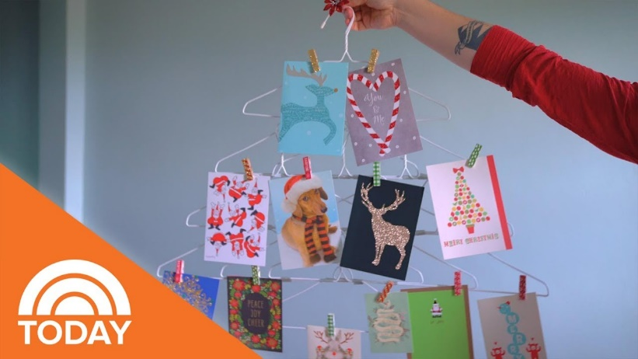

Description – Christmas cards are one of the hallmarks of the holiday season However, with so many holiday greeting cards being sent to you by your friends and family members, you may be seeking an aesthetically pleasing way to display them all. Sure, they'll look great up propped up on your holiday mantel, but sometimes we're after a more creative landing spot, like these DIY Christmas card holders. An easy to make Christmas Card Holder out of hanger.

Materials needed:

1. Hanger
2. Tape
3. Small clothes pins
4. Festive ornament(optional)

Procedure:

1. Arrange hangers in the shape of a tree.
2. Then attach using tape.
3. Use small clothes pins to hang cards from the tree.
4. Stick a festive ornament on top.

Video Link:

https://www.youtube.com/watch?v=0U-XmW7qqLE

* Christmas Tree Straws

Images:

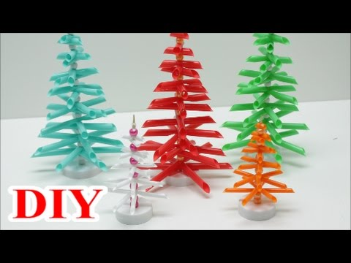

Description - A Christmas tree is a decorated tree, usually an evergreen conifer, such as a spruce, pine, or fir, or an artificial tree of similar appearance, but rather than that materials what we used are a bunch of straws to make a cute and a budget wise Christmas tree.

Materials needed:

1. Straws
2. Scissors
3. Pointed Stick
4. Cap of a bottle

Procedure:

1. Draw a guide of the size of the tree branch.
2. Cut the straws depending on the size.
3. Make a hole in the middle of the straw.
4. Put the straw in the stick-on alternate directions and make a space in between every three straws.
5. Cut the straws on what design you want.
6. Then finally put the cap under it to act as base of the tree.

video link:

https://www.youtube.com/watch?v=dv4W_12KO3I

* Festive Throw Pillow

Images:

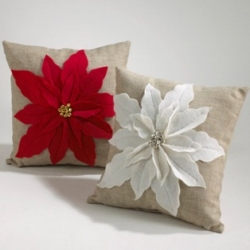

Description - a small, decorative soft furnishing item made from a wide range of textiles including cotton, linen, silk, leather, microfiber, suede, chenille, and velvet., designed with a poinsettia and a bell.

Materials needed:

1. Pillow
2. Felt
3. Hem tape
4. Jingle bells
5. Thread
6. Fabric Glue

Procedure:

1. Make three leaf sizes.
2. Trace each of the leaf over the felt.
3. Trim around each leaf.
4. Glue the two sides together.
5. Stitch down each of the center of the leaf.
6. Use hem tape to put the leaf to the pillow.
7. String the bells onto the thread.
8. Hand sew the bells on the center of the flower.

Video link:

https://www.youtube.com/watch?v=OOyCy8pKNB4

* Snowman of Cups

Images:

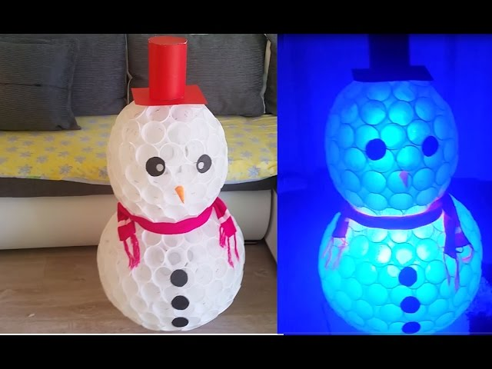

Description - snow sculpture often built-in regions with sufficient snowfall. In many places, typical snowmen consist of three large snowballs of different sizes with some additional accoutrements for facial and other features. But this time the snowman will be built out of cups.

Materials needed:

1. Scarf
2. Bunch of cups
3. Stapler
4. Scissors
5. Glue Gun
6. Color Paper

Procedure:

1. Draw a circle guide on how big the snowman(optional).
2. Staple each cup to each other until it forms a dome.
3. Do another one but only go halfway, then staple it to the first made dome.
4. Repeat step B and C but with smaller cups.
5. Combine the two to form the snowman.
6. Cut color paper into circles for the eyes, and body, While carrot shape for the nose.
7. Make a hat and put the scarf on it.

Video link:

<https://www.youtube.com/watch?v=9_9IE1uzDno>

* Easter Basket

Images:

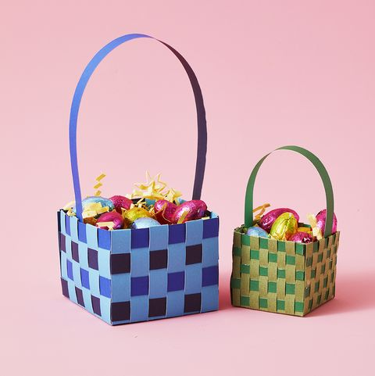

Description - is a special basket used in Easter celebrations. Easter baskets are typically filled with Easter eggs, food, toys, or other gifts depending on one's culture. As many people give up sweets as their Lenten sacrifice, individuals receive them in their Easter baskets after having abstained from them during the preceding forty days of Lent.

Materials needed:

1. Construction paper
2. Scissors
3. Glue Gun
4. Ruler

Procedure:

1. Prepare your supplies
2. Cut 1” wide strips of paper.
3. Cut 4 18” pieces of one color and 1 for the handle.
4. Set aside the 1 for the handle.
5. Cut 4 14” long pieces of your first color.
6. Cut 4 14” long pieces of your second color. (If you don’t have paper that is long enough you can tape two pieces together.)
7. Arrange the 14” pieces 4 across, being sure to alternat colors.
8. Weave 4 more 14” pieces in the other direction of the 4 you already have placed down, alternating colors again. Adjust the inner square (where the paper is overlapping) to make a 4” x 4” square.
9. Glue down each corner that is overlapping to secure.
10. Fold each piece inwards towards the center to start building the side walls.
11. With the 18” pieces, measure and mark every 4” and then fold on each mark. Glue the ends together.
12. Weave each of these pieces to form the basket by following the under/over weaving pattern.
13. After you weave the 4 18” pieces onto the walls, fold over any excess paper and glue to the inside (or trim and glue to the inside).
14. Glue each side of the handle to the inside of the basket and you are done!

Video link:

https://www.youtube.com/watch?v=sEgEKwHOKSQ

* Holiday Brass Ring Wreath

Images:

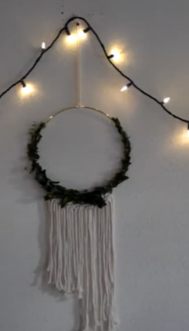

Description - An assortment of flowers, leaves, fruits, twigs, or various materials that is constructed to form a ring. In English-speaking countries, wreaths are used typically as household ornaments, most commonly as an Advent and Christmas decoration.

Materials needed:

1. 18” Brass Hoop
2. Wire Cutters
3. Fabric Scissors
4. 8 strands 35” rope
5. 30-gauge Gold Wire
6. Greenery
7. Floral Wire

Procedure:

1. Tie rope around hoop with a larks head knot.
2. Tie two rows of square knots.
3. Experiment with how you want your greenery to look.
4. Then attach by wrapping floral wire around the greenery and the hoop.
5. Then hang and enjoy.

Video link:

<https://www.youtube.com/watch?v=-2gC9YaU7oc>

* Centerpiece

Images:

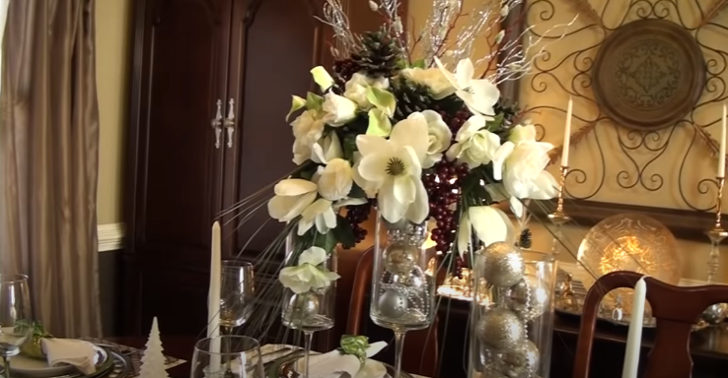

Description - an important item of a display, usually of a table setting. Centerpieces help set the theme of the decorations and bring extra decorations to the room. A centerpiece also refers to any central or important object in a collection of items.

Materials needed:

1. Large glass
2. Wine glass
3. Candle holder
4. Decorations (silver balls, White Magnolia Bouquet, 7-Stem white Rose Bush, Onion Grass Sprays, Berry Bouquet, Red Blooming Branches, Holiday Silver Branches).
5. Foam
6. Glue

Procedure:

1. Glue the glass piece by pair.
2. After it dry, fill the glass with silver balls.
3. Put the foam inside the glass.
4. Then put your decorations one by one.

Video link:

<https://www.youtube.com/watch?v=j3lc4mMXB0U>

* Gift Wrapping Decorations

Images:

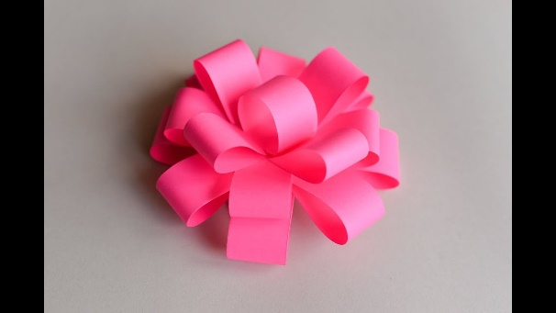

Description – The one you put after the gift wrapper to please the eyes of the receiver, and this one is called paper bow.

Materials needed:

1. Color Paper
2. Scissors
3. Glue

Procedure:

1. Fold the paper horizontally 3 times for the guide.
2. Cut the paper based on the guide.
3. Make the half of the pieces smaller than the other half.
4. Glue them on each end to form a circle, then glue again on the center to form infinity sign.
5. Do this to all the pieces.
6. Combine the larger ones with glue on the center like your drawing a star.
7. Add the smaller ones like your painting a star.
8. Do a small circle and put it on top to finish the product.

Video link:

<https://www.youtube.com/watch?v=u7CWu2oxMT4>

* Holiday Lanterns

Images:

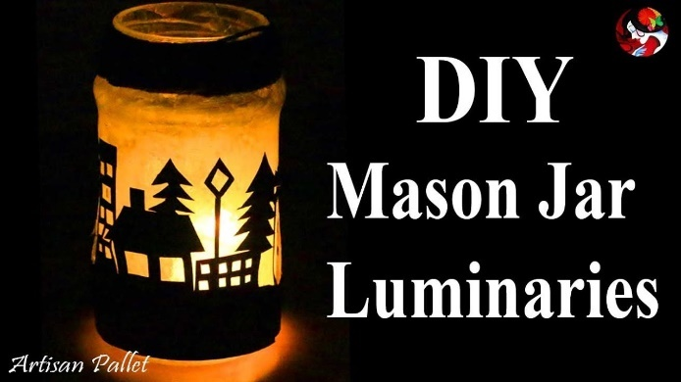

Description - Portable source of lighting, typically featuring a protective enclosure for the light source, Designed with color paper.

Materials needed:

1. Color paper
2. Ruler
3. Scissors
4. Cutter
5. Glue
6. Jar
7. White Pencil

Procedure:

1. Mark the jar with the paper so you know the size.
2. Draw your designs.
3. Cut it up neatly.
4. Put glue inside the jar and dry it up.
5. Stick your designs to the jar.
6. Put the candle inside and you’re done!

Video link:

<https://www.youtube.com/watch?v=kTTzmxz9wlE>

* Festive Banners

Images:

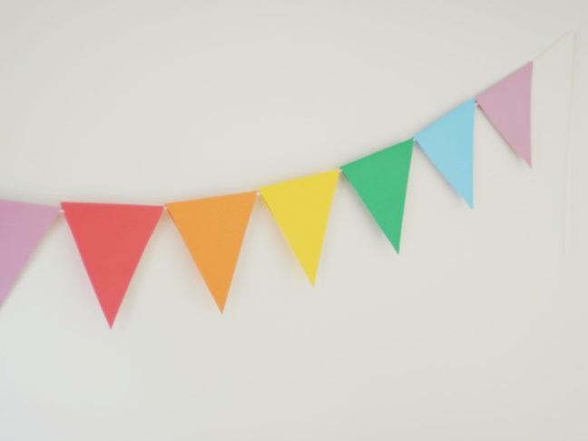

Description – A triangular shape paper with different colors to match the theme of the festival, hang onto public place when a festival is happening.

Materials needed:

1. Scrapbook Paper
2. Scissors
3. String

Procedure:

1. Cut the papers into triangular shape.
2. Make a few holes on the bottom of the triangle.
3. Attach the flag to the strings.
4. Lastly, hang it the banners.

Video link:

<https://www.youtube.com/watch?v=QjcySzcTQ_M>