CrossOver News

Design Document

The document outlines the technologies and design patterns used along with overall activity and sequence diagram to brief the application flow.

2015

Jabez Eliezer

[Type the company name]

3/30/2015

# Technologies and Patterns used

* UI
  + Twitter Bootstrap
  + jQuery
  + Tiny MCE
  + Razor MVC for plain HTML handling
  + Future extensions
    - SPA with AngularJS
* Backend
  + A mix of Onion and N-tier architecture
    - Programming to Interfaces
  + Repository Pattern
  + Entity Framework
  + Unity for DI
  + NUnit for unit testing
  + Moq for mocking objects
  + SQL Server
  + WCF Service (Restful & RSS feed)

# Activity Diagram

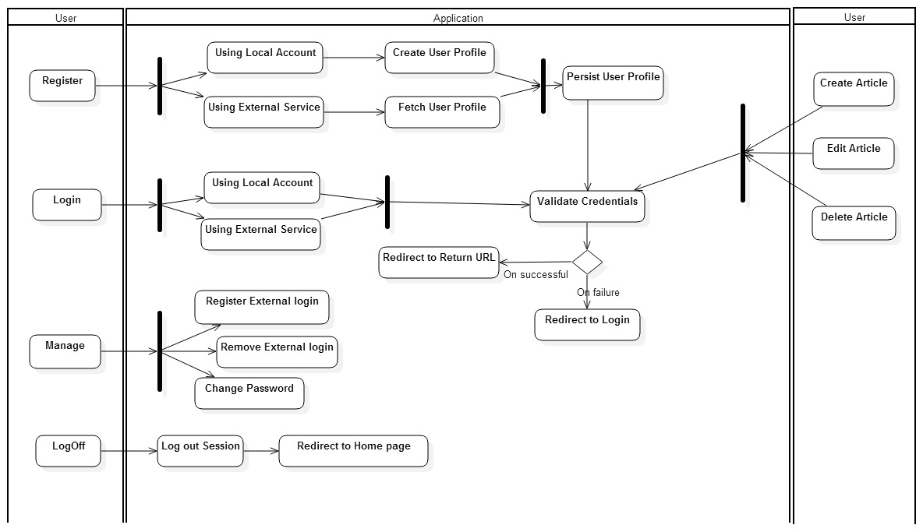

# Sequence Diagram

