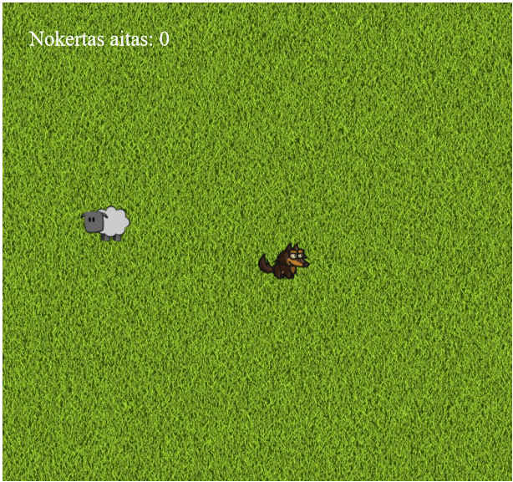

Uz 2d canvas bāzēta spēle, kur vilks ķer aitu. Pēc katras reizes kad aita noķerta, vilks atdzimst laukuma centrā un aita random vietā. Tiek skaitīts cik reizes aita noķerta.

*// Vilks un aita atdzimst jaunas vietas, kad vilks noker aitu***var** *reset* = **function** () {  
 *// Novietojam vilku centra* ***wolf***.**x** = ***canvas***.**width** / 2;  
 ***wolf***.**y** = ***canvas***.**height** / 2;  
  
 *// Aita atdzimst random pozicija uz canvas* ***sheep***.**x** = 32 + (***Math***.random() * (***canvas***.**width** - 64));  
 ***sheep***.**y** = 32 + (***Math***.random() * (***canvas***.**height** - 64));  
};

*// Atjaunojam speles objektus***var** *update* = **function** (modifier) {  
 **if** (38 in ***keysDown***) { *// Tiek tureta bultina uz augshu* ***wolf***.**y** -= ***wolf***.**speed** * modifier;  
 }  
 **if** (40 in ***keysDown***) { *// Tiek tureta bultina uz leju* ***wolf***.**y** += ***wolf***.**speed** * modifier;  
 }  
 **if** (37 in ***keysDown***) { *// Tiek tureta bultina pa kreisi* ***wolf***.**x** -= ***wolf***.**speed** * modifier;  
 }  
 **if** (39 in ***keysDown***) { *// Tiek tureta bultina pa labi* ***wolf***.**x** += ***wolf***.**speed** * modifier;  
 }  
  
 *// Parbaudam vai aita nokerta...* **if** (  
 ***wolf***.**x** <= (***sheep***.**x** + 32)  
 && ***sheep***.**x** <= (***wolf***.**x** + 32)  
 && ***wolf***.**y** <= (***sheep***.**y** + 32)  
 && ***sheep***.**y** <= (***wolf***.**y** + 32)  
 ) {  
 ++***sheepsCaught***;  
 *reset*();  
 }  
};

*// uzzīmējam visu*

**var** *render* = **function** () {  
 **if** (***backgroundReady***) {  
 ***ctx***.drawImage(***backgroundImage***, 0, 0);  
 }  
  
 **if** (***wolfReady***) {  
 ***ctx***.drawImage(***wolfImage***, ***wolf***.**x**, ***wolf***.**y**);  
 }  
  
 **if** (***sheepReady***) {  
 ***ctx***.drawImage(***sheepImage***, ***sheep***.**x**, ***sheep***.**y**);  
 }  
  
 *// Attelojam rezultatu* ***ctx***.**fillStyle** = **"rgb(250, 250, 250)"**;  
 ***ctx***.**font** = **"25px Aerial"**;  
 ***ctx***.**textAlign** = **"left"**;  
 ***ctx***.**textBaseline** = **"top"**;  
 ***ctx***.fillText(**"Nokertas aitas: "** + ***sheepsCaught***, 32, 32);  
};

*// palaižam spēli*

**var** *main* = **function** () {  
  
 **var** now = Date.now();  
 **var** delta = now - ***then***;  
  
 *update*(delta / 1000);  
 *render*();  
  
 ***then*** = now;  
  
 **requestAnimationFrame**(*main*);  
};