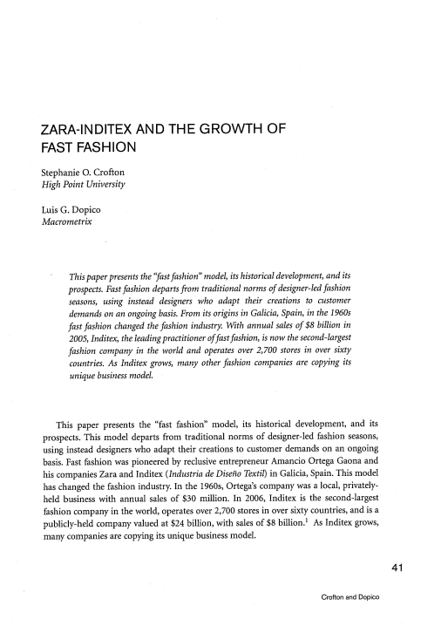
ZARA-INDITEX AND THE GROWTH OF
FAST FASHION
Stephanie 0. Crofton
High Point University
Luis G. Dopico
Macrometrix
This paper presents the “fastfashion” model, its historical development, and its prospects. Fastfashion departsfrom traditional norms of designer-led fashion seasons, using instead designers who adapt their creations to customer demands on an ongoing basis. From its origins in Galicia, Spain, in the 1960s fast fashion changed the fashion industry. With annual sales of $8 billion in 2005, Inditex, the leadingpractitioner offastfashion, is now the second-largest fashion company in the world and operates over 2,700 stores in over sixty countries. As Inditex grows, many other fashion companies are copying its unique business model.
This paper presents the “fast fashion” model, its historical development, and its prospects. This model departs from traditional norms of designer-led fashion seasons, using instead designers who adapt their creations to customer demands on an ongoing basis. Fast fashion was pioneered by reclusive entrepreneur Amancio Ortega Gaona and his companies Zara and Inditex (Industria de Diseno Textil) in Galicia, Spain. This model has changed the fashion industry. In the 1960s, Ortega’s company was a local, privately held business with annual sales of $30 million. In 2006, Inditex is the second-largest publicly-held company valued at $24 billion, with sales of $8 billion. 1 As Inditex grows,
fashion company in the world, operates over 2,700 stores in over sixty countries, and is a many companies are copying its unique business model.
41
Crofton and Dopico
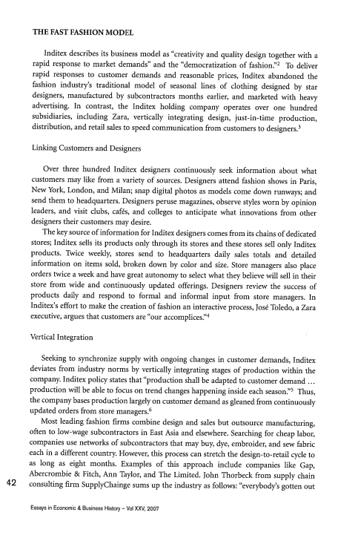
THE FAST FASHION MODEL
rapid response to market demands” and the “democratization of fashion.” 2 To deliver
Inditex describes its business model as “creativity and quality design together with a
rapid responses to customer demands and reasonable prices, Inditex abandoned the fashion industry’s traditional model of seasonal lines of clothing designed by star designers, manufactured by subcontractors months earlier, and marketed with heavy advertising. In contrast, the Inditex holding company operates over one hundred distribution, and retail sales to speed communication from customers to designers. 3
subsidiaries, including Zara, vertically integrating design, just-in-time production,
Linking Customers and Designers
Over three hundred Inditex designers continuously seek information about what customers may like from a variety of sources. Designers attend fashion shows in Paris, New York, London, and Milan; snap digital photos as models come down runways; and send them to headquarters. Designers peruse magazines, observe styles worn by opinion leaders, and visit clubs, cafés, and colleges to anticipate what innovations from other designers their customers may desire.
The key source of information for Inditex designers comes from its chains of dedicated stores; Inditex sells its products only through its stores and these stores sell only Inditex products. Twice weekly, stores send to headquarters daily sales totals and detailed information on items sold, broken down by color and size. Store managers also place orders twice a week and have great autonomy to select what they believe will sell in their store from wide and continuously updated offerings. Designers review the success of products daily and respond to formal and informal input from store managers. In
executive, argues that customers are “our accomplices.” 4
Inditex’s effort to make the creation of fashion an interactive process, José Toledo, a Zara
Vertical Integration
Seeking to synchronize supply with ongoing changes in customer demands, Inditex deviates from industry norms by vertically integrating stages of production within the production will be able to focus on trend changes happening inside each season’ 5Thus,
company. Inditex policy states that “production shall be adapted to customer demand updated orders from store managers. 6
the company bases production largely on customer demand as gleaned from continuously
Most leading fashion firms combine design and sales but outsource manufacturing, often to low-wage subcontractors in East Asia and elsewhere. Searching for cheap labor, companies use networks of subcontractors that may buy, dye, embroider, and sew fabric each in a different country. However, this process can stretch the design-to-retail cycle to as long as eight months. Examples of this approach include companies like Gap, Abercrombie & Fitch, Ann Taylor, and The Limited. John Thorbeck from supply chain 42 consulting firm SupplyChainge sums up the industry as follows: “everybody’s gotten out
Essays in Economic & Business History — Vol XXV, 2007
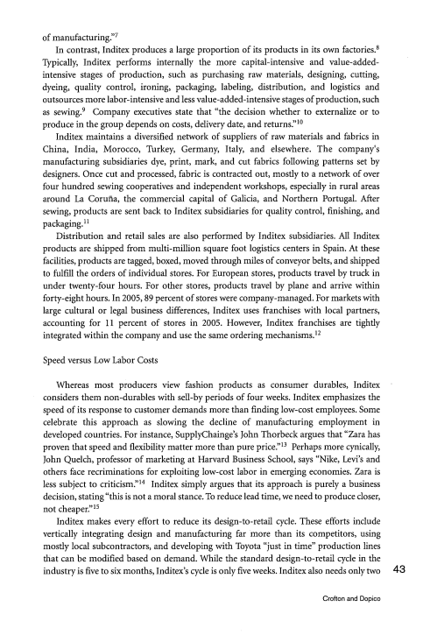
of manufacturing’ 7
In contrast, Inditex produces a large proportion of its products in its own factories. 8 Typically, Inditex performs internally the more capital-intensive and value-added intensive stages of production, such as purchasing raw materials, designing, cutting, dyeing, quality control, ironing, packaging, labeling, distribution, and logistics and as sewing. 9 Company executives state that “the decision whether to externalize or to
outsources more labor-intensive and less value-added-intensive stages of production, such
produce in the group depends on costs, delivery date, and returns”°
Inditex maintains a diversified network of suppliers of raw materials and fabrics in China, India, Morocco, Turkey, Germany, Italy, and elsewhere. The company’s manufacturing subsidiaries dye, print, mark, and cut fabrics following patterns set by designers. Once cut and processed, fabric is contracted out, mostly to a network of over four hundred sewing cooperatives and independent workshops, especially in rural areas around La Coruna, the commercial capital of Galicia, and Northern Portugal. After sewing, products are sent back to Inditex subsidiaries for quality control, finishing, and packaging.”
Distribution and retail sales are also performed by Inditex subsidiaries. All Inditex products are shipped from multi-million square foot logistics centers in Spain. At these facilities, products are tagged, boxed, moved through miles of conveyor belts, and shipped to fulfill the orders of individual stores. For European stores, products travel by truck in under twenty-four hours. For other stores, products travel by plane and arrive within forty-eight hours. In 2005, 89 percent of stores were company-managed. For markets with large cultural or legal business differences, Inditex uses franchises with local partners,
integrated within the company and use the same ordering mechanisms.’ 2 accounting for 11 percent of stores in 2005. However, Inditex franchises are tightly
Speed versus Low Labor Costs
Whereas most producers view fashion products as consumer durables, Inditex - considers them non-durables with sell-by periods of four weeks. Inditex emphasizes the speed of its response to customer demands more than finding low-cost employees. Some celebrate this approach as slowing the decline of manufacturing employment in proven that speed and flexibility matter more than pure price.” 3 Perhaps more cynically,
developed countries. For instance, SupplyChainge’s John Thorbeck argues that “Zara has
John Quelch, professor of marketing at Harvard Business School, says “Nike, Levi’s and less subject to criticism” 4Inditex simply argues that its approach is purely a business
others face recriminations for exploiting low-cost labor in emerging economies. Zara is not cheaper.” 5
decision, stating “this is not a moral stance. To reduce lead time, we need to produce closer,
Inditex makes every effort to reduce its design-to-retail cycle. These efforts include vertically integrating design and manufacturing far more than its competitors, using mostly local subcontractors, and developing with Toyota “just in time” production lines that can be modified based on demand. While the standard design-to-retail cycle in the industry is five to six months, Inditex’s cycle is only five weeks. Inditex also needs only two 43
Crofton and Dopico
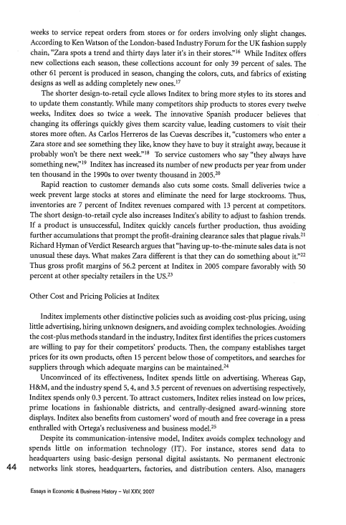
weeks to service repeat orders from stores or for orders involving only slight changes. chain, “Zara spots a trend and thirty days later it’s in their stores.” 6 While Inditex offers
According to Ken Watson of the London-based Industry Forum for the UK fashion supply
new collections each season, these collections account for only 39 percent of sales. The other 61 percent is produced in season, changing the colors, cuts, and fabrics of existing
designs as well as adding completely new ones.’ 7
The shorter design-to-retail cycle allows Inditex to bring more styles to its stores and to update them constantly. While many competitors ship products to stores every twelve weeks, Inditex does so twice a week. The innovative Spanish producer believes that changing its offerings quickly gives them scarcity value, leading customers to visit their stores more often. As Carlos Herreros de las Cuevas describes it, “customers who enter a Zara store and see something they like, know they have to buy it straight away, because it probably won’t be there next To service customers who say “they always have
something new:” 9Inditex has increased its number of new products per year from under ten thousand in the 1990s to over twenty thousand in ^{2005.20}
Rapid reaction to customer demands also cuts some costs. Small deliveries twice a week prevent large stocks at stores and eliminate the need for large stockrooms. Thus, inventories are 7 percent of Inditex revenues compared with 13 percent at competitors. The short design-to-retail cycle also increases Inditex’s ability to adjust to fashion trends. further accumulations that prompt the profit-draining clearance sales that plague rivals. 2’
If a product is unsuccessful, Inditex quickly cancels further production, thus avoiding
Richard Hyman ofVerdict Research argues that “having up-to-the-minute sales data is not unusual these days. What makes Zara different is that they can do something about it.” 22 Thus gross profit margins of 56.2 percent at Inditex in 2005 compare favorably with 50 percent at other specialty retailers in the US. 23
Other Cost and Pricing Policies at Inditex
Inditex implements other distinctive policies such as avoiding cost-plus pricing, using little advertising, hiring unknown designers, and avoiding complex technologies. Avoiding the cost-plus methods standard in the industry, Inditex first identifies the prices customers are willing to pay for their competitors’ products. Then, the company establishes target prices for its own products, often 15 percent below those of competitors, and searches for
suppliers through which adequate margins can be maintained. 24
Unconvinced of its effectiveness, Inditex spends little on advertising. Whereas Gap, H&M, and the industry spend 5,4, and 3.5 percent of revenues on advertising respectively, Inditex spends only 0.3 percent. To attract customers, Inditex relies instead on low prices, prime locations in fashionable districts, and centrally-designed award-winning store
enthralled with Ortega’s reclusiveness and business model. 2’
displays. Inditex also benefits from customers’ word of mouth and free coverage in a press
Despite its communication-intensive model, Inditex avoids complex technology and spends little on information technology (IT). For instance, stores send data to headquarters using basic-design personal digital assistants. No permanent electronic 44 networks link stores, headquarters, factories, and distribution centers. Also, managers
Essays in Economic & Business History — Vol XXV, 2007
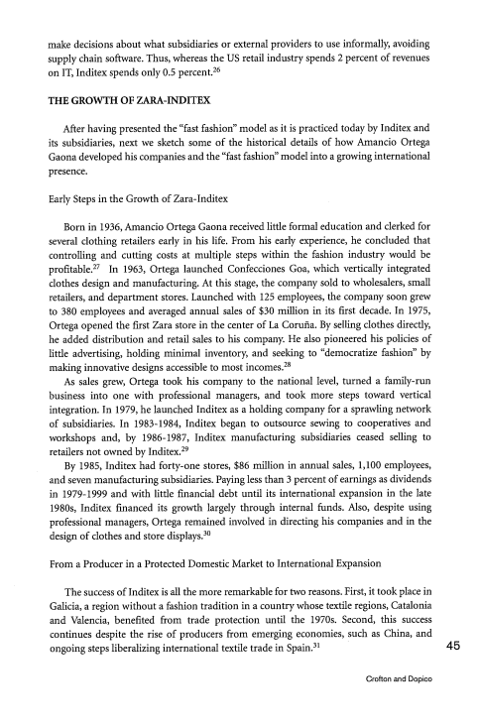
make decisions about what subsidiaries or external providers to use informally, avoiding supply chain software. Thus, whereas the US retail industry spends 2 percent of revenues
on IT, Inditex spends only 0.5 percent. 26
THE GROWTH OF ZARA-INDITEX
After having presented the “fast fashion” model as it is practiced today by Inditex and its subsidiaries, next we sketch some of the historical details of how Amancio Ortega Gaona developed his companies and the “fast fashion” model into a growing international presence.
Early Steps in the Growth of Zara-Inditex
Born in 1936, Amancio Ortega Gaona received little formal education and clerked for several clothing retailers early in his life. From his early experience, he concluded that controlling and cutting costs at multiple steps within the fashion industry would be
profitable. 27 In 1963, Ortega launched Confecciones Goa, which vertically integrated clothes design and manufacturing. At this stage, the company sold to wholesalers, small retailers, and department stores. Launched with 125 employees, the company soon grew to 380 employees and averaged annual sales of $30 mfflion in its first decade. In 1975, Ortega opened the first Zara store in the center of La Coruña. By selling clothes directly, he added distribution and retail sales to his company. He also pioneered his policies of little advertising, holding minimal inventory, and seeking to “democratize fashion” by
making innovative designs accessible to most incomes. 28
As sales grew, Ortega took his company to the national level, turned a family-run business into one with professional managers, and took more steps toward vertical integration. In 1979, he launched Inditex as a holding company for a sprawling network of subsidiaries. In 1983-1984, Inditex began to outsource sewing to cooperatives and workshops and, by 1986-1987, Inditex manufacturing subsidiaries ceased selling to
retailers not owned by Inditex, 29
By 1985, Inditex had forty-one stores, $86 million in annual sales, 1,100 employees, and seven manufacturing subsidiaries. Paying less than 3 percent of earnings as dividends in 1979-1999 and with little financial debt until its international expansion in the late 1980s, Inditex financed its growth largely through internal funds. Also, despite using
design of clothes and store displays. 3°
professional managers, Ortega remained involved in directing his companies and in the
From a Producer in a Protected Domestic Market to International Expansion
The success of Inditex is all the more remarkable for two reasons. First, it took place in Galicia, a region without a fashion tradition in a country whose textile regions, Catalonia and Valencia, benefited from trade protection until the 1970s. Second, this success ongoing steps liberalizing international textile trade in Spain. 3’ 45
continues despite the rise of producers from emerging economies, such as China, and Crofton and Dopico
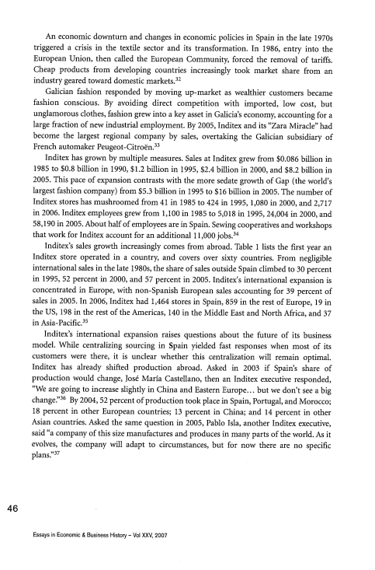
An economic downturn and changes in economic policies in Spain in the late 1970s triggered a crisis in the textile sector and its transformation. In 1986, entry into the European Union, then called the European Community, forced the removal of tariffs. Cheap products from developing countries increasingly took market share from an
industry geared toward domestic markets. 32
Galician fashion responded by moving up-market as wealthier customers became fashion conscious. By avoiding direct competition with imported, low cost, but unglamorous clothes, fashion grew into a key asset in Galicia’s economy, accounting for a large fraction of new industrial employment. By 2005, Inditex and its “Zara Miracle” had French automaker Peugeot-Citroen. 33
become the largest regional company by sales, overtaking the Galician subsidiary of
Inditex has grown by multiple measures. Sales at Inditex grew from $0.086 billion in 1985 to $0.8 bfflion in 1990, $1.2 billion in 1995, $2.4 billion in 2000, and $8.2 bfflion in 2005. This pace of expansion contrasts with the more sedate growth of Gap (the world’s largest fashion company) from $5.3 billion in 1995 to $16 bfflion in 2005. The number of Inditex stores has mushroomed from 41 in 1985 to 424 in 1995, 1,080 in 2000, and 2,717 in 2006. Inditex employees grew from 1,100 in 1985 to 5,018 in 1995, 24,004 in 2000, and 58,190 in 2005. About half of employees are in Spain. Sewing cooperatives and workshops that work for Inditex account for an additional 11,000 jobs. 34
Inditex’s sales growth increasingly comes from abroad. Table 1 lists the first year an Inditex store operated in a country, and covers over sixty countries. From negligible international sales in the late 1980s, the share of sales outside Spain climbed to 30 percent in 1995, 52 percent in 2000, and 57 percent in 2005. Inditex’s international expansion is concentrated in Europe, with non-Spanish European sales accounting for 39 percent of sales in 2005. In 2006, Inditex had 1,464 stores in Spain, 859 in the rest of Europe, 19 in in Asia-Pacific. 35
the US, 198 in the rest of the Americas, 140 in the Middle East and North Africa, and 37
Inditex’s international expansion raises questions about the future of its business model. While centralizing sourcing in Spain yielded fast responses when most of its customers were there, it is unclear whether this centralization will remain optimal. Inditex has already shifted production abroad. Asked in 2003 if Spain’s share of production would change, José MarIa Castellano, then an Inditex executive responded, “We are going to increase slightly in China and Eastern Europe... but we don’t see a big
change.” 36 By 2004, 52 percent of production took place in Spain, Portugal, and Morocco; 18 percent in other European countries; 13 percent in China; and 14 percent in other Asian countries. Asked the same question in 2005, Pablo Isla, another Inditex executive, said “a company of this size manufactures and produces in many parts of the world. As it evolves, the company will adapt to circumstances, but for now there are no specific
plans.” 37
46
Essays in Economic & Business History — Vol XXV, 2007
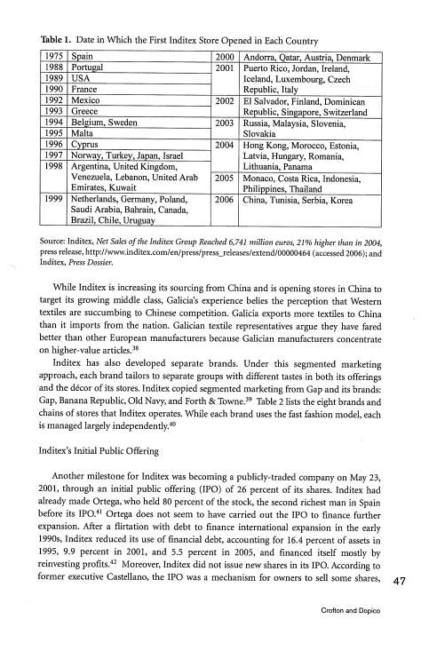
Table 1. Date in Which the First Inditex Store Opened in Each Country
1975 Spain 2000 Andorra, Qatar, Austria, Denmark 1988 Portugal 2001 Puerto Rico, Jordan, Ireland, 1989 USA Iceland, Luxembourg, Czech 1990 France Republic, Italy
1992 Mexico 2002 El Salvador, Finland, Dominican 1993 Greece Republic, Singapore, Switzerland 1994 Belgium, Sweden 2003 Russia, Malaysia, Slovenia, 1995 Malta Slovakia
1996 Cyprus 2004 Hong Kong, Morocco, Estonia, 1997 Norway, Turkey, Japan, Israel Latvia, Hungary, Romania, 1998 Argentina, United Kingdom, Lithuania, Panama
Venezuela, Lebanon, United Arab 2005 Monaco, Costa Rica, Indonesia, Emirates, ^{Kuwait} Philippines, Thailand
1999 Netherlands, Germany, Poland, 2006 China, Tunisia, Serbia, Korea Saudi Arabia, Bahrain, Canada,
Brazil, Chile, Uruguay
Source: Inditex, Net Sales of the Inditex Group Reached 6,741 million euros, 21% higher than in 2004, press release, http://www.inditex.com/en/press/press_releases/extend/00000464 _{(accessed 2006); and} Inditex, Press Dossier.
While Inditex is increasing its sourcing from China and is opening stores in China to target its growing middle class, Galicia’s experience belies the perception that Western textiles are succumbing to Chinese competition. Galicia exports more textiles to China than it imports from the nation. Galician textile representatives argue they have fared better than other European manufacturers because Galician manufacturers concentrate
on higher-value articles. 38
Inditex has also developed separate brands. Under this segmented marketing approach, each brand tailors to separate groups with different tastes in both its offerings and the decor of its stores. Inditex copied segmented marketing from Gap and its brands:
Gap, Banana Republic, Old Navy, and Forth & Towne. 39 Table 2 lists the eight brands and is managed largely independently. 40
chains of stores that Inditex operates. While each brand uses the fast fashion model, each
Inditex’s Initial Public Offering
Another milestone for Inditex was becoming a publicly-traded company on May 23, 2001, through an initial public offering (IPO) of 26 percent of its shares. Inditex had before its IPO. 4’Ortega does not seem to have carried out the IPO to finance further
already made Ortega, who held 80 percent of the stock, the second richest man in Spain
expansion. Aiter a flirtation with debt to finance international expansion in the early 1990s, Inditex reduced its use of financial debt, accounting for 16.4 percent of assets in 1995, 9.9 percent in 2001, and 5.5 percent in 2005, and financed itself mostly by
reinvesting profits. 42 Moreover, Inditex did not issue new shares in its IPO. According to former executive Castellano, the IPO was a mechanism for owners to sell some shares,
Crofton and Dopico
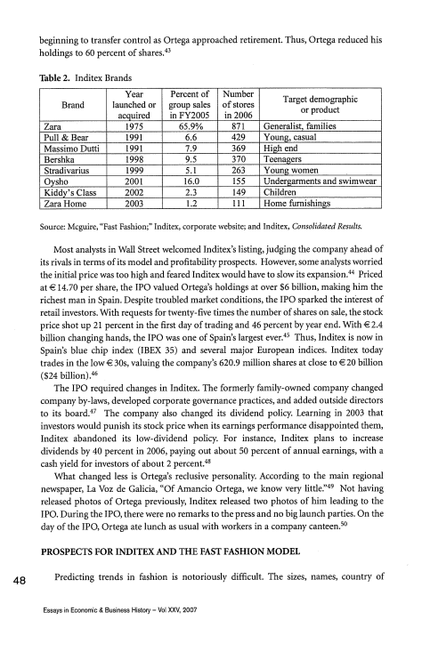
beginning to transfer control as Ortega approached retirement. Thus, Ortega reduced his holdings to 60 percent of shares. 43
Table 2. Inditex Brands
Year Percent of Number
Brand launched or _{group sales of stores} Target demographic or product _{acquired in FY2005 in 2006}
Zara 1975 65.9% 871 Generalist, families Pull & Bear 1991 6.6 429 Young, casual
Massimo Dutti 1991 7.9 369 High end
Bershka 1998 9.5 370 Teenagers
Stradivarius 1999 5.1 263 Young women
Oysho 2001 16.0 155 Undergarments and swimwear Kiddy’s Class 2002 2.3 149 Children
Zara Home 2003 1.2 111 Home furnishings Source: Mcguire, “Fast Fashion;” Inditex, corporate website; and Inditex, Consolidated Results.
Most analysts in Wall Street welcomed Inditex’s listing, judging the company ahead of its rivals in terms of its model and profitability prospects. However, some analysts worried
the initial price was too high and feared Inditex would have to slow its expansion. 44 Priced at €14.70 per share, the IPO valued Ortega’s holdings at over $6 billion, making him the richest man in Spain. Despite troubled market conditions, the IPO sparked the interest of retail investors. With requests for twenty-five times the number of shares on sale, the stock price shot up 21 percent in the first day of trading and 46 percent by year end. With €2.4
billion changing hands, the IPO was one of Spain’s largest ever. 45 Thus, Inditex is now in Spain’s blue chip index (IBEX 35) and several major European indices. Inditex today trades in the low € 30s, valuing the company’s 620.9 mfflion shares at close to €20 billion
($24 billion). 46
The IPO required changes in Inditex. The formerly family-owned company changed company by-laws, developed corporate governance practices, and added outside directors to its board. 47 The company also changed its dividend policy. Learning in 2003 that investors would punish its stock price when its earnings performance disappointed them, Inditex abandoned its low-dividend policy. For instance, Inditex plans to increase dividends by 40 percent in 2006, paying out about 50 percent of annual earnings, with a
cash yield for investors of about 2 percent. 48
What changed less is Ortega’s reclusive personality. According to the main regional newspaper, La Voz de Galicia, “Of Amancio Ortega, we know very little’ 49 Not having released photos of Ortega previously, Inditex released two photos of him leading to the day of the IPO, Ortega ate lunch as usual with workers in a company canteen. 5°
IPO. During the IPO, there were no remarks to the press and no big launch parties. On the
PROSPECTS FOR INDITEX AND THE FAST FASHION MODEL
48 Predicting trends in fashion is notoriously difficult. The sizes, names, country of Essays in Economic & Business History — Vol XXV, 2007
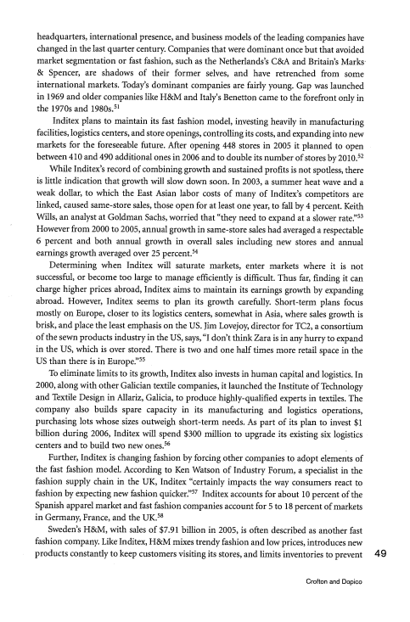
headquarters, international presence, and business models of the leading companies have changed in the last quarter century. Companies that were dominant once but that avoided market segmentation or fast fashion, such as the Netherlands’s C&A and Britain’s Marks & Spencer, are shadows of their former selves, and have retrenched from some international markets. Today’s dominant companies are fairly young. Gap was launched the 1970s and 1980s. 5’
in 1969 and older companies like H&M and Italy’s Benetton came to the forefront only in
Inditex plans to maintain its fast fashion model, investing heavily in manufacturing facilities, logistics centers, and store openings, controlling its costs, and expanding into new markets for the foreseeable future. After opening 448 stores in 2005 it planned to open between 410 and 490 additional ones in 2006 and to double its number of stores by ^{2010.52}
iVhile Inditex’s record of combining growth and sustained profits is not spotless, there is little indication that growth will slow down soon. In 2003, a summer heat wave and a weak dollar, to which the East Asian labor costs of many of Inditex’s competitors are linked, caused same-store sales, those open for at least one year, to fall by 4 percent. Keith Wills, an analyst at Goldman Sachs, worried that “they need to expand at a slower rate.” 53 However from 2000 to 2005, annual growth in same-store sales had averaged a respectable 6 percent and both annual growth in overall sales including new stores and annual
earnings growth averaged over 25 percent. 54
Determining when Inditex will saturate markets, enter markets where it is not successful, or become too large to manage efficiently is difficult. Thus far, finding it can charge higher prices abroad, Inditex aims to maintain its earnings growth by expanding abroad. However, Inditex seems to plan its growth carefully. Short-term plans focus mostly on Europe, closer to its logistics centers, somewhat in Asia, where sales growth is brisk, and place the least emphasis on the US. Jim Lovejoy, director for TC2, a consortium of the sewn products industry in the US, says, “I don’t think Zara is in any hurry to expand in the US, which is over stored. There is two and one half times more retail space in the
US than there is in Europe.” 55
To eliminate limits to its growth, Inditex also invests in human capital and logistics. In 2000, along with other Galician textile companies, it launched the Institute of Technology and Textile Design in Allariz, Galicia, to produce highly-qualified experts in textiles. The company also builds spare capacity in its manufacturing and logistics operations, purchasing lots whose sizes outweigh short-term needs. As part of its plan to invest $1 billion during 2006, Inditex will spend $300 million to upgrade its existing six logistics centers and to build two new ones. 56
Further, Inditex is changing fashion by forcing other companies to adopt elements of the fast fashion model. According to Ken Watson of Industry Forum, a specialist in the fashion supply chain in the UK, Inditex “certainly impacts the way consumers react to
fashion by expecting new fashion quicker.” 57 Inditex accounts for about 10 percent of the Spanish apparel market and fast fashion companies account for 5 to 18 percent of markets in Germany, France, and the UK. 58
Sweden’s H&M, with sales of $7.91 billion in 2005, is often described as another fast fashion company. Like Inditex, H&M mixes trendy fashion and low prices, introduces new products constantly to keep customers visiting its stores, and limits inventories to prevent 49
Crofton and Dopico
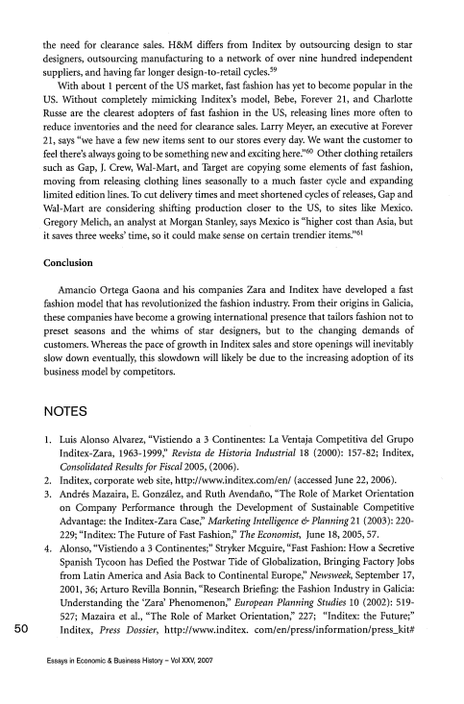
the need for clearance sales. H&M differs from Inditex by outsourcing design to star designers, outsourcing manufacturing to a network of over nine hundred independent suppliers, and having far longer design-to-retail cycles. 59
With about 1 percent of the US market, fast fashion has yet to become popular in the US. Without completely mimicking Inditex’s model, Bebe, Forever 21, and Charlotte Russe are the clearest adopters of fast fashion in the US, releasing lines more often to reduce inventories and the need for clearance sales. Larry Meyer, an executive at Forever feel there’s always going to be something new and exciting here.” 6°Other clothing retailers
21, says “we have a few new items sent to our stores every day. We want the customer to
such as Gap, _{1.} Crew, Wal-Mart, and Target are copying some elements of fast fashion, moving from releasing clothing lines seasonally to a much faster cycle and expanding limited edition lines. To cut delivery times and meet shortened cycles of releases, Gap and Wal-Mart are considering shifting production closer to the US, to sites like Mexico. Gregory Melich, an analyst at Morgan Stanley, says Mexico is “higher cost than Asia, but it saves three weeks’ time, so it could make sense on certain trendier items.” 61
Conclusion
Amancio Ortega Gaona and his companies Zara and Inditex have developed a fast fashion model that has revolutionized the fashion industry From their origins in Galicia, these companies have become a growing international presence that tailors fashion not to preset seasons and the whims of star designers, but to the changing demands of customers. Whereas the pace of growth in Inditex sales and store openings will inevitably slow down eventually, this slowdown will likely be due to the increasing adoption of its business model by competitors.
NOTES
1. Luis Alonso Alvarez, “Vistiendo a 3 Continentes: La Ventaja Competitiva del Grupo Inditex-Zara, 1963-1999:’ Revista de Historia Industrial 18 (2000): 157-82; Inditex, Consolidated Resultsfor Fiscal 2005, (2006).
2. Inditex, corporate web site, http://www.inditex.com/en/ (accessed June 22, 2006). 3. Andrés Mazaira, E. Gonzalez, and Ruth Avendano, “The Role of Market Orientation on Company Performance through the Development of Sustainable Competitive Advantage: the Inditex-Zara Case:’ Marketing Intelligence & Planning 21 (2003): 220- 229; “Inditex: The Future of Fast Fashion:’ The Economist, June 18, 2005, 57. 4. Alonso, “Vistiendo a 3 Continentes;” Stryker Mcguire, “Fast Fashion: How a Secretive Spanish Tycoon has Defied the Postwar Tide of Globalization, Bringing Factory Jobs from Latin America and Asia Back to Continental Europe:’ Newsweek, September 17, 2001, 36; Arturo Revifia Bonnin, “Research Briefing: the Fashion Industry in Galicia: Understanding the ‘Zara’ Phenomenon:’ European Planning Studies 10 (2002): 519- 527; Mazaira et al., “The Role of Market Orientation’ 227; “Inditex: the Future;” 50 Inditex, Press Dossier, http://www.inditex. com/en/press/information/press_kit#
Essays in Economic & Business History — Vol XXV, 2007
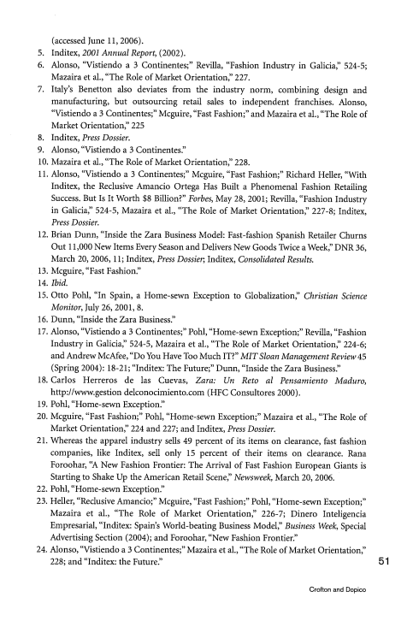
(accessed June 11, 2006).
5. Inditex, 2001 Annual Report, (2002).
6. Alonso, “Vistiendo a 3 Continentes;” Revilla, “Fashion Industry in Galicia,” 524-5; Mazaira et al., “The Role of Market Orientation:’ 227.
7. Italy’s Benetton also deviates from the industry norm, combining design and manufacturing, but outsourcing retail sales to independent franchises. Alonso, “Vistiendo a 3 Continentes;” Mcguire, “Fast Fashion;” and Mazaira et al., “The Role of Market Orientation,” 225
8. Inditex, Press Dossier.
9. Alonso, “Vistiendo a 3 Continentes’
10. Mazaira et a!., “The Role of Market Orientation,” 228.
11. Alonso, “Vistiendo a 3 Continentes;” Mcguire, “Fast Fashion;” Richard Heller, “With Inditex, the Reclusive Amancio Ortega Has Built a Phenomenal Fashion Retailing Success. But Is It Worth $8 Bfflion?” Forbes, May 28, 2001; Revifia, “Fashion Industry in Galicia,” 524-5, Mazaira et al., “The Role of Market Orientation,” 227-8; Inditex, Press Dossier.
12. Brian Dunn, “Inside the Zara Business Model: Fast-fashion Spanish Retailer Churns Out 11,000 New Items Every Season and Delivers New Goods Twice a Week,” DNR 36, March 20, 2006, 11; Inditex, Press Dossier Inditex, Consolidated Results.
13. Mcguire, “Fast Fashion.”
14. Ibid.
15. Otto Pohl, “In Spain, a Home-sewn Exception to Globalization,” Christian Science Monitor, July 26, 2001, 8.
16. Dunn, “Inside the Zara Business’
17. Alonso, “Vistiendo a 3 Continentes;” Pohl, “Home-sewn Exception;” Revilla, “Fashion Industry in Galicia,” 524-5, Mazaira et al., “The Role of Market Orientation,” 224-6; and Andrew McAfee, “Do You Have Too Much IT?” MIT Sloan Management Review 45 (Spring 2004): 18-2 1; “Inditex: The Future;” Dunn, “Inside the Zara Business.”
18. Carlos Herreros de las Cuevas, Zara: Un Reto al Pensamiento Maduro, http://www.gestion delconocimiento.com (HFC Consultores 2000).
19. Pohl, “Home-sewn Exception:’
20. Mcguire, “Fast Fashion;” Pohl, “Home-sewn Exception;” Mazaira et al., “The Role of Market Orientation,” 224 and 227; and Inditex, Press Dossier.
21. ‘vVhereas the apparel industry sells 49 percent of its items on clearance, fast fashion companies, like Inditex, sell only 15 percent of their items on clearance. Rana Foroohar, “A New Fashion Frontier: The Arrival of Fast Fashion European Giants is Starting to Shake Up the American Retail Scene,” Newsweek, March 20, 2006.
22. Pohl, “Home-sewn Exception.”
23. Heller, “Reclusive Amancio;” Mcguire, “Fast Fashion;” Pohl, “Home-sewn Exception;” Mazaira et al., “The Role of Market Orientation,” 226-7; Dinero Inteligencia Empresaria!, “Inditex: Spain’s World-beating Business Model,” Business Week, Special Advertising Section (2004); and Foroohar, “New Fashion Frontier.”
24. Alonso, “Vistiendo a 3 Continentes;” Mazaira et ad., “The Role of Market Orientation,” 228; and “Inditex: the Future’ 51
Crofton and Dopico
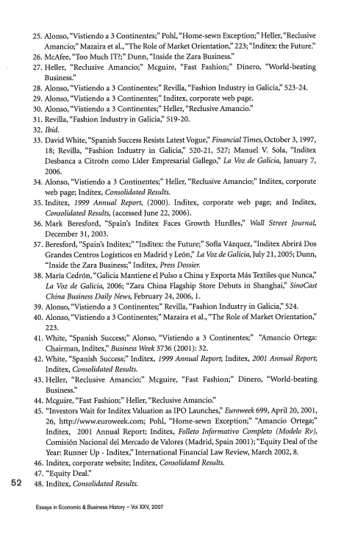
25. Alonso, “Vistiendo a 3 Continentes;” Pohi, “Home-sewn Exception;” Heller, “Reclusive Amancio;” Mazaira et aL, “The Role of Market Orientation:’ 223; “Inditex: the Future’ 26. McAfee, “Too Much IT?;” Dunn, “Inside the Zara Business’
27. HeIler, “Reclusive Ainancio;” Mcguire, “Fast Fashion;” Dinero, “World-beating Business.”
28. Alonso, “Vistiendo a 3 Continentes;” Revilla, “Fashion Industry in Galicia:’ 523-24. 29. Alonso, “Vistiendo a 3 Continentes;” Inditex, corporate web page.
30. Alonso, “Vistiendo a 3 Continentes;” Heller, “Reclusive Amancio’
31. Revilla, “Fashion Industry in Galicia,” 519-20.
32. Ibid.
33. David White, “Spanish Success Resists Latest Vogue:’ Financial Times, October 3, 1997, 18; Revifia, “Fashion Industry in Galicia,” 520-21, 527; Manuel V. Sola, “Inditex Desbanca a Citroën como LIder Empresarial Gallego,” La Voz de Galicia, January 7, 2006.
34. .Alonso, “Vistiendo a 3 Continentes;” Heller, “Reclusive Amancio;” Inditex, corporate web page; Inditex, Consolidated Results.
35. Inditex, 1999 Annual Report, (2000). Inditex, corporate web page; and Inditex, Consolidated Results, (accessed June 22, 2006).
36. Mark Beresford, “Spain’s Inditex Faces Growth Hurdles:’ Wall Street Journal, December 31, 2003.
37. Beresford, “Spain’s Inditex;” “Inditex: the Future;” Sofia Vkzquez, “Inditex Abrirá Dos Grandes Centros LogIsticos en Madrid y Leon:’ La Voz de Galicia, July 21, 2005; Dunn, “Inside the Zara Business;” Inditex, Press Dossier.
38. Maria Cedrón, “Galicia Mantiene el Pulso a China y Exporta Más Textiles que Nunca:’ La Voz de Galicia, 2006; “Zara China Flagship Store Debuts in Shanghai,” SinoCast China Business Daily News, February 24, 2006, 1.
39. Alonso, “Vistiendo a 3 Continentes;” Revilla, “Fashion Industry in Galicia,” 524. 40. Alonso, “Vistiendo a 3 Continentes;” Mazaira et aL, “The Role of Market Orientation,” 223.
41. White, “Spanish Success;” Alonso, “Vistiendo a 3 Continentes;” “Amancio Ortega: Chairman, Inditex,” Business Week 3736 (2001): 32.
42. White, “Spanish Success;” Inditex, 1999 Annual Report, Inditex, 2001 Annual Report, Inditex, Consolidated Results.
43. Heller, “Reclusive Amancio;” Mcguire, “Fast Fashion;” Dinero, “World-beating Business.”
44. Mcguire, “Fast Fashion;” Heller, “Reclusive Amancio’
45. “Investors Wait for Inditex Valuation as IPO Launches:’ Euroweek 699, April 20, 2001, 26, http://www.euroweek.com; PohI, “Home-sewn Exception;” “Ainancio Ortega;” Inditex, 2001 Annual Report; Inditex, Folleto Informativo Completo (Modelo Rv), Comisión Nacional del Mercado de Valores (Madrid, Spain 2001); “Equity Deal of the Year: Runner Up ₋ Inditex,” International Financial Law Review, March 2002, 8.
46. Inditex, corporate website; Inditex, Consolidated Results.
47. “Equity Deal.”
52 48. Inditex, Consolidated Results.
Essays in Economic & Business History — Vol XXV, 2007
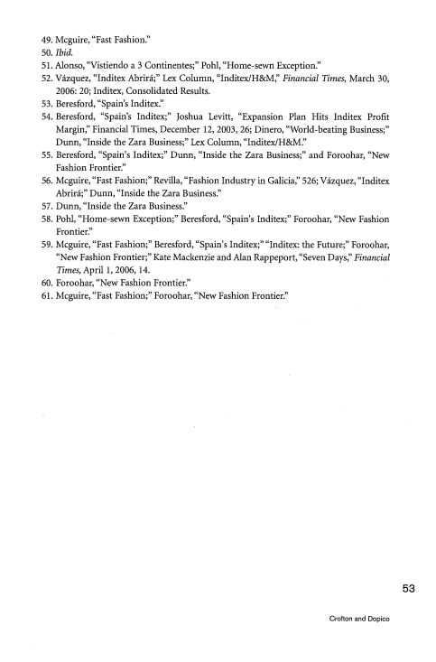
49. Mcguire, “Fast Fashion.”
50. Ibid.
51. Alonso, “Vistiendo a 3 Continentes;” Pohi, “Home-sewn Exception.”
52. Vázquez, “Inditex Abrirá;” Lex Column, “InditexlH&M’ Financial Times, March 30, 2006: 20; Inditex, Consolidated Results.
53. Beresford, “Spain’s Inditex’
54. Beresford, “Spain’s Inditex;” Joshua Levitt, “Expansion Plan Hits Inditex Profit Margin’ Financial Times, December 12, 2003, 26; Dinero, “World-beating Business;” Dunn, “Inside the Zara Business;” Lex Column, “Inditex/H&M’
55. Beresford, “Spain’s Inditex;” Dunn, “Inside the Zara Business;” and Foroohar, “New Fashion Frontier’
56. Mcguire, “Fast Fashion;” Revilla, “Fashion Industry in Galicia’ 526; Vázquez, “Inditex Abrirá;” Dunn, “Inside the Zara Business.”
57. Dunn, “Inside the Zara Business.”
58. Pohl, “Home-sewn Exception;” Beresford, “Spain’s Inditex;” Foroohar, “New Fashion Frontier’
59. Mcguire, “Fast Fashion;” Beresford, “Spain’s Inditex;” “Inditex: the Future;” Foroohar, “New Fashion Frontier;” Kate Mackenzie and Alan Rappeport, “Seven Days’ Financial Times, April 1, 2006, 14.
60. Foroohar, “New Fashion Frontier.”
61. Mcguire, “Fast Fashion;” Foroohar, “New Fashion Frontier’
53
Crofton and Dopico

54
Essays in Economic & Business History — Vol XXV, 2007

