Progress Report: Week 4
Project Phase: Multi-Provider Data Collection, Rebuilt for the 10-Category Dataset

1. Goal
This revised Week 4 report replaces the prior Week 4 submission, which was built against the incomplete 5-category dataset. The goal of this revision was to rebuild the three provider runners (Gemini, Mistral, Groq) to correctly target the corrected 220-prompt, 10-category dataset from the Week 3 revision, and to close remaining gaps identified against the project proposal: tracking temperature and latency as explicit variables (Proposal Section 2), capturing a controlled environment specification, and supporting the 20-prompt stochastic reliability sample (5x repetition) established in Week 3.

2. Method
Each of the three provider runners retains the safety architecture verified in the original Week 4 build — proactive throttling, reactive backoff with jitter, persistent-error detection with early stop, atomic cache writes, and resume-by-cache-file — while adding three new capabilities. First, repeat-count awareness: prompts marked stochastic_sample in the dataset are called 5 times each, with each run saved to its own file (e.g. gemini_P037_run1.json through run5.json), while the remaining 200 prompts are called once as before; resume logic now operates per individual run, not just per prompt, so an interrupted repeat-set resumes only the missing runs. Second, every API call now records a fixed temperature (0.7, held constant across all three providers for fair comparison) and measured latency in seconds. Third, a separate environment-capture script records the controlled environment (OS, CPU, RAM, Python version, SDK versions, network status, model configuration) as a timestamped snapshot, satisfying the proposal's Controlled Environment requirement.

3. Process

3.1 Repeat-Count Logic
Each runner's run() method now iterates per run rather than strictly per prompt: standard prompts execute once, while the 20 stochastic-sample prompts execute their full repeat_count. Cache-checking, atomic writes, and the persistent-error stop logic all operate at the level of an individual run, so a script interrupted partway through a 5-run set resumes only the missing runs rather than re-doing completed ones or skipping the whole prompt.
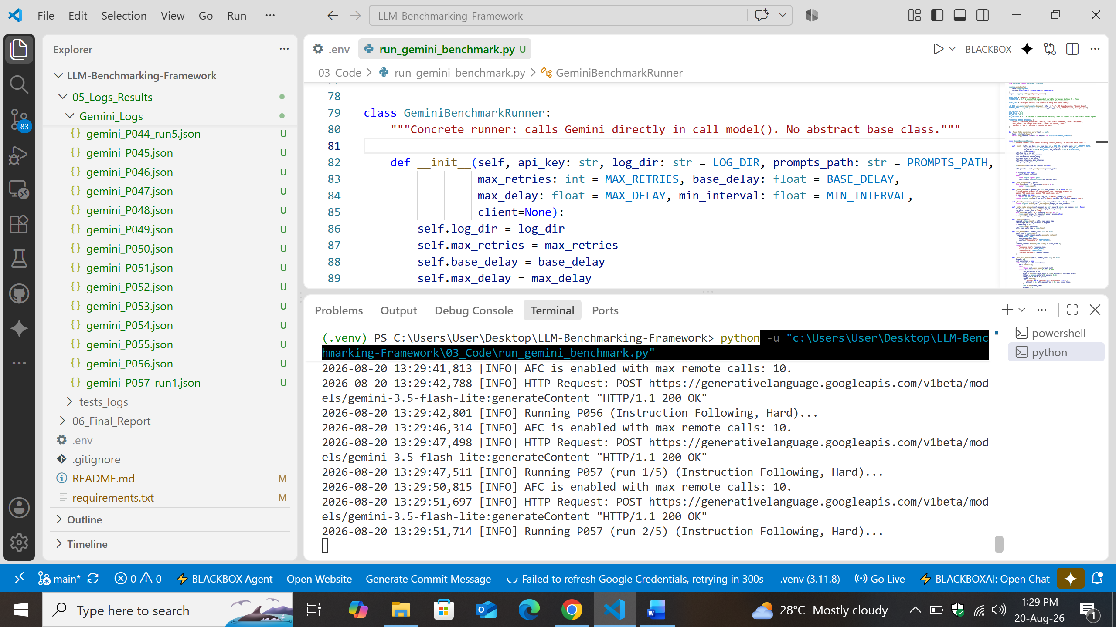

3.2 Temperature and Latency Tracking
Temperature is fixed at 0.7 across all three providers as a controlled variable, passed explicitly in every API call. Latency is measured by timing the API call itself (not including throttle wait time), rounded to four decimal places, and saved into every response record alongside the response text.
[ Insert Screenshot: a real saved response JSON file showing populated temperature and latency_seconds fields ]

3.3 Controlled Environment Capture
capture_environment.py records the operating system, CPU, RAM, Python version, installed SDK versions, network connectivity status, and the fixed model/temperature configuration for all three providers, saved as a timestamped JSON snapshot. This is intended to be run at the start of each data collection session, so any run-to-run inconsistency can later be checked against whether the environment itself changed.
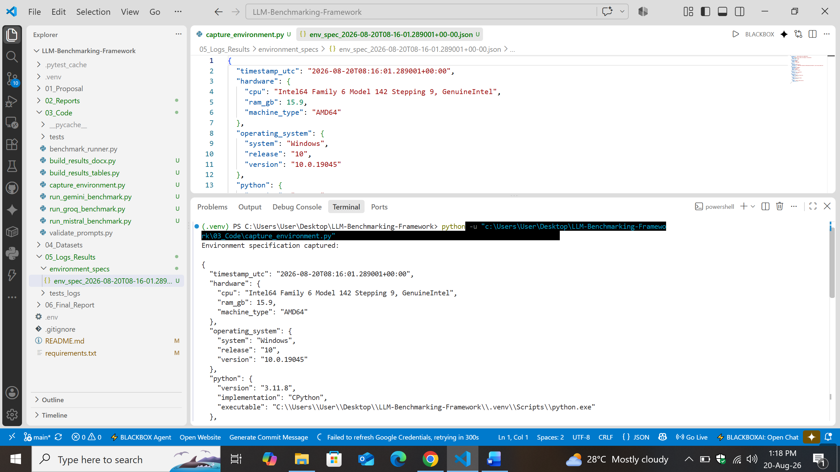

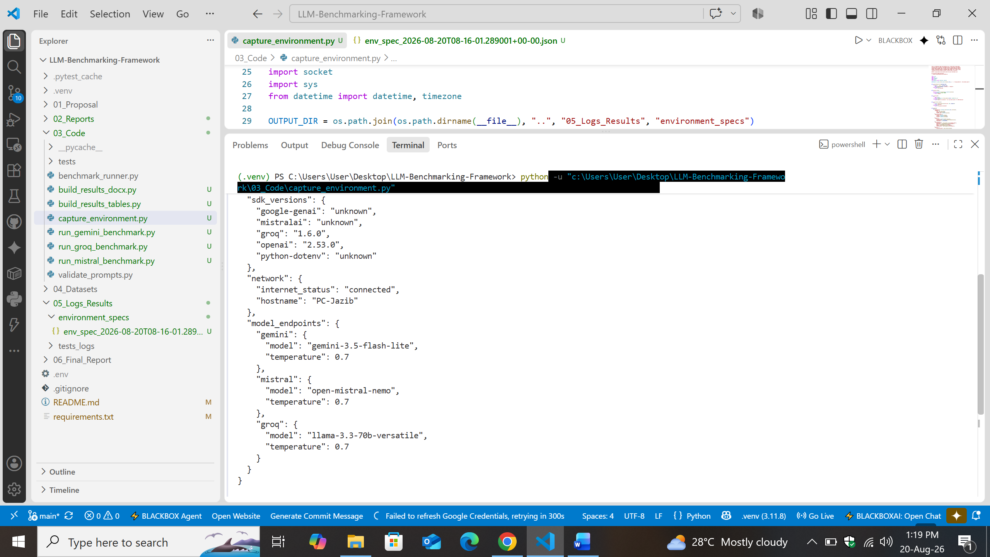
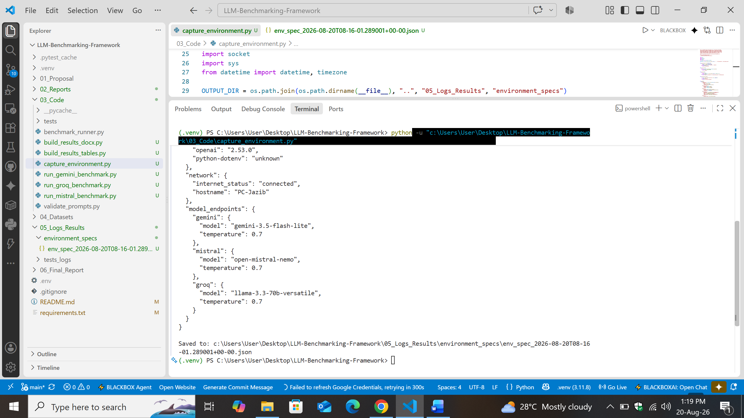

3.4 Results Consolidation, Updated for Multi-Run Data
build_results_tables.py and build_results_docx.py were updated to correctly group the 5 separate response files belonging to each stochastic-sample prompt into a single record with a uniform runs array, rather than treating each run as an unrelated entry. The consolidation script also reports any prompt with an incomplete run count (fewer than the expected 5), so a partially-completed collection session is never silently treated as finished. The human-readable Word output highlights stochastic-sample prompts and displays all of their response variants together, clearly labeled, so run-to-run variation is directly visible to a reader.
[ Insert Screenshot: Readable_Results docx showing a stochastic-sample prompt with all 5 runs visible ]

3.5 Supervisor Compliance & Validation
The repeat-count logic, temperature/latency capture, and multi-run consolidation grouping were each verified against representative test scenarios prior to being used for real data collection, including the specific edge case of an interrupted repeat-set (partial completion) to confirm resume logic operates correctly at the individual-run level rather than only the prompt level. Real execution against the live provider APIs, and the corresponding screenshots, are the next step following this report.

4. Results
- Three provider runners (Gemini, Mistral, Groq) rebuilt to target the 220-prompt, 10-category dataset, with repeat-count logic supporting the 20-prompt stochastic reliability sample.
- Temperature (fixed, controlled) and latency (measured) now recorded in every response, addressing the proposal's Variables requirement.
- Environment capture script built and produces a complete, timestamped environment specification.
- Results consolidation scripts updated to correctly handle both single-run and multi-run (5x) prompt data without conflating or losing any response.
[ Insert Screenshot: real execution output from each of the three providers, and the resulting Gemini_Logs / Mistral_Logs / Groq_Logs folders ]
[ Insert Screenshot: final repository view showing all updated runner scripts, capture_environment.py, and the consolidation scripts, committed ]

Next Steps
Execute all three runners for real against the full 220-prompt dataset (300 calls per provider, accounting for the stochastic sample), capture the environment specification at the start of the collection session, then proceed to Week 5's automated scoring using the already-built llm_judge_scorer.py, which includes explicit success/failure scoring anchors per the supervisor's requirement.

