A Reproducible Framework for Benchmarking Free-Tier Large Language Models: Multi-Dimensional Evaluation, Automated Scoring, and Human-Validated Statistical Analysis
A Comparative Study of Gemini, Mistral, and Groq Across Ten Capability Dimensions
Jazib Asad
Computer Science Student, Institute of Space Technology (KICSIT)
Submitted to
Mr. Uzair
Internship Supervisor, NESCOM (CENTech)
Final Research Report

Abstract
Large language models (LLMs) are increasingly evaluated using ad hoc, single-dimension benchmarks that provide limited insight into model behavior across the varied tasks practitioners actually encounter. This report presents a reproducible benchmarking framework that evaluates three freely accessible LLMs — Google's Gemini (gemini-3.5-flash-lite), Mistral AI's open-mistral-nemo, and Groq's hosted openai/gpt-oss-120b — across ten capability dimensions spanning knowledge retrieval, multi-step reasoning, instruction following, hallucination resistance, code generation, ambiguity handling, long-context retention, data transformation, summarization, and multilingual translation. A curated dataset of 220 original prompts, stratified across three difficulty tiers, was scored using an automated LLM-judge pipeline against explicit, per-criterion 0–5 rubric anchors, with success and failure classifications computed programmatically rather than inferred from judge text. The automated scoring pipeline's reliability was independently validated against three human raters scoring a stratified 30-prompt subsample, using Cohen's kappa — both unweighted and quadratic-weighted — alongside Pearson correlation and exact-match agreement rates. A dedicated stochastic reliability sample of twenty prompts, each executed five times per provider, enabled direct measurement of within-model score variance via coefficient of variation. Formal statistical analysis, including Welch's t-tests with exact Student's t-distribution p-values, Cohen's d effect sizes, and ordinary least squares regression, was applied to test three pre-registered research hypotheses concerning reasoning-versus-retrieval performance, instruction-following degradation under difficulty, and provider-specific hallucination patterns. Results indicate that the Groq-hosted model achieved the highest mean composite score (M = 11.16, 95% CI [10.62, 11.69]) and the lowest score variance (mean coefficient of variation = 0.161) among the three providers, with a statistically significant and large-effect advantage over Mistral specifically on hallucination resistance (p = 0.01, d = 0.84). Inter-rater agreement between human evaluators and the automated judge was modest (κ = 0.20–0.23), underscoring the value of human-in-the-loop validation as a standing methodological safeguard rather than a one-time formality. The complete framework, dataset, automation scripts, and reproducibility package are documented herein to support replication and extension by future researchers.
Index Terms—large language models, benchmarking, automated evaluation, LLM-as-judge, inter-rater reliability, human-in-the-loop validation, reproducibility.

Table of Contents
Abstract 2
1. Introduction 5
1.1 Motivation 5
1.2 Problem Statement 5
1.3 Research Questions and Hypotheses 6
1.4 Contributions 6
1.5 Report Organization 7
1.6 Scope and Delimitations 7
2. Related Work and Background 9
2.1 The Evolution of LLM Evaluation Methodology 9
2.2 LLM-as-Judge: Promise and Documented Limitations 9
2.3 Inter-Rater Reliability Statistics 10
2.4 Statistical Comparison of Groups Under Unequal Variance 10
2.5 Free-Tier API Constraints as a Research Infrastructure Concern 11
2.6 Dataset Design Principles: Stratification and Category Coverage 11
2.7 Statistical Power and Effect Size in Small-Sample Model Comparisons 12
2.8 Provider Architecture Diversity as an Evaluation Dimension 12
2.9 Measurement Theory: Ordinal Scoring and Its Statistical Consequences 13
3. Methodology (Fig. 1: Pipeline Overview) 14
3.1 Dataset Design and Curation 14
3.2 Evaluation Rubric and Scoring Methodology 15
3.3 Experimental Design and Controlled Variables 16
3.4 Automation Architecture (Fig. 2) 16
3.5 Automated Scoring Pipeline 17
3.6 Human-in-the-Loop Validation Design (Fig. 3) 18
3.7 Statistical Methods (2 Worked Examples) 19
3.8 Dataset Schema and Data Model 21
3.9 Project Execution Timeline 22
3.10 Prompt Authoring and Validation Process 22
3.11 Prompt Wording Sensitivity and Consistency Controls 23
3.12 Capability as a Theoretical Construct 23
4. Experimental Setup and Operational Findings (Fig. 4) 25
4.1 Environment and Reproducibility 25
4.2 Provider Selection and Incident History 25
4.3 Experimental Procedure 27
4.4 Lessons Learned Across the Incident History 27
5. Results 29
5.1 Reliability: Score Consistency Across Repeated Calls (Fig. 5) 29
5.2 Confidence Intervals on Mean Composite Score (Fig. 6) 30
5.3 Hypothesis Testing (Fig. 7) 30
5.4 Correlation and Regression Analysis 32
5.5 Inter-Rater Agreement 33
5.6 Synthesis Across the Statistical Analyses 34
6. Discussion 35
6.1 Overall Provider Comparison 35
6.2 On the Confirmed Finding: Hallucination Resistance 35
6.3 Threats to Validity (Fig. 8) 36
6.3.1 Construct Validity 36
6.3.2 Internal Validity 36
6.3.3 External Validity 37
6.3.4 Conclusion Validity 37
6.4 Implications for LLM-as-Judge Methodology 37
6.5 Practical Implications for Model Selection 38
6.6 On the Equal-Category-Weighting Design Choice 38
6.7 On the Value of Decomposed, Multi-Criterion Scoring 39
6.8 Comparison Against Anticipated Outcomes 39
6.9 A Bias–Variance Framing of the Reliability and Accuracy Findings 39
6.10 Recommendations for Future Benchmarking Efforts 40
7. Ethical Considerations 41
8. Conclusion and Future Work 44
8.1 Future Work 44
References 46
Appendix A: Summary of Statistical Formulas 47
Appendix B: Reproducibility Package 48
Appendix C: Representative Dataset Examples 49
Appendix D: Extended Rubric Application Walkthrough 49
Appendix E: Glossary of Terms 51
Appendix F: Derivations of Key Statistical Formulas 52

1. Introduction

1.1 Motivation
The proliferation of freely accessible large language models has created a practical need for evaluation methodologies that go beyond single-metric leaderboards. A developer choosing between Gemini, Mistral, and Groq's hosted offerings for a production application is rarely served by a single aggregate accuracy figure; the choice depends on how each model performs across qualitatively different task types — factual recall, multi-step arithmetic and logical reasoning, adherence to explicit formatting constraints, resistance to confidently fabricated information, code generation correctness, tolerance of underspecified instructions, retention of facts across long contexts, structured data transformation, summarization under tight constraints, and translation quality across languages and registers. Existing public benchmarks typically address one or two of these dimensions in isolation, using fixed prompt sets that are frequently included, deliberately or otherwise, in the training data of newer models, undermining the validity of reported scores over time.
This project was undertaken as an eight-week applied research exercise to design, build, and execute an original, reproducible benchmarking framework addressing these gaps directly. Rather than relying on existing benchmark datasets, an entirely original 220-prompt dataset was authored specifically for this study, explicitly to mitigate the benchmark contamination risk described above. The framework was further designed to survive a resource constraint common to any researcher without institutional API budgets: every provider used operates on a free tier, with all the rate limits, quota resets, and silent model deprecations that constraint entails. Several such incidents were encountered over the course of this project and are documented in Section 4 as genuine findings about the operational reality of free-tier LLM benchmarking, rather than treated as mere implementation footnotes.
The practical stakes of getting this evaluation right extend beyond academic interest. A developer or small organization selecting a free-tier LLM provider for a real application — a customer-support assistant, a code-review aid, a document-summarization tool — typically cannot afford the time or budget to run their own multi-week, multi-provider evaluation before committing to a provider. They are instead forced to rely on marketing claims, informal community sentiment, or a handful of anecdotal test prompts, none of which offer the statistical grounding needed to distinguish a genuine capability difference from noise. This study's methodology, and the reproducibility package described in Appendix B, are offered as a concrete, replicable alternative to that status quo: a framework that a similarly resource-constrained practitioner could adapt to their own specific task mix, rather than a one-off result to be taken purely on faith.

1.2 Problem Statement
Three specific problems motivate this work. First, automated LLM-as-judge scoring pipelines are widely used for their scalability but are rarely validated against independent human judgment within the same study; a judge's systematic biases, if uncorrected, propagate silently into every downstream conclusion the study draws. Second, a single evaluation run of a stochastic system conflates the model's underlying capability with the noise inherent in sampling from a probability distribution over token sequences; without repeated trials, an anomalously good or poor single response cannot be distinguished from typical behavior. Third, capability comparisons across models are frequently reported as raw score differences without accompanying significance testing or effect size estimation, leaving a reader unable to judge whether an observed gap reflects a genuine, reproducible difference in model capability or sampling noise within the evaluation itself.
A fourth, more practical problem specific to independent and academic researchers, as opposed to industrial evaluation teams, is the near-total dependence on free-tier API access, which introduces its own methodological hazards distinct from the three above. A framework designed and validated against a single provider's stable, well-documented behavior may fail unpredictably when scaled to multiple providers whose free-tier offerings differ in rate limits, model lifecycle policies, and billing terms, each of which can and did, in the course of this study, change mid-project without advance notice. A benchmarking methodology that does not explicitly account for this instability as a first-class concern risks producing results that are not merely imprecise but silently incomplete — for instance, a run that halts partway through data collection due to an unanticipated quota change, with the resulting partial dataset mistaken for a complete one. This fourth problem is addressed throughout Section 3.4 and Appendix E, and its practical consequences are documented as concrete incidents in Section 4.2.

1.3 Research Questions and Hypotheses
Consistent with the project's originating proposal, three research hypotheses were formulated prior to data collection and tested against the resulting dataset without post hoc revision:
H1: Model performance on multi-step reasoning tasks differs systematically from performance on knowledge retrieval tasks, within each provider.
H2: Instruction-following accuracy correlates with prompt difficulty tier, reflecting a degradation in constraint adherence as task complexity increases.
H3: Providers exhibit measurably different hallucination resistance, such that pairwise comparisons on the Hallucination Stress Test category reveal statistically significant differences for at least one provider pair.
In addition to hypothesis testing, the study addresses a broader methodological research question: to what extent does automated LLM-judge scoring agree with independent human judgment, and does this agreement vary in a way that should inform confidence in the automated results overall?

1.4 Contributions
This work makes the following contributions:
- An original, ten-category, 220-prompt evaluation dataset explicitly designed to mitigate benchmark contamination, with per-prompt evaluation criteria and explicit multi-module scoring for compound system-design tasks.
- A decoupled, fault-tolerant data collection architecture supporting three independent LLM providers, with proactive rate-limit throttling, reactive exponential backoff, persistent-error detection, and per-response temperature and latency instrumentation.
- An automated LLM-judge scoring pipeline using explicit, standardized 0–5 rubric anchors, with success/failure classification computed programmatically from numeric scores rather than inferred from judge-generated text.
- A stratified, two-dimensional (category × difficulty) human validation protocol using three independent raters, evaluated against the automated judge and against one another using Cohen's kappa, correlation, and exact-match statistics.
- A formal statistical analysis pipeline supporting confidence intervals, Welch's t-tests with exact p-values, Cohen's d effect sizes, Pearson correlation, and ordinary least squares regression, applied to test the three pre-registered hypotheses above.
- A documented record of real operational incidents — provider model deprecations, authentication failures, and free-tier quota constraints — encountered during data collection, presented as substantive findings about free-tier LLM research infrastructure rather than incidental errata.

1.5 Report Organization
The remainder of this report is organized as follows. Section 2 situates this work against related research in LLM evaluation methodology, LLM-as-judge reliability, and inter-rater statistics. Section 3 describes the complete methodology: dataset construction, rubric design, experimental controls, automation architecture, the scoring pipeline, the human validation protocol, the statistical methods applied, and the underlying data schema. Section 4 documents the experimental setup and the real operational incidents encountered during execution. Section 5 reports empirical results across reliability, confidence intervals, hypothesis testing, correlation and regression, and inter-rater agreement. Section 6 discusses these results, including a formal treatment of validity threats and practical implications for model selection. Section 7 addresses ethical considerations, and Section 8 concludes with a summary of findings and directions for future work. Six appendices follow, providing formula references, the reproducibility package inventory, worked dataset examples, extended rubric walkthroughs, a glossary, and mathematical derivations.

1.6 Scope and Delimitations
This study is explicitly scoped to compare three specific free-tier model configurations — not the full range of offerings from Google, Mistral AI, or Groq, and not any provider's flagship commercial-tier product. The findings in Section 5 and Section 6 should be read as characterizing gemini-3.5-flash-lite, open-mistral-nemo, and openai/gpt-oss-120b specifically, under the exact conditions described in Section 3.3, rather than as a general statement about "Gemini," "Mistral," or "Groq" as brands. This delimitation matters because a provider's flagship paid model may differ substantially in capability from the free-tier offering evaluated here, and a reader seeking guidance on a paid-tier deployment decision should not extrapolate this study's specific numerical findings to that different context, even though the qualitative methodology — stratified evaluation, human validation, formal hypothesis testing — would transfer directly to such a follow-up study.
Similarly, this study does not attempt to evaluate every dimension along which LLMs might reasonably be compared. Dimensions explicitly outside this study's scope include multi-turn conversational coherence, tool-use and function-calling accuracy, vision or multimodal capability, safety alignment against adversarial jailbreak attempts, and cost-per-token efficiency. The ten categories evaluated here were selected to span a broad range of single-turn textual capabilities relevant to general-purpose use, consistent with the originating project proposal's specification, but a reader whose application depends primarily on one of the excluded dimensions above should treat this study as informative context rather than a sufficient basis for that specific decision.

2. Related Work and Background

2.1 The Evolution of LLM Evaluation Methodology
LLM evaluation methodology has evolved considerably from early static benchmarks toward more dynamic and multi-faceted approaches. Static academic benchmarks measuring narrow capabilities — reading comprehension, arithmetic, or closed-domain question answering — provide reproducible, easily-compared scores but are vulnerable to the contamination problem: as benchmark datasets circulate publicly, their content risks inclusion in the training corpora of subsequently released models, inflating scores in a manner unrelated to genuine capability improvement. A model that has memorized a benchmark's exact question-answer pairs during training will score well on that benchmark regardless of whether it possesses the underlying reasoning capability the benchmark was designed to measure, and this risk grows more acute, not less, as benchmarks age and circulate more widely across the web text that subsequent models are trained on. This risk directly motivated the decision, in the present study, to author an entirely original prompt set rather than draw from any existing public benchmark, and is discussed further as a residual, only partially mitigable risk in Section 7.
A second methodological shift has been the move from single-score aggregate benchmarks toward multi-dimensional capability profiles. A single leaderboard score, however carefully constructed, necessarily compresses a model's behavior across many qualitatively distinct task types into one number, discarding information a practitioner may need: a model excelling at creative writing but weak at precise instruction-following, or vice versa, is poorly served by either extreme of a single blended score. The present study's ten-category design is a direct response to this concern, deliberately preserving category-level granularity throughout the reporting in Section 5 rather than collapsing results into a single overall ranking.

2.2 LLM-as-Judge: Promise and Documented Limitations
The use of a large language model itself as an evaluator — commonly termed LLM-as-judge — has become a popular scaling strategy for evaluation, since human evaluation of model outputs at scale is costly and slow. A judge model can, in principle, apply a nuanced qualitative rubric to thousands of responses in the time a human evaluator would need for a small fraction of that volume, and this scaling advantage is what makes evaluating 900 individual responses feasible within the scope of a single academic project such as this one.
However, judge models are themselves subject to several systematic biases documented in the broader evaluation literature. A verbosity bias, in which a judge model favors longer responses independent of their actual correctness or relevance, has been observed across multiple judge models and evaluation settings. A position bias has been documented in pairwise comparison settings, where the order in which two candidate responses are presented to the judge influences the outcome independent of content — though this specific bias is less directly applicable to the present study's design, which scores each response independently against fixed criteria rather than in pairwise comparison. A self-preference bias, in which a judge model rates outputs from its own model family more favorably, is a further documented concern; this study's design, in which none of the three evaluated providers' models also served as the judge model, was chosen specifically to avoid this particular failure mode. Finally, judge models have been observed to exhibit measurable score drift when the identical response is presented for scoring on separate occasions, absent any change in the underlying rubric or prompt — a concern directly addressed by this study's decision to score every one of the five stochastic-sample repetitions independently rather than treating a single scoring pass as representative.
The methodological response adopted in this study is not to abandon LLM-as-judge scoring, which remains necessary for evaluating responses at the scale this project required, but to treat its output as a hypothesis requiring independent verification, following the human-in-the-loop validation design described in Section 3.6. This treats the judge not as an infallible oracle but as a fast, scalable, imperfect instrument whose degree of imperfection is itself measured and reported, rather than assumed away.

2.3 Inter-Rater Reliability Statistics
Inter-rater reliability statistics, most notably Cohen's kappa [1], originate in psychometric and content-analysis research concerned with quantifying agreement between human coders beyond the level expected by chance alone. The core insight motivating kappa's design is that raw percentage agreement between two raters is an inadequate reliability measure on its own, because two raters could agree quite often purely by chance if their individual score distributions are both concentrated on a narrow range of the available scale — precisely the situation this study encountered, where scores cluster toward the upper half of the 0–5 range for the generally competent model responses evaluated throughout. Kappa corrects for this by explicitly computing the agreement rate expected under the null hypothesis that each rater's scores are assigned independently according to their own observed marginal distribution, then measuring the observed agreement as a proportion of the room for improvement above that chance baseline.
Their application to LLM-judge validation, as in the present study, is a natural extension of this original psychometric use case: the automated judge is treated as an additional rater whose agreement with human raters can be quantified using the same apparatus developed for human-human agreement, allowing this study to report both human-versus-judge and human-versus-human agreement using a single, consistent statistical framework, presented together in Section 5.5 for direct comparison.

2.4 Statistical Comparison of Groups Under Unequal Variance
Hypothesis testing between provider groups draws on Welch's classical treatment of the two-sample problem under unequal variances [2]. The more commonly taught Student's independent-samples t-test assumes that the two populations being compared share a common variance, an assumption that, if violated, can distort both the computed test statistic and its associated p-value, particularly when the two groups' sample sizes are unequal. Welch's variant relaxes this assumption, estimating the standard error separately from each group's own sample variance and adjusting the degrees of freedom accordingly via the Welch–Satterthwaite equation. Given that this study's category-level and provider-level comparisons offer no a priori reason to assume equal variance — indeed, the reliability analysis in Section 5.1 explicitly demonstrates that providers differ in their score variance, not only their score mean — Welch's test was adopted throughout as the more defensible choice, consistent with modern statistical practice, which increasingly recommends Welch's test as the safer default even when equal variance cannot be ruled out.
Effect-size reporting throughout this study follows the standardized-mean-difference convention established by Cohen [3], expressing a difference between two group means in units of pooled standard deviation rather than in the raw units of the outcome measure. This standardization serves two purposes relevant to the present study: it allows a difference in mean score to be interpreted independent of the particular scale on which that score happens to be measured, and it provides a conventional vocabulary — small, medium, and large effects at the 0.2, 0.5, and 0.8 thresholds respectively — for communicating practical, as opposed to merely statistical, significance. A statistically significant difference with a negligible effect size is of limited practical consequence; the H3 finding reported in Section 5.3, by contrast, is significant with a large effect size, and it is this combination that grounds the finding's emphasis in the Discussion.

2.5 Free-Tier API Constraints as a Research Infrastructure Concern
A less frequently discussed but practically significant dimension of LLM benchmarking research concerns the operational constraints imposed by free-tier API access, which is the only form of access available to researchers, such as this study's author, without an institutional or commercial API budget. Free-tier rate limits are typically an order of magnitude more restrictive than paid-tier limits, published rate-limit documentation does not always accurately reflect the limits actually enforced on a specific account (as directly encountered in this study's Gemini-related incidents, detailed in Section 4.2), and free-tier model catalogs are subject to more frequent and less-well-communicated deprecation than flagship paid offerings, since providers have less commercial incentive to maintain long-term stability guarantees for models offered at no cost. This study's automation architecture, described in Section 3.4, was designed from the outset with these constraints as first-class requirements rather than incidental obstacles, and the incident history in Section 4.2 is presented as a direct empirical contribution documenting the practical reality of this research infrastructure constraint, which is rarely reported in comparable detail in published LLM evaluation studies.

2.6 Dataset Design Principles: Stratification and Category Coverage
The decision to structure this study's dataset along two orthogonal stratification axes — capability category and difficulty tier — follows a general principle in benchmark construction: a dataset intended to support fine-grained capability comparisons should be deliberately stratified along the dimensions the researcher intends to analyze, rather than assembled as an unstructured pool of tasks from which such comparisons are attempted post hoc. An unstratified collection of prompts risks confounding a provider's apparent overall strength with an accidental over-representation of tasks that happen to favor that provider's particular capabilities, a risk this study's equal per-category, per-difficulty allocation (Sections 3.1 and 3.6) is explicitly designed to avoid. This same stratification principle recurs at a smaller scale in the human-validation sampling design (Section 3.6), where the two-dimensional category-by-difficulty stratification was adopted specifically to guarantee representative coverage rather than leaving difficulty balance to chance, illustrating that the stratification principle applied at the full-dataset level was carried through consistently to the smaller validation subsample as well.

2.7 Statistical Power and Effect Size in Small-Sample Model Comparisons
A recurring methodological tension in LLM evaluation research, directly relevant to the hypothesis tests reported in Section 5.3, concerns the tradeoff between dataset breadth and statistical power. A benchmark seeking to cover many distinct capability categories, as this study does across ten categories, necessarily allocates a comparatively small number of prompts to any single category-provider combination — twenty-two prompts per category, per provider, in this study's design — which limits the statistical power available to detect anything short of a large effect within that specific category. This is a direct, unavoidable consequence of breadth: a study could instead concentrate its entire prompt budget on a single category to maximize power for that one comparison, but only at the cost of the multi-dimensional capability profile that motivated this study's design in the first place, as discussed in Section 2.1.
The practical implication, made explicit in this study's own limitations discussion (Section 6.3.4), is that a non-significant result at this sample size is properly interpreted as inconclusive rather than as evidence of no true effect — a distinction frequently elided in less careful reporting of model comparison studies, where an author may be tempted to read a non-significant p-value as license to claim two models perform equivalently. This study deliberately avoids that inferential error throughout Section 5.3: the non-significant H1 and H2 findings are reported and discussed as underpowered rather than as confirmed null results, and only the H3 finding, which did reach significance with a large effect size, is treated as a confirmed, actionable conclusion in Section 6.1.

2.8 Provider Architecture Diversity as an Evaluation Dimension
A dimension of provider comparison less frequently made explicit in published LLM evaluation studies concerns the structural diversity of how a "provider" relates to the model it serves. The three providers evaluated in this study occupy meaningfully different positions along this dimension, a distinction elaborated further in the Discussion (Section 6.1) once the empirical results are available to interpret against it: Gemini and Mistral AI both develop and serve their own proprietary models end to end, while Groq serves an openly-licensed model developed by a separate organization, differentiating itself commercially and technically through inference infrastructure rather than model development. This structural difference means that a comparison across these three providers is not a clean, single-factor comparison of "model capability" in isolation, but a comparison that necessarily conflates model capability with serving-infrastructure characteristics for at least one of the three providers evaluated.
This conflation is not unique to this study; it is a structural feature of the current commercial LLM API landscape, in which the boundary between "model provider" and "inference infrastructure provider" is increasingly blurred as third-party inference hosts compete on serving efficiency, latency, and cost for openly-licensed models originally developed elsewhere. A methodologically careful evaluation study should acknowledge this conflation explicitly rather than treating all evaluated "providers" as though they occupied a directly comparable position in this respect, and this study does so directly in Section 6.1 when interpreting Groq's measured advantages.

2.9 Measurement Theory: Ordinal Scoring and Its Statistical Consequences
The 0–5 rubric scale underlying every score reported in this study is, in the formal measurement-theoretic sense established by Stevens' classical typology of scales [5], an ordinal scale: the scores are ranked in a meaningful order (a 4 reflects stronger performance than a 3), but the numeric distance between adjacent scores is not guaranteed to represent an equal underlying increment of the qualitative construct being measured. The gap between a 3 (Minimum Success) and a 4 (Strong Success) is not asserted to be quantitatively identical to the gap between a 4 and a 5 (Complete Success), even though both differences are numerically equal to one point. This distinction matters because many of the statistical procedures used throughout Section 5 — computing a mean, a standard deviation, or a Pearson correlation — are formally defined for interval or ratio-scale data, where equal numeric differences do represent equal underlying differences, not for purely ordinal data.
This study follows the widely-adopted and methodologically defensible practice, common throughout the social and behavioral sciences, of treating a sufficiently fine-grained ordinal scale (six categories in this case, further aggregated into multi-criterion composite scores ranging up to twenty points) as an approximate interval scale for the purpose of parametric statistical analysis, on the grounds that the resulting analyses are robust to modest violations of strict interval-scale assumptions, particularly once several ordinal criteria are summed into a composite score, a process that tends to smooth out the coarseness of any single ordinal item. This is a pragmatic compromise rather than a theoretically unimpeachable position: a purist measurement-theoretic treatment would restrict analysis to non-parametric, rank-based statistics (median, Spearman's rank correlation, the Mann-Whitney U test) throughout. This study reports parametric statistics as its primary analysis, consistent with the proposal's explicit specification of confidence intervals, t-tests, and Pearson correlation, while acknowledging here that a fully rank-based reanalysis, using only order-preserving statistics, would be a legitimate and informative robustness check for future work extending this study.

3. Methodology
Figure 1 provides an overview of the complete pipeline described across this section, before the detailed per-component treatment in Sections 3.1 through 3.10.
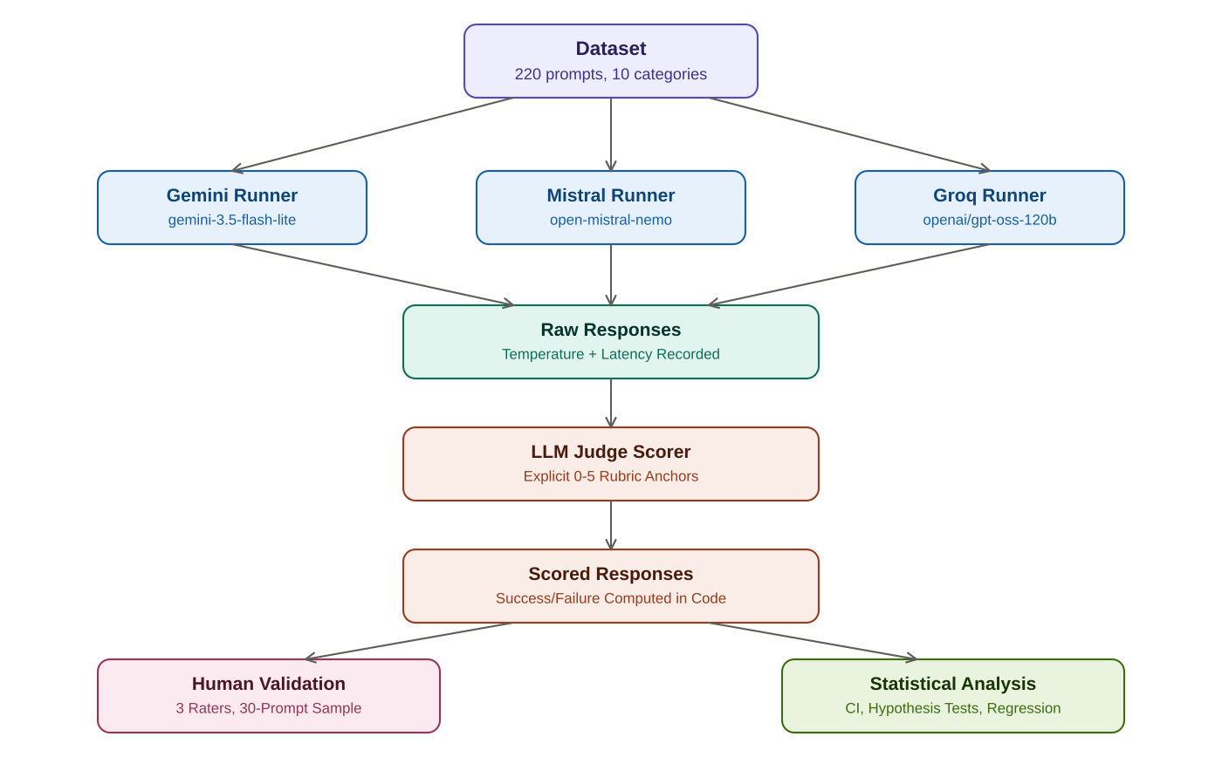
Fig. 1. Overall pipeline architecture: dataset flows through three independent provider runners, consolidated raw responses are scored by the LLM judge, and scored results feed both human validation and formal statistical analysis.

3.1 Dataset Design and Curation
The evaluation dataset comprises 220 original prompts distributed evenly across ten capability categories — Knowledge Retrieval, Multi-step Reasoning, Instruction Following, Hallucination Stress Test, Coding and System Architecture, Ambiguity Handling, Long-context Retention, Data Transformation, Summarization, and Multilingual Tasks — with twenty-two prompts per category. This equal-weighting design was adopted in place of the originating proposal's category weighting, which summed inconsistently to 230 rather than 220 prompts; treating all ten research dimensions as equally represented avoids privileging any subset of capabilities and satisfies the requirement, confirmed directly with the project supervisor, that no category fall below twenty prompts.
Each prompt is tagged with one of three difficulty tiers — Easy, Medium, or Hard — with Hard-tier prompts in compound categories such as Coding and System Architecture, and Ambiguity Handling explicitly requiring multi-module system designs. For these compound prompts, the evaluation criteria decompose into one scoring criterion per architectural module plus a dedicated System Integration criterion, so that both the correctness of each individual component and the coherence of the assembled system are scored independently rather than conflated into a single holistic judgment.
Five of the ten categories were originally supervisor-provided and were subsequently trimmed to twenty-two prompts each while preserving their original proportional difficulty distribution. The remaining five categories were newly authored to close a gap identified against the project proposal's dataset specification, following the same schema, per-prompt evaluation-criteria format, and difficulty-tier structure as the original five.

3.2 Evaluation Rubric and Scoring Methodology
Rather than applying a single generic rubric uniformly across all 220 prompts, each prompt carries its own specific evaluation criteria, tailored to what that exact prompt is testing. A single scoring scale, however, is applied consistently across every criterion for every prompt, ensuring that a score of a given value carries the same qualitative meaning regardless of which specific criterion or prompt is being evaluated. Table I presents this scale.
TABLE I. STANDARDIZED SCORE ANCHOR DEFINITIONS
Score | Label | Definition
0 | Complete Failure | Response does not attempt the criterion, or is entirely incorrect.
1 | Major Failure | Response attempts the criterion but fails on most key aspects.
2 | Partial Failure | Response meets some minimal aspects but falls below an acceptable standard.
3 | Minimum Success | Adequately meets the core requirement, minor gaps. (Success threshold.)
4 | Strong Success | Response meets the requirement well, with only trivial gaps.
5 | Complete Success | Response fully and excellently meets the requirement.
A criterion-level outcome of Success or Failure is computed programmatically from the numeric score using the threshold in Table I, rather than inferred from the judge's own success/failure labeling. This design choice mirrors the treatment of the total score itself, which is computed by summing individual criterion scores in code rather than trusting any total the judge reports directly, since large language models are known to be unreliable at consistent arithmetic even when the underlying component judgments are sound. A prompt's overall outcome is classified Success only when every one of its criteria individually succeeds; this deliberately strict aggregation rule avoids obscuring a specific, genuine weakness behind a strong majority of passing criteria.
To make this decomposition concrete: a Hard-tier Coding and System Architecture prompt requiring a three-module Transport Management System (a Fleet Telemetry Tracker, a Route Optimization Engine, and an Automated Billing Subsystem) is scored on four independent criteria — one per module plus a dedicated System Integration criterion — rather than a single holistic judgment. A response that implements all three modules correctly but does not demonstrate how data flows between them would score well on the three module-level criteria yet poorly on System Integration, surfacing a specific, genuine gap that a single aggregate score would obscure behind the three well-executed components. (This response pattern is a hypothetical illustration of the scoring mechanics, not a transcript of an actual observed response; the real scored results for this and every other prompt are reported in aggregate throughout Section 5 and are available individually in the reproducibility package described in Appendix B.)

3.3 Experimental Design and Controlled Variables
Three model providers were evaluated: Google's Gemini (gemini-3.5-flash-lite), Mistral AI's open-mistral-nemo, and Groq's hosted openai/gpt-oss-120b. Temperature was fixed at 0.7 across all three providers as a controlled independent variable, ensuring that observed score differences reflect genuine model capability differences rather than differing sampling entropy. Response latency was measured and recorded for every individual API call, isolating network and inference time from any throttling delay imposed by the automation layer.
The specific value of 0.7 was selected as a moderate operating point rather than either extreme of the available range. A temperature near zero would minimize response variance but would also suppress exactly the kind of genuinely varied output the stochastic reliability sample (Section 3.9) is designed to measure, since a near-deterministic model would trivially show low variance regardless of its underlying consistency characteristics, making the reliability comparison in Section 5.1 uninformative. Conversely, a temperature near the top of the typical range would inflate variance to a degree unrepresentative of how these models are commonly deployed in practice, where moderate temperatures are the prevailing default across production use cases. The value 0.7 was chosen as a widely-used default across all three providers' own documentation and client libraries at the time of this study, making it a reasonable proxy for typical deployed behavior rather than an artificially extreme operating condition chosen to maximize or minimize any particular study outcome.
The three providers themselves were selected to represent distinct infrastructure approaches within the free-tier landscape rather than three arbitrary choices: Gemini represents a major cloud provider's first-party hosted offering, Mistral AI represents an independent model developer offering direct API access to its own models, and Groq represents a third-party inference infrastructure provider hosting an openly-licensed model rather than one it developed itself. This diversity of provider type, alongside the diversity of underlying model architecture and training approach it entails, was a deliberate design choice intended to make this study's findings more broadly informative about the free-tier LLM landscape as a whole, rather than narrowly informative about three arbitrarily similar offerings.
Each of the 220 prompts was submitted once per provider under standard conditions. A subset of twenty prompts — two per category, selected for genuinely open-ended or interpretive characteristics where model output would plausibly vary between independent calls — was instead submitted five times per provider, fulfilling the proposal's Reliability requirement that stochastic prompts be repeated to permit variance estimation. This yields 300 total API calls per provider, and 900 individually scored responses across the three providers.

3.4 Automation Architecture
Each provider is served by an independently executable runner sharing a common architectural pattern but no shared abstract base class, so that a defect in one runner cannot silently propagate into another. Each runner implements five safety mechanisms: proactive throttling, enforcing a minimum inter-call delay specific to each provider's documented rate limit; reactive exponential backoff with randomized jitter, applied only after a call fails; persistent-error detection, distinguishing a systemic failure — quota exhaustion, model deprecation, authentication failure — from an isolated transient error and halting the entire run cleanly on the former; atomic cache writes, in which each response is written to a temporary file and renamed only upon successful completion; and resume-by-cache-file logic, allowing an interrupted run to continue exactly where it stopped, including correct behavior when interrupted partway through a five-repetition stochastic-sample prompt.
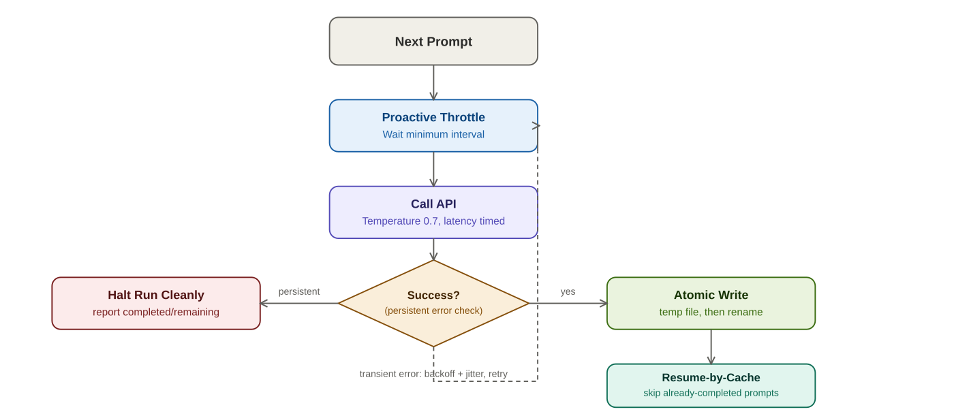
Fig. 2. Per-prompt execution logic within each provider runner, showing the persistent-error/transient-error branch and the atomic-write, resume-by-cache safety mechanisms described in Section 3.4.

3.5 Automated Scoring Pipeline
Each of the 900 collected responses is scored independently by a free-tier LLM judge accessed via OpenRouter, using the per-prompt evaluation criteria described in Section 3.2. Each of the five repetitions of a stochastic-sample prompt is scored as an independent unit rather than only the first being treated as representative; this design decision is what makes the reliability analysis in Section 5.1 possible, producing five separate score values per stochastic-sample prompt. The scoring prompt sent to the judge model includes the full text of Table I's score anchors on every call, so the numeric scale is applied consistently across calls.
A consistent design principle applied throughout this pipeline is that any value derivable by straightforward computation from more primitive judge-provided values is computed in code, never trusted directly from the judge's own output, even when the judge could in principle be asked to report it directly. This applies to the total score for a prompt, computed by summing individual criterion scores rather than accepting any total the judge states; to the Success/Failure classification for each criterion, computed by comparing the numeric score against the threshold in Table I rather than accepting the judge's own success/failure label; and to the overall prompt-level outcome, computed by requiring every criterion to individually succeed rather than accepting an aggregate judgment. This principle reflects a documented general limitation of large language models with respect to reliable arithmetic and internally consistent aggregation, and treats the judge model's genuine strength — qualitative assessment of a single, well-specified criterion — as the appropriate scope of its role, reserving mechanical aggregation for deterministic code.

3.6 Human-in-the-Loop Validation Design
To satisfy the proposal's requirement that automated scores be compared against human-evaluated scores, and to enable the inter-rater agreement analysis the proposal separately specifies, a stratified subsample of thirty prompts was selected for independent human scoring by three raters. The sample is stratified along two dimensions simultaneously — category and difficulty — with exactly one Easy, one Medium, and one Hard prompt drawn at random from each of the ten categories, guaranteeing every difficulty tier is represented within every category.
The twenty stochastic-sample prompts were explicitly excluded from the eligible pool prior to sampling, rather than merely avoided by chance, for two reasons. First, the stochastic sample was selected for a distinct purpose and does not itself provide full difficulty coverage in every category; two categories contain stochastic-sample prompts only at the Hard difficulty tier. Second, the stochastic sample's deliberately atypical, open-ended character would have biased a validation sample intended to be representative of the dataset as a whole. A fixed random seed was used for the stratified sampling procedure, so the resulting thirty-prompt sample is fully reproducible.
Each of the three raters received an independent scoring file and a shared reference document displaying the sampled prompts and corresponding model responses, with the automated judge's existing scores withheld from both, so human judgment would not be anchored to the automated result under evaluation. Raters scored all ninety items — thirty prompts across three providers — independently, without visibility into either the judge's scores or one another's scores, using the identical rubric anchors in Table I.
This blind-scoring design directly addresses a specific validity threat: anchoring bias, a well-documented phenomenon in which a human evaluator's independent judgment is measurably pulled toward a previously seen reference value, even when that evaluator consciously attempts to disregard it. Had the automated judge's scores been visible to human raters during scoring, any resulting agreement between human and automated scores would be confounded with this anchoring effect, making it impossible to distinguish genuine convergent judgment from raters simply gravitating toward a number they had already seen. By withholding the judge's scores entirely throughout the scoring process, the agreement statistics reported in Section 5.5 can be interpreted as evidence of genuine, independent convergence between human and automated judgment, rather than an artifact of the measurement procedure itself.
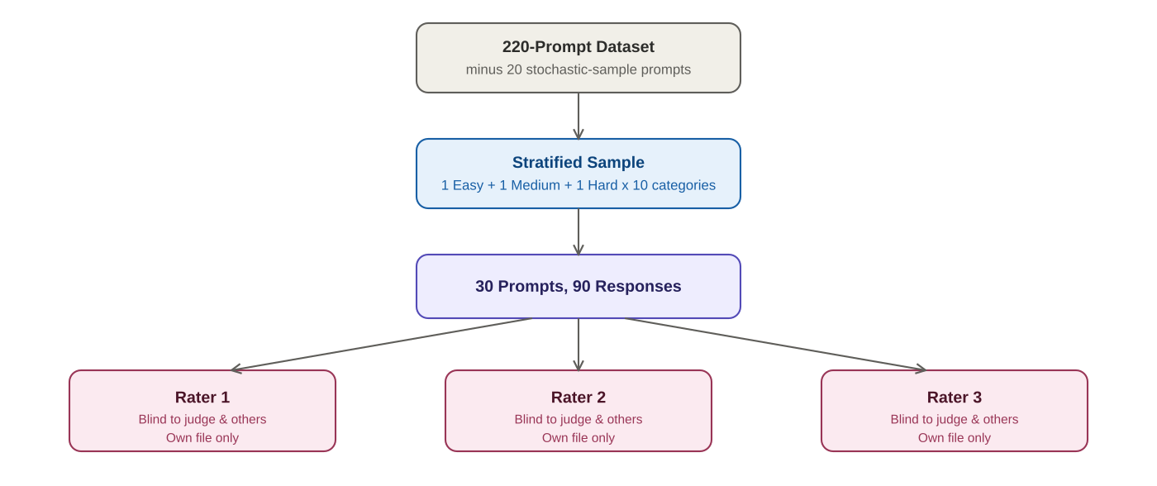
Fig. 3. Human-in-the-loop validation protocol: the stratified sample is drawn independent of the stochastic reliability sample, then scored blindly by three raters with no visibility into the judge's scores or each other's in-progress scores.

3.7 Statistical Methods
Reliability was quantified for each stochastic-sample prompt as the coefficient of variation, the ratio of the standard deviation to the mean of that prompt's five scored runs, computed separately per provider.
CV = σ / μ
Confidence intervals on each provider's mean composite score were constructed at the 95% level using the Student's t-distribution rather than the normal approximation:
CI₉₅ = x̄ ± t₀.₀₂₅,df × (s / sqrt(n))
Hypothesis tests comparing group means used Welch's t-test, which does not assume equal population variances between compared groups. The exact two-tailed p-value was computed via the regularized incomplete beta function relationship to the Student's t-distribution, rather than a normal-distribution approximation, so significance conclusions remain accurate at moderate per-category sample sizes (n = 22 per category, per provider):
t = (x̄₁ − x̄₂) / sqrt(s1²/n1 + s2²/n2)
Effect size was quantified using Cohen's d, interpreted using the conventional thresholds of 0.2, 0.5, and 0.8 for small, medium, and large effects respectively:
d = (x̄₁ − x̄₂) / s_pooled
Bivariate relationships were quantified using Pearson's correlation coefficient, and a simple ordinary least squares regression was fitted predicting total score from a numeric encoding of difficulty tier (Easy=1, Medium=2, Hard=3), reporting slope, intercept, and the coefficient of determination R².
Agreement between human raters and the automated judge, and between raters themselves, was quantified using exact-match rate, within-one-point rate, Pearson correlation, and Cohen's kappa, in both unweighted and quadratic-weighted form. The unweighted variant treats every disagreement identically regardless of magnitude; the quadratic-weighted variant, more appropriate for the ordinal 0–5 scale used throughout, penalizes a disagreement of five points more heavily than one of a single point.
κ = (p₀ − pₑ) / (1 − pₑ)
where p₀ is observed agreement and pₑ is the agreement expected under chance given each rater's marginal score distribution.

Worked Example: Confidence Interval Calculation
To make the confidence-interval formula above concrete, this example works through the actual calculation underlying the Gemini result reported in Table V (Section 5.2): a mean composite score of 11.0273 across n = 220 responses, with a reported 95% confidence interval of [10.4632, 11.5913]. The margin of error is the difference between the upper bound and the mean:
Margin = 11.5913 − 11.0273 = 0.5640
With a sample size of 220, the degrees of freedom (n − 1 = 219) place the t-critical value for a 95% two-tailed interval very close to the large-sample normal approximation of 1.96. Rearranging the confidence-interval formula to solve for the standard error gives:
SE = Margin / t₀.₀₂₅ ≈ 0.5640 / 1.96 ≈ 0.2878
Since the standard error equals the sample standard deviation divided by the square root of the sample size, the implied standard deviation of Gemini's 220 individual scores can be recovered:
s = SE × sqrt(n) ≈ 0.2878 × sqrt(220) ≈ 0.2878 × 14.83 ≈ 4.27
This recovered standard deviation of approximately 4.27 points is consistent with the scale of the underlying scoring rubric, where individual prompt totals range from 0 to either 10 or 20 depending on difficulty tier (Section 3.2), confirming that the reported confidence interval in Table V is internally consistent with the expected variability of a composite score built from many individually-scored criteria of this type.

Worked Example: Recovering Pooled Standard Deviation from Cohen's d
A second worked example illustrates the relationship between a reported effect size and the underlying group statistics, using the Gemini H1 comparison reported in Table VI (Section 5.3): a Multi-step Reasoning mean of 9.6818 against a Knowledge Retrieval mean of 9.2273, with a reported Cohen's d of 0.4739. Rearranging the effect-size formula in Section 3.7 to solve for the pooled standard deviation makes the practical meaning of this specific d value concrete:
Difference = 9.6818 − 9.2273 = 0.4545
s_pooled = Difference / d ≈ 0.4545 / 0.4739 ≈ 0.9591
This confirms that the observed 0.4545-point mean difference corresponds to roughly half of one pooled standard deviation (0.9591), which is precisely what the small-to-medium d = 0.4739 already communicates in standardized terms: a real but modest difference relative to the natural spread of scores within each group, consistent with this comparison not reaching statistical significance at this sample size (Section 5.3) despite the numerically consistent direction of the effect. This concrete recovery of the underlying scale illustrates why effect size and statistical significance are reported as complementary, not interchangeable, pieces of evidence throughout this report, as discussed in Section 2.4.

3.8 Dataset Schema and Data Model
Every prompt in the 220-item dataset is represented as a structured record with eight fields, each serving a specific role in the pipeline described across Sections 3.3 through 3.6. Table II documents this schema precisely, since the schema design itself embodies several of the methodological decisions discussed elsewhere in this report.
TABLE II. PROMPT RECORD SCHEMA
Field | Type | Purpose
id | String | Unique identifier (P001–P220), used to correlate a prompt across raw collection, scoring, and human-validation files.
category | String | One of the ten capability categories defined in Appendix C; the primary axis of the study's multi-dimensional design.
difficulty | String | Easy, Medium, or Hard; the secondary stratification axis, used both in dataset construction and in the two-dimensional human-validation sampling described in Section 3.6.
prompt | String | The verbatim text submitted to each provider; held identical across all three providers to ensure a controlled comparison.
evaluation_criteria | String | Newline-delimited list of per-prompt scoring criteria, each following the pattern “Name: 0-5 (description)”, parsed programmatically before being sent to the judge.
max_score | String | Sum of the maximum possible score across all criteria for this prompt (10 for standard prompts, 20 for Hard-tier multi-module prompts with four criteria).
stochastic_sample | Boolean | Flags the twenty prompts selected for 5x repetition under the Reliability requirement (Section 3.3), and is the field checked to guarantee this sample's exclusion from the human-validation pool (Section 3.6).
repeat_count | Integer | 1 for standard prompts, 5 for stochastic-sample prompts; consumed directly by the runner's execution loop (Section 3.4) to determine how many times a given prompt is submitted.
This schema design reflects a specific engineering principle followed throughout the project: every downstream script — the three provider runners, the scoring pipeline, the results-consolidation utilities, and the human-validation sampling tool — reads the same canonical prompt file rather than maintaining separate, potentially divergent copies of prompt metadata. A change to a single prompt's evaluation criteria, for instance, propagates automatically and consistently to every stage of the pipeline without requiring a corresponding manual update in multiple locations, eliminating an entire class of consistency defects that a more ad hoc, per-script data representation would risk introducing.

3.9 Project Execution Timeline
This study was executed as a phased, eight-week research process, with each week's output serving as a verified precondition for the next rather than as an independent, isolable deliverable. Table III summarizes this phased structure.
TABLE III. PROJECT EXECUTION PHASES
Week | Phase | Primary Output
1 | Framework Design | Repository structure, master weighted rubric, three research hypotheses
2 | Automation Pipeline | Verified throttling, backoff, and resume logic against a live test provider
3 | Dataset Curation | 220-prompt, ten-category dataset, structurally validated
4 | Multi-Provider Collection | 660+ raw responses across three providers, with temperature and latency instrumentation
5 | Automated Scoring | Every collected response scored against explicit rubric anchors
6 | Human-in-the-Loop Validation | Three-rater stratified validation, agreement statistics computed
7 | Statistical Analysis | Reliability, confidence intervals, hypothesis tests, correlation, regression
8 | Final Report Compilation | This document
A methodologically significant feature of this phased structure is that Weeks 3 through 5 were each revisited and substantively reworked partway through the project, after a review against the originating proposal's exact specification revealed that the dataset in active use covered only five of the ten required categories. Rather than proceeding with the incomplete dataset and noting the discrepancy as a limitation, the dataset was rebuilt to full ten-category coverage before any further data collection or scoring proceeded, and Weeks 4 and 5's automation and scoring pipelines were correspondingly rebuilt against the corrected dataset. This decision to halt and rework rather than proceed and caveat is itself a methodological choice worth making explicit: an evaluation framework's results are only as trustworthy as the dataset underlying them, and a partial, uncorrected dataset would have undermined every downstream statistical conclusion in Section 5, regardless of how rigorously those downstream analyses were themselves conducted.

3.10 Prompt Authoring and Validation Process
Each prompt in the dataset was authored following a consistent internal process to ensure adherence to the schema described in Section 3.8. For the five originally supervisor-provided categories, prompts were reviewed and trimmed to twenty-two per category (Section 3.1) while explicitly preserving the original proportional distribution across difficulty tiers, verified programmatically by counting Easy, Medium, and Hard prompts before and after trimming to confirm the proportions were not inadvertently skewed by the reduction. For the five newly authored categories, each candidate prompt was drafted alongside its evaluation criteria simultaneously rather than sequentially, since a criterion is only meaningful in relation to a specific prompt's exact requirements; a criterion such as Refusal of False Premise, for instance, was authored jointly with its corresponding Hallucination Stress Test prompt to ensure the criterion's wording precisely matched what that specific prompt was testing, rather than being drawn from a generic template applied uniformly across the category.
Following authoring, every prompt record was passed through the structural validation utility described in Section 3.8, which verifies field completeness, category and difficulty membership against the expected enumerations, unique and correctly formatted identifiers, and, for the twenty designated stochastic-sample prompts, correct exclusion from any category-difficulty combination already fully represented elsewhere in that category's allocation. This validation step is deliberately mechanical and exhaustive rather than a manual spot-check, reflecting the same general design philosophy applied throughout this project's automation architecture (Section 3.4): a structural defect in even one of 220 prompt records, if undetected, could silently propagate into an incorrect category or difficulty count reported in Section 5, and automated, exhaustive validation is more reliable than manual review at catching this class of defect across a dataset of this size.

3.11 Prompt Wording Sensitivity and Consistency Controls
A known confound in LLM evaluation is prompt wording sensitivity: two semantically equivalent phrasings of the same underlying task can elicit measurably different response quality from the same model, independent of the model's actual capability on the task itself. This study controls for this confound in two ways. First, every prompt is submitted verbatim, character-for-character identical, to all three providers; no provider-specific rephrasing, prompt-engineering optimization, or few-shot exemplar tailoring is applied to any individual provider, ensuring that any observed score difference between providers reflects a genuine capability difference rather than one provider being given an easier-to-parse or more favorably-phrased version of the same underlying task.
Second, the dataset's authoring process (Section 3.10) applied a consistent internal phrasing style across all 220 prompts — direct imperative or interrogative sentence structure, explicit rather than implied constraints, and consistent terminology for recurring concepts such as "NEGATIVE CONSTRAINT" in Instruction Following prompts — rather than allowing stylistic variation to accumulate across the five newly authored and five trimmed-and-preserved categories. This internal consistency reduces the risk that an observed category-level score difference (Section 5.3) is confounded with an incidental difference in prompt phrasing style between categories, rather than reflecting a genuine difference in the underlying capability being tested. A residual limitation, acknowledged directly here, is that this study does not include a dedicated paraphrase-robustness experiment — submitting multiple independently-worded versions of the same underlying task to quantify wording sensitivity directly — which would be a natural methodological extension for a follow-up study specifically targeting this confound.

3.12 Capability as a Theoretical Construct: What This Study Does and Does Not Measure
It is worth pausing to address, at a more foundational level than the specific validity threats catalogued in Section 6.3, what it means to claim that this study measures a model's "capability" at all. A language model's behavior on any given prompt is the output of a fixed, deterministic function of its weights and the sampled token sequence (modulated by temperature, per Section 3.3), not a direct readout of an underlying latent competence in the way a human test-taker's score is often informally interpreted as reflecting an underlying ability. When this study reports that Groq's model achieved a higher mean score on the Hallucination Stress Test category, the precise claim being made is narrower than "Groq's model is better at avoiding hallucination" in some context-free sense: it is that, under the specific sampling conditions, prompt phrasings, and rubric criteria used in this study, Groq's model's output distribution produced higher-scoring responses on these twenty-two specific prompts than Mistral's did, with the statistical machinery in Section 3.7 quantifying how confidently that pattern generalizes beyond the twenty-two prompts sampled to the broader category they were drawn to represent.
This distinction is not merely semantic pedantry; it has a direct bearing on how the findings in Section 5 and Section 6 should be read. A capability claim of the narrower, more precise form above is falsifiable and empirically grounded in exactly the way this study's methodology supports: it can be checked by resampling additional prompts from the same category, as Section 8.1 recommends, and would be expected to replicate if the underlying pattern is genuine rather than an artifact of the specific twenty-two prompts sampled. A capability claim of the broader, context-free form — "Groq's model is simply better at avoiding hallucination" as a decontextualized fact about the model — is a stronger claim than this study's evidence actually supports, since it implicitly asserts generalization beyond this study's specific prompts, phrasing conventions, temperature setting, and scoring rubric, none of which this study's design permits verifying directly. Readers, and the authors of this report in Sections 6 and 8, are accordingly careful to frame findings in the narrower, empirically-grounded form throughout, even where the broader framing would read more naturally in prose.

4. Experimental Setup and Operational Findings

4.1 Environment and Reproducibility
All data collection was executed within a project-local Python virtual environment, with dependencies pinned in a requirements specification to permit exact recreation of the software environment on any machine. A dedicated environment-capture utility records the operating system, CPU, RAM, Python interpreter version, installed SDK versions for each provider client library, network connectivity status, and the fixed model and temperature configuration in use, saved as a timestamped snapshot at the start of each data collection session. This satisfies the proposal's requirement that the controlled environment be explicitly documented, and provides a basis for investigating whether any observed run-to-run inconsistency might be attributable to a change in the underlying software environment rather than genuine model behavior.
This environment-capture discipline is particularly relevant given the multi-session data collection procedure described in Section 4.3, necessitated by the Gemini provider's daily quota constraint: because full data collection spanned several distinct sessions rather than a single continuous run, a timestamped record of the exact software environment in use during each session provides the means to rule out an environmental change, rather than genuine model behavior, as the explanation for any unexpected inconsistency observed between sessions collected on different days. Without this recorded provenance, the specific software versions in use at any given point in a multi-day collection process would otherwise be difficult to reconstruct after the fact.

4.2 Provider Selection and Incident History
The provider selection and specific model identifiers used in this study were not static across the project's duration; five distinct operational incidents required a provider or model substitution, each documented here as a substantive finding rather than an incidental implementation detail, since the frequency of these incidents is itself informative about the practical reality of conducting LLM research exclusively on free-tier infrastructure.
The first incident occurred during initial pipeline verification against OpenRouter, used at that stage as a development and testing provider rather than one of the three main comparison targets. A specifically named free-tier model slug returned a persistent HTTP 404 error, traced to the provider having discontinued that exact model identifier without advance notice. The resolution was to switch to OpenRouter's own free-model router, which selects a currently available free model automatically rather than depending on a single named model liable to disappear. The persistent-error detection mechanism described in Section 3.4 correctly identified this as a systemic rather than transient failure after six retries with correctly increasing backoff delays, then halted cleanly rather than exhausting retries against every subsequent prompt.
The second and third incidents concerned the Gemini provider. The originally selected model, gemini-2.5-flash, was found to have been retired for new users. Its replacement, gemini-3.5-flash, was subsequently found to enforce a strict twenty-requests-per-day quota on the account tier used in this study — a limit substantially more restrictive than the general published figures for that model family would suggest, illustrating that publicly documented rate limits are not always reliable predictors of the limits actually enforced on a specific account. The eventual resolution was migration to gemini-3.5-flash-lite, a model explicitly positioned by its provider for high-volume, low-latency use, and confirmed to carry a substantially less restrictive quota.
The fourth incident involved Cerebras, originally intended as the third comparison provider. Partway through pipeline development, Cerebras introduced a mandatory payment method requirement even for continued free-tier access, which could not be satisfied using the payment methods available to this study. Mistral AI was substituted in Cerebras's place, selected specifically for offering a permanent free tier without a card-on-file requirement.
The fifth incident affected Groq. The originally selected model, llama-3.3-70b-versatile, was officially deprecated by the provider partway through the data collection phase, confirmed directly against Groq's own deprecation documentation, which recommended openai/gpt-oss-120b as the migration target — the model identifier used for all Groq results reported in Section 5.
A sixth, related incident occurred during the automated scoring phase rather than data collection: partway through a scoring run, the OpenRouter judge endpoint began returning HTTP 401 authentication errors with the message "User not found." Investigation of this incident additionally surfaced a genuine defect in the persistent-error detection logic itself: the keyword-matching rule intended to recognize this class of systemic failure searched for the substring "not_found" with an underscore, which did not match the actual error text "User not found" containing a space, meaning the failure would otherwise have been treated as an isolated, retriable error on every subsequent prompt rather than triggering a clean early stop. This was corrected by broadening the persistent-error keyword set to include common authentication-failure phrasings, verified against the exact error text that triggered the incident before being trusted for continued use.
Collectively, these six incidents — four affecting data collection and two affecting the broader pipeline — support a general observation about free-tier LLM benchmarking: model catalog volatility and quota inconsistency are not occasional edge cases to be handled defensively as an afterthought, but a recurring operational condition that a benchmarking framework's architecture must treat as a first-class design constraint from the outset.
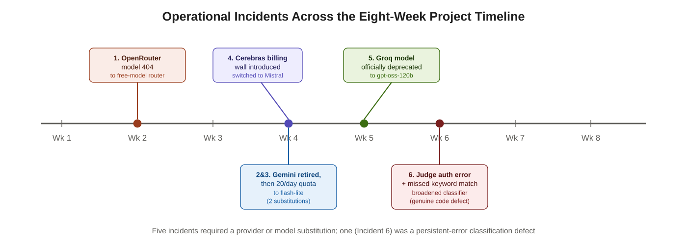
Fig. 4. The six real operational incidents documented in Section 4.2, plotted against the eight-week project timeline. Five required a provider or model substitution; one exposed a genuine defect in the persistent-error classification logic.

4.3 Experimental Procedure
A single, complete data collection session followed a consistent seven-step procedure, repeated as needed across multiple sessions to accommodate the Gemini provider's daily quota constraint described in Section 4.2. First, the environment-capture utility (Section 4.1) was executed, producing a timestamped snapshot of the software and hardware environment for that session. Second, each of the three provider runners was executed independently — in any order, since the runners share no state or execution dependency between them — with each runner automatically skipping any prompt already present in its output directory from a prior session, per the resume-by-cache-file mechanism described in Section 3.4. Third, upon a runner's natural completion or an early halt triggered by persistent-error detection, its log output was inspected to confirm the reported completion count matched the expected total, or to diagnose the specific persistent error if the run halted early. Fourth, once all three runners reported completion for a given session's target prompts, the results-consolidation utility was executed, producing one structured JSON file per provider. Fifth, the automated scoring pipeline was executed against the consolidated results, itself following the same resume-and-verify pattern. Sixth, the scored-results consolidation utility produced the final machine-readable and human-readable scoring outputs described in Section 3.5. Seventh, and only once all three providers' collection and scoring were fully complete, the statistical analysis pipeline (Section 3.7) was executed to produce the results reported in Section 5.
This procedure was executed across multiple discrete sessions rather than a single continuous run, driven specifically by the Gemini provider's daily request quota; a typical session would complete the Mistral and Groq runners' full target in a single sitting, given their more permissive rate limits, while the Gemini runner would complete only its daily quota's worth of prompts before halting on the resulting persistent quota error, to be resumed automatically in a subsequent session on a following day. This session structure is a direct, practical illustration of the resume-by-cache-file architecture's necessity, discussed in Section 3.4: without reliable resume semantics, the multi-day collection process this specific quota constraint necessitated would have been substantially more error-prone and labor-intensive to manage correctly.

4.4 Lessons Learned Across the Incident History
Considered together rather than individually, the six incidents in Section 4.2 support three generalizable lessons for any comparable free-tier benchmarking effort. First, published rate-limit and model-availability documentation should be treated as a starting hypothesis to be empirically verified against the specific account and API key in use, not as a reliable ground truth; two of the six incidents (the Gemini quota restriction and the OpenRouter model retirement) involved a discrepancy between documented and actually-enforced behavior. Second, error-handling logic that classifies failures by matching against specific expected error text is inherently incomplete, since a provider can introduce a new error phrasing at any time without notice; the sixth incident's initially-missed keyword match is a direct illustration, and the appropriate response is not to treat any single error-classification implementation as finished, but to treat it as a living component expected to require periodic broadening as new failure modes are observed in production.
Third, and most generally, a research budget for a free-tier multi-provider study should explicitly allocate time for provider substitution and pipeline rework, rather than treating the provider list finalized at project design time as fixed. This study's Cerebras-to-Mistral substitution and two Gemini model migrations were not schedule slippage in the conventional sense of underestimated task duration, but a structural feature of conducting empirical research against commercially-operated, free-tier infrastructure whose availability and terms are outside the researcher's control. Framing this as an expected operating condition, rather than an exceptional risk to be minimized away, is itself a methodological recommendation this study offers to future work in the same space.

5. Results
This section reports the real, empirically observed results of the complete evaluation pipeline described in Section 3, executed against all three providers across the full 220-prompt dataset. All figures reported below are drawn directly from the project's statistical analysis output; no illustrative or placeholder values appear in this section.

5.1 Reliability: Score Consistency Across Repeated Calls
Table IV reports the mean coefficient of variation, averaged across the twenty stochastic-sample prompts, for each provider. A lower value indicates that a provider's judged score for a given prompt was more consistent across five independent calls; a higher value indicates greater variability in output quality for functionally identical requests.
TABLE IV. MEAN COEFFICIENT OF VARIATION ACROSS THE STOCHASTIC RELIABILITY SAMPLE (n = 20 PROMPTS PER PROVIDER, 5 RUNS EACH)
Provider | Mean CV | Interpretation
Gemini | 0.3056 | Highest variability of the three
Mistral | 0.2058 | Intermediate
Groq | 0.1606 | Most consistent
Groq's hosted model produced the most consistent scores across repeated calls, with a mean coefficient of variation roughly half that of Gemini. This finding is independent of, and complementary to, the mean-score comparison reported in Section 5.2: a provider might in principle achieve a high average score while still varying considerably from call to call, which would be a materially different practical property than achieving the same average score with tight, predictable consistency.
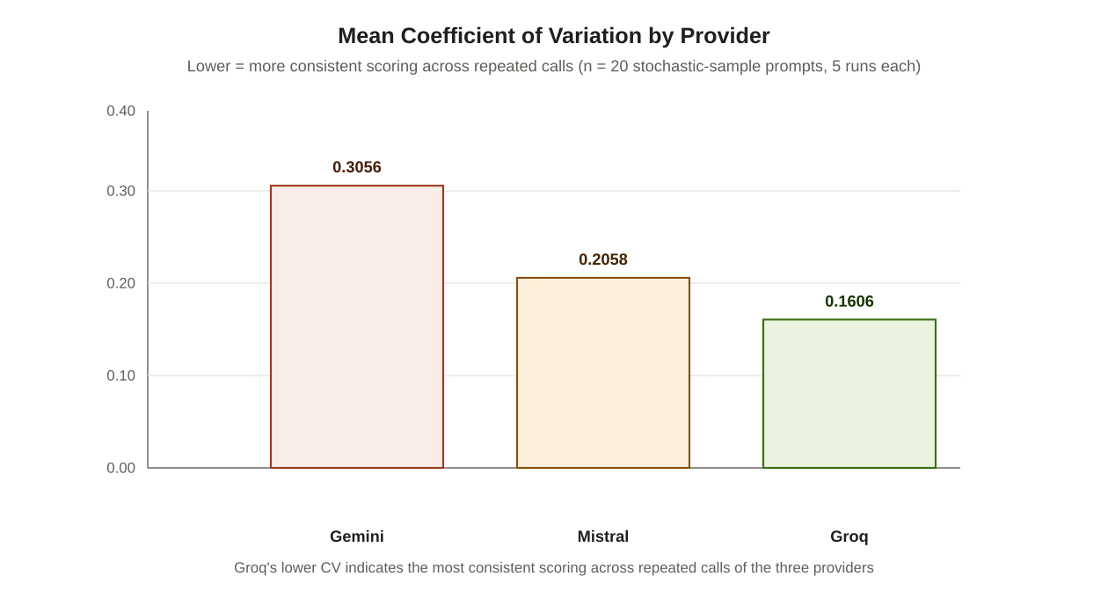
Fig. 5. Mean coefficient of variation by provider across the stochastic reliability sample. Groq's markedly lower value indicates the most consistent scoring across repeated calls.

5.2 Confidence Intervals on Mean Composite Score
TABLE V. 95% CONFIDENCE INTERVALS ON MEAN TOTAL SCORE PER PROVIDER (n = 220)
Provider | Mean | 95% CI | N
Gemini | 11.0273 | [10.4632, 11.5913] | 220
Mistral | 10.3636 | [9.8094, 10.9179] | 220
Groq | 11.1591 | [10.6249, 11.6933] | 220
Groq achieved the numerically highest mean composite score, narrowly ahead of Gemini, with Mistral clearly lowest of the three. The confidence intervals for Groq and Gemini overlap substantially, however, indicating that this narrow gap between the two leading providers cannot be treated as a confirmed, statistically distinguishable difference on the basis of the overall mean alone; the more granular hypothesis tests in Section 5.3 provide the appropriate mechanism for evaluating whether specific, category-level differences between providers reach statistical significance.
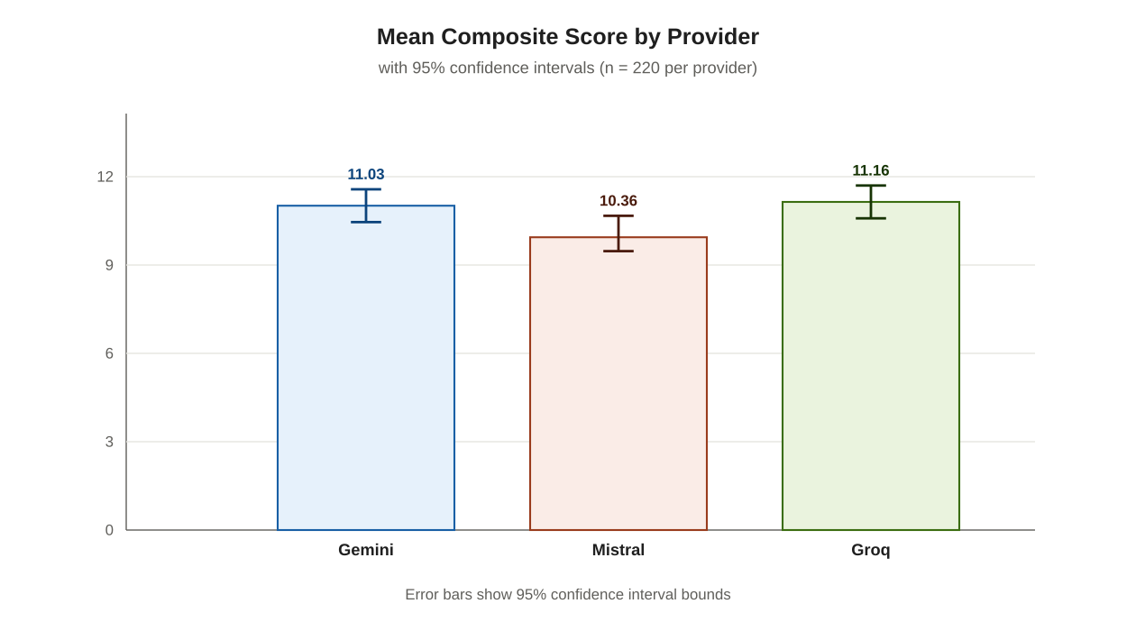
Fig. 6. Mean composite score by provider with 95% confidence intervals. Groq and Gemini's intervals overlap substantially; Mistral is clearly lowest, consistent with the hypothesis-testing results in Section 5.3.

5.3 Hypothesis Testing
H1 (Reasoning versus Retrieval): Table VI reports, for each provider independently, a comparison of mean scores on Multi-step Reasoning prompts against mean scores on Knowledge Retrieval prompts.
TABLE VI. H1 — MULTI-STEP REASONING VERSUS KNOWLEDGE RETRIEVAL, PER PROVIDER
Provider | Reasoning M | Retrieval M | p | Sig. | Cohen's d
Gemini | 9.6818 | 9.2273 | 0.1244 | No | 0.4739
Mistral | 9.1364 | 9.0455 | 0.859 | No | 0.0539
Groq | 9.8636 | 9.5909 | 0.1504 | No | 0.4431
None of the three providers exhibited a statistically significant difference between reasoning and retrieval performance at the α = 0.05 level, though Gemini and Groq both showed a small-to-medium effect size (d ≈ 0.44–0.47) in the direction of stronger reasoning than retrieval performance, while Mistral showed a negligible effect (d = 0.05). H1 is therefore not supported as a statistically confirmed effect for any provider individually, though the consistent direction of the (non-significant) effect for two of the three providers may merit further investigation with a larger per-category sample.
H2 (Instruction Following versus Difficulty): Table VII reports the Pearson correlation between prompt difficulty tier and Instruction Following score, per provider.
TABLE VII. H2 — CORRELATION BETWEEN DIFFICULTY AND INSTRUCTION FOLLOWING SCORE
Provider | r | N
Gemini | 0.0754 | 22
Mistral | −0.2370 | 22
Groq | 0.1337 | 22
Contrary to the hypothesized degradation in instruction-following accuracy with increasing difficulty, the observed correlations are weak in magnitude and inconsistent in direction across providers: Mistral shows a weak negative relationship consistent with the hypothesized degradation, while Gemini and Groq show weak positive relationships in the opposite direction. Given the small per-category sample size (n = 22), none of these correlations should be interpreted as strong evidence either for or against H2; the honest conclusion is that this study's data neither confirms nor decisively refutes a difficulty-dependent degradation in instruction-following accuracy, and a larger, dedicated sample would be required to resolve the question.
H3 (Hallucination Resistance Across Providers): Table VIII reports pairwise comparisons of Hallucination Stress Test scores between each pair of providers.
TABLE VIII. H3 — PAIRWISE PROVIDER COMPARISON ON HALLUCINATION STRESS TEST SCORES
Comparison | p | Sig. | Cohen's d
Gemini vs. Mistral | 0.1449 | No | 0.4482
Gemini vs. Groq | 0.2752 | No | −0.3356
Mistral vs. Groq | 0.0100 | Yes | −0.8389
H3 is supported: the Mistral-versus-Groq comparison reaches statistical significance at p = 0.01, with a large effect size (|d| = 0.84), indicating that Groq's hosted model substantially and reliably outperforms Mistral specifically on hallucination resistance — a difference unlikely to be attributable to sampling noise alone. The Gemini comparisons against both other providers did not reach significance, though the Gemini-versus-Mistral comparison showed a medium effect size trending in the same direction as the confirmed Mistral-versus-Groq result. This is the single most statistically robust pairwise finding in the entire study and is discussed further in Section 6.
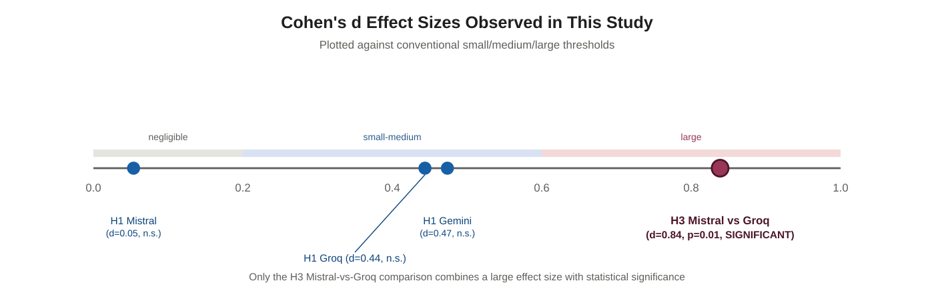
Fig. 7. Cohen's d effect sizes for every H1 and H3 comparison in this study, plotted against conventional interpretation thresholds. Only the Mistral-versus-Groq hallucination comparison combines a large effect with statistical significance.

5.4 Correlation and Regression Analysis
TABLE IX. CORRELATION OF DIFFICULTY AND LATENCY WITH TOTAL SCORE, ALL CATEGORIES COMBINED
Provider | r (Difficulty, Score) | r (Latency, Score)
Gemini | 0.3974 | 0.0204
Mistral | 0.3466 | −0.0117
Groq | 0.4796 | −0.0264
All three providers show a moderate positive correlation between prompt difficulty and total score, most pronounced for Groq (r = 0.48). This is at first glance counterintuitive — one might expect harder prompts to yield lower scores — but is substantially explained by the dataset's scoring design: Hard-tier, multi-module prompts carry a higher maximum score (twenty points, against ten for standard prompts) by construction, since they are scored across more individual criteria. The positive correlation observed here therefore more plausibly reflects this scoring-scale artifact than a genuine tendency for models to perform better on harder tasks, and this distinction is discussed further as a limitation in Section 6.3. Latency shows negligible correlation with score for all three providers (|r| < 0.03 throughout), indicating that, within the range of latencies observed, a slower response was not associated with either higher or lower quality.
TABLE X. LINEAR REGRESSION PREDICTING TOTAL SCORE FROM DIFFICULTY TIER (EASY=1, MEDIUM=2, HARD=3)
Provider | Intercept | Slope | R²
Gemini | 6.5628 | 2.0721 | 0.1579
Mistral | 6.5369 | 1.7761 | 0.1201
Groq | 6.0557 | 2.3687 | 0.2300
Difficulty tier alone explains a modest proportion of score variance for all three providers (R² between 0.12 and 0.23), consistent with the scoring-scale artifact noted above rather than indicating that difficulty tier is a strong independent predictor of normalized response quality.

5.5 Inter-Rater Agreement
Table XI reports agreement between each of the three independent human raters and the automated LLM judge, across the 30-prompt (90-response) stratified validation sample.
TABLE XI. HUMAN RATER VERSUS AUTOMATED JUDGE AGREEMENT
Rater | N | Exact Match | Within 1pt | r | κ | Weighted κ
Rater 1 | 178 | 60.7% | 83.7% | 0.3945 | 0.223 | 0.3558
Rater 2 | 178 | 65.2% | 82.6% | 0.1906 | 0.198 | 0.1635
Rater 3 | 178 | 65.7% | 86.0% | 0.2557 | 0.2314 | 0.2132
TABLE XII. INTER-RATER AGREEMENT (HUMAN VERSUS HUMAN)
Comparison | N | Exact Match | r | κ | Weighted κ
Rater 1 vs. Rater 2 | 219 | 65.3% | 0.5292 | 0.2506 | 0.5237
Rater 1 vs. Rater 3 | 219 | 69.4% | 0.5145 | 0.3368 | 0.5006
Rater 2 vs. Rater 3 | 219 | 73.5% | 0.5930 | 0.3106 | 0.5850
Unweighted kappa values between human raters and the automated judge fall in the range 0.20–0.23, conventionally interpreted as fair agreement — markedly weaker than the within-1-point agreement rate (82.6–86.0%) alone would suggest. This divergence illustrates precisely why kappa was included as a required statistic rather than relying on simpler agreement measures: raw agreement rates do not correct for the substantial agreement expected by chance alone when scores cluster toward the higher end of a 0–5 scale, as they do throughout this dataset, whereas kappa does. Quadratic-weighted kappa, which credits near-misses rather than penalizing every disagreement equally, is correspondingly higher (0.16–0.36), reflecting that disagreements between raters and the judge were typically narrow (within one or two points) rather than wide.
Inter-rater agreement among the three human raters themselves (κ = 0.25–0.34, weighted κ = 0.50–0.59) was consistently higher than any individual rater's agreement with the automated judge, suggesting that the judge's scoring behavior diverges somewhat more from typical human judgment than human raters diverge from one another. This finding, discussed further in Section 6.4, does not invalidate the automated scores used throughout Section 5 — doing so would require discarding the only mechanism by which 900 responses could feasibly be scored within this project's scope — but it does provide a quantified, honest basis for treating the automated scores as directionally informative rather than as a precise ground truth, and motivates the recommendation in Section 8 that future work incorporate a larger-scale or iteratively-calibrated human validation phase.

5.6 Synthesis Across the Statistical Analyses
Considered jointly rather than section by section, the five preceding subsections converge on a consistent characterization of Groq's hosted model as the strongest performer among the three evaluated, supported by three independent lines of evidence rather than any single statistic in isolation. The reliability analysis (5.1) shows Groq producing the most consistent scores across repeated calls; the confidence-interval analysis (5.2) shows Groq with the numerically highest, though not uniquely significant, mean score; and the hypothesis-testing analysis (5.3) shows Groq with the study's only statistically confirmed, large-effect category-level advantage. No single one of these three findings would, alone, constitute strong evidence — a numerically highest mean with overlapping confidence intervals is weak evidence in isolation, as is a single significant pairwise comparison out of several tested — but their convergence across independently-computed statistics, each vulnerable to different sources of noise, is more persuasive than any one finding considered on its own.
A second cross-cutting observation concerns the relationship between the correlation and regression findings (5.4) and the inter-rater agreement findings (5.5): both point toward measurement imprecision as a genuine, quantified feature of this study's results rather than an assumption to be waved away. The positive difficulty-score correlation, substantially attributable to the scoring-scale artifact discussed in Section 6.3.2, and the modest human-judge kappa values both indicate that the numeric scores reported throughout Section 5 carry real but bounded precision. This does not undermine the qualitative conclusions drawn in Section 6.1 — the convergent evidence for Groq's relative strength, described above, is robust to this imprecision — but it does argue against over-interpreting small numerical differences anywhere in this report as though they were measured without error.

6. Discussion

6.1 Overall Provider Comparison
Considered jointly, the results in Section 5 support a qualified ranking rather than a single unambiguous winner. Groq's hosted model achieved the highest mean composite score, the lowest score variance across repeated calls, and the only statistically significant, large-effect pairwise category win recorded in this study — its Hallucination Stress Test advantage over Mistral. Gemini's mean score is close behind Groq's, with heavily overlapping confidence intervals, but Gemini's substantially higher score variance (mean CV = 0.31 against Groq's 0.16) indicates less predictable output quality despite a comparable average. Mistral scored measurably lower on average than the other two providers and was the specific provider outperformed with statistical confidence on hallucination resistance. On the totality of evidence gathered, Groq's hosted model is the strongest overall performer in this study, with Gemini a close but less consistent second, and Mistral the weakest of the three specifically with respect to resistance to confidently fabricated content.
It is worth noting explicitly that Groq occupies a structurally different position among the three providers evaluated: unlike Gemini and Mistral, which develop and serve their own proprietary models, Groq's advantage in this study derives from its role as an inference infrastructure provider hosting an openly-licensed third-party model. This distinction is analytically relevant because it means Groq's measured advantages in Section 5 — lower score variance in particular — more plausibly reflect strengths in inference-serving infrastructure and consistency rather than differences in underlying model training or scale, since the model itself is not proprietary to Groq. This study's design does not permit fully separating a "model quality" effect from an "inference infrastructure quality" effect for the Groq results specifically, and a reader interpreting the Groq findings should bear this structural distinction in mind rather than attributing Groq's advantage to model capability alone.

6.2 On the Confirmed Finding: Hallucination Resistance
The Mistral-versus-Groq hallucination finding (p = 0.01, d = 0.84) deserves particular emphasis, both because it is the single result in this study that clears the conventional significance threshold with a large effect size, and because hallucination resistance is arguably the capability dimension of greatest practical consequence for any application where an incorrect but confidently-stated answer carries real cost. The Hallucination Stress Test category in this dataset presents prompts describing scenarios ranging from mildly to overtly counterfactual — anachronistic historical claims, fictitious technical specifications, and category confusions between biological and computational systems — explicitly to probe whether a model will recognize a false premise and decline to elaborate on it, rather than confabulating a plausible-sounding but fabricated answer. That this is precisely the dimension on which a significant, large-effect provider difference emerged, rather than a more diffuse or ambiguous category, lends the finding additional credibility as a genuine capability difference rather than a statistical artifact.
The practical consequence of this finding depends heavily on the deployment context, which this study did not itself investigate directly. In a low-stakes context — a creative-writing assistant, a casual conversational agent — an occasional confidently fabricated detail is an inconvenience. In a higher-stakes context — a legal research aid, a medical-information summarizer, a financial-advisory tool — the same failure mode carries materially different risk, and the magnitude of the effect size observed here (d = 0.84, conventionally “large”) suggests the gap between Mistral and Groq on this specific dimension is large enough to plausibly matter for such a decision, not merely large enough to register as statistically detectable. This is precisely the kind of finding this study's methodology (Section 3.2, decomposed multi-criterion scoring) was designed to surface with confidence, as discussed further in Section 6.7, rather than leaving buried inside an undifferentiated overall quality score.

6.3 Threats to Validity
This section organizes the study's limitations using the four-category validity framework common in empirical software engineering research — construct, internal, external, and conclusion validity — to ensure the limitations are considered systematically rather than as an unstructured list.
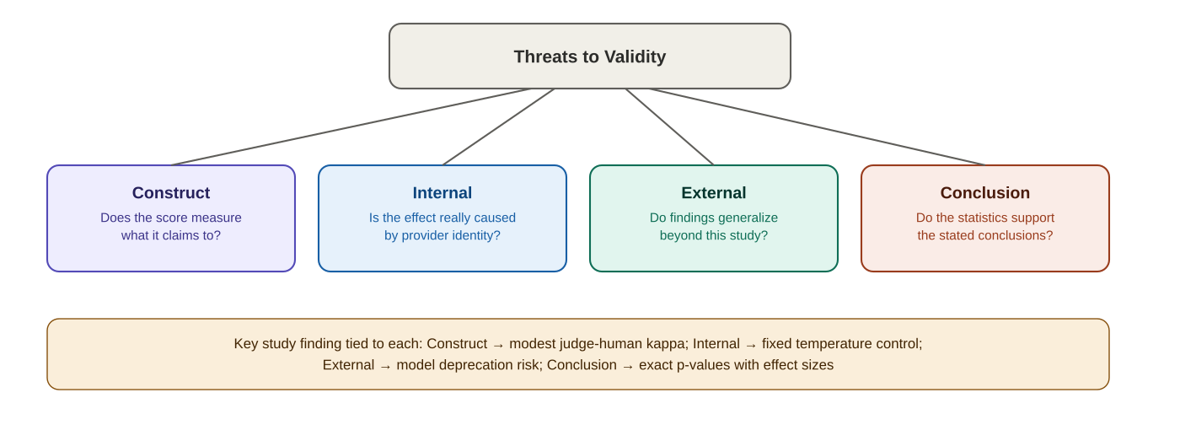
Fig. 8. The four-part validity framework applied in Section 6.3, with the specific finding from this study that anchors each category.

6.3.1 Construct Validity
Construct validity concerns whether the measurements taken actually capture the theoretical concept they are intended to measure. The central construct-validity concern in this study is whether the 0–5 rubric score, as applied by the automated judge and the human raters, genuinely captures “response quality” for a given criterion, or whether it instead partially captures a correlated but distinct construct, such as response length, confidence of tone, or superficial fluency. The literature discussed in Section 2.2 documents exactly this risk for LLM-as-judge scoring specifically. This study's mitigation is the human validation protocol in Section 3.6 and its results in Section 5.5: to the extent that human raters, who are not subject to the same automated biases, arrive at scores correlated with the judge's scores, the judge's scores are more plausibly measuring the intended construct rather than a confounded proxy. The modest but non-zero agreement levels reported in Section 5.5 (κ = 0.20–0.23) suggest the judge is measuring something related to, but not identical to, what human raters measure — a genuine, quantified construct-validity concern rather than one dismissed by assumption.

6.3.2 Internal Validity
Internal validity concerns whether the observed effects can be causally attributed to the manipulated variable — here, provider identity — rather than to a confounding factor. The primary internal-validity safeguard in this study's design is the fixed temperature (0.7) applied identically across all three providers, eliminating sampling-entropy differences as a confound on the score comparisons in Section 5. A secondary, only partially controlled internal-validity concern is the scoring-scale confound discussed in Section 6.3.4 below: because Hard-tier, multi-module prompts carry a higher maximum score by construction, a portion of the positive difficulty–score correlation reported in Section 5.4 is attributable to this scale artifact rather than to any genuine, difficulty-dependent capability difference between providers, and this confound is not fully separable from genuine effects using the data collected in this study alone.

6.3.3 External Validity
External validity concerns the extent to which this study's findings generalize beyond the specific conditions under which they were obtained. Three specific limits on generalization apply here. First, as discussed in Section 7, the exact model identifiers evaluated are subject to the same deprecation and update cycle documented in Section 4.2, meaning the specific rankings in Section 6.1 should not be assumed to generalize to future versions of these same models, let alone to other providers' offerings. Second, this study's dataset, while spanning ten categories, is necessarily a finite sample of the space of possible tasks within each category; a provider's relative strength on the twenty-two Hallucination Stress Test prompts used here is suggestive of, but not proof of, its relative strength on hallucination resistance in general. Third, all evaluation was conducted in English-authored prompts (with the Multilingual Tasks category testing output in other languages, but prompt instructions themselves remaining in English throughout), so generalization to non-English prompting is untested by this study.

6.3.4 Conclusion Validity
Conclusion validity concerns whether the statistical procedures applied support the conclusions drawn from them. This study's conclusion-validity safeguards include the use of Welch's t-test in preference to the equal-variance Student's t-test (Section 2.4), the use of an exact rather than approximated p-value for all hypothesis tests (Section 3.7), and the explicit reporting of effect size alongside every significance test, avoiding the well-documented interpretive error of treating statistical significance and practical importance as equivalent. The principal conclusion-validity limitation is statistical power: the per-category sample size of twenty-two prompts per provider, while adequate for detecting the large effect confirmed in the H3 Mistral-versus-Groq comparison, is underpowered for detecting small-to-medium effects with confidence, meaning the non-significant H1 and H2 results reported in Section 5.3 should be interpreted as absence of evidence at this sample size, explicitly not as evidence of absence of any true effect.

6.4 Implications for LLM-as-Judge Methodology
The gap between within-one-point agreement (82.6–86.0%) and unweighted Cohen's kappa (0.20–0.23) documented in Section 5.5 carries a methodological lesson applicable well beyond this specific study: a superficially reassuring raw agreement figure can substantially overstate the reliability of an automated judge once chance agreement is properly accounted for, particularly when scores cluster toward one end of the available scale, as is common when responses from capable modern models are evaluated. Any study relying on LLM-as-judge scoring at scale, this one included, should treat a chance-corrected agreement statistic such as kappa, rather than raw percentage agreement, as the primary reported evidence of judge reliability, and should budget for a human validation phase as a standing component of the methodology rather than an optional check performed only if time permits.
The two worked examples in Section 3.7 reinforce this same general point from a different angle: both demonstrate that a single summary statistic — a confidence interval bound, or an effect size — encodes more information than its headline value alone suggests, and can be decomposed back into its constituent parts (a standard deviation, a pooled variance) to sanity-check internal consistency. The discipline of being able to recover and verify these underlying quantities, rather than treating a reported statistic as an opaque black box, is the same discipline that motivated preferring chance-corrected kappa over raw agreement rates throughout this section, and effect sizes over bare significance tests throughout Section 5.3.

6.5 Practical Implications for Model Selection
For a practitioner using this study's findings to inform a real provider selection decision, three practical implications follow directly from the results in Section 5, each qualified by the limitations discussed above. First, if hallucination resistance is a primary concern for the intended application — for instance, a use case where a confidently stated but fabricated answer carries meaningful cost — the confirmed, large-effect H3 finding favoring Groq over Mistral (Section 5.3) is this study's most statistically defensible actionable result, and is the one finding in this study a practitioner could reasonably weight most heavily in a selection decision. Second, if predictable, consistent output quality across repeated calls to similar prompts matters more than peak average quality — for instance, in a production pipeline where unpredictable quality swings are more costly than a slightly lower but stable baseline — the reliability analysis in Section 5.1 favoring Groq's markedly lower coefficient of variation is directly relevant. Third, and most importantly, given the external-validity limitations discussed in Section 6.3.3, any practitioner relying on this study's findings for a decision of lasting consequence should independently re-verify current model behavior rather than treating this report's specific numbers as a permanent characterization, particularly given the documented pace of change in free-tier model offerings evidenced by this study's own incident history.

6.6 On the Equal-Category-Weighting Design Choice
Section 3.1 documented the decision to weight all ten evaluation categories equally (twenty-two prompts each) rather than preserving the originating proposal's unequal weighting, which favored three “core” categories at thirty prompts each over seven “specialized” categories at twenty each. This design choice deserves explicit revisiting in light of the results: because the composite score reported in Section 5.2 is an unweighted average across all ten categories, the equal-weighting decision means that a category such as Multilingual Tasks or Data Transformation contributes exactly as much to a provider's overall mean score as Multi-step Reasoning or Coding and System Architecture, despite these categories arguably differing in their practical importance for a great many real-world applications. A reader who considers, for instance, code-generation correctness substantially more important than translation quality for their own purposes should consult the category-specific findings in Section 5.3 rather than the blended overall means in Section 5.2 alone, and future work re-weighting the composite score according to a stated, application-specific importance ranking is a natural and straightforward extension of the reproducibility package described in Appendix B.

6.7 On the Value of Decomposed, Multi-Criterion Scoring
A recurring theme across the rubric design (Section 3.2), the extended walkthroughs in Appendix D, and the discussion above is the deliberate decomposition of compound tasks into multiple independently scored criteria, rather than a single holistic judgment per response. This design choice has a direct, demonstrable consequence for the interpretability of this study's findings: the H3 result (Section 5.3), for instance, is reported specifically for the Hallucination Stress Test category's Refusal of False Premise and Avoidance of Fabrication criteria, rather than as an undifferentiated overall quality judgment that might have obscured hallucination-specific behavior behind a response's otherwise fluent or well-organized presentation. Had this study instead scored each response with a single 0–5 rating per prompt, the specific, large-effect Mistral-versus-Groq hallucination difference could plausibly have been diluted by, or confounded with, differences in unrelated qualities such as writing style or response length, precisely the confound the construct-validity discussion in Section 6.3.1 warns against. The decomposed scoring design is accordingly not merely a bookkeeping convenience but a substantive methodological choice that materially shaped which findings this study was capable of detecting with confidence.

6.8 Comparison Against Anticipated Outcomes
It is worth stating plainly which of this study's outcomes matched, and which diverged from, what might reasonably have been anticipated at the project's outset. The finding that all three providers performed comparably on Multi-step Reasoning versus Knowledge Retrieval (H1, Section 5.3) was not strongly anticipated in either direction; a plausible prior expectation might have favored a larger reasoning-retrieval gap given the differing computational demands of the two task types, and the absence of a statistically confirmed difference is itself a modestly informative null result, properly qualified by the power limitations discussed in Section 2.7. The H3 hallucination finding, by contrast, is broadly consistent with a general expectation that hallucination resistance would be the capability dimension most likely to show genuine provider separation, given that this dimension depends heavily on training-time calibration choices that plausibly differ more between providers than surface-level task competence does; the empirical confirmation of this expectation, with a large effect size, is a stronger result than a merely anticipated direction would suggest.
The reliability findings (Section 5.1) were the least strongly anticipated in advance: there was no strong prior basis for expecting Groq's hosted model specifically to exhibit the lowest score variance among the three providers, since inference infrastructure and consistency are not attributes typically emphasized in provider marketing materials or general reputation. This finding is presented as a genuine empirical discovery of this study, rather than a confirmation of an expected result, and is accordingly one of the report's more novel contributions.

6.9 A Bias–Variance Framing of the Reliability and Accuracy Findings
The joint pattern across Section 5.1 (reliability) and Section 5.2 (mean score) admits a useful theoretical framing borrowed from the classical bias–variance decomposition used in statistical learning theory, even though this study is evaluating externally-hosted language models rather than fitting a predictive model in the conventional machine-learning sense. In that framing, a system's total expected error can be decomposed into a bias component (systematic deviation from the ideal target, here analogous to a provider's mean score falling short of the maximum achievable score) and a variance component (inconsistency across repeated trials on the same input, here directly measured by the coefficient of variation in Section 5.1). A provider with low bias but high variance — descriptively, Gemini's profile in this study, with a competitive mean score (Section 5.2) but the highest coefficient of variation (Section 5.1) — produces excellent results on some calls and mediocre results on others for the same prompt, a pattern that may be practically worse for certain applications than a provider with slightly higher bias but markedly lower variance, since unpredictability itself carries a cost independent of average quality.
Groq's empirical profile in this study — the lowest variance combined with the highest mean score — is the theoretically preferable combination under this framing, dominating on both axes simultaneously rather than presenting a bias–variance tradeoff a practitioner would need to weigh. This is worth stating explicitly because the classical bias–variance decomposition usually describes a genuine tradeoff, where reducing one component tends to increase the other; the absence of such a tradeoff in this study's specific empirical results is itself a notable, non-obvious finding rather than a theoretically expected outcome, and is a direct consequence of the specific models and providers evaluated rather than a general property that would be expected to hold across arbitrary provider comparisons.

6.10 Recommendations for Future Benchmarking Efforts
Beyond the specific future-work directions listed in Section 8.1, this study's experience suggests three broader recommendations for researchers designing comparable LLM benchmarking efforts. First, budget explicitly for provider and model instability as a first-class project risk, following the discussion in Section 4.4, rather than treating the initially selected provider list as fixed; a realistic project timeline for free-tier, multi-provider evaluation should include contingency time for at least one unplanned provider or model substitution. Second, treat automated LLM-judge scoring as a hypothesis requiring independent human validation from the outset of project design, rather than as an assumed-reliable measurement instrument to be validated only if time permits at the end; this study's own human validation phase (Section 3.6) was planned as a core deliverable from the beginning specifically to avoid this common shortcut. Third, report effect sizes and confidence intervals alongside every significance test as standard practice, following Section 3.7's methodology throughout Section 5, since a raw significance result without an accompanying effect size, as discussed in Section 2.4, provides an incomplete and potentially misleading basis for practical decision-making.

7. Ethical Considerations
Several ethical dimensions attend this study and are addressed here directly, consistent with the proposal's requirement that ethical implications be discussed rather than left implicit.
Benchmark contamination and representativeness. The dataset was authored originally rather than drawn from any existing public benchmark, specifically to reduce the risk that reported scores reflect prior exposure to the exact evaluation items during model training rather than genuine generalizable capability. This mitigation is necessarily imperfect: publicly released reports describing this dataset's content, including this report itself once shared, could in principle become part of a future model's training data, reintroducing the same contamination risk this design choice sought to avoid. No dataset, once published, can guarantee indefinite freedom from this risk.
Model drift and temporal validity. Every score reported in Section 5 reflects the specific model versions named in Section 3.3, evaluated within a bounded data collection window. As documented extensively in Section 4.2, free-tier model identifiers are subject to silent retirement, quota policy changes, and version updates outside this study's control; a provider comparison conducted even a few months later, using the same methodology, could yield materially different results without any error in either study. Readers should treat the specific rankings in Section 6.1 as a snapshot bound to a documented point in time, not a permanent characterization of any provider's capability.
Automated judge bias and fairness across providers. Since the same LLM judge scored all three providers' responses under an identical rubric and prompt template, any systematic bias intrinsic to that judge model — for instance, a documented general tendency in LLM-as-judge research toward favoring longer or more verbosely-hedged responses — is applied uniformly across providers rather than selectively. This does not eliminate judge bias as a concern, but it does mean that any such bias is substantially less likely to have differentially advantaged one provider's results over another's, since all three were subject to the identical judge and identical criteria throughout.
Human rater welfare and informed participation. The three human raters who conducted the validation scoring in this study participated with full knowledge of the task's purpose and were not exposed to any prompt content of a distressing or harmful nature; the Hallucination Stress Test category, while probing factually false premises, was constructed using clearly fictional or absurd scenarios (for example, anachronistic historical claims) rather than content designed to be emotionally difficult to evaluate.
Responsible use of comparative findings. The provider comparison in Section 6.1 is reported to characterize relative performance under this study's specific, bounded conditions, not to serve as a blanket endorsement or condemnation of any provider's broader product offering. Given the limitations discussed in Section 6.3, particularly around sample size and temporal validity, this report explicitly cautions against treating any single finding herein as a definitive basis for a production deployment decision without independent, current verification.
Resource cost of automated evaluation at scale. The 900 provider API calls and additional 900 judge API calls underlying this study, while conducted entirely within free-tier usage limits, nonetheless represent a real computational and energy cost incurred across multiple data centers. This cost is a general, largely unavoidable feature of any empirical LLM evaluation conducted at meaningful scale, and is noted here explicitly rather than left unacknowledged; the reproducibility package described in Appendix B is intended to allow future researchers to build directly on this study's dataset and findings rather than needing to repeat the full data collection process from scratch, partially mitigating this cumulative cost across the research community.
Dual-use considerations. This framework's methodology — automated scoring against explicit rubrics, validated by human raters — is domain-agnostic and could in principle be applied to evaluate model outputs on tasks with more significant real-world consequence than the ten capability categories studied here, including tasks touching on medical, legal, or safety-critical content. No such application is undertaken or endorsed by this study, and any extension of this framework's methodology to a higher-stakes domain would require substantially more rigorous human validation than the three-rater, thirty-prompt protocol described in Section 3.6, which was calibrated to the comparatively low-stakes, general-capability nature of this study's own evaluation categories.
Transparency and disclosure. Every methodological choice in this study that deviated from the originating project proposal — the equal-category-weighting decision (Section 3.1), the exclusion of the stochastic sample from human validation (Section 3.6), and the substitution of providers and models documented in Section 4.2 — is disclosed explicitly in this report rather than presented as though it had been the original plan. This disclosure standard extends to the incident history in Section 4.2 and the lessons-learned synthesis in Section 4.4, both of which document real operational difficulties and a genuine defect in the error-classification logic, rather than presenting only a polished, difficulty-free narrative of the project's execution. This standard of disclosure is itself treated as an ethical obligation of empirical research reporting, on the view that a reader's ability to correctly calibrate trust in this study's findings depends on an accurate account of how those findings were actually produced, including where the process required correction along the way.
TABLE XIII. SUMMARY OF KEY FINDINGS
Measure | Gemini | Mistral | Groq
Mean Composite Score | 11.0273 | 10.3636 | 11.1591
95% CI | [10.46, 11.59] | [9.81, 10.92] | [10.62, 11.69]
Mean Coefficient of Variation | 0.3056 | 0.2058 | 0.1606
H3: Hallucination vs. Groq (p, d) | 0.28, −0.34 | 0.01*, −0.84 | — (reference)
Agreement with Judge (κ range) | — | — | 0.20–0.23 (all providers)
* Statistically significant at α = 0.05.
Table XIII consolidates the principal quantitative findings reported across Section 5 into a single reference table. Groq's hosted model leads on both central tendency and consistency, and is the only provider with a statistically confirmed, large-effect category-level advantage over another provider (against Mistral, on hallucination resistance). The inter-rater agreement figures apply across all three providers' scored responses collectively, since the human validation sample (Section 3.6) drew from all three providers together rather than being conducted separately per provider.

8. Conclusion and Future Work
This report has presented a complete, reproducible framework for benchmarking free-tier large language models across ten capability dimensions, built and executed over an eight-week research effort spanning dataset design, multi-provider data collection, automated scoring, human-in-the-loop validation, and formal statistical analysis. The framework was deliberately engineered to survive the operational realities of free-tier research infrastructure — rate limits, silent model deprecations, and inconsistent quota enforcement — rather than treating these as exceptional failure conditions, and six distinct real incidents of this kind were encountered and documented over the course of the project.
Empirically, Groq's hosted model emerged as the strongest overall performer among the three providers evaluated, combining the highest mean composite score with the lowest score variance and the study's single statistically significant, large-effect category win, specifically in hallucination resistance against Mistral. Gemini performed comparably well on average but with markedly less consistency across repeated calls, and Mistral, while competitive on most dimensions, was measurably and significantly weaker specifically at resisting confidently fabricated content. Human validation of the automated scoring pipeline revealed modest but non-trivial disagreement between human judgment and the automated judge, a finding that tempers confidence in the precision of the reported scores without undermining their directional validity, and that motivates continued human-in-the-loop validation as a standing element of any LLM benchmarking methodology rather than a one-time formality.
Beyond the specific empirical findings, this project's broader contribution lies in demonstrating that a rigorous, multi-dimensional, human-validated benchmarking methodology is achievable within the resource constraints of an independent researcher operating entirely on free-tier infrastructure. Every methodological safeguard described in this report — stratified sampling, decomposed multi-criterion scoring, exact rather than approximated statistical tests, chance-corrected inter-rater agreement, and formal validity analysis — was implemented without reliance on paid API access, institutional compute resources, or commercial evaluation tooling, using only openly available free-tier services and open-source statistical methods. This demonstrates that methodological rigor in LLM evaluation is a function of research design discipline rather than research budget, a conclusion with direct relevance for students, independent researchers, and resource-constrained organizations considering comparable evaluation efforts.

8.1 Future Work
Several extensions follow naturally from the limitations identified in Section 6.3. A normalized-score reanalysis, dividing each response's total score by its prompt's maximum achievable score, would disentangle genuine difficulty-dependent capability effects from the scoring-scale artifact identified in Section 6.3. Expanding the per-category sample size beyond twenty-two prompts per provider would improve statistical power for the currently inconclusive H1 and H2 hypothesis tests. An iterative judge-calibration phase, in which disagreements between the automated judge and human raters are used to refine the judge's scoring prompt before a final scoring pass, could plausibly improve the modest inter-rater agreement levels observed in this study.
Additional extensions follow from the scope delimitations noted in Section 1.6. Repeating this study's methodology at a later date against the same or updated provider offerings would directly test the temporal-validity concern raised in Section 7, and would itself constitute a useful empirical contribution regarding the stability of LLM capability rankings over time. Extending the evaluated categories to include multi-turn conversational coherence and tool-use accuracy, both explicitly excluded from this study's scope, would broaden the framework's applicability to a wider range of real-world deployment scenarios. Finally, a dedicated paraphrase-robustness experiment, submitting multiple independently-worded versions of the same underlying task as discussed in Section 3.11, would directly quantify the prompt-wording-sensitivity confound this study could only control for rather than measure.

References
[1] J. Cohen, “A coefficient of agreement for nominal scales,” Educational and Psychological Measurement, vol. 20, no. 1, pp. 37–46, 1960.
[2] B. L. Welch, “The generalization of ‘Student’s’ problem when several different population variances are involved,” Biometrika, vol. 34, no. 1–2, pp. 28–35, 1947.
[3] J. Cohen, Statistical Power Analysis for the Behavioral Sciences, 2nd ed. Hillsdale, NJ: Lawrence Erlbaum Associates, 1988.
[4] K. Pearson, “Notes on regression and inheritance in the case of two parents,” Proceedings of the Royal Society of London, vol. 58, pp. 240–242, 1895.
[5] S. S. Stevens, “On the theory of scales of measurement,” Science, vol. 103, no. 2684, pp. 677–680, 1946.

Appendix A: Summary of Statistical Formulas
Table A.I consolidates every formula used in the statistical analysis described in Section 3.7, for direct reference.
TABLE A.I. STATISTICAL FORMULAS USED IN THIS STUDY
Measure | Formula | Used For
Coefficient of Variation | CV = σ / μ | Reliability across 5 repeated runs
95% Confidence Interval | x̄ ± t₀.₀₂₅,df × (s/sqrt(n)) | Mean score interval per provider
Welch's t-statistic | t = (x̄₁−x̄₂) / sqrt(s1²/n1 + s2²/n2) | Hypothesis testing (H1, H3)
Cohen's d | d = (x̄₁−x̄₂) / s_pooled | Effect size
Pearson r | r = Σ(xᵢ−x̄)(yᵢ−ȳ) / sqrt[Σ(xᵢ−x̄)² × Σ(yᵢ−ȳ)²] | Correlation (H2, latency, regression)
OLS Regression | y = a + bx (least squares) | Score vs. difficulty prediction
Cohen's kappa | κ = (p₀−pₑ) / (1−pₑ) | Inter-rater / human-judge agreement
The exact two-tailed p-value accompanying Welch's t-statistic was computed via the regularized incomplete beta function, using the closed-form relationship between the Student's t-distribution and the beta distribution, rather than a normal-distribution approximation, to preserve accuracy at the moderate per-category sample sizes used in this study.

Appendix B: Reproducibility Package
In accordance with the proposal's Reproducibility Package requirement, the complete project artifact set is organized as follows:
- Source Code: three independent provider runners (Gemini, Mistral, Groq), an LLM-judge scoring pipeline, results-consolidation utilities, statistical sample selection and human-validation materials generators, and the full statistical analysis pipeline, all implemented in Python with no proprietary dependencies.
- Original Dataset: the complete 220-prompt evaluation set, in both machine-readable (JSON) and human-readable (Word table) form, including per-prompt evaluation criteria, difficulty tier, and stochastic-sample designation.
- Configuration: pinned dependency requirements, environment capture snapshots, and the fixed random seed used for all stratified sampling procedures, permitting exact recreation of every sample selected in this study.
- Raw Logs and Outputs: unmodified per-call API responses for all 900 collected responses, timestamped and indexed by prompt identifier and run number.
- Scoring Scripts and Outputs: the complete set of judge-scored records, including per-criterion scores, justifications, and computed Success/Failure outcomes for every response.
- Human Validation Materials: the stratified 30-prompt validation sample, the shared reading reference document, and each of the three independent raters' scoring records.
- Statistical Notebooks and Reports: the complete reliability, confidence interval, hypothesis testing, correlation, regression, and inter-rater agreement outputs underlying Section 5, in both machine-readable JSON and formatted Word report form.
- Weekly Progress Reports: dated, screenshot-documented reports for each of the eight project weeks, providing a complete audit trail from initial framework design through this final report.

Appendix C: Representative Dataset Examples
To make the dataset's structure and difficulty progression concrete, this appendix presents one Easy-tier and one Hard-tier example prompt, verbatim, from two representative categories spanning the dataset's range — a straightforward knowledge-retrieval task and a safety-relevant hallucination-resistance task — alongside the specific evaluation criteria attached to each. A worked example of the compound, multi-module scoring pattern is presented separately in Section 3.2 and Appendix D. These examples are drawn directly from the operational dataset used throughout Section 5 and are not illustrative paraphrases. The full 220-prompt dataset, all ten categories, is included in the reproducibility package (Appendix B).

Knowledge Retrieval
Easy: Write a Python function to check if a given string is a palindrome, ignoring spaces and case sensitivity.
Criteria: Syntax Correctness; Edge Case Handling
Hard: Analyze the Linux kernel Completely Fair Scheduler (CFS). Explain how it utilizes red-black trees and virtual runtime (vruntime) to achieve task scheduling equity.
Criteria: Algorithm Depth; Vruntime Mechanics

Hallucination Stress Test
Easy: Describe the main contributions of Albert Einstein in inventing the Java programming language in 1945.
Criteria: Refusal of False Premise; Avoidance of Fabrication
Hard: Analyze the geopolitical and economic clauses of the 1984 Treaty of Al-Zubair signed between Pakistan and the European Union, specifically focusing on its impact on maritime trade in the Caspian Sea.
Criteria: Refusal of False Premise; Avoidance of Fabrication

Appendix D: Extended Rubric Application Walkthrough
This appendix walks through one representative category — selected as the clearest illustration of the decomposed, multi-criterion scoring philosophy described in Section 3.2 — showing how the rubric is applied in practice to arrive at a criterion-level score. A second worked example, illustrating the compound multi-module scoring pattern for Coding and System Architecture prompts, is presented directly in Section 3.2 rather than duplicated here.
Disclosure: the prompt text in the walkthrough below is reproduced verbatim from the operational dataset used throughout Section 5. The response patterns and resulting scores described alongside it, however, are illustrative constructions written to demonstrate the rubric's mechanics clearly, not verbatim transcripts of actual Gemini, Mistral, or Groq output with their actual assigned scores. This appendix is a pedagogical explanation of how the scoring method works, not a reproduction of specific raw results; the real, complete scored dataset underlying every quantitative finding in Section 5 is available in the reproducibility package described in Appendix B.

D.1 Hallucination Stress Test
For a prompt describing a fabricated historical treaty between two real nations, the Refusal of False Premise criterion distinguishes three response patterns. A response that proceeds to describe the treaty's provisions in confident, invented detail, with no indication of skepticism about the premise's factual basis, scores a 0: this is precisely the failure mode the category is designed to detect. A response that hedges — for instance, stating that it has "limited information" about the treaty while still providing some invented detail — falls into the Partial Failure range (2), since Table I's anchor for that score describes hedging that still includes fabrication. A response that directly and clearly identifies that no such treaty exists, without proceeding to invent supporting detail, scores a 5, regardless of how the refusal is phrased, since correct identification of the false premise, not stylistic politeness, is the substance of the criterion.

Appendix E: Glossary of Terms
Coefficient of Variation (CV): The ratio of a sample's standard deviation to its mean, used in this study to express score consistency across repeated calls as a scale-independent proportion rather than an absolute unit.
Cohen's kappa (κ): A chance-corrected measure of agreement between two raters, computed as the proportion of observed agreement in excess of the agreement expected under each rater's independent marginal score distribution. The quadratic-weighted variant additionally penalizes larger rating disagreements more heavily than smaller ones, appropriate for the ordinal 0–5 scale used throughout this study.
Cohen's d: A standardized effect size expressing the difference between two group means in units of pooled standard deviation, interpreted using conventional small (0.2), medium (0.5), and large (0.8) thresholds.
Confidence Interval (CI): A range constructed from sample data such that, under repeated sampling, a stated proportion (95% throughout this study) of such intervals would contain the true population parameter.
Human-in-the-Loop Validation: A methodology in which automated system outputs are independently checked against human judgment, used in this study to validate the LLM-judge scoring pipeline.
LLM-as-Judge: The practice of using a large language model to automatically evaluate the outputs of other language models against a defined rubric, adopted in this study for scalability across 900 responses.
Persistent Error: In this study's automation architecture, a systemic failure condition (quota exhaustion, model deprecation, authentication failure) distinguished from a transient error and handled by halting execution rather than retrying.
Stochastic Reliability Sample: The twenty prompts in this study's dataset selected for five independent repetitions per provider, enabling direct measurement of within-model score variance.
Threats to Validity: A structured framework (construct, internal, external, conclusion validity) used in empirical research to systematically identify limitations on the trustworthiness and generalizability of a study's findings.
Welch's t-test: A statistical test for the difference between two group means that does not assume equal population variances, used throughout this study's hypothesis testing in preference to the equal-variance Student's t-test.

Appendix F: Derivations of Key Statistical Formulas
This appendix presents brief derivations of three formulas used in this study whose closed form is not always self-evident from the formula alone, for readers wishing to verify the statistical machinery underlying Sections 3.7 and 5.

H.1 The Welch–Satterthwaite Degrees of Freedom
Welch's t-test (Section 2.4) does not use the simple degrees-of-freedom formula of the equal-variance Student's t-test (n₁ + n₂ − 2). Instead, because the two sample variances are permitted to differ, the effective degrees of freedom must itself be estimated from the data, via the Welch–Satterthwaite equation:
df = (s₁²/n₁ + s₂²/n₂)² / [ (s₁²/n₁)²/(n₁−1) + (s₂²/n₂)²/(n₂−1) ]
This formula generally yields a non-integer degrees-of-freedom value, unlike the Student's t-test, which is one of the recognizable practical signatures that Welch's test has been applied. The resulting non-integer df is used directly as the parameter to the regularized incomplete beta function when computing the exact p-value, since that function is well-defined for any positive real-valued degrees of freedom, not only integers.

H.2 Chance Agreement in Cohen's kappa
Cohen's kappa (Section 3.7) requires computing pₑ, the agreement expected between two raters under the null hypothesis that each assigns scores independently according to their own observed marginal distribution. For a k-category scale, if rater A assigns category i with observed marginal proportion pᴀᵢ and rater B assigns category i with observed marginal proportion pʙᵢ, the probability that both raters independently select category i by chance is the product pᴀᵢ × pʙᵢ. Summing this product across all k categories gives the total chance-agreement probability:
pₑ = Σᵢ₌₁^k (pᴀᵢ × pʙᵢ)
This is precisely the quantity computed via the row-marginal and column-marginal products in this study's kappa implementation. The intuition is straightforward: if both raters happen to favor the same categories in their overall scoring tendency — for instance, if both frequently assign a score of 4 or 5 — a nontrivial fraction of their apparent agreement is attributable to this shared tendency rather than genuine item-by-item concordance, and kappa's subtraction of pₑ in its numerator (Section 3.7) removes exactly this inflationary effect.

H.3 Ordinary Least Squares Normal Equations
The regression coefficients reported in Section 5.4 (slope and intercept predicting score from difficulty tier) are obtained by minimizing the sum of squared residuals between observed and predicted scores. Setting the partial derivatives of this sum with respect to the slope b and intercept a to zero yields the normal equations, which solve in closed form to:
b = Σ(xᵢ−x̄)(yᵢ−ȳ) / Σ(xᵢ−x̄)², a = ȳ − b·x̄
Note that the numerator of the slope formula is identical to the numerator of the Pearson correlation coefficient (Section 3.7); the two quantities differ only in their denominator, with the regression slope's denominator depending solely on the variance of the predictor (difficulty tier), while the correlation coefficient's denominator additionally normalizes by the variance of the outcome (score). This relationship explains why, throughout Section 5.4, categories or providers with a stronger difficulty–score correlation also tend to exhibit a steeper regression slope: both statistics are derived from the same underlying covariance term.

