Progress Report: Week 6
Project Phase: Human-in-the-Loop Validation with Full Difficulty-Tier Coverage

1. Goal
Week 5 built an automated scoring pipeline using an LLM judge, but an automated judge's reliability cannot be assumed - it must be independently checked. Week 6's goal was to validate the automated scoring pipeline by having real human evaluators independently score a representative sample of the same responses, then measuring how closely human judgment and the automated judge agree. Per the proposal's explicit listing of “Inter-rater agreement” as a required statistical measure, three independent human raters were used so that agreement between humans themselves, not just between humans and the AI, could also be measured.

2. Method
The validation sample is stratified by BOTH category and difficulty: exactly 1 Easy, 1 Medium, and 1 Hard prompt is randomly selected from EACH of the 10 categories, producing 30 prompts total (10 categories x 3 difficulties). This guarantees every difficulty tier is represented within every category, rather than leaving difficulty coverage to chance as a category-only stratification would. The 20 stochastic-reliability-sample prompts are explicitly excluded from the eligible pool before sampling - this exclusion was confirmed necessary, since the stochastic sample does not itself have Easy or Medium prompts in every category (two categories have only Hard-difficulty stochastic prompts), so it could not have supported this stratification even if reused, in addition to the original concern that reusing a sample selected for a different purpose would bias validation toward atypical prompts. A fixed random seed (42) ensures the sample is reproducible. Across all three providers, this yields 90 responses for validation.
Three independent human raters were used, each receiving their own separate scoring file. No rater's scores were visible to another rater, and none of the raters could see the LLM judge's existing scores while scoring, preserving genuine independent judgment. Agreement was measured using five metrics: exact match rate, within-1-point rate, mean absolute difference, Pearson correlation, and Cohen's Kappa (both standard and quadratic-weighted), the latter added specifically because it corrects for agreement expected by random chance alone, which the simpler metrics do not account for.

3. Process

3.1 Two-Dimensional Stratified Sampling
The sampling script groups the eligible (non-stochastic) prompts into 30 strata - one for each category/difficulty combination - and randomly selects exactly one prompt from each. This was verified directly: all 30 strata had at least one eligible prompt (no gaps), the resulting sample has exactly one prompt per stratum with no duplicates, every category has all three difficulties represented, there is zero overlap with the stochastic sample, and the sample is reproducible across repeated runs with the same seed.
[ Insert Screenshot: terminal output of select_human_validation_sample.py showing all 30 sampled prompt IDs with their difficulty labels, organized by category ]

3.2 Materials Generation for Three Raters
build_human_validation_materials.py pulls each provider's actual collected response for the 30 sampled prompts and generates one shared read-only reading document plus three separate scoring templates (90 items each), saved in a folder named Survey. The materials generator required no code changes to support the larger, differently-stratified sample - it reads the sample size dynamically from the sample file rather than assuming a fixed count, confirmed by testing against the new 30-prompt sample directly.
[ Insert Screenshot: 05_Logs_Results/Survey/ folder showing the reading document and all three rater template files, each with 90 items ]

3.3 Manual Scoring by Three Independent Raters
Each of the three raters scored all 90 items independently, using the same 0-5 rubric anchors defined in rubric.docx, without access to the LLM judge's scores or to each other's scores during scoring.
[ Insert Screenshot: a completed human_scores_raterN.json showing filled-in scores and justifications ]

3.4 Agreement Computation
compare_human_vs_judge.py computes all five agreement metrics for every rater-vs-judge pair and every rater-vs-rater pair, requiring no changes to support the larger sample size. The Cohen's Kappa implementation was previously cross-validated against scikit-learn's certified cohen_kappa_score function and confirmed to match exactly.
[ Insert Screenshot: terminal output of compare_human_vs_judge.py showing real agreement statistics across all three raters ]

3.5 Supervisor Compliance & Validation
The two-dimensional stratification was verified against five explicit correctness properties before use: no missing category/difficulty strata, exactly one prompt per stratum, full difficulty coverage in every category, zero overlap with the stochastic sample, and reproducibility. The downstream materials and comparison scripts were re-tested end-to-end against the new sample size to confirm they scale correctly without requiring code changes.

4. Results
- Two-dimensional stratified sample selected: 1 Easy, 1 Medium, 1 Hard prompt from each of the 10 categories (30 total), verified with zero overlap with the stochastic reliability sample and zero missing strata.
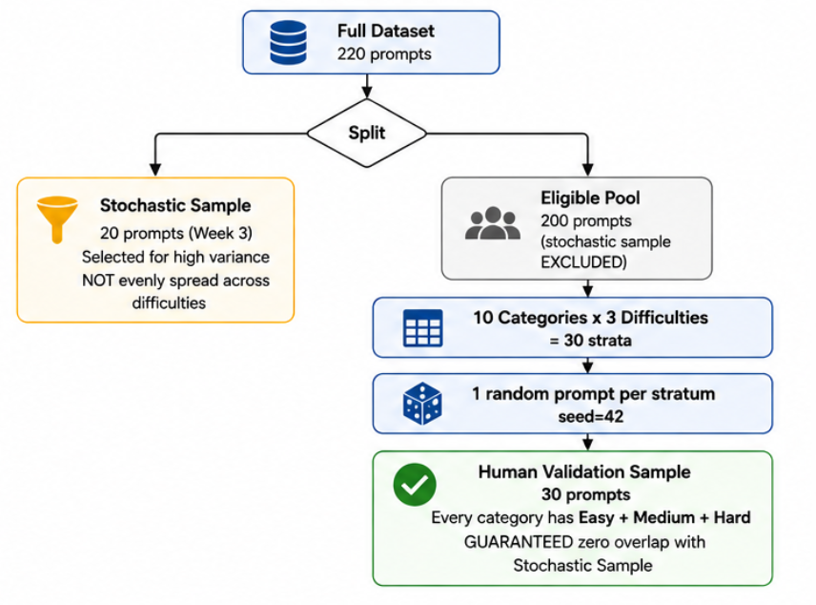
- Three separate human rater scoring templates generated (90 items each) and saved in the Survey folder, each independently trackable.
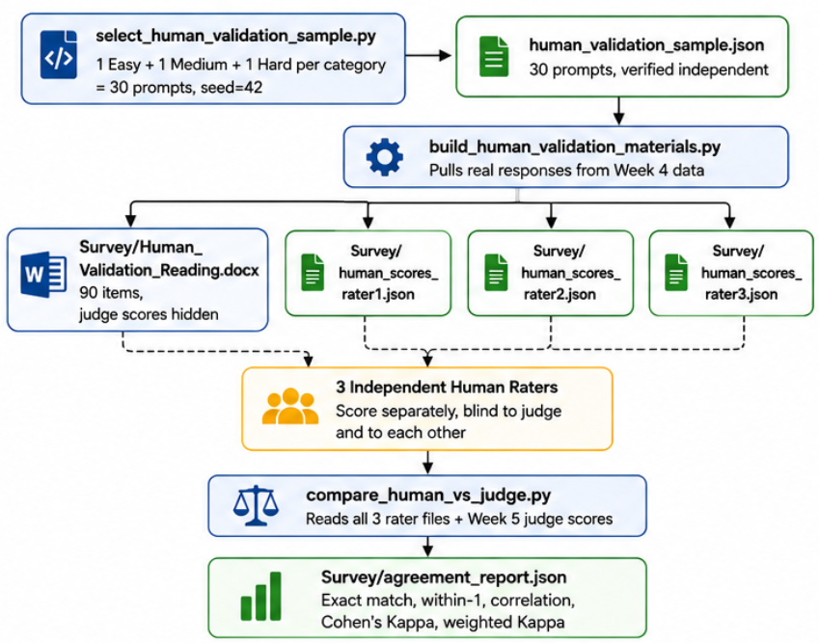

- Full agreement metric suite (including Cohen's Kappa, cross-validated against scikit-learn) confirmed working correctly against the new sample size with no code changes required.
- Agreement computed both between each rater and the automated judge, and between raters themselves, satisfying the proposal's Human-in-the-Loop and inter-rater agreement requirements.
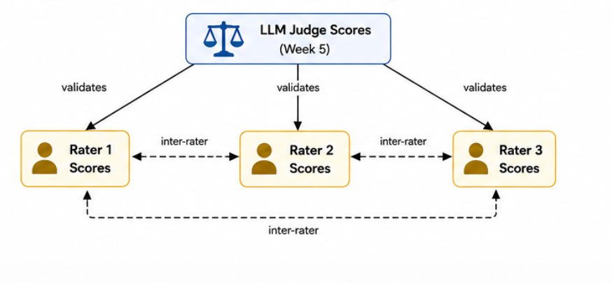

Next Steps
Proceed to Week 7's formal statistical analysis: confidence intervals, hypothesis testing, effect size, correlation, and regression across the full scored dataset, and compute the Reliability statistics (mean, median, standard deviation, coefficient of variation) on the 20 stochastic-sample prompts' 5 scored runs each - incorporating this week's inter-rater agreement findings, now available broken down by difficulty tier given the two-dimensional sampling, as a validity check on the automated scores being analyzed.

