Progress Report: Week 5
Project Phase: Automated Scoring with Explicit Success/Failure Anchors

1. Goal
The goal of Week 5 was to turn the raw collected responses from Week 4 into actual scores, satisfying the supervisor's explicit requirement (August 18) that “automated scores should be carefully derived from final metrics of success or failure” and that “each of the criteria for the success or failure must be meticulously defined and explained.” This required building an LLM-judge scoring pipeline that scores every individual response run - including all 5 runs of each of the 20 stochastic-sample prompts, not just one - against the specific evaluation criteria for that exact prompt, using an explicit, documented scoring scale rather than leaving score interpretation to the judge's discretion.

2. Method
A single scoring script (llm_judge_scorer.py) reads the consolidated raw response data from Week 4 and scores each run independently using a free LLM judge via OpenRouter. Every criterion is scored 0-5 against a standardized, explicit scale (0 = Complete Failure through 5 = Complete Success, with 3 defined as the Minimum Success Threshold), sent to the judge as part of every scoring prompt so the scale is applied consistently. Critically, the Success/Failure outcome for each criterion, and the overall outcome for each prompt run, are computed in code from the judge's numeric scores using this documented threshold - never trusted from the judge's own labeling, following the same principle already used for total_score (summed in code, not trusted from the judge's arithmetic). A prompt run's overall outcome is Success only if every one of its criteria individually succeeded, a deliberately strict definition rather than an averaged one.

3. Process

3.1 Per-Run Scoring Architecture
Because Week 4's data collection produces a runs array per prompt (1 entry for standard prompts, 5 for the stochastic reliability sample), the scorer was built to score each run as an independent unit rather than only scoring one representative response per prompt. This is deliberate: scoring all 5 runs of each stochastic-sample prompt independently produces 5 separate score values per prompt, which is what actually enables computing mean, median, standard deviation, and coefficient of variation on scores later, not just on response text.
[ Insert Screenshot: terminal output of a real scoring run showing both a single-run prompt and a multi-run prompt being scored separately ]

3.2 Explicit Score Anchors
A standardized six-point scale definition (0 through 5) is included in every judge prompt, explaining precisely what distinguishes each score level and explicitly marking 3 as the Minimum Success Threshold. This directly addresses the supervisor's requirement that scoring criteria be meticulously defined rather than left implicit.

3.3 Unit Testing Before Real Scoring
Ten unit tests were written and run using an injected fake judge client, verifying: criteria parsing, that the score anchors appear correctly in the constructed judge prompt, correct per-run file naming for both single-run and multi-run prompts, the exact boundary case (a score of precisely 3 correctly classifies as Success), resume logic operating at the individual-run level, backoff/retry behavior, and atomic writes leaving no orphaned temp files.
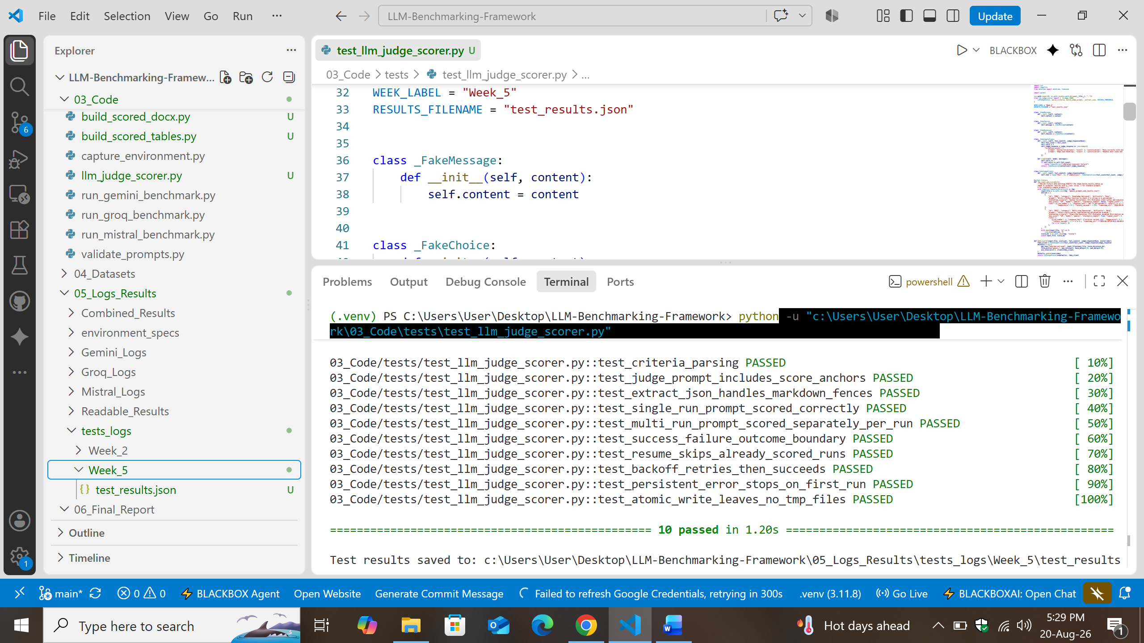
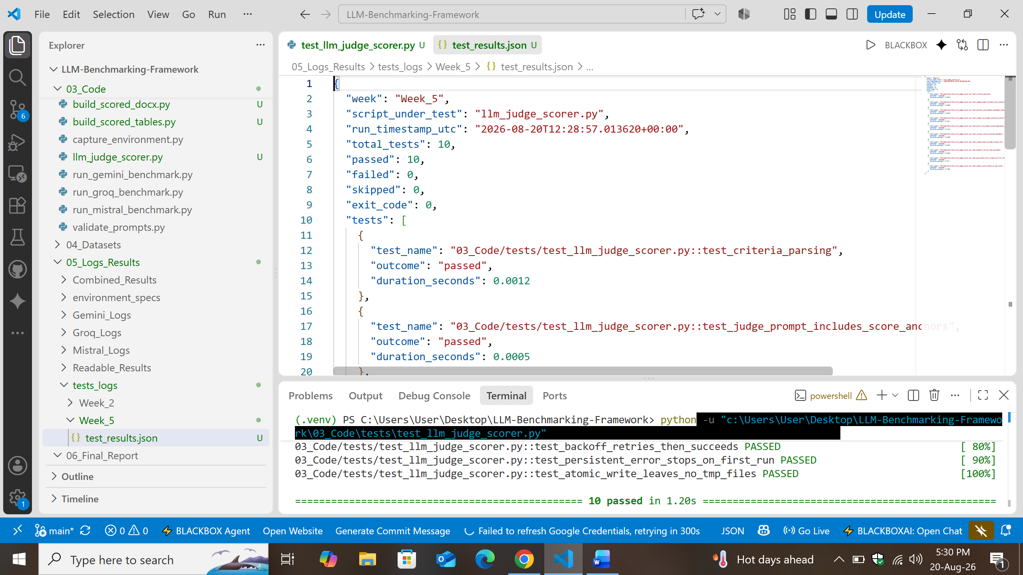

3.4 Results Consolidation
Two scripts consolidate the per-run scored files: build_scored_tables.py produces one structured JSON per provider, grouping all runs of each prompt together with aggregate success/failure counts; build_scored_docx.py produces a human-readable Word table per provider showing every criterion's score, justification, and computed outcome, with failed rows and stochastic-sample prompts visually highlighted for quick review.
[ Insert Screenshot: Readable_Scores docx showing a real scored prompt with visible Success/Failure color-coding ]

3.5 Supervisor Compliance & Validation
The scoring logic, success/failure boundary computation, and multi-run consolidation grouping were each verified against representative test scenarios before being used for real API calls, including the specific edge case of a score landing exactly on the success threshold. Real execution against the live OpenRouter API, and the corresponding screenshots of actual scored output, are the next step following this report.

4. Results
- LLM judge scoring pipeline built and unit-tested (10/10 passing), scoring each response run independently rather than only one representative run per prompt.

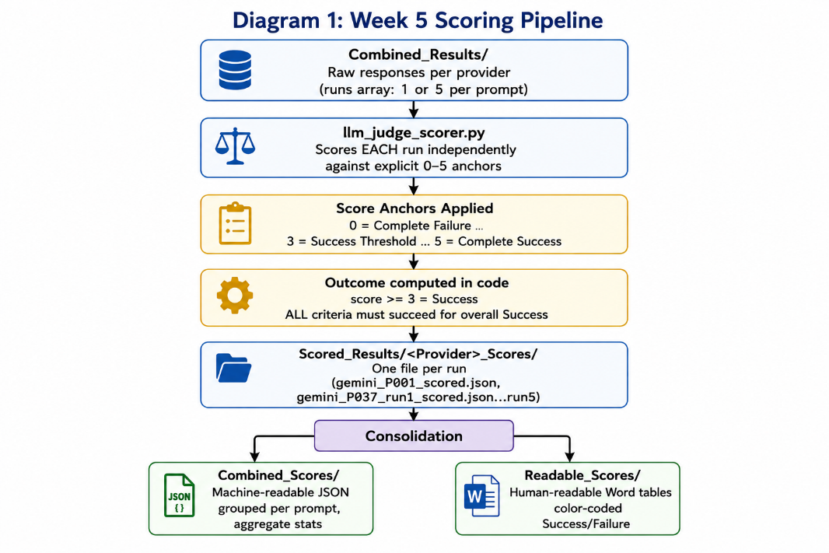
- Explicit, standardized 0-5 score anchors defined and embedded in every judge prompt, satisfying the supervisor's requirement that success/failure criteria be meticulously defined and explained.

- Success/Failure outcome computed in code from a documented threshold (score >= 3), never trusted from the judge's own text - verified correct at the exact boundary case.

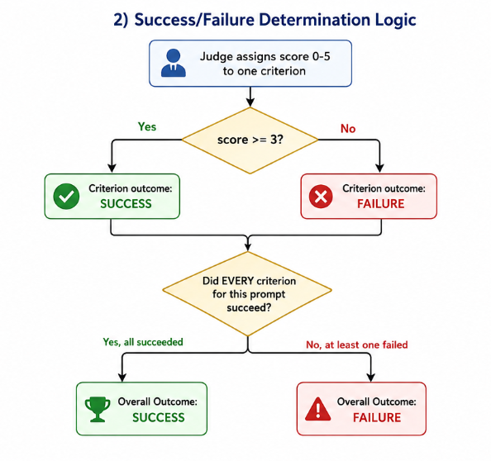
- Consolidation scripts built and verified: machine-readable JSON grouping all runs per prompt with aggregate statistics, and human-readable Word tables with color-coded outcomes.

Next Steps
Now proceed to Week 6's human evaluation - manually scoring a sample of the same responses and comparing against the automated LLM-judge scores to validate the scoring pipeline's reliability.

