Progress Report: Week 2
Project Phase: Automation Architecture, Pipeline Initialization, and Live API Verification

1. Goal
The goal of Week 2 was to build the core automation pipeline that calls a real free-tier LLM API for every prompt in the dataset, to prove this pipeline can run safely without triggering rate limits or a ban, and to establish a reproducible development environment so the project's dependencies are isolated and can be recreated on any machine. OpenRouter was selected as the provider for this stage of pipeline development and verification, since it offers an OpenAI-compatible API with accessible free-tier models. Groq is reserved as one of the three providers used in the full data collection run in Week 4.

2. Method
A single self-contained BenchmarkRunner class was implemented in benchmark_runner.py, combining two independent safety mechanisms: proactive throttling (a fixed minimum delay enforced before every API call) and reactive exponential backoff with randomized jitter (a growing, randomized delay applied only after a call fails). The class calls OpenRouter's OpenAI-compatible chat completions endpoint, and also implements disk-based JSON caching per prompt and resume logic. To test this logic without any risk of real rate limits, a fake client mimicking the OpenAI-compatible response shape was injected into the runner in place of the real API client. Separately, a project-local virtual environment was created and all dependencies were declared in a requirements file, so the project's Python environment no longer depends on whatever happens to be installed globally on the machine.

3. Process

3.1 Automation Pipeline Implementation
Implemented BenchmarkRunner with call_model() (the real OpenRouter API call, made through the OpenAI-compatible SDK pointed at OpenRouter's base URL), _throttle() (proactive delay), _call_with_backoff() (reactive exponential backoff with jitter), disk caching via _cache_path(), and resume logic via _already_done().
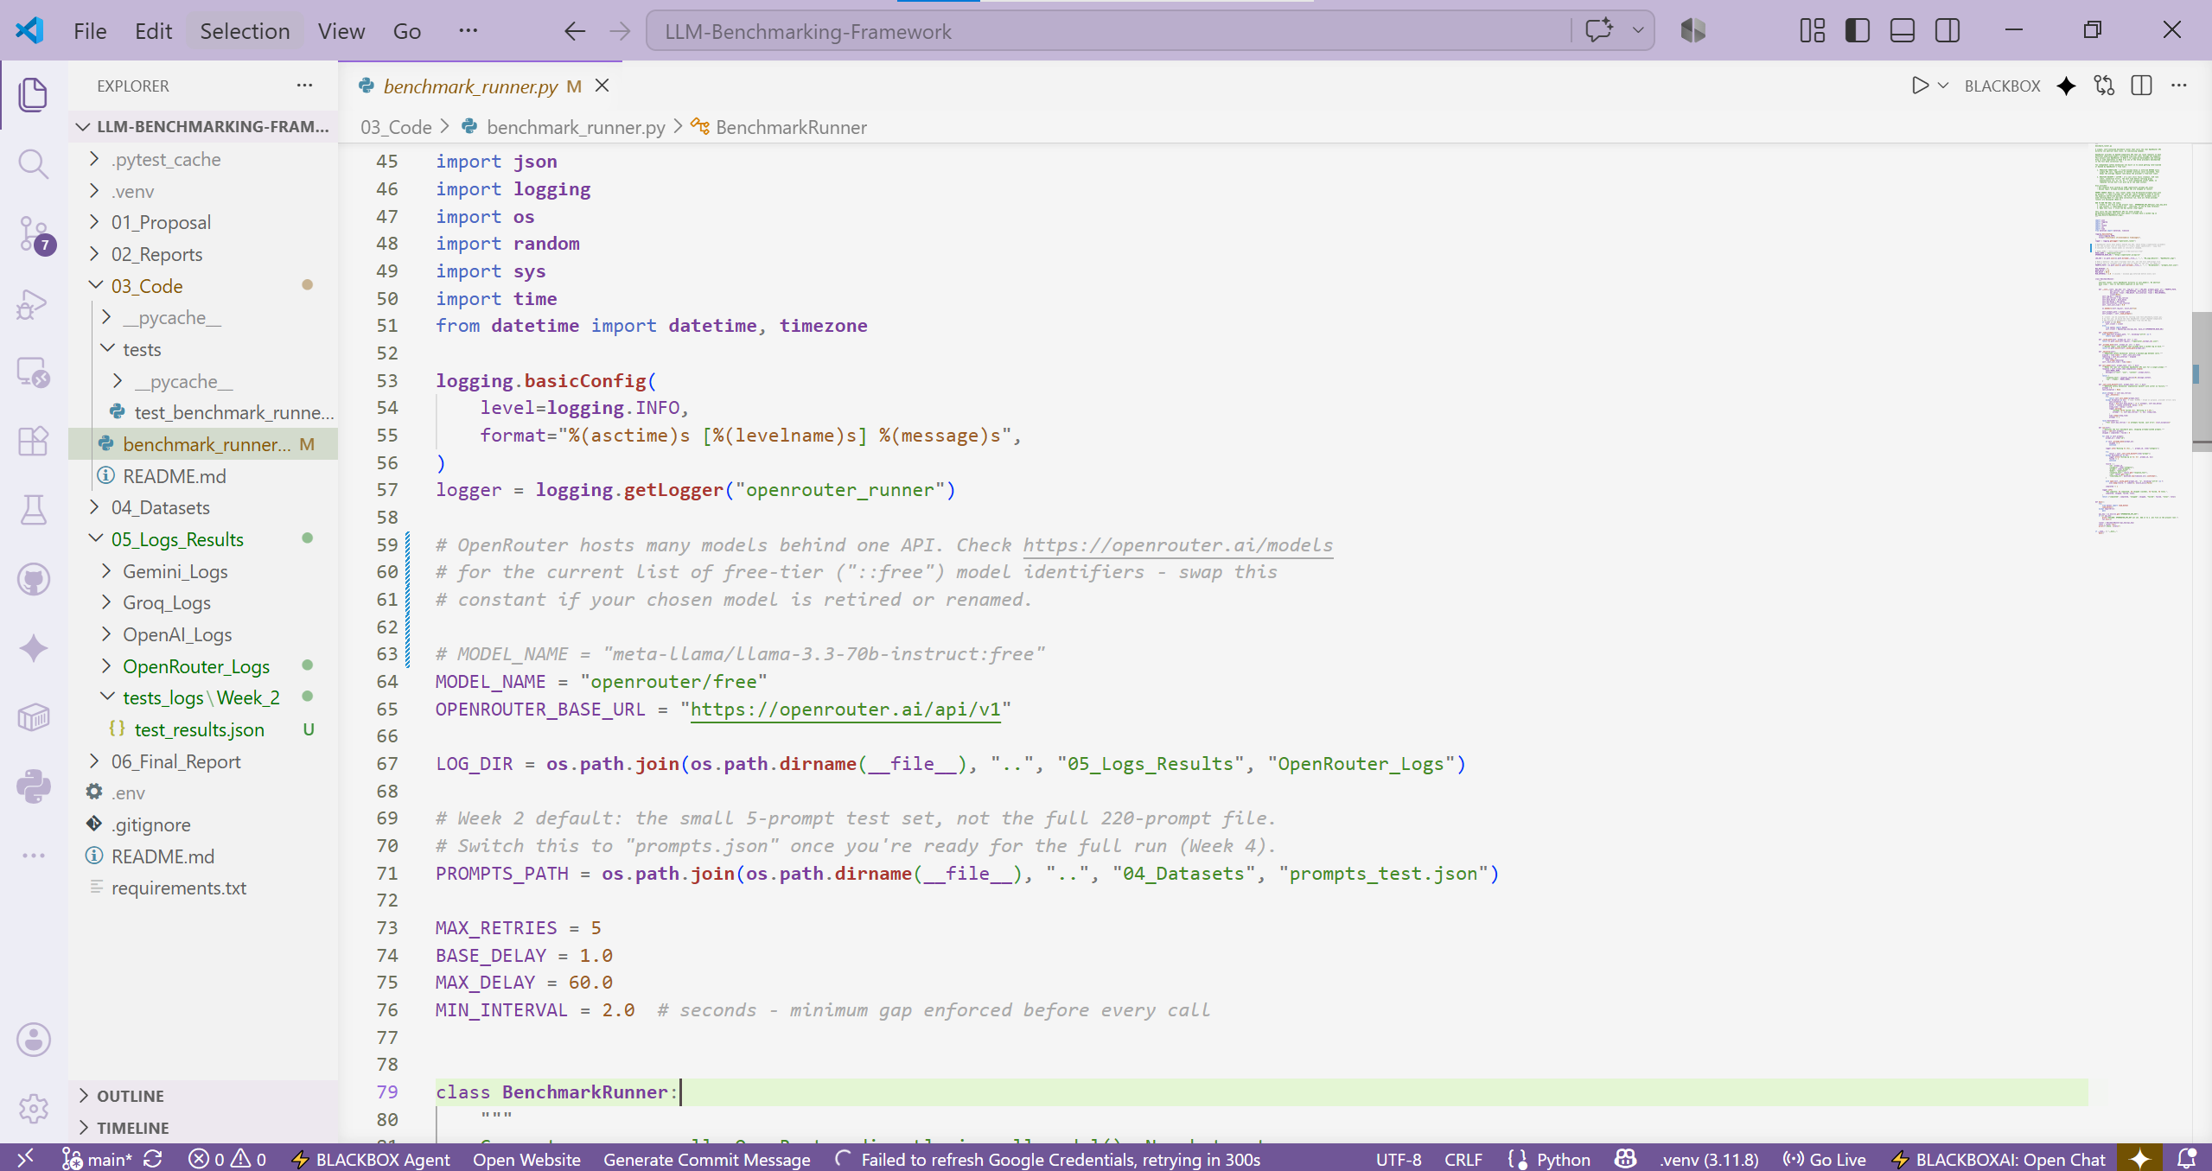

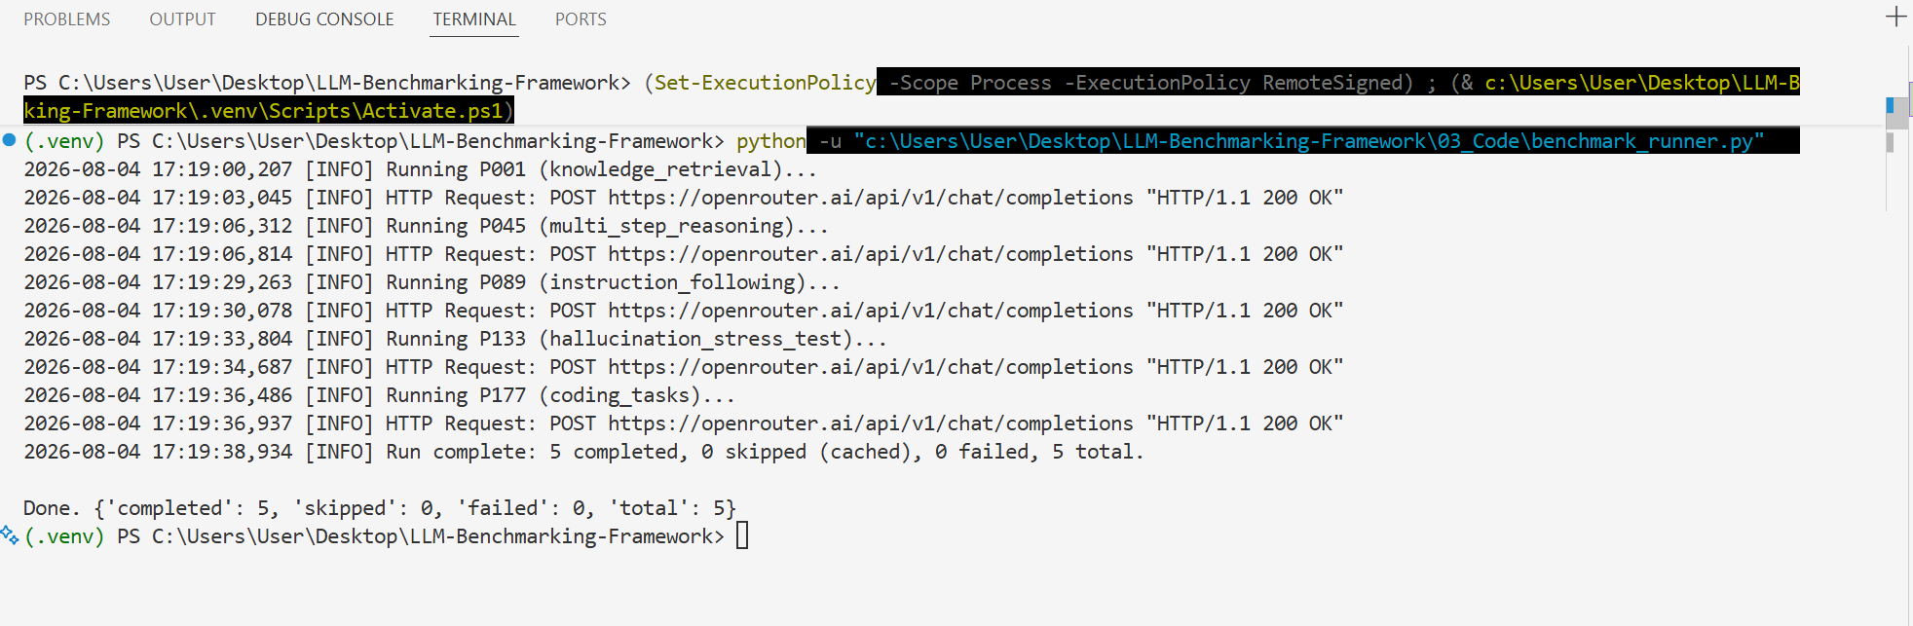

3.2 Unit Testing (No Real API Calls)
Built test_benchmark_runner.py using an injected FakeOpenRouterClient that mimics the OpenAI-compatible client's shape without any network call. Nine tests were written and executed, covering: prompt loading, cache path format, one-JSON-per-prompt output, resume/skip logic, backoff-then-recovery, giving up after max retries, exponential growth of retry delay, minimum-interval throttling, and jitter randomness. The test file is self-contained: running it directly (not through the pytest Testing sidebar) automatically saves a JSON summary of every test outcome to 05_Logs_Results/tests_logs/Week_2/test_results.json, giving a persistent, dated record of test execution for this week. Each subsequent week's test file follows the same pattern with its own Week_N folder.

File -> test_benchmark_runner.py
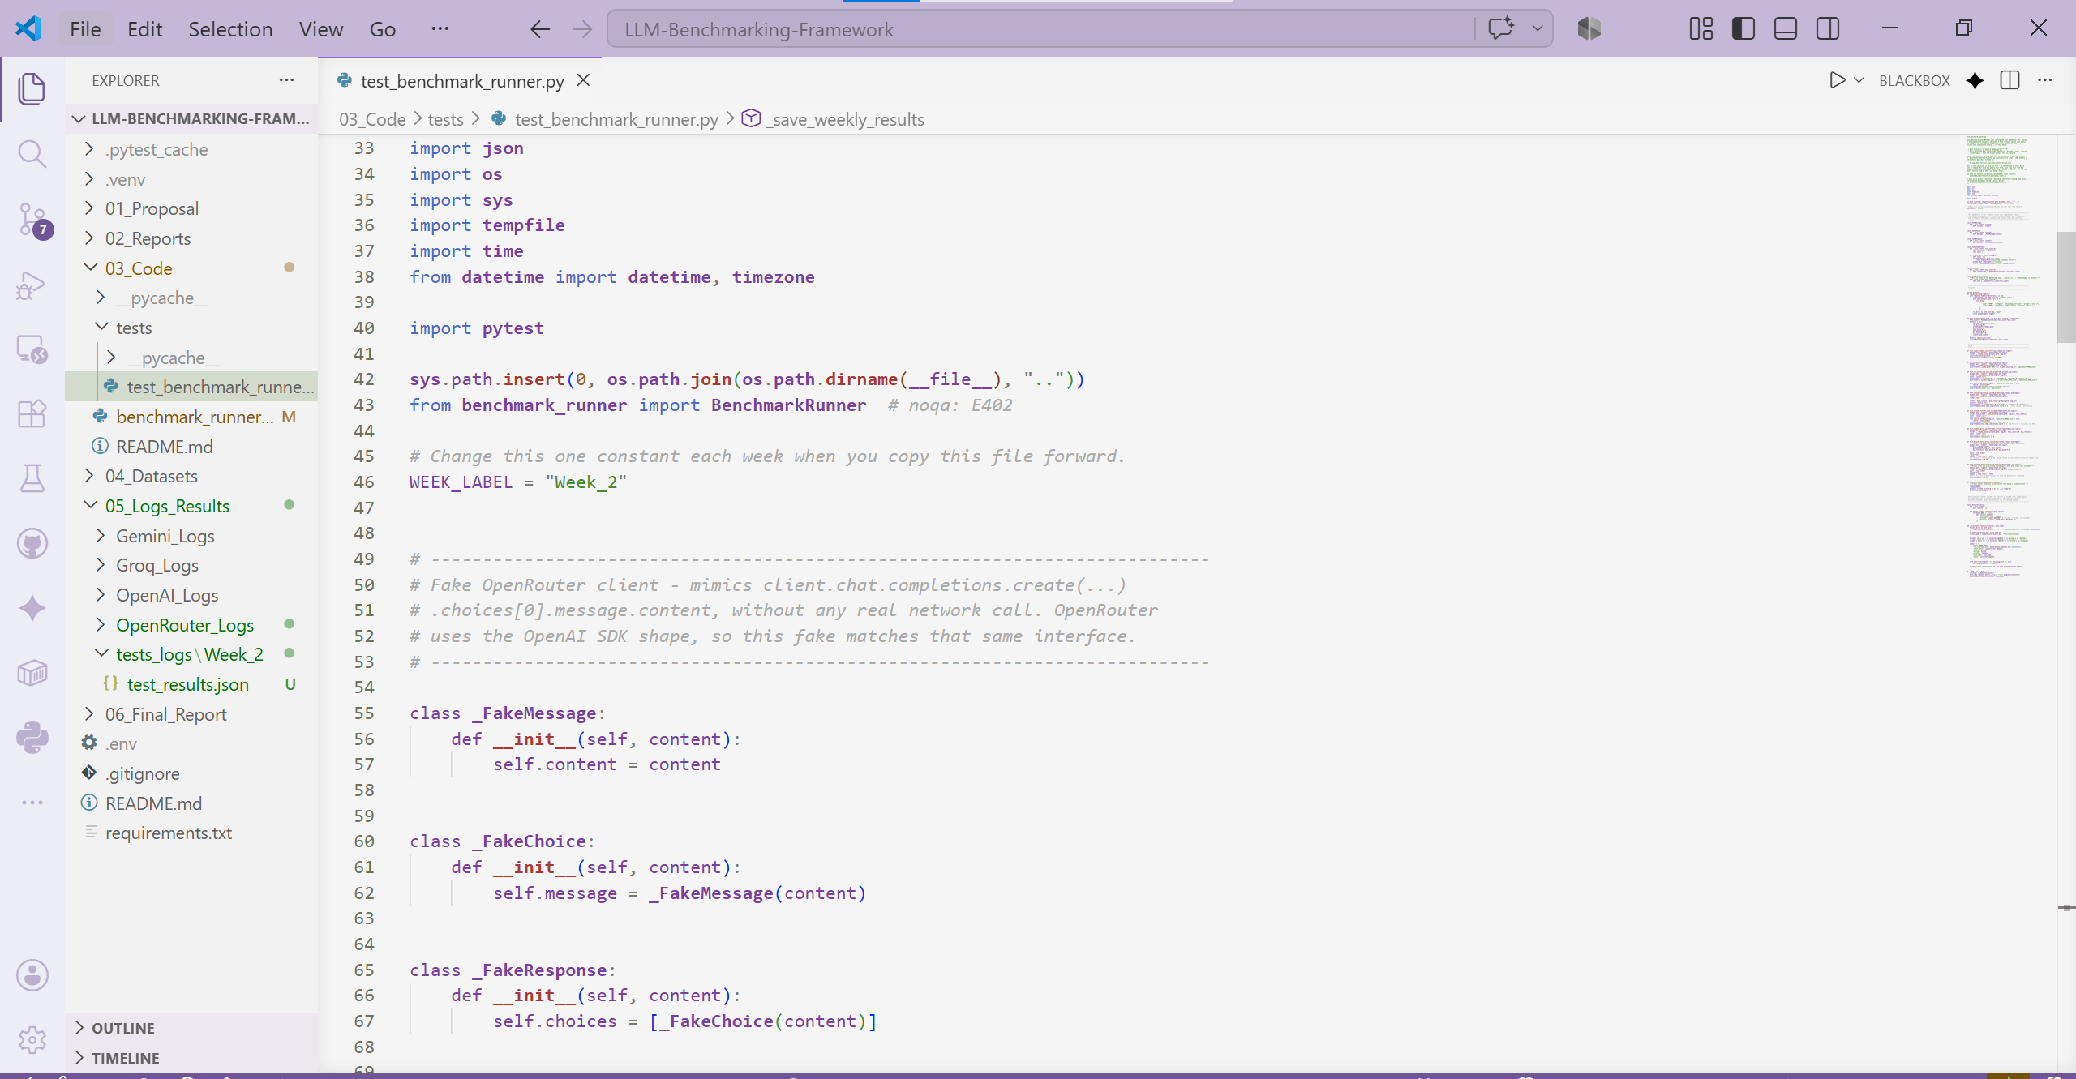

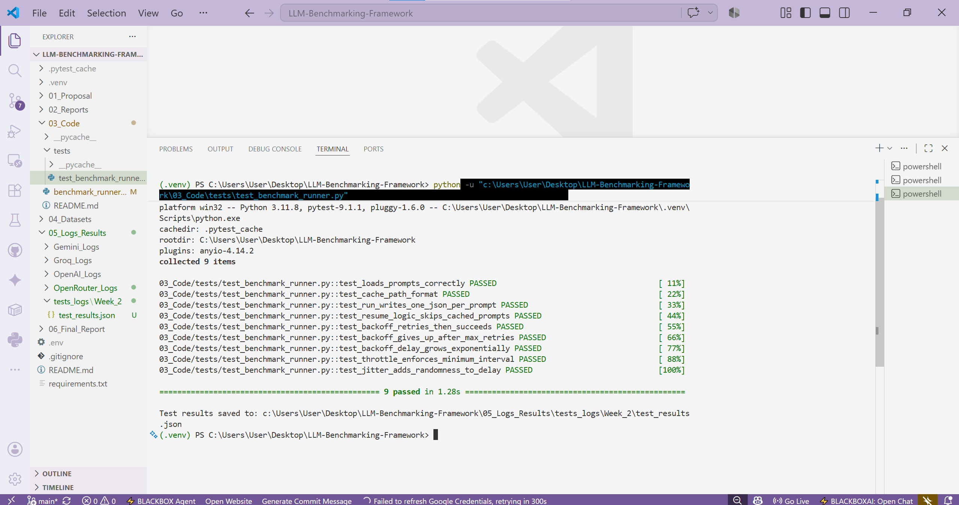

3.3 Live OpenRouter API Verification, Including a Real Failure
Ran benchmark_runner.py directly against the real OpenRouter API using a valid OPENROUTER_API_KEY stored in a local .env file (never committed to the repository). The first real run surfaced a genuine failure: the originally selected free model slug had been discontinued by the provider, returning a 404 error. This was valuable evidence rather than a setback — the backoff mechanism responded exactly as designed, retrying six times with correctly growing delays (approximately 1.4s, 2.9s, 4.6s, 10.2s, 20.6s, and 35.3s) before failing cleanly with a full error trace rather than hanging indefinitely. The root cause was identified as an external provider change, not a defect in the pipeline. The fix was to switch the model constant to OpenRouter's own free-model router (openrouter/free), which automatically selects a currently available free model instead of depending on one named model that can be discontinued without notice. After this change, live calls succeeded and returned real responses, written to disk in the expected log schema.

File -> benchmark_runner.py
BEFORE Changing MODEL NAME:
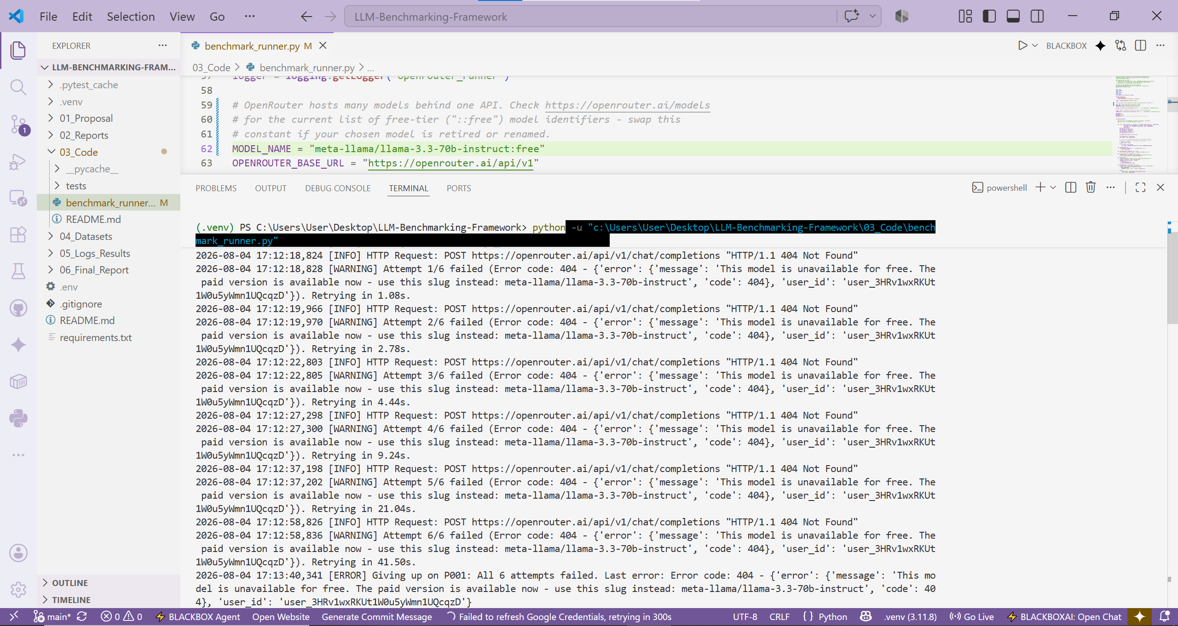

AFTER Changing MODEL NAME:
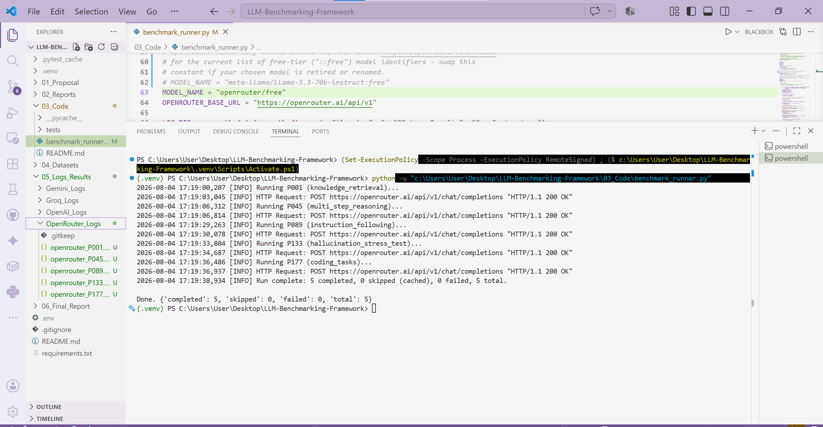

JSON File Result Format:
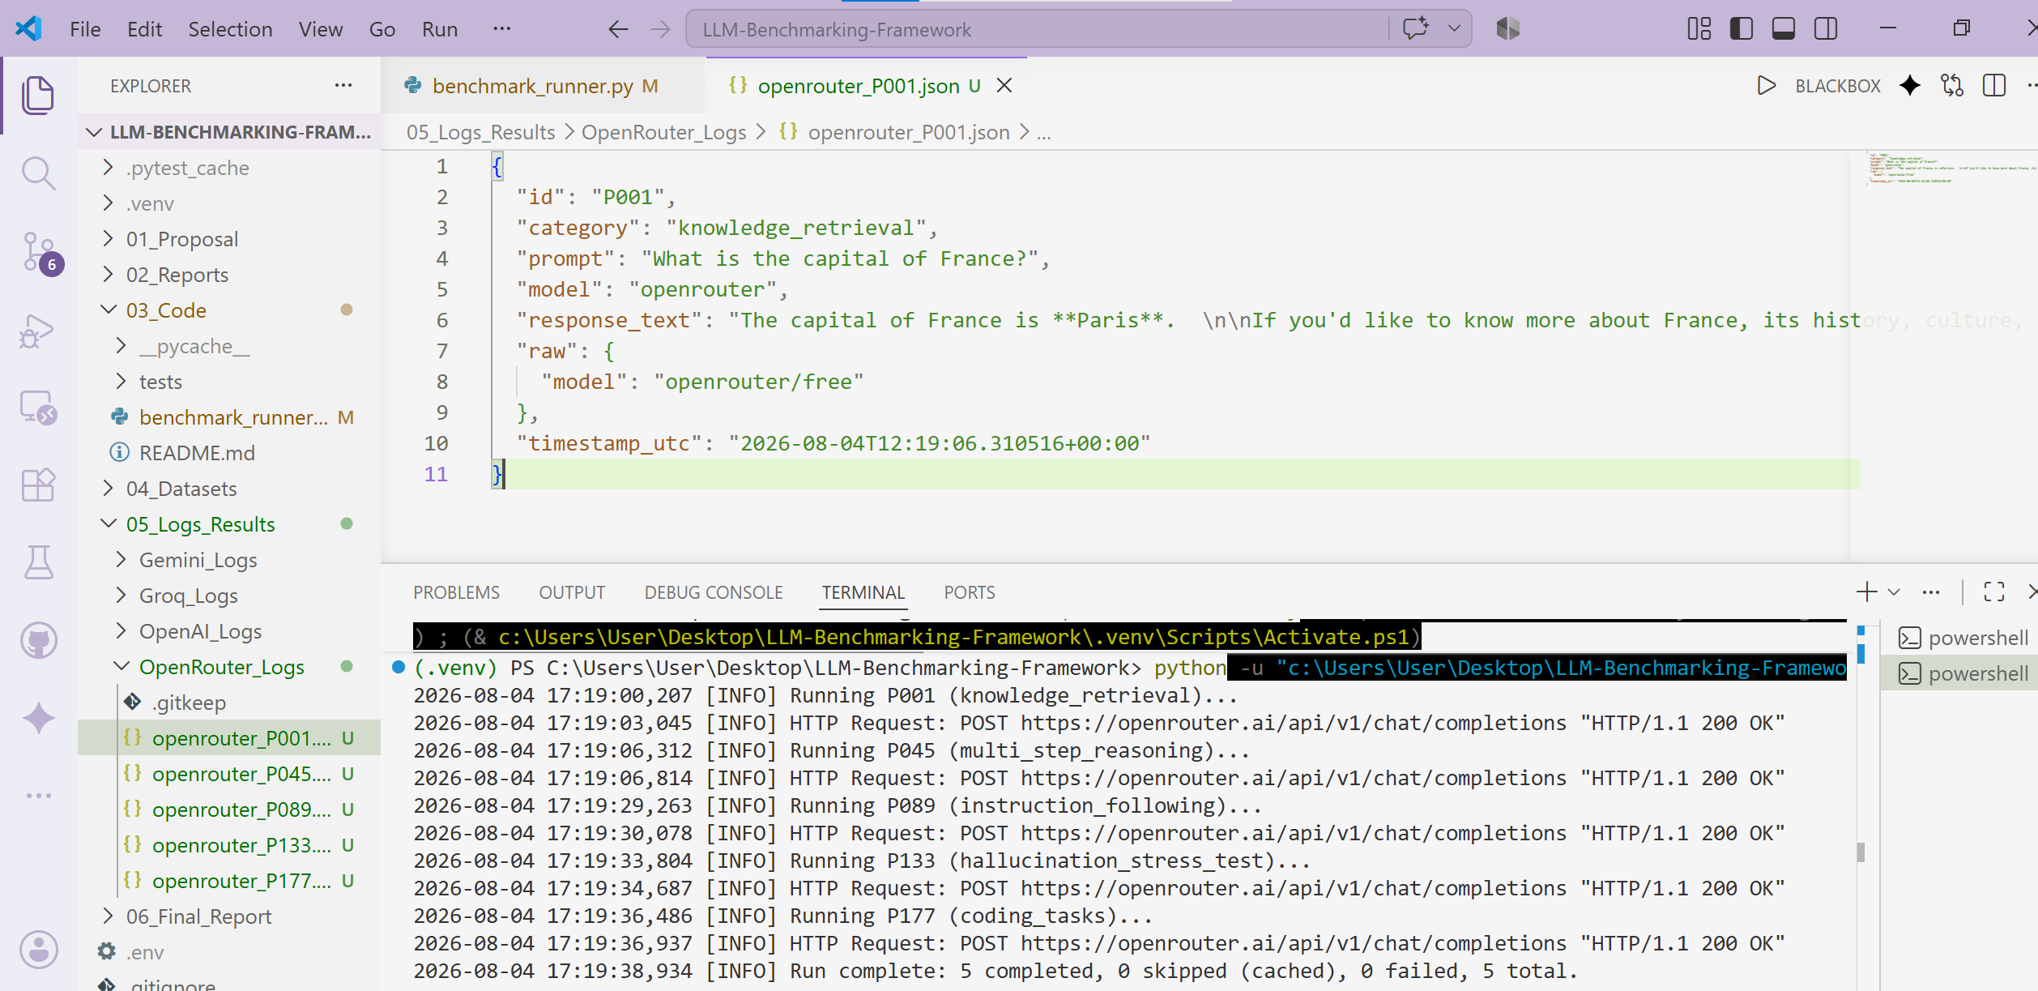

3.4 Environment Reproducibility (.venv and requirements.txt)
Created a project-local virtual environment (.venv) using VS Code's built-in environment manager, isolating this project's Python packages from the machine's global installation. All dependencies (openai, python-dotenv, pytest) were declared explicitly in requirements.txt, so the exact same environment can be recreated by anyone from a single command. The .venv folder itself was excluded from version control via .gitignore, since it is fully regenerable from requirements.txt and would otherwise bloat the repository with thousands of installed package files
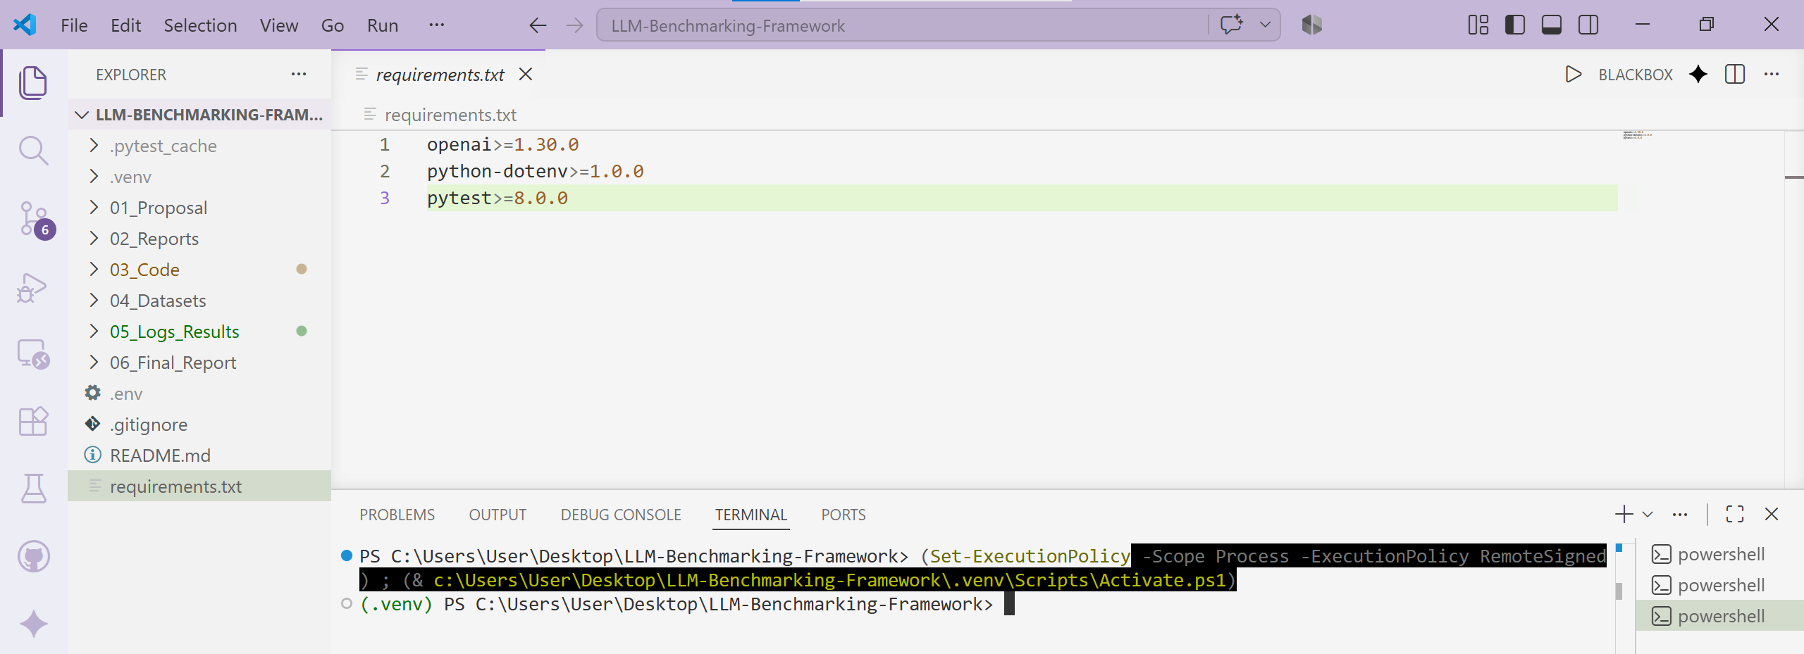

3.5 Supervisor Compliance & Validation
Unit testing was performed in the same week the code was written, rather than being deferred — all 9 tests were run and confirmed passing before any live API call was attempted, and the results are saved persistently rather than only appearing transiently in the terminal. The live API call itself doubles as verification of the baseline execution log schema, since the resulting JSON record was checked against the required field set (id, category, prompt, model, response_text, raw, timestamp_utc). The real 404 failure and subsequent fix additionally serve as live evidence that the reliability mechanisms (backoff, clean failure handling) work correctly under a genuine, unplanned fault condition, not only under the mocked test scenarios.

4. Results
- BenchmarkRunner successfully implemented with both proactive throttling and reactive backoff-with-jitter as independent, separately-tested safety mechanisms.
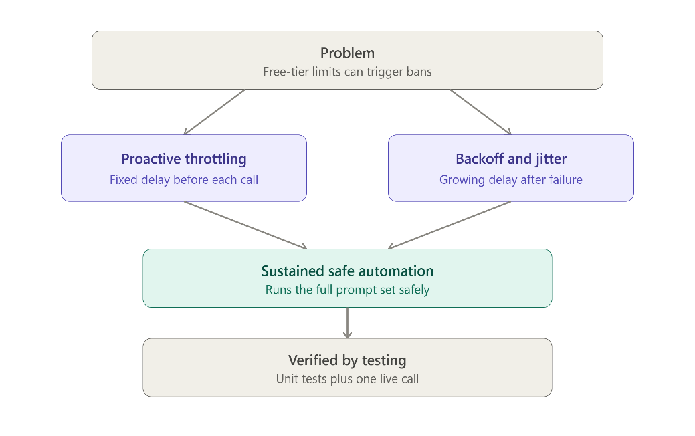
- All 9 unit tests in test_benchmark_runner.py passed using a fake injected client — zero real API calls were needed to verify the automation logic — and results are automatically saved to 05_Logs_Results/tests_logs/Week_2/test_results.json on every run.
- A real API failure (discontinued free model, HTTP 404) was encountered and handled correctly: 6 retries with correctly growing backoff delays, followed by a clean failure with a full error trace.
- Root cause was diagnosed and fixed by switching to OpenRouter's free-model router (openrouter/free); a subsequent real, live call to the OpenRouter API succeeded, confirming the API key, network connectivity, and response schema all work correctly.

- Resume logic confirmed: a second run against already-cached prompts skips them entirely rather than re-calling the API.
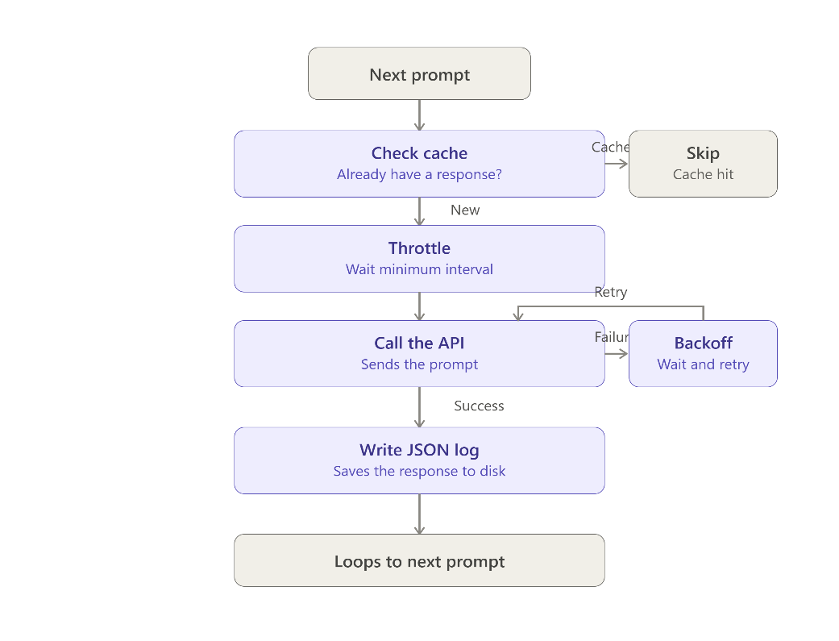
- A reproducible, isolated development environment (.venv + requirements.txt) was established and verified to run all tests identically to the prior setup.
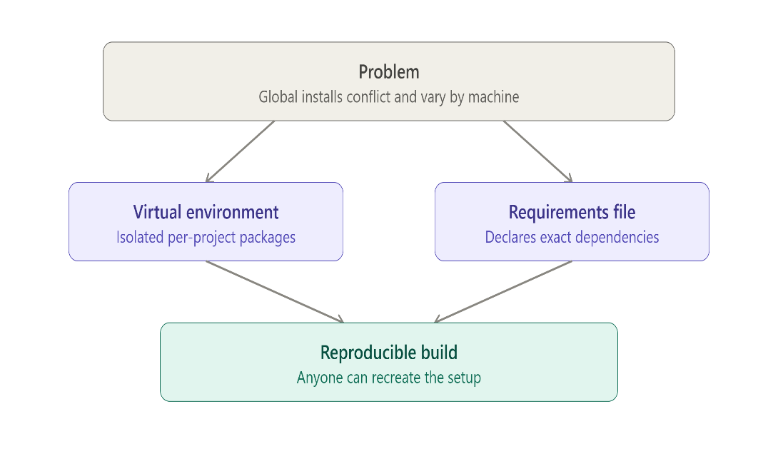

- Provider decision confirmed: OpenRouter is used for pipeline development and verification in Week 2; Groq is reserved for Week 4's full data collection run alongside the other providers.

Next Week Plan (Week 3)
Decouple the single-provider pipeline into independent runner scripts for each provider used in Week 4 (Gemini, OpenAI, Groq), each writing to its own partitioned log directory and its own Week_3 test results folder, so no single provider's failures or rate limits can affect another's data collection.

