Progress Report: Week 7
Project Phase: Formal Statistical Analysis

1. Goal
The goal of Week 7 was to complete the Statistical Analysis requirements specified in the project proposal: Reliability statistics (mean, median, standard deviation, coefficient of variation), confidence intervals, hypothesis testing, effect size, correlation, and regression, applied to the full scored dataset collected and validated in Weeks 4 through 6. This week also consolidated Week 6's inter-rater agreement results into the same statistical report, since the proposal lists inter-rater agreement under the same Statistical Analysis section as the other measures.

2. Method
Two analysis scripts were built. compute_reliability_statistics.py computes mean, median, standard deviation, and coefficient of variation across the 5 scored runs of each of the 20 stochastic-sample prompts, per provider - directly satisfying the proposal's Reliability requirement. statistical_analysis.py computes 95% confidence intervals on mean score per provider, tests the project's three research hypotheses (H1: reasoning vs retrieval score differences, H2: instruction-following score vs difficulty correlation, H3: hallucination score differences between providers) using Welch's t-test and Cohen's d for effect size, computes correlation between difficulty/latency and score, fits a simple linear regression predicting score from difficulty, and incorporates Week 6's inter-rater agreement results. A third script, build_statistical_report_docx.py, converts both scripts' JSON output into one consolidated, human-readable Word report with formatted tables.
The p-value for hypothesis testing is computed using the exact Student's t-distribution (via the regularized incomplete beta function), rather than a normal-distribution approximation, so that significance conclusions are accurate even at the smaller sample sizes present in some category comparisons.

3. Process

3.1 Reliability Statistics
For each of the 20 stochastic-sample prompts, the 5 independently scored runs (Week 5) were used to compute mean, median, standard deviation, and coefficient of variation, per provider. A lower coefficient of variation indicates a model produced more consistent quality (as scored) across repeated calls to the same prompt.
[ Insert Screenshot: terminal output of compute_reliability_statistics.py ]

3.2 Confidence Intervals, Hypothesis Testing, and Effect Size
95% confidence intervals were computed on each provider's mean total score. The three research hypotheses were tested directly against the scored dataset using Welch's t-test (which does not assume equal variance between groups) and Cohen's d as the accompanying effect size measure.
[ Insert Screenshot: terminal output of statistical_analysis.py showing confidence intervals and H1/H2/H3 results ]

3.3 Correlation and Regression
Pearson correlation was computed between prompt difficulty and score, and between response latency and score, for each provider. A simple linear regression was fitted predicting total score from difficulty tier.
[ Insert Screenshot: terminal output showing correlation and regression results ]

3.4 Consolidated Reporting
build_statistical_report_docx.py combines the reliability statistics, confidence intervals, hypothesis test results, correlation/regression findings, and Week 6's inter-rater agreement results into one Word document with formatted, color-coded tables, suitable for direct inclusion in the final research report.
[ Insert Screenshot: Week7_Statistical_Report.docx showing the generated tables ]

4. Results
- Reliability statistics computed for all 20 stochastic-sample prompts across all three providers, with coefficient of variation as the key consistency indicator.
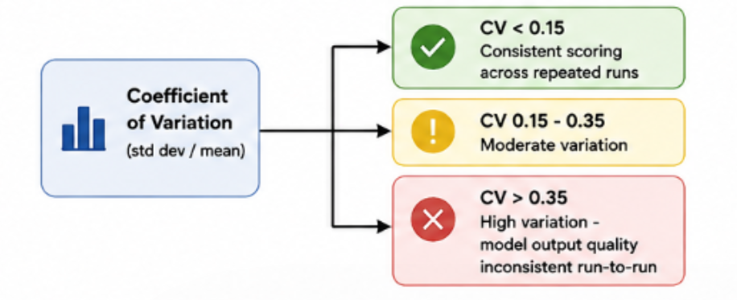
- 95% confidence intervals computed for mean score, per provider.
- All three research hypotheses (H1, H2, H3) tested against the scored dataset, with p-values, significance at 0.05, and Cohen's d effect sizes reported.
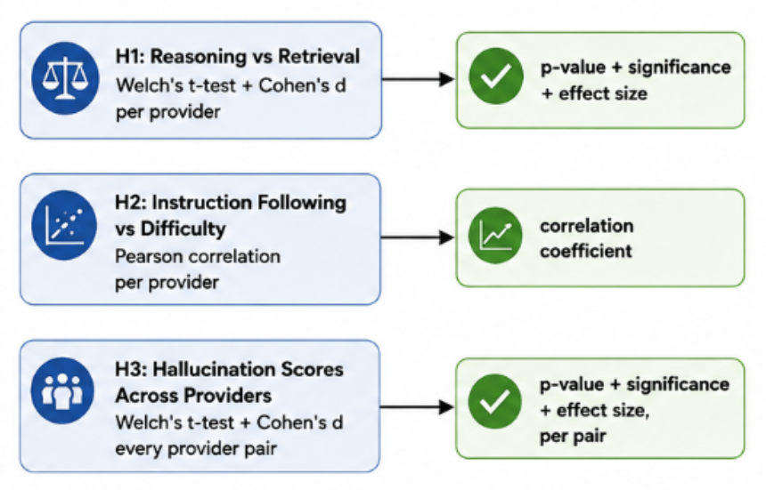

- Correlation and regression analysis completed relating prompt difficulty and latency to score.
- Week 6's inter-rater agreement results consolidated into the same statistical report.
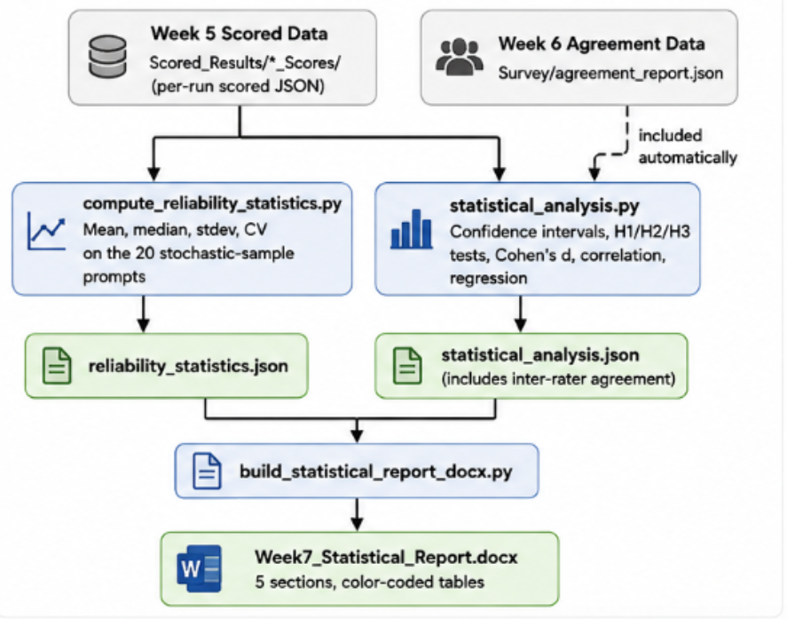

Next Steps
Proceed to Week 8: compile the final comprehensive research report (50-80 pages per the proposal), consolidating all seven weeks' methodology, results, and statistical findings, along with the reproducibility package (source code, datasets, logs, and this project's full documentation) and final presentation.

