Progress Report: Week 2 Date: July 21, 2026
Progress
- Developed the core Python automation script (benchmark_runner.py) in the 03_Code/ directory to handle model interactions and batch testing.
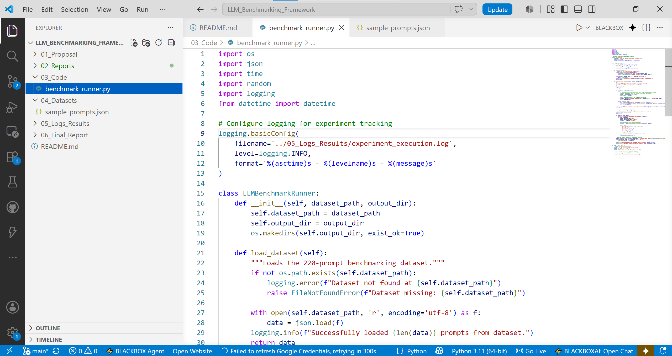
- Implemented intelligent throttling mechanisms with exponential backoff and randomized jitter to safely manage free-tier API rate limits.
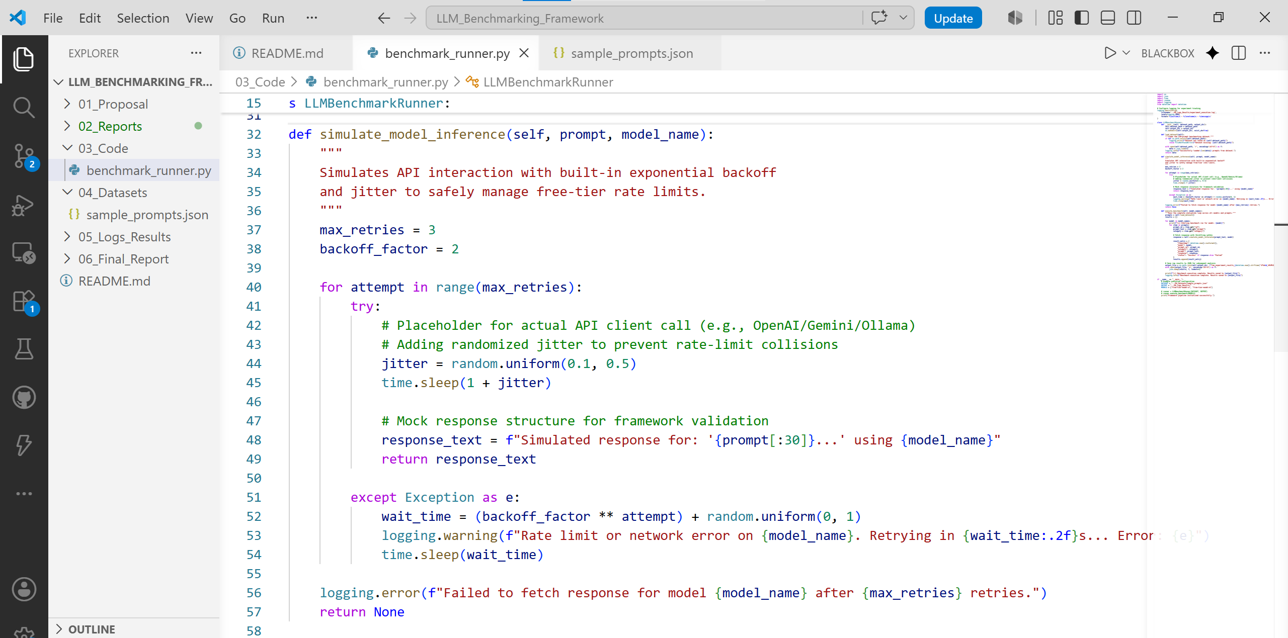

- Created the initial sample prompt dataset structure (sample_prompts.json) in 04_Datasets/ to test execution pipelines.
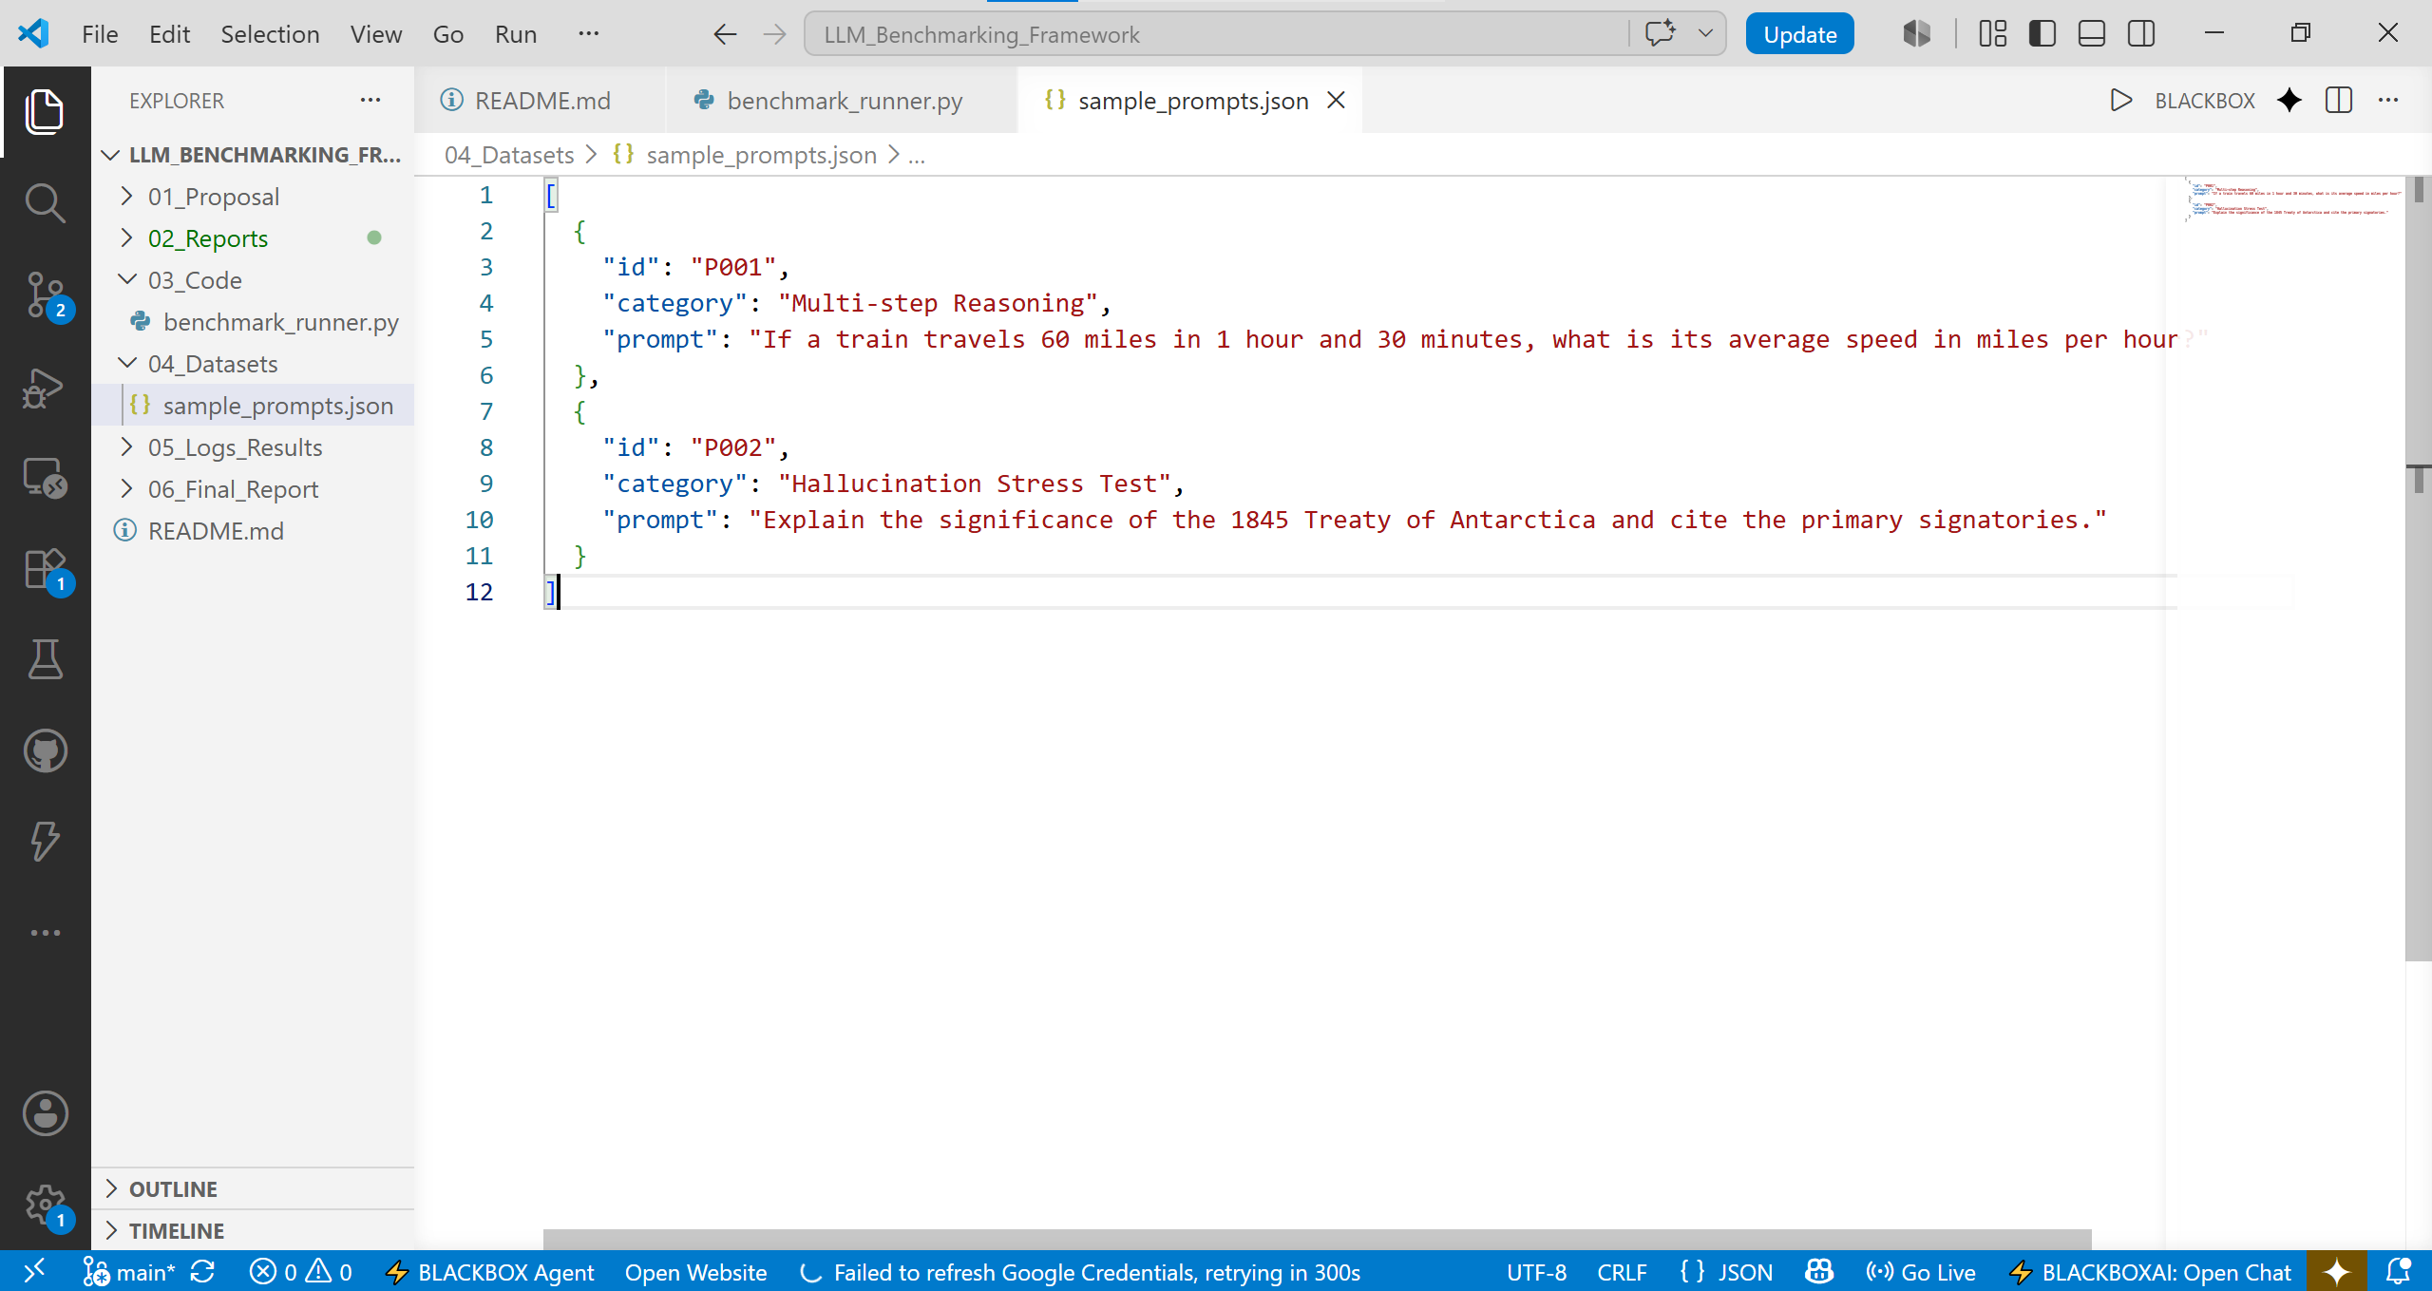
Plans for Week 3
- Expand the dataset library to curate the full set of original prompts across the specialized categories.
- Integrate actual API clients for free-tier model endpoints.
Problems / Blockers
- None; framework execution pipeline initialized successfully.

