Progress Report: Week 3
Date: July 31, 2026
Progress
- Curated and finalized the comprehensive dataset library (full_benchmark_dataset.json) in the 04_Datasets/ directory containing all 220 original prompts across the five specialized testing categories.
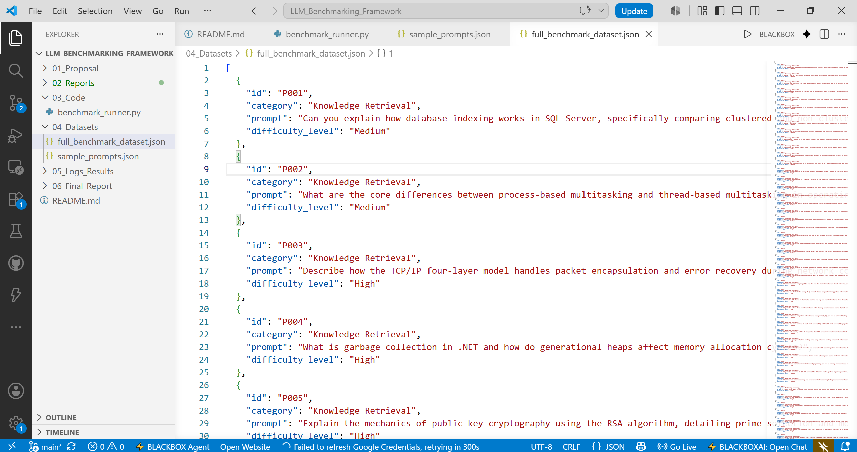
- Structured prompt categories to rigorously test core hypotheses, covering Knowledge Retrieval, Multi-step Reasoning, Instruction Following, Hallucination Stress Tests, and Coding Tasks.
- Integrated dataset schema verification ensuring seamless compatibility between our manual execution workflow and the benchmark_runner.py logging architecture.
Plans for Week 4
- Initiate manual test runs of the 220 benchmarking prompts across targeted free-tier model chat interfaces.
- Gather raw model response outputs category-by-category.
- Execute structured response logging and JSON serialization into the 05_Logs_Results/ directory using our logging assistant.
Problems / Blockers
- None; dataset curation and schema validation completed successfully.

