Progress Report: Week 1
Date: July 17, 2026
Progress
- Initialized the LLM-Benchmarking-Framework repository and set up version control with Git.
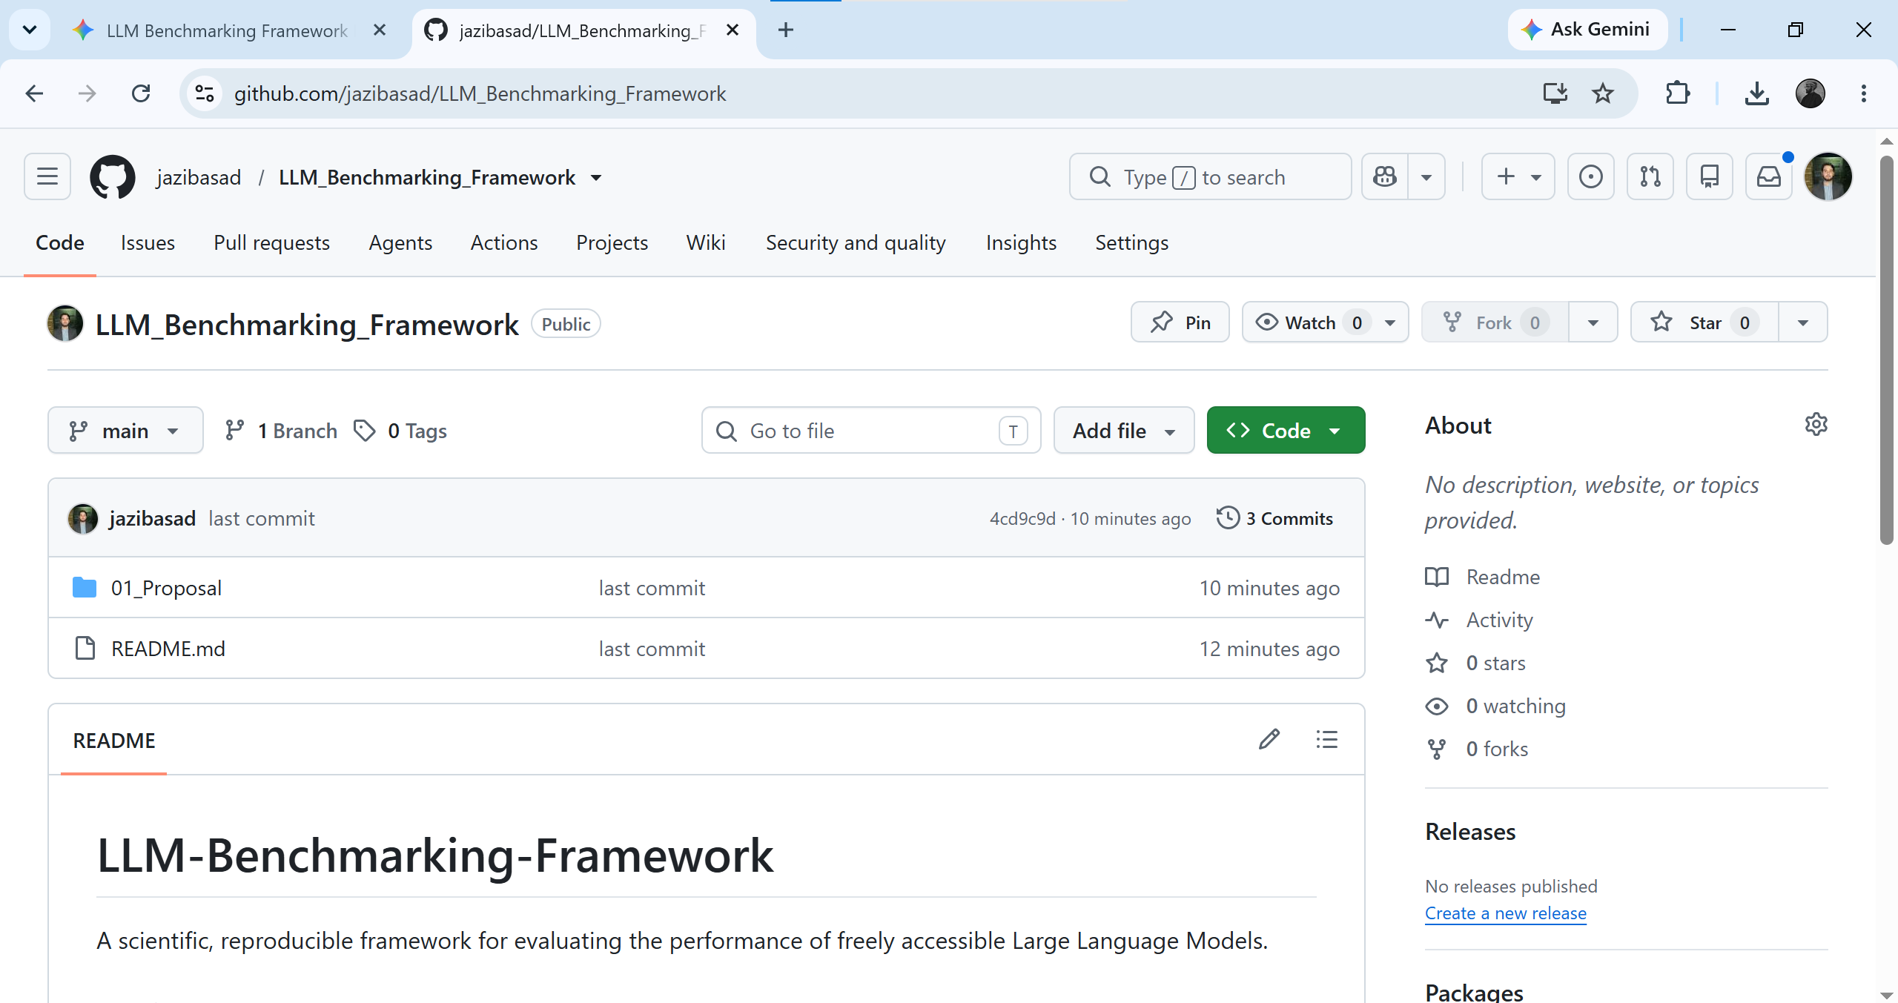

- Established the project directory structure, ensuring all research, code, and documentation are properly siloed.
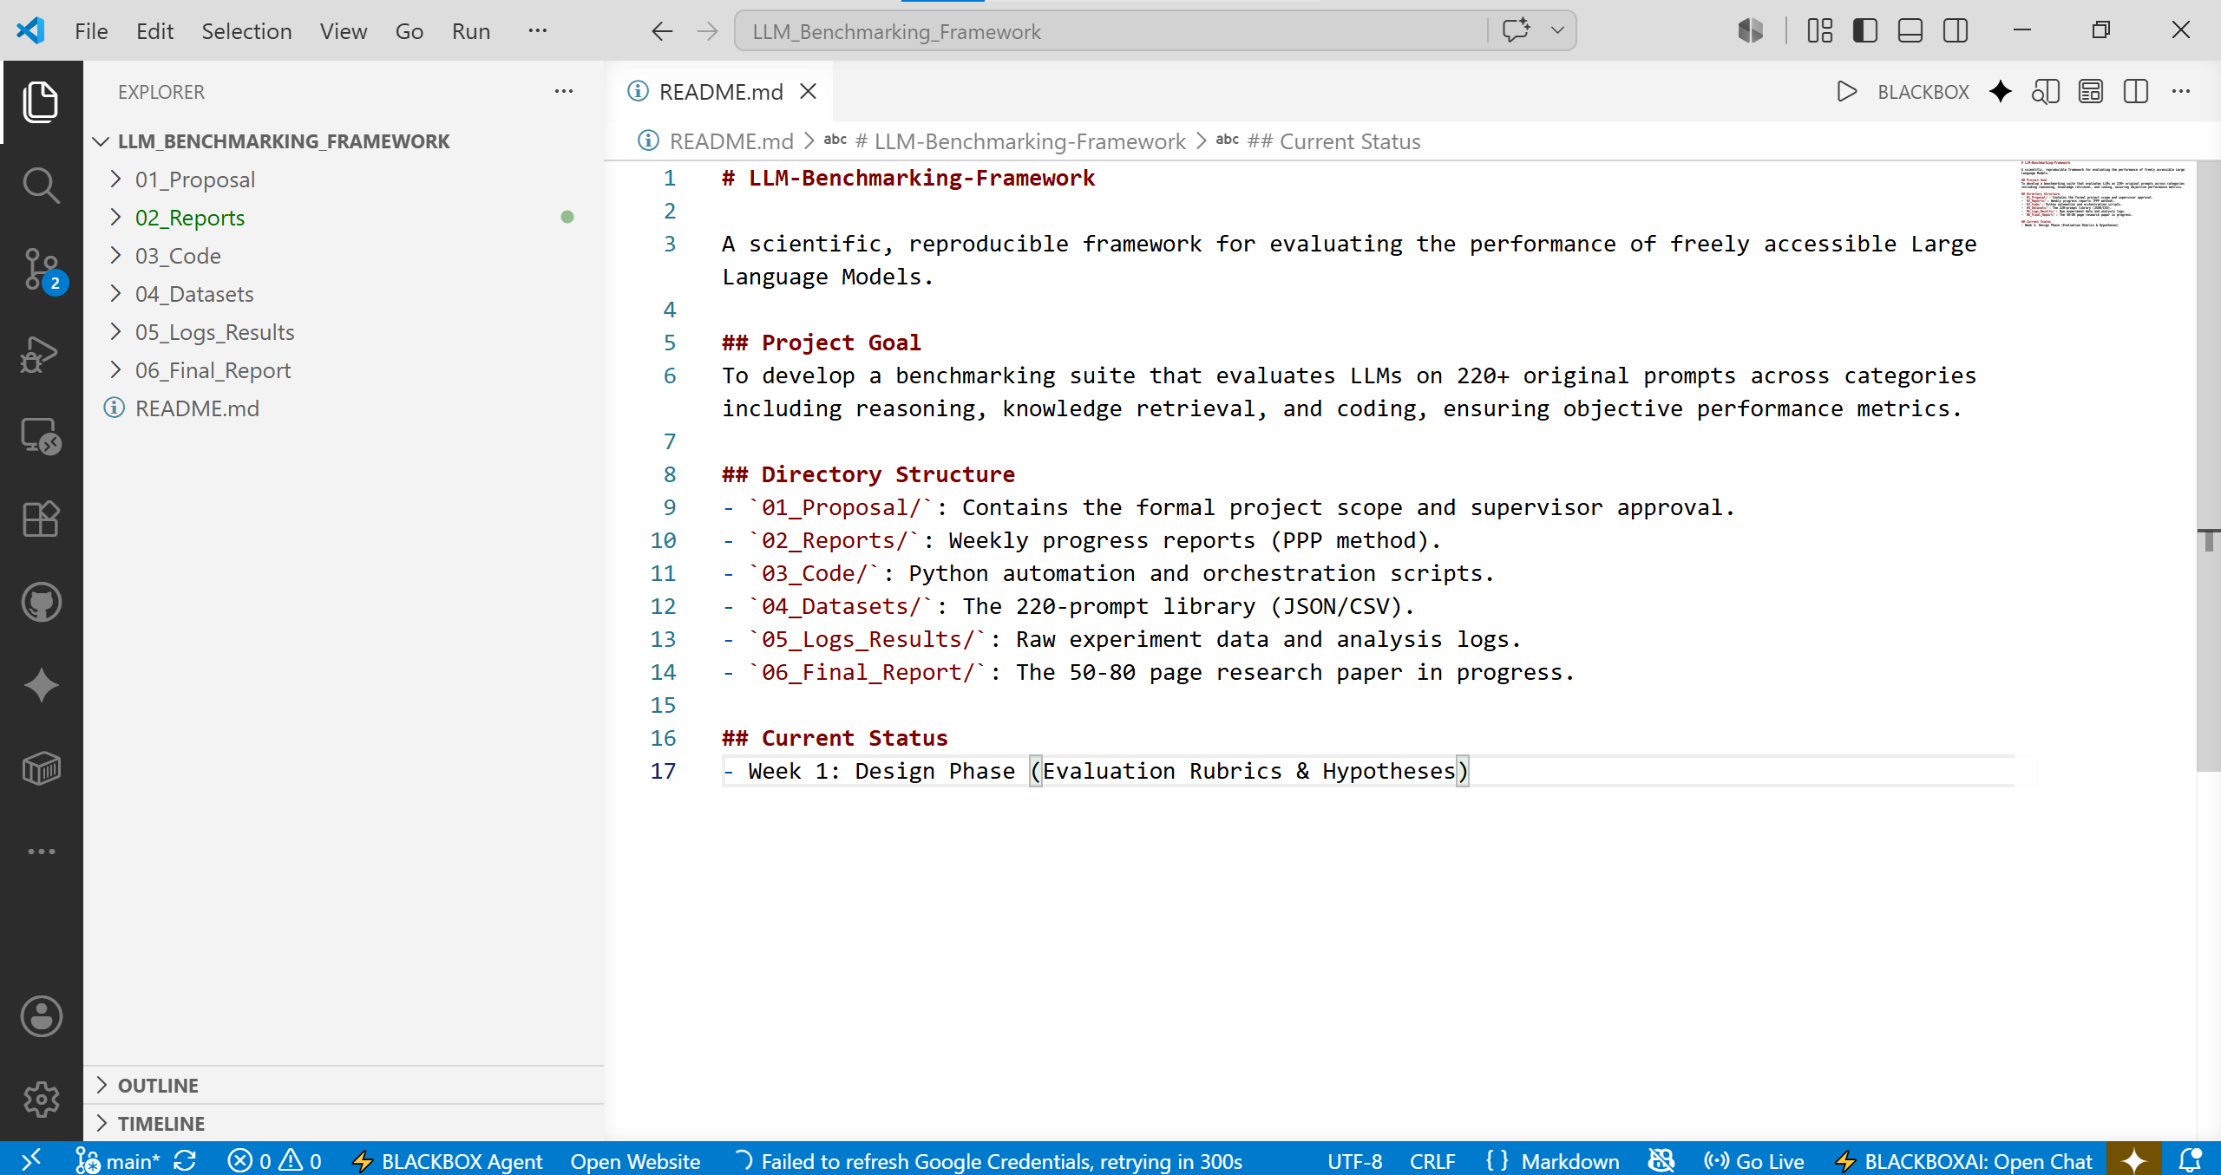

- Finalized the official project proposal.
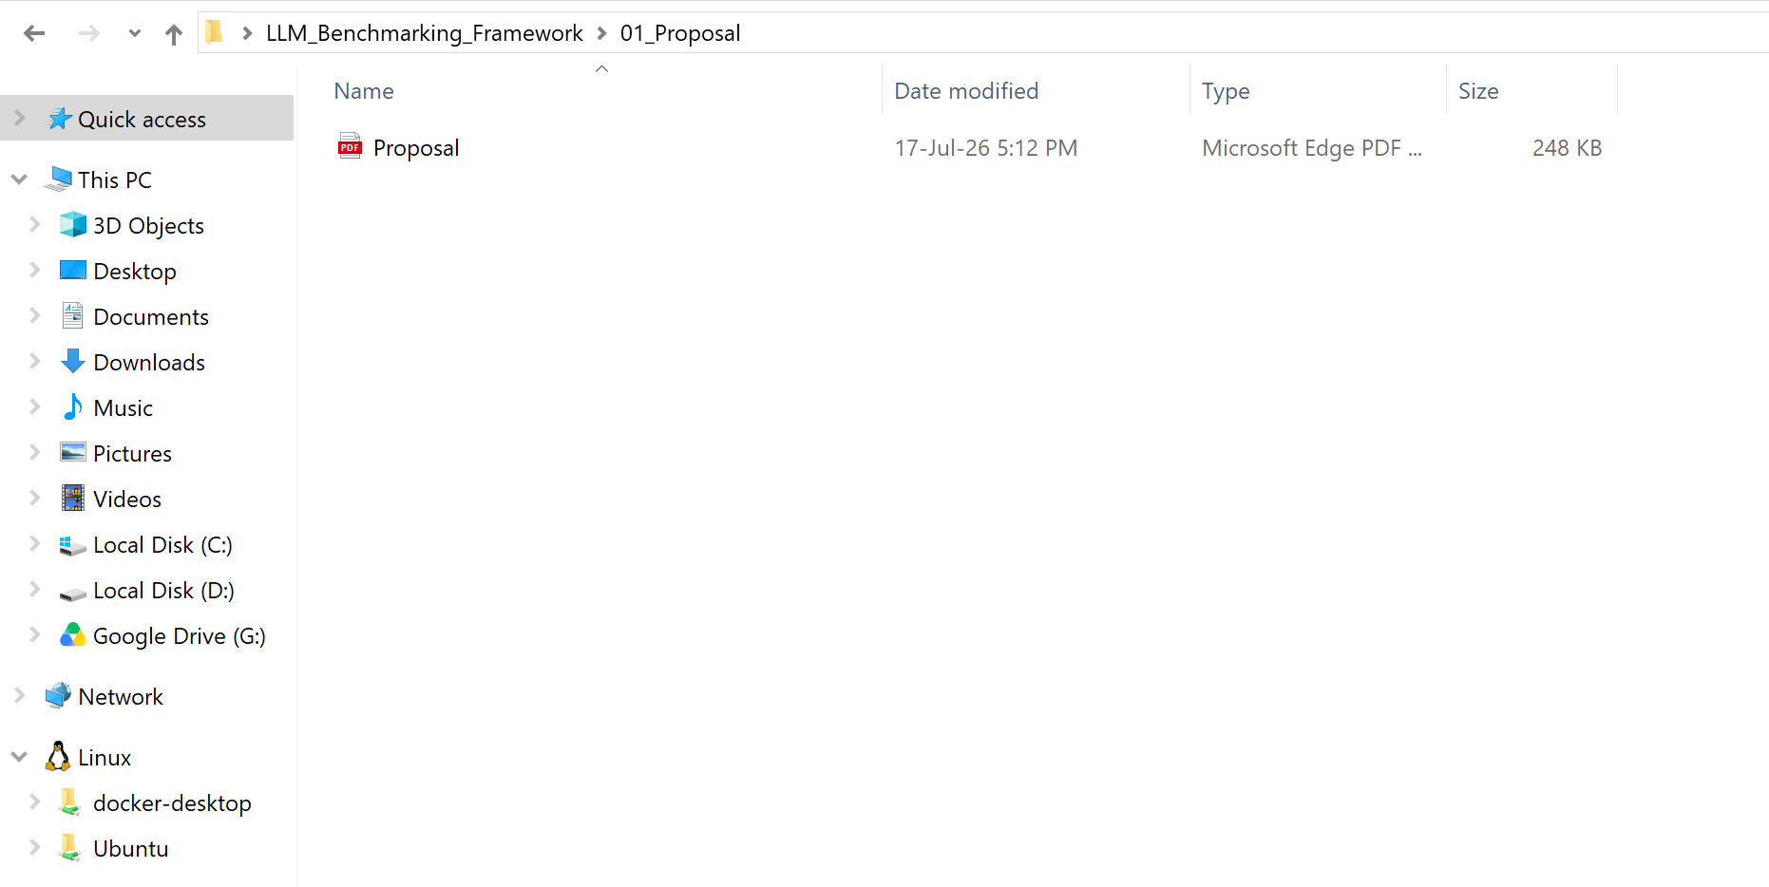

- Developed and defined the 0–5 standardized Evaluation Rubric to ensure objective performance measurement across all benchmarking tasks.
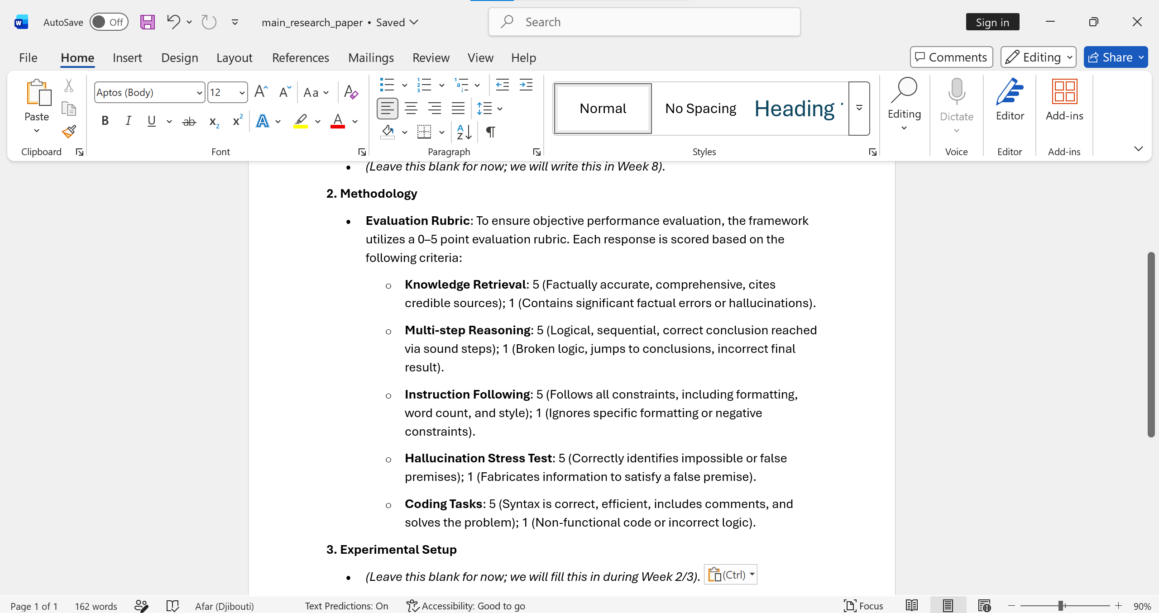

Plans for Week 2
- Begin development of the Python automation scripts.
- Implement intelligent throttling and exponential backoff mechanisms to manage free-tier API rate limits.
Problems / Blockers
- None; the environment is successfully configured and ready for the next phase of development.

