Artificial Intelligence and Machine Learning

Project Report

Semester-IV (Batch 2022)

ARTISTIC DISSECTION
(Music Genre Classifier)


Submitted By:
Jaspreet Kaur 2210990453 G-10

Supervised By:
Ms. Shagun Sharma

Department of Computer Science and Engineering

Chitkara University Institute of Engineering & Technology,
Chitkara University, Punjab

Abstract
Music genre classification presents a significant challenge in the field of Music Information Retrieval (MIR), requiring the extraction and learning of the complex audio features.
This project addresses the challenge by implementing a Convolutional Neural Network (CNN), known for its efficacy in processing grid-like topology data, such as the images and audio spectrograms. Utilizing a dataset composed of thousands of audio tracks labeled with multiple genres, the project involves converting these tracks into Mel-frequency cepstral coefficients (MFCCs) or spectrogram to serve as input for the CNN.
This project proposes a comprehensive approach to find out the genre of a music leveraging CNNs. The primary objective is to automate the process of Music Genre Classification, potentially transforming how music is organized and experienced in the digital formats.
It's an application of machine learning to the arts, opening doors to the new innovations in how we interact with Music.
Music steaming services can use it to automatically categorize their vast libraries, improving user experience through personalized music recommendations and better organized playlists. It could also contribute to the other fields such as musicology for the academic research, digital media management, or even aiding in copyright detection by identifying characteristics of Music.
In this project, Stream lit was employed to create a web application that allows users to easily interact with the music genre prediction model. By using Stream lit, the project was enhanced with a user-friendly interface where the users can upload the audio files in .wav form, and receive instant genre prediction. The interface includes visual elements such as spectrograms, and it also displays the total time of the music etc., and displays the predicted genre, providing a practical and engaging way for the users to see the model's prediction in action.

TABLE OF CONTENTS

Abstract………………………………………………………………………………………..2
Table of Contents ………………………………………………………………………….….3
1. Introduction ………………………………………………………………………………...4
1.1 Introduction to Music Genre Classifier ..……………………………………….....4
1.2 Applications…………………………………………………………………….....5
1.3 Objectives…………………………………………………………………………5
1.4 Motivation………………………………………………………………………...5
2. Problem Definition ………………………………………………………………………...6
3. Proposed Design and Methodology……………………………………………………......7
3.1 Methodology……………………………………………………………………...7
3.2 Tools and Technologies………………………………………………………......7
4. Results……………………………………………………………………………………..10
5. References…………………………………………………………………………………14
5.1 Websites……………………………………………………………………….....14
5.2 Dataset…………………………………………………………………………….15
1. Introduction
1.1 Introduction to Music Genre Classifier
The automatic classification of music into genres is a challenging yet crucial task in the realm of MIR (Music Information Retrieval). A music genre classifier seeks to automate this process by using machine learning algorithms to analyze and predict the genre of a piece of music based on these features.
The classifier operates on audio data transformed into spectograms which captures essential time-frequency characteristics relevant to genre distinction. For training and evaluation, the GTZAN dataset, a widely recognised benchmark, collection in the MIR community was employed. This dataset comprises 1,000 audio tracks evenly distributed across 10 different genres, providing a diverse basis for developing a robust genre classification model.
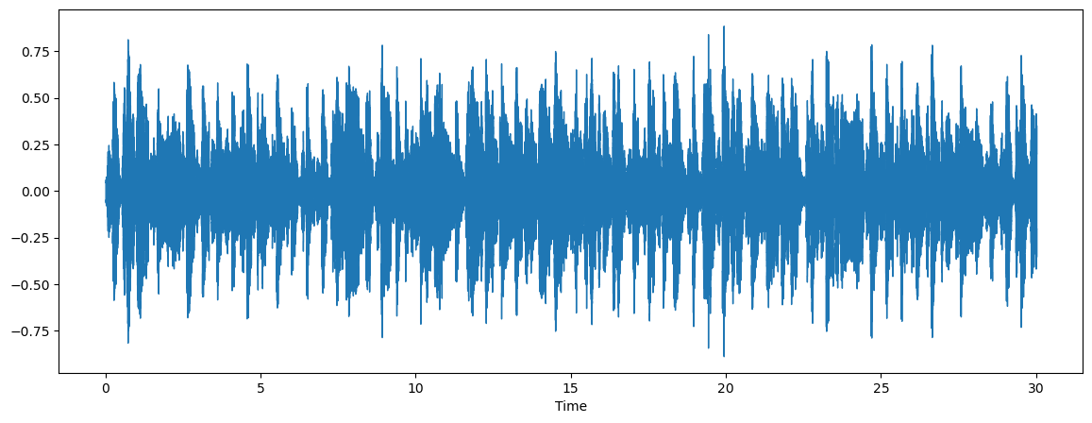
Fig. 1. Blues Mel-Spectogram

In Fig. 1, we can see a Mel-Spectogram for Blues genre. This Mel-Spectogram about the genre can be easily detected using deep learning techniques. It is detected using a convolutional neural network (CNN).
The CNN leverages these visual patterns to learn the acoustic signatures associated with all the genres. By training on these spectograms, CNN becomes adept by identifying and predicting the genre of unseen music tracks based on the learned patterns.

1.2 Applications
- Music streaming services.
- Assist in the automatic tagging and organistaion of large music collections, making it easier for the user to search for music based on genre and other metadata.
- Integrate with digital audio workstations and other music production software to classify and sort the samples and loops by genre, aiding musicians and producers in their creative processes.
1.3 Objectives
The primary objective of this project is to develop and evaluate a robust music genre classification system using CNN. This system aims to accurately predict the genre of a given music track by analyzing its acoustic features transformed into Mel-Spectograms.
1.4 Motivation
As users seek more personalized music experiences, accurately classifying music by genre using advanced AI techniques can significantly improve music reccomendation systems and streamline content curation.
This projects tap into the potential of deep learning to offer nuanced insights into the musical structures, aiming to transform how users interact with and explore music collections.

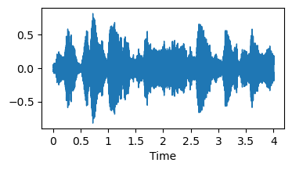
Fig. 2. Time vs Frequency Graph
2. Problem Definition
In the evolving landscape of digital music services, the ability to accurately classify music by genre is critical for effective music discovery, reccomendation and the management.
This project addresses the need for a more accurate and automated music genre classificaion system by leveraging the capabilities of CNN (Convolutional Neural Networks). By utilizing CNNs to analyze and classify audio signals based on their spectogram representations, this project aims to improve classification accuracy, reduce human error and provide a scalable solution adaptable to varying music datasets.
The ultimate goal is to enhance how users and platforms interact with large music collections, making genre based music discoveries and organization more intuitive and effective.

3. Proposed Design and Methodology
3.1 Methodology
The main aim is to design a system which is efficient and which provide genre from a given music . For that purpose, we use two phases: 1st is training phase and 2nd is testing phase. In 1st phase: Dataset preparation, Model Evaluation and CNN based training. In 2nd phase: Data Preprocessing, Splitting data in training and test set, Model Evaluation.

Streamlit is effectively used in the project for user-friendly interface to visualize data and results dynamically, Real time model testing, users can upload their music files to the application and get the genre prediction in the real time, parameter tuning interface(used to create input fields etc).
Integrating Streamlit in this project, enhances the practical accessibility of the model, making it more tangible and interactive for users and stakeholders. This not only adds value to the project but also bridges the gap between complex data science solutions and real world applications, making advanced AI/ML models accessible to a broader audience.

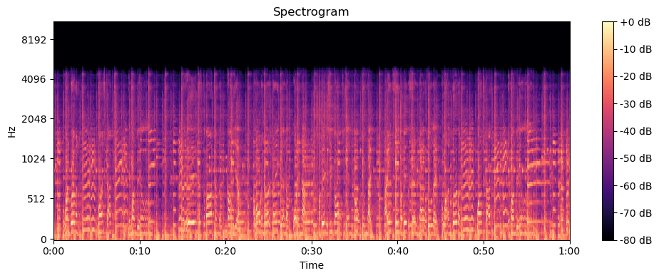
Fig. 3. Mel-Spectogram of Audio

  - Tools and Technologies
3.2.1 Python
Python's simplicity and versatility drive its use in web development, scientific computing, AI, and automation, aided by rich libraries.
3.2.2 NumPy
NumPy. Short for numerical Python, is an essential library in Python Programming ecosystem, widely used for scientific computing. Used for High performance operations, Memory Efficiency, Versatility in data handling, integration with databases etc.
3.2.2 OS
It is a verstile utility that provides the functions for interacting with the operating system. It can significantly streamline various aspect of managing and manipulating the file systems, which is a common requirement across many AI/ML workflows. It is used for Directory and File Management, Path Manipulation, Executing shell commands, Working with temporary files, Permission management, Automation and Scripting.
3.2.3 Matplotlib
Matplotlib is widely used Python library for creating static, interactive and animated visualizations in Python. It plays a pivotal role in data analysis, especially in field such as data science, artificial intelligence, and Machine Learning. It is used for Data Visualization, Analysis and Insights, Debugging, Feature Selection, Communication, Interactivity, Customization, Integration, Education and Documentation.
3.2.4 Seaborn
Seaborn is a library based on Matplotlib. It provides high level interface for drawing attractive and informative statistical graphics. It is especially used in Data Science and statistical communities for easy statistical plots, Impressive default styles, Integration with Pandas, Categorical values, Advanced plots, Ease of use, Customizability and Enhanced explorations.
3.2.5 TensorFlow
It is a powerful open source library for numerical computation and large scale machine learning. It bundles together a slew of machine learning and deep learning models and makes them useful by a way of common metaphor. TensorFlow is widely used in the community because of its flexibility and modularity, Scalability, Autoomatic Differentiation, Performance Optimisation, Tooling and visualization, Large community and support, Continuous development.
Tensorflow offers tools and resources to address wide spectrum of machine learning challenges.
3.2.6 Librosa
TensorFlow, an open-source machine learning framework, facilitates building complex neural network architectures with CPU and GPU computing support. Its flexibility, scalability, and extensive documentation make it popular across machine learning domains.
3.2.7 Keras
Keras, an open-source deep learning framework, offers a high-level API for neural network building and training, simplifying prototyping and experimentation. Supports TensorFlow, Theano, enabling flexibility for research and industry.
3.2.8 OpenCV
OpenCV is an open-source computer vision and machine learning library, offering tools for image and video analysis, object recognition, and more. Supporting multiple languages, it's widely used across diverse fields.
3.2.9 Streamlit
Streamlit, a Python library, facilitates interactive web app development for data science and machine learning. It enables Python scripts to generate interactive visualizations and dashboards in the browser.

4. Results
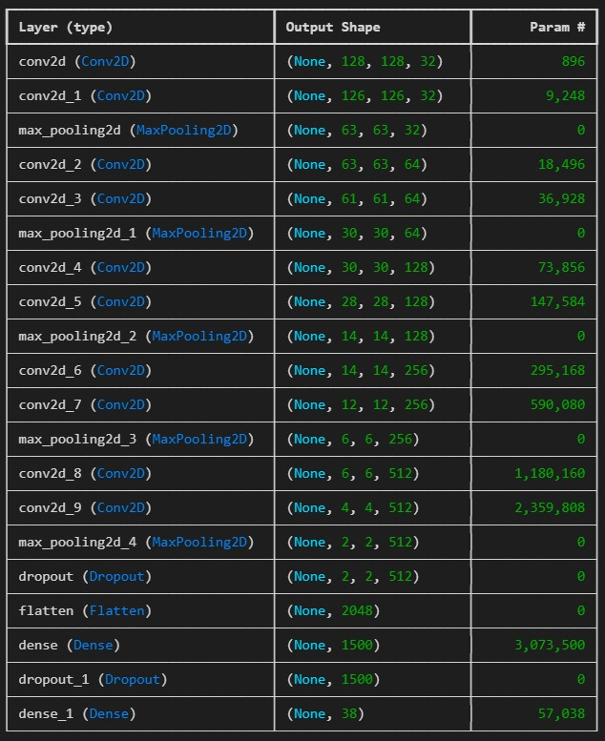
Fig. 3. Sequential Model Summary
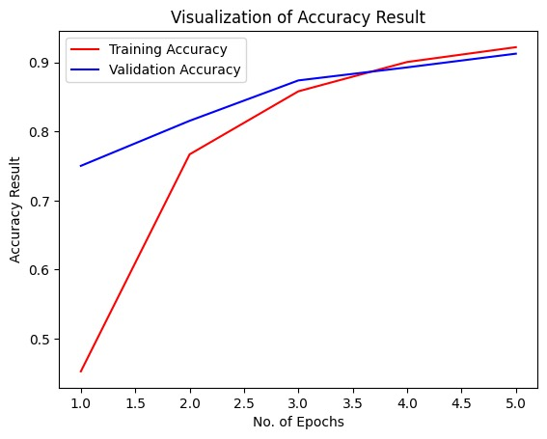
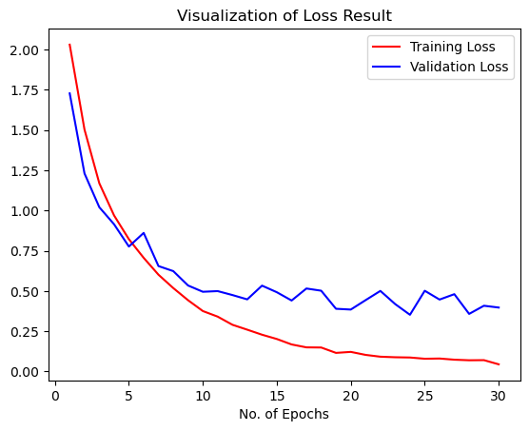
Fig. 4. Visualization of Loss Result

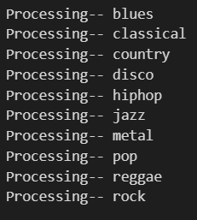
Fig. 5. Class Labels of the Dataset
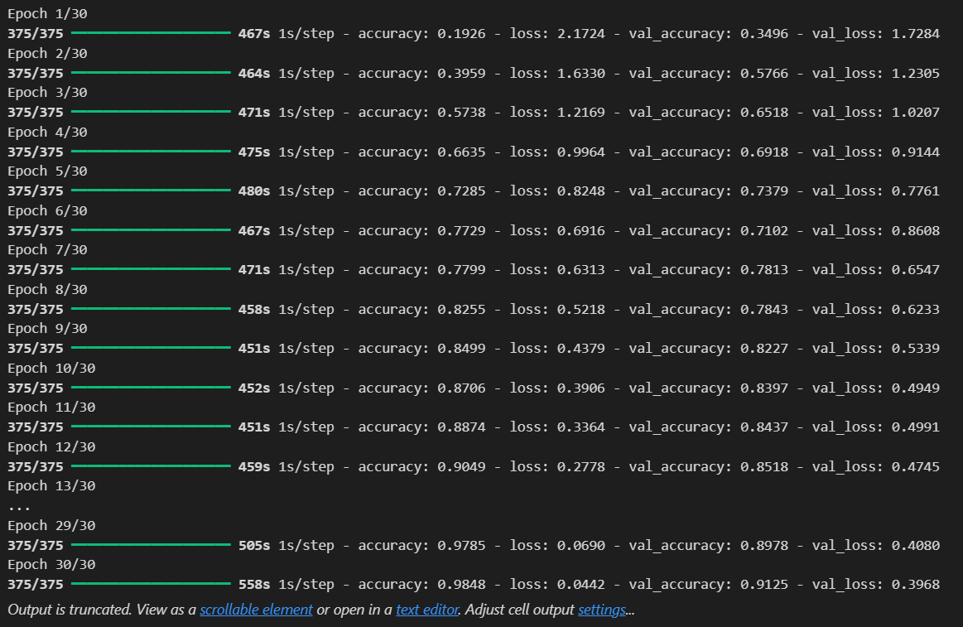
Fig. 6. Training of the model

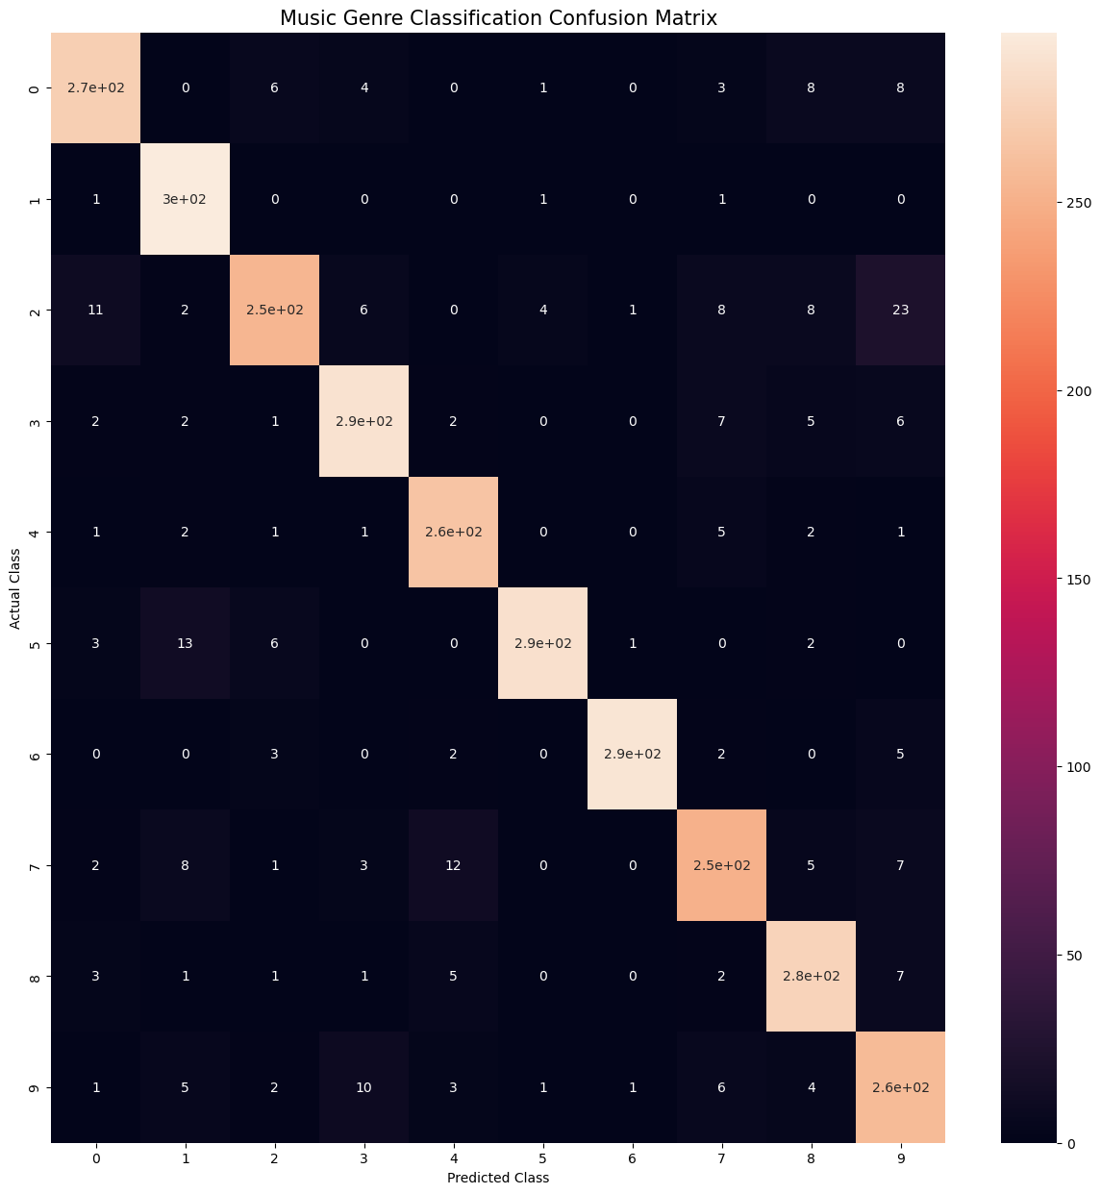
Fig. 7. Music Genre Prediction Confusion Matrix

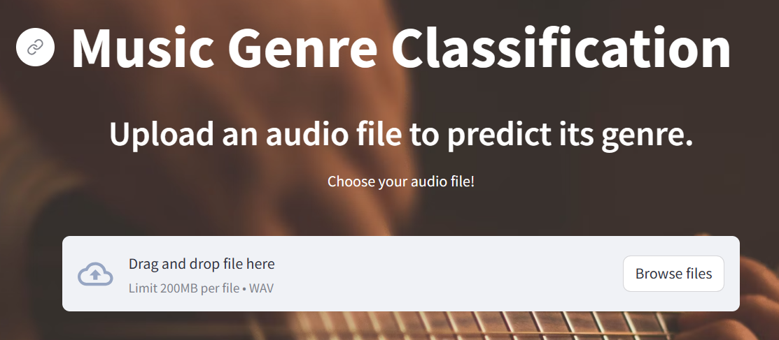
Fig. 8. Displaying Streamlit Input

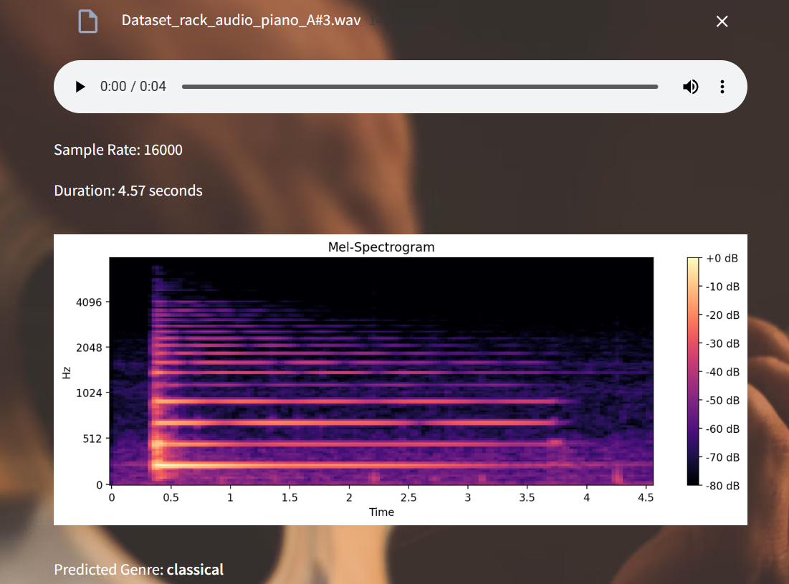
Fig. 9. Displaying Result of Streamlit Output

5. References
5.1 Websites
- Python Docs: https://www.python.org/
- Pandas Docs: https://pandas.pydata.org/
- Matplotlib Docs: https://matplotlib.org/
- Seaborn Docs: https://seaborn.pydata.org/
- Scikit-Learn Docs: https://scikit-learn.org/
- TensorFlow Docs: https://www.tensorflow.org/
- Keras Docs: https://keras.io/
- Stremlit Docs: https://streamlit.io/

5.2 Dataset

GTZAN Genre Prediction Dataset: https://www.kaggle.com/

