Software System Design Document (SDD) Template
Version: 1.2
Project: DocNo – Document Number Generator System
Organization: Esigma Technologies
Domain: https://docno.esigmatech.com
Purpose: Reusable system documentation template for internal software projects

1. Executive Summary
This document describes the architecture, design, deployment, and operational model of the DocNo system. The document also serves as a reusable template for documenting future internal software projects.

2. System Overview
The DocNo system generates unique structured document numbers for organizational documents. The numbering scheme ensures sequential ordering, uniqueness, and concurrent safety.
Example document number:
HR-MEM-2026-0001

3. High-Level Architecture
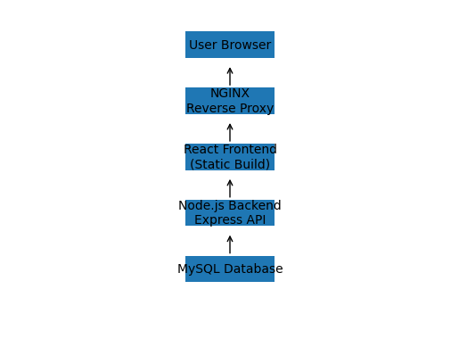
┌─────────────────┐
│ User Browser │
└────────┬────────┘
│ HTTPS
┌────────▼────────┐
│ NGINX │
│ Reverse Proxy │
└────────┬────────┘
│
┌────────▼────────┐
│ React Frontend │
│ Static Build │
└────────┬────────┘
│ API
┌────────▼────────┐
│ Node.js Backend │
│ Express API │
└────────┬────────┘
│
┌────────▼────────┐
│ MySQL DB │
└─────────────────┘

4. Technology Stack
- Frontend: React + Vite + TailwindCSS
- Backend: Node.js + Express
- Database: MySQL
- Authentication: JWT
- Email: Nodemailer SMTP
- Process Manager: PM2
- Web Server: NGINX

5. Backend Architecture
backend
│
server.js
│
config
└ db.js
│
middleware
├ authMiddleware.js
└ adminMiddleware.js
│
routes
├ auth.js
├ password.js
├ documents.js
└ admin.js
│
services
├ numberGenerator.js
├ emailService.js
└ auditService.js
│
utils
└ logger.js
│
migrations
└ 001_docno_schema.sql

6. Frontend Architecture
frontend/src
│
components
context
services
constants
pages
admin pages

7. Database Model
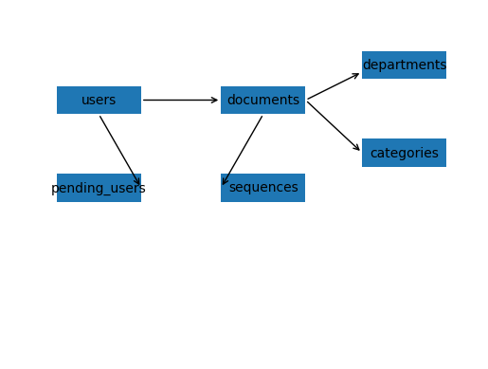
users
│
├─ created_by
│
documents
│
├─ department_id → departments
└─ category_id → categories
pending_users → departments
sequences
│
├─ department_id
└─ category_id
allowed_email_domains
audit_logs → users

8. Document Number Generation Algorithm
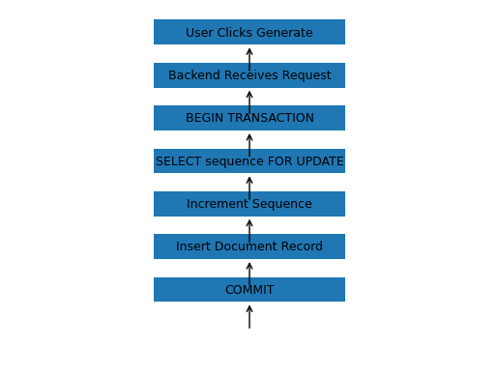
BEGIN TRANSACTION
SELECT sequence FOR UPDATE
IF sequence row not exist
INSERT new row
ELSE
increment sequence
END IF
generate document number
INSERT document record
COMMIT TRANSACTION

9. API Endpoints Overview
POST /api/auth/login
POST /api/auth/register
POST /api/password/forgot
POST /api/password/reset
POST /api/documents/generate
GET /api/documents/history
GET /api/admin/departments
GET /api/admin/categories
GET /api/admin/users

10. Security Model
- JWT authentication
- bcrypt password hashing
- role-based route protection
- admin approval workflow
- allowed email domain restrictions
- token expiration auto logout

11. Deployment Architecture
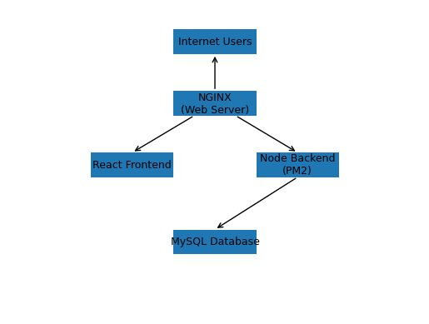
Internet
│
▼
docno.esigmatech.com
│
▼
NGINX
│
├── React static frontend
│
└── /api → Node.js backend (PM2)
│
▼
MySQL

12. Backup and Recovery
Automated database backups are executed using a shell script.
scripts/backup_db.sh
Daily backup: 02:00
Retention: 30 days
Backup location: /backups

13. Monitoring and Logging
- PM2 process monitoring
- NGINX access logs
- Application error logs
- Audit logs for admin actions

14. Development Workflow
git clone repository
create feature branch
develop and test
commit changes
merge into main branch
tag release version
deploy to server

15. Future Enhancements
- Visual document analytics dashboard
- Advanced search and filters
- Document templates integration
- Multi‑organization support
- SSO integration

16. Using This Document as a Template
This document structure can be reused for other internal software projects by updating the following sections:
- System Overview
- Architecture
- Database Model
- API Endpoints
- Deployment Architecture
- Security Model

