**Caba, Ritz Renee BSIT 4-5**

**Garcia, Thomas Jullian R.**

**Reyes, Jazmine E.**

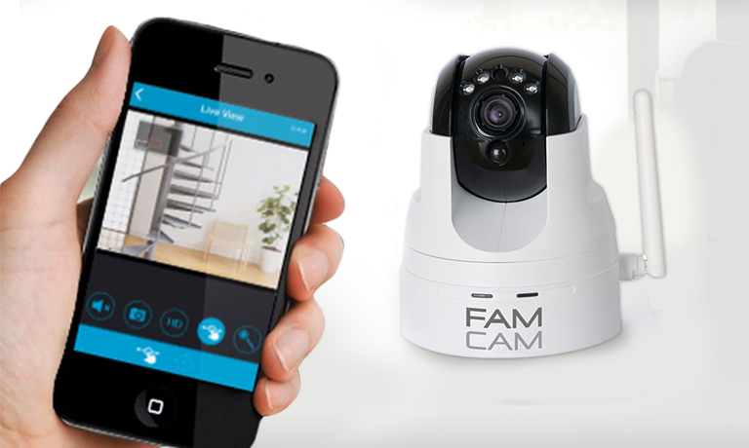

Fam Cam is a home monitoring system that can help you watch over your family & home from wherever you are. Access real-time video feeds from your smartphones, tablets, or computers and talk to your loved ones through the device