**Name:** William Sydney Porter

**Pen Name:** O. Henry

**Birthdate:** September 11, 1862

**Death date:** June 5, 1910

**Place of Birth:** Greensboro, North Carolina

**Place of Death:** New York

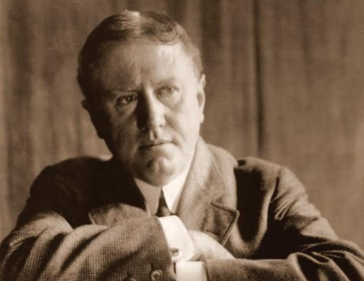

Autobiography

**O. Henry** (1862 - 1910) was an American short story author named **William Sydney Porter**, raised in Greensboro, North Carolina. Henry's rich canon of work reflected his wide-range of experiences and is distinctive for its witticism, clever wordplay, and unexpected twist endings.

Like many other writers, O. Henry's early career aspirations were unfocused and he wandered across different activities and professions before he finally found his calling as a short story writer. He started working in his uncle's drugstore in 1879 and became a licensed pharmacist by the age of 19. His first creative expressions came while working in the pharmacy where he would sketch the townspeople that frequented the store. The customers reacted warmly to his drawings and he was admired for his artistry and drawing skills.

O. Henry moved to Texas in March of 1882 hoping to get rid of a persistent cough that he had developed. While there, he took up residence on a sheep ranch, learned shepherding, cooking, babysitting, and bits of Spanish and German from the many migrant farmhands. He had an active social life in Austin and was a fine musician, skilled with the guitar and mandolin. Over the next several years, Porter -- as he was still known -- took a number of different jobs, from pharmacy to drafting, journalism, and banking.

Here's where the twists and turns really started. Banking, in particular, was not to be O. Henry's calling; he was quite careless with his bookkeeping, fired by the bank and charged with embezzlement in 1894. His father-in-law posted bail for him, but he fled the day before the trial in 1896, first to New Orleans, then to Honduras, where there was no extradition treaty. He befriended a notorious train robber there, Al Jennings, who later wrote a book about their friendship. O. Henry sent his wife and daughter back to Texas, after which he holed up in a hotel to write his first collection of short stories, **Cabbages and Kings** published in 1904. He learned his wife was dying of tuberculosis and could not join him in Honduras, so he returned to Austin and turned himself in to the court. His father-in-law again posted his bail so he could remain with his wife until her death in 1897. He was sentenced and served in Federal prison in Ohio for five years from 1989-1902.

O. Henry was always a lover of classic literature, and while pursuing his many ventures, O. Henry had begun writing as a hobby. When he lost his banking position he moved to Houston in 1895 and started writing for the **The Post**, earning $25 per month (an average salary at this time in American history was probably about $300 a year). O. Henry collected ideas for his column by loitering in hotel lobbies and observing and talking to people there. He relied on this technique to gain creative inspiration throughout his writing career; which is a fun fact to keep in mind while reading an imaginative masterpiece of a story like [Transients in Arcadia](https://americanliterature.com/author/o-henry/short-story/transients-in-arcadia). The many twists and turns of his own life, including his travels in Latin America and time spent in prison, clearly inspired his stories' twists and wordplay.

O. Henry's prolific writing period began in 1902 in New York City, where he wrote **381 short stories**. Some of his best and least known work is contained in **Cabbages and Kings**, whose title was inspired by [Lewis Carroll](https://americanliterature.com/author/lewis-carroll)'s poem, [The Walrus and the Carpenter](https://americanliterature.com/author/lewis-carroll/poem/the-walrus-and-the-carpenter). The stories were set in a Midwestern American town in which sub-plots and larger plots are interwoven in an engaging manner. His second collection of stories, **The Four Million**, was released in 1906. The stories are set in New York City, and the title is based on the population of the city at that time. The collection contained several short story masterpieces, including [**The Gift of the Magi**](https://americanliterature.com/author/o-henry/short-story/the-gift-of-the-magi)**,**[**The Cop and the Anthem**](https://americanliterature.com/author/o-henry/short-story/the-cop-and-the-anthem), and many others. Henry had an obvious affection for New York City and its diversity of people and places, a reverence that rises up through many of his stories.

O. Henry's trademark is his witty, plot-twisting endings, and his warm characterization of the awkward and difficult situations and the creative ways people find to resolve them. All of O. Henry's stories are highly entertaining, whether read for pleasure or studied in classrooms around the world.

Unfortunately, O. Henry's personal tragedy was heavy drinking. By 1908, his health had deteriorated and his writing dropped off accordingly. He died in 1910 of cirrhosis of the liver, complications of diabetes, and an enlarged heart. The funeral was held in New York City, but he was buried in North Carolina, the state where he was born. He was a gifted short story writer and left us a rich legacy of great stories to enjoy.

The Ransom of the Red Chief *by O. Henry*

**"The Ransom of Red Chief"** is a 1910 [short story](https://en.wikipedia.org/wiki/Short_story) by [O. Henry](https://en.wikipedia.org/wiki/O._Henry) first published in [The Saturday Evening Post](https://en.wikipedia.org/wiki/The_Saturday_Evening_Post). It follows two men who kidnap and attempt to ransom a wealthy [Alabamian](https://en.wikipedia.org/wiki/Alabama)'s son; eventually, the men are driven crazy by the boy's spoiled and hyperactive behavior, and pay the boy's father to take him back.

The story and its main idea have become a part of popular culture, with many [children's television](https://en.wikipedia.org/wiki/Children%27s_television) programs using a version of the story as one of their episodes. The tale is a light-hearted example of the ultimate in "poetic justice" and fortuitous intervention for the public good: the crooks had intended to use the ransom money to fund an even larger and much more elaborate scam that would likely have caused widespread monetary damage to the local populace, and so having their plans "foiled in their infancy" by Red Chief's shrewd father saves countless other honest folks from financial ruin. It has also been often used as a classic example of two ultimate comic ironies – a supposed "hostage" actually liking his abductors and enjoying being captured, and his captors getting their [just deserts](https://en.wikipedia.org/wiki/Just_deserts) by having the tables turned on them, and being compelled to pay to be rid of him.

It is not simply a story in the [O. Henry](https://www.enotes.com/topics/o-henry?en_action=content_body_click&en_label=%2Ftopics%2Fransom-red-chief&en_category=internal_campaign) tradition of surprise endings; it is also a story in the pattern of classical comedy, which assures the reader that sometimes in this world the underdog can win. Generally, however, slaves or servants, wives or lovers, have prevailed by outwitting their masters.

Although it is a funny story, the message of “The Ransom of Red Chief” is that “crime does not pay.” O. Henry had served several years in state prison on a felony conviction of embezzlement. He met countless career criminals in and out of prison and came to the conclusion that most of them were losers. He never got over the disgrace of having been a convict. He changed his name from William Sydney Porter to O. Henry and lived in fear of having his past catch up with him.

**Name:** Ernest Hemingway

**Pen Name:** Ernest Hemingway

**Birthdate:** July 21, 1899

**Death date:** July 2, 1961

**Place of Birth:** Oak Park, Illinois

**Place of Death:** Ketchum, Idaho

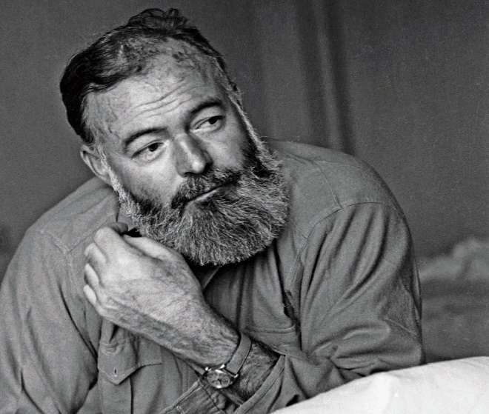

Autobiography

**Ernest Miller Hemingway** (July 21, 1899 – July 2, 1961) was an American novelist, short story writer, and journalist. His economical and understated style—which he termed the [iceberg theory](https://en.wikipedia.org/wiki/Iceberg_theory)—had a strong influence on [20th-century fiction](https://en.wikipedia.org/wiki/20th_century_in_literature), while his adventurous lifestyle and his public image brought him admiration from later generations. Hemingway produced most of his work between the mid-1920s and the mid-1950s, and won the [Nobel Prize in Literature](https://en.wikipedia.org/wiki/Nobel_Prize_in_Literature) in 1954. He published seven novels, six short-story collections, and two non-fiction works. Three of his novels, four short story collections, and three non-fiction works were published posthumously. Many of his works are considered classics of [American literature](https://en.wikipedia.org/wiki/American_literature).

Hemingway was raised in [Oak Park, Illinois](https://en.wikipedia.org/wiki/Oak_Park,_Illinois). After high school, he reported for a few months for [*The Kansas City Star*](https://en.wikipedia.org/wiki/The_Kansas_City_Star), before leaving for the [Italian Front](https://en.wikipedia.org/wiki/Italian_Front_(World_War_I)) to enlist as an [ambulance driver in World War I](https://en.wikipedia.org/wiki/List_of_ambulance_drivers_during_World_War_I). In 1918, he was seriously wounded and returned home. His wartime experiences formed the basis for his novel [*A Farewell to Arms*](https://en.wikipedia.org/wiki/A_Farewell_to_Arms) (1929).

In 1921, he married [Hadley Richardson](https://en.wikipedia.org/wiki/Hadley_Richardson), the first of what would be four wives. The couple moved to Paris, where he worked as a [foreign correspondent](https://en.wikipedia.org/wiki/Correspondent) and fell under the influence of the [modernist](https://en.wikipedia.org/wiki/Modernism) writers and artists of the 1920s "[Lost Generation](https://en.wikipedia.org/wiki/Lost_Generation)" expatriate community. His [debut novel](https://en.wikipedia.org/wiki/Debut_novel), [*The Sun Also Rises*](https://en.wikipedia.org/wiki/The_Sun_Also_Rises), was published in 1926.

Hemingway used his experiences as a reporter during the civil war in Spain as the background for his most ambitious novel, *For Whom the Bell Tolls* (1940). Among his later works, the most outstanding is the short novel, *The Old Man and the Sea* (1952), the story of an old fisherman’s journey, his long and lonely struggle with a fish and the sea, and his victory in defeat.

Shortly after the publication of [*The Old Man and the Sea*](https://en.wikipedia.org/wiki/The_Old_Man_and_the_Sea) (1952), the author continued his forays into Africa and sustained several injuries during his adventures, even surviving multiple plane crashes.

In 1954, he won the Nobel Prize in Literature. Even at this peak of his literary career, though, the burly Hemingway's body and mind were beginning to betray him. Recovering from various old injuries in Cuba, Hemingway suffered from depression and was treated for numerous conditions such as high blood pressure and liver disease.

He wrote A Moveable Feast, a memoir of his years in Paris, and retired permanently to Idaho. There he continued to battle with deteriorating mental and physical health.

Early on the morning of July 2, 1961, Ernest Hemingway committed suicide in his Ketchum home.

Hemingway left behind an impressive body of work and an iconic style that still influences writers today. His personality and constant pursuit of adventure loomed almost as large as his creative talent.

A Clean, Well-Lighted Place *by Ernest Hemingway*

The short story "**A Clean Well-Lighted Place**” by **Ernest Hemingway** focuses on the existential crisis, the search for meaning that faces human beings. To truly get a deeper understanding of this story, one must have some knowledge about the author’s life. Hemingway was married four times and won the Nobel Prize for literature. When he became ill, he ended his life the same way as did his father, he committed suicide.

Hemingway was dealing with despair, depression and desperation for much of his life. He struggled throughout, to find true meaning and purpose. Hemingway's theory proposes that life is naturally meaningless. This doesn't mean that life has to be meaningless, rather that one must find what the purpose of life is. One has to set standards for oneself and conform to them with dignity, thus not falling into despair. This theory can be found in this short story and throughout Hemingway's` writings.

This story demonstrates the emotional journey of despair and the never ending desire to acquire spiritual tranquility. Equivalent strength can be put on the powerful contrast Hemingway looks at, describing the difference in conduct between the young and the old. The outlook on life through the eyes of an experienced and inexperienced individual. The title of this story "A Clean Well-Lighted Place is a sign in itself for a man`s longing for tranquility, security and comfort. It provides protection from the darkness outside.

Knowing more about Hemingway's life gave us a better understanding of this short story. His writing style and the philosophical message of this story are both enjoyable. Hemingway’s style is very short and to the point. His method is to describe actions or a dialogue and spending minimal time inside a characters mind. Hemingway expects the reader to make an effort to truly comprehend and appreciate the profound significance behind his writing. As he mentioned in his Nobel prize acceptance speech: "A writer should write what he has to say and not speak it.”

References

* Biography. (n.d.). Retrieved from <https://www.imdb.com/name/nm0377958/bio>
* O. Henry. (n.d.). Retrieved from <https://americanliterature.com/author/o-henry>
* What is the main idea of O.Henry's story, ''The Ransom of Red Chief''? (n.d.). Retrieved from <https://www.enotes.com/homework-help/what-main-idea-o-henrys-story-ransom-red-chief-43427>
* The Nobel Prize in Literature 1954. (n.d.). Retrieved from <https://www.nobelprize.org/prizes/literature/1954/hemingway/biographical/>
* Ernest Hemingway. (2018, October 11). Retrieved from <https://en.wikipedia.org/wiki/Ernest_Hemingway#Influence_and_legacy>
* (n.d.). Retrieved from <https://freecustomwritings.com/analysis-of-a-clean-well-lighted-place-by-earnest-hemingway>