A+ Computer Science STARFIGHTER I

Lab Goal : This lab was designed to teach you more about classes and inheritance.

Lab Description : Write a first person shooter game. You are the StarFighter and your job is to destroy all of the enemies that enter your space. The StarFighter ship and enemy ships will share lots of the same properties. This lab provides the perfect opportunity to use lots of classes and inheritance. You will also review ifs, loops, arrays, and ArrayList.

Task One – Write the MovingThing class. Make sure you think it through and that it compiles. Test it thoroughly.
Task Two – Extend the MovingThing class to make the Ship class. Use the ShipTester to test the Ship class.
Task Three – Use StarFighter and OuterSpace to further test the Ship class. The Ship should move all around the screen in all 4 directions. Key presses will be used to move the Ship.

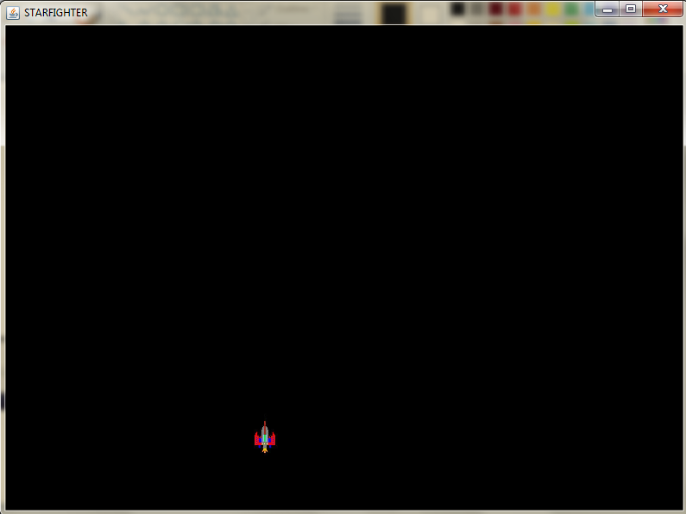
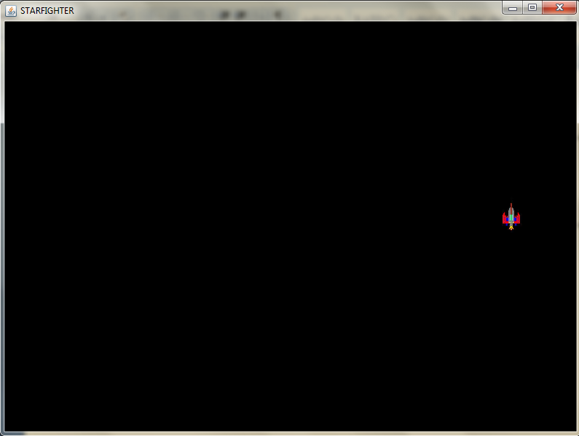
KEYS TO CONTROL THE SHIP

h - left
j - right
u - up
n - down

