A+ Computer Science STARFIGHTER III

Lab Goal : This lab was designed to teach you more about classes and inheritance.

Lab Description : Write a first person shooter game. You are the StarFighter and your job is to destroy all of the enemies that enter your space. The StarFighter ship and enemy ships will share lots of the same properties. This lab provides the perfect opportunity to use lots of classes and inheritance. You will also review ifs, loops, arrays, and ArrayList.

Task Six – Make your Ship shoot some type of Ammo. You must create an Ammo class. Start with just a single Ammo object so you can make sure all of your logic works. An ArrayList of Ammo will be added once the single Ammo has been tested thoroughly.

Task Seven – Make your Ship shoot and destroy the Alien.

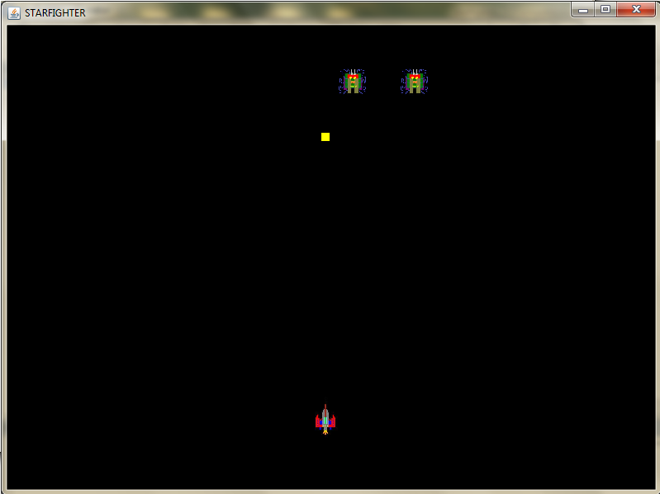
KEYS TO CONTROL THE SHIP

h - left
j - right
u - up
n - down

