DETAILS/SYNOPSIS OF ACCOMPLISHMENT

ARRESTED SUSPECTS INVOLVED IN CARNAPPING:

- A total of apprehended suspected involved in carnapping without warrant of arrest and recovered items from their possession:
Name/s of suspect
Date arrested
Nature of arrest
Unit involved
Place of Arrest
Offense charged/ docketed number
Status of suspect/s

- A total () of apprehended suspected involved in carnapping with warrant of arrest and recovered items from their possession:

Name/s of suspect
Date arrested
Nature of arrest
Unit involved
Place of Arrest
Offense charged/ docketed number
Status of suspect/s

- A total of _ apprehended suspected involved in carnapping during service of search warrant and recovered items from their possession:
Picture | Name/s of suspect
Picture | Date arrested
Picture | Nature of arrest
Picture | Unit involved
Picture | Place of Arrest
Picture | Offense charged/ docketed number
Picture | Status of suspect

- A total of _ Dead in Police Operation (DIPO):
Name/s of suspect
Date arrested/neutralized
Nature of arrest
Unit involved
Place of Arrest/Encounter
Offense charged/ docketed number
Status of DIPO

DETAILS OF RECOVERED VEHICLES
- A total of () recovered MV

Date and Place of Recovery

Mode of Operation

Recovering unit

Make/Type/Model

Plate Number

Chassis Number

Motor Number

Color

Alarmed/Blotter No.

Mode of Loss

Status

Driver/possessor

Address

Registered Owner

Address

- A total of () recovered MCs:

Date and Place of Recovery

Mode of Operation

Recovering unit

Make/Type/Model

Plate Number

Chassis Number

Motor Number

Color

Alarmed/Blotter No.

Mode of Loss

Status

Driver/possessor

Address

Registered Owner

Address
c. A total of __ recovered tampered Motor Vehicles:
Picture | Date and place
Picture | Mode of Operation
Picture | Recovering unit
Picture | Make/Type/Model
Picture | Plate Number
Picture | Chassis Number
Picture | Motor Number
Picture | Color
Picture | CRIMLAB Result
Picture | Status
Picture | Driver/possessor
Picture | Address
Picture | Registerd Owner
Picture | Address

d. A total of __ recovered tampered Motorcycles:
Picture | Date and Place
Picture | Mode of Operation
Picture | Recovering unit
Picture | Make/Type/Model
Picture | Plate Number
Picture | Chassis Number
Picture | Motor Number
Picture | Color
Picture | CRIMLAB Result
Picture | Status
Picture | Driver/possessor
Picture | Address
Picture | Registered Owner
Picture | Address

- ACCOMPLISHMENT ON IMPOUNDED VEHICLES

IMPOUNDED MOTORCYCLES:
Nr | Make/Type/ include picture | Date of Recovery | Unit involved | Plate Nr/ Conduction sticker | Mode of Recovery | Place of Recovery | Violation | Status
1 | 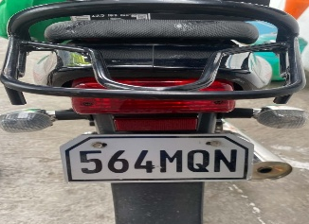 | October 12, 2026 | GSCHPT | 564MQN | AnCar, RA 4136 and Other related laws | NHW CONEL,GSC | OR/CR Not carried "ATTA" | Impounded for verification
2 | 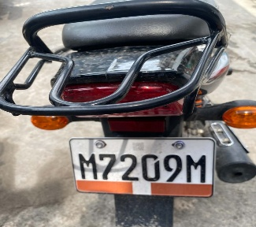 | October 12, 2026 | GSCHPT | M7209M | AnCar, RA 4136 and Other related laws | NHW CONEL,GSC | Driver License Not carried "ATTA" | Impounded for verification
3 | 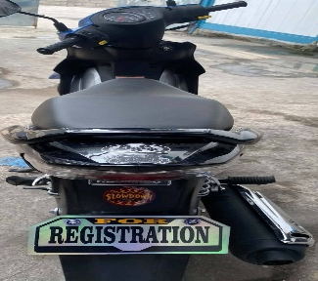 | October 12, 2026 | GSCHPT | FOR REGISTRATION | AnCar, RA 4136 and Other related laws | NHW CONEL,GSC | OR/CR Not carried "ATTA" | Impounded for verification
4 | 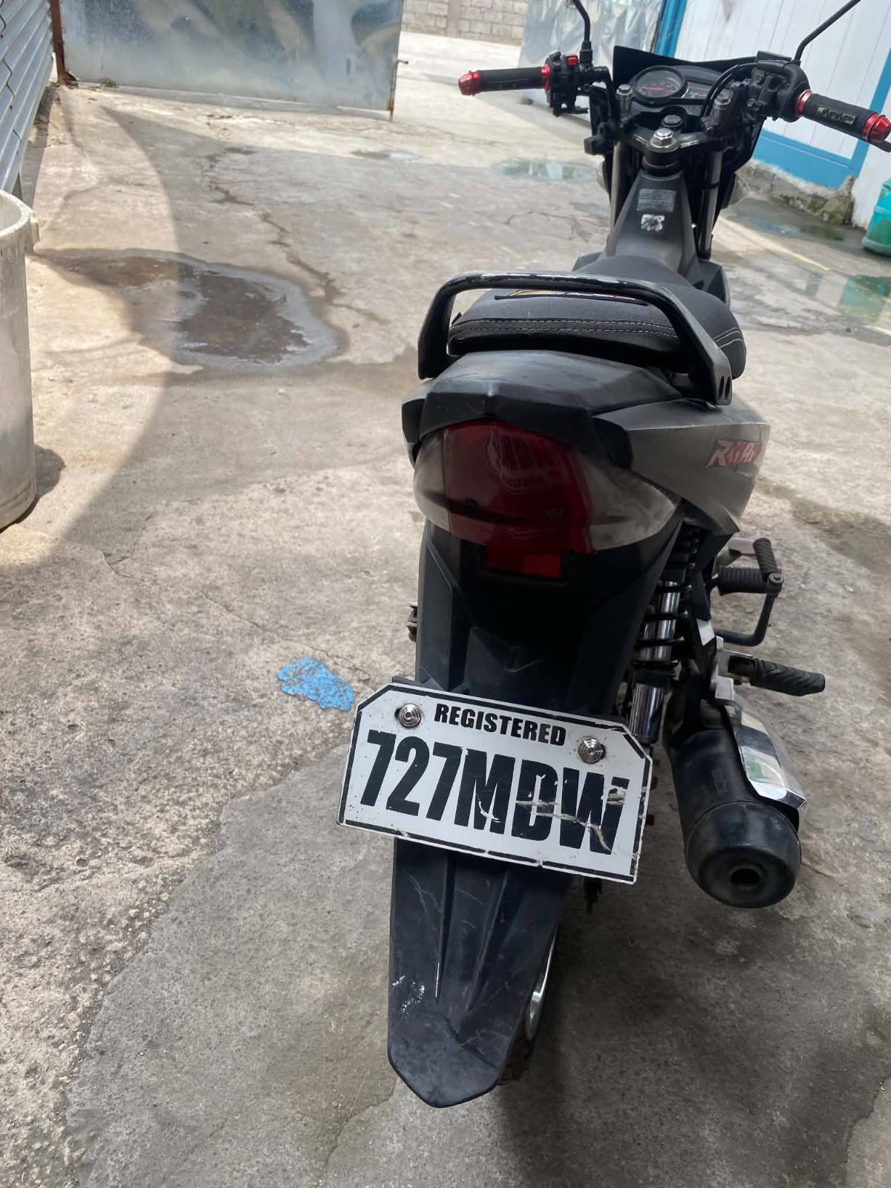 | October 12, 2026 | GSCHPT | 727MDW | AnCar, RA 4136 and Other related laws | NHW CONEL,GSC | Driver License Not carried "ATTA" | Impounded for verification
5 | 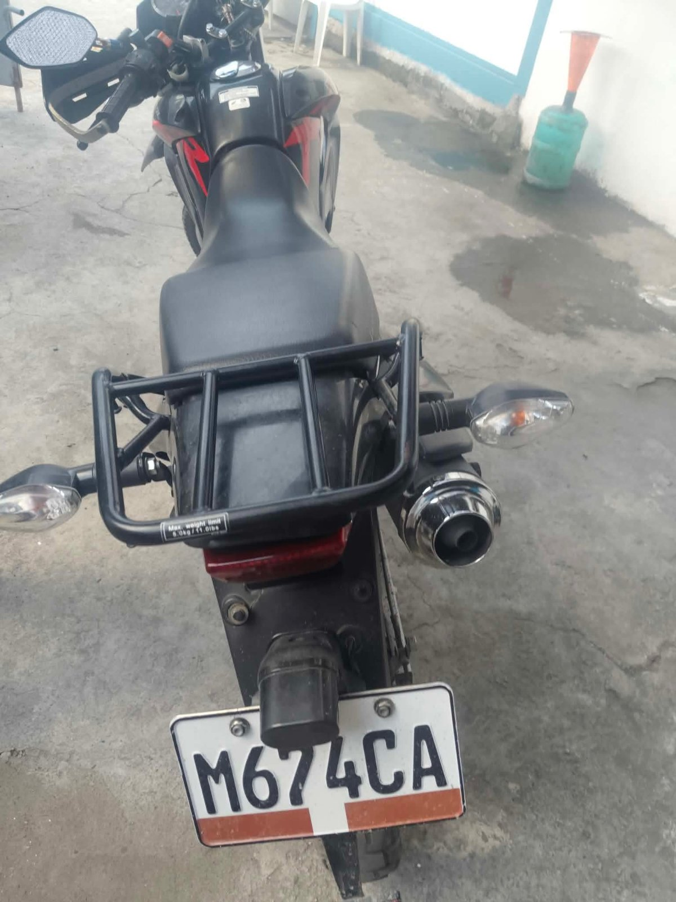 | October 12, 2026 | GSCHPT | M674CA | AnCar, RA 4136 and Other related laws | NHW CONEL,GSC | OR/CR Not carried "ATTA" | Impounded for verification
6 | 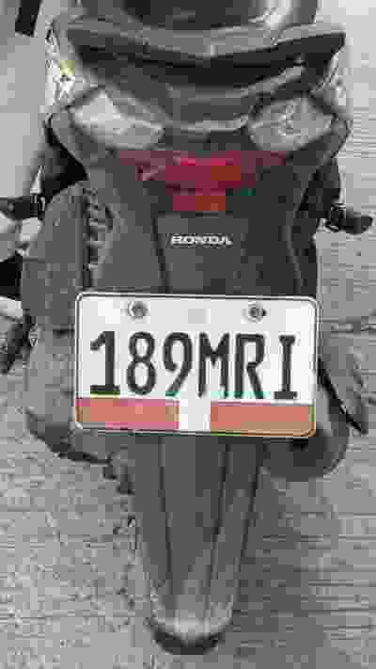 | October 15, 2026 | GSCHPT | 189MRI | AnCar, RA 4136 and Other related laws | NHW Apopong, General Santos City | OR/CR not carried "ATTA" | Impounded for verification
7 | 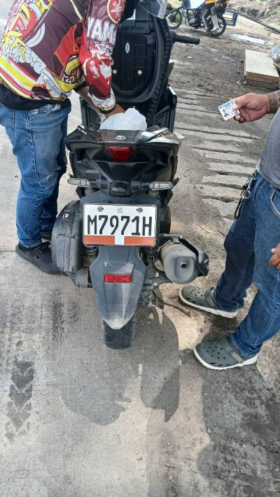 | October 15, 2026 | GSCHPT | M7971H | AnCar, RA 4136 and Other related laws | NHW Apopong, General Santos City | OR/CR Not carried "ATTA" | Impounded for verification
8 | 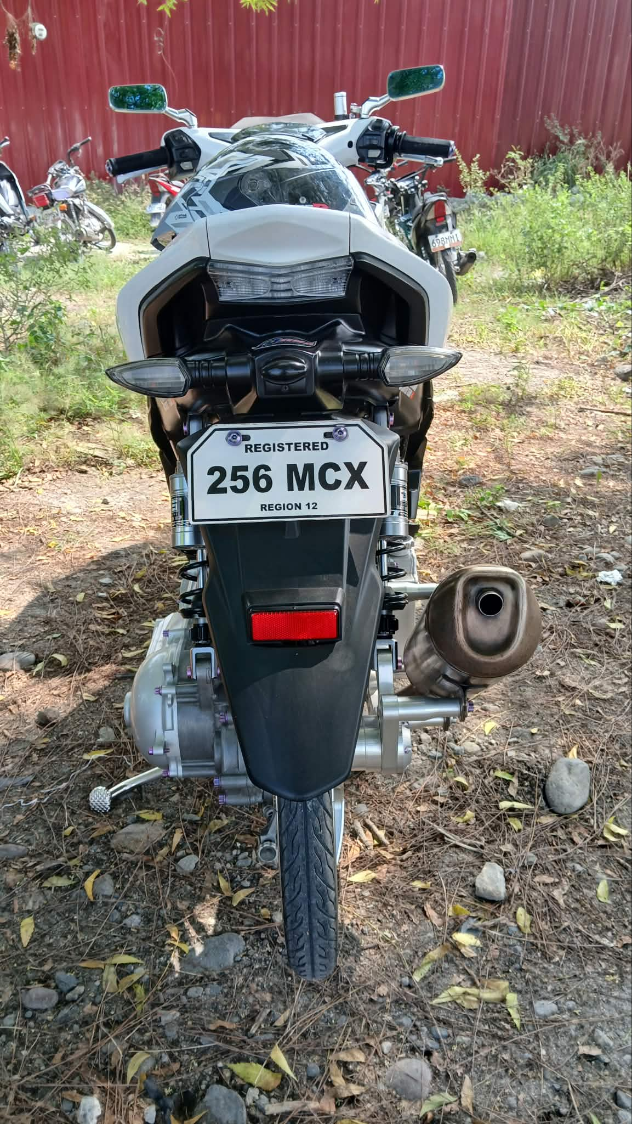 | October 16, 2026 | GSCHPT | 256MCX | AnCar, RA 4136 and Other related laws | NHW MABUHAY, GSC | OR/CR Not carried "ATTA" | Impounded for verification

IMPOUNDED MOTOR VEHICLE:
Nr | Make/Type/ include picture | Date of Recovery | Unit involve bed | Plate Nr/ Conduction sticker | Mode of Recovery | Place of Recovery | Violation | Status
1 | 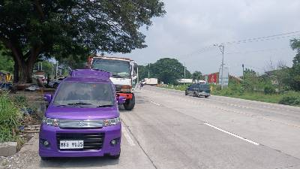 | October 15, 2026 | GSCHPT | MBG9035 | AnCar, RA 4136 and Other related laws | NHW Apopong, General Santos City | OR/CR not carried "ATTA" | Impounded for verification
2 | 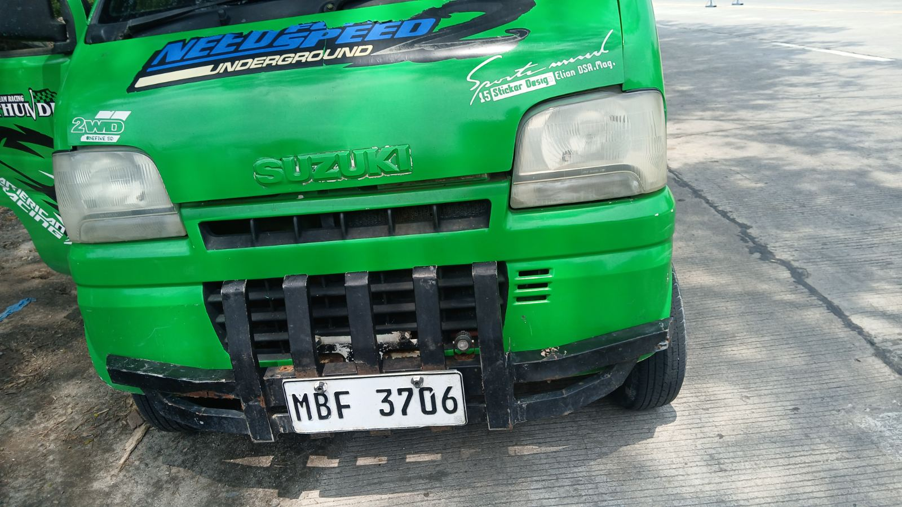 | October 15, 2026 | GSCHPT | MBF3706 | AnCar, RA 4136 and Other related laws | NHW Apopong, General Santos City | OR/CR not carried "ATTA" | Impounded for verification
3 | 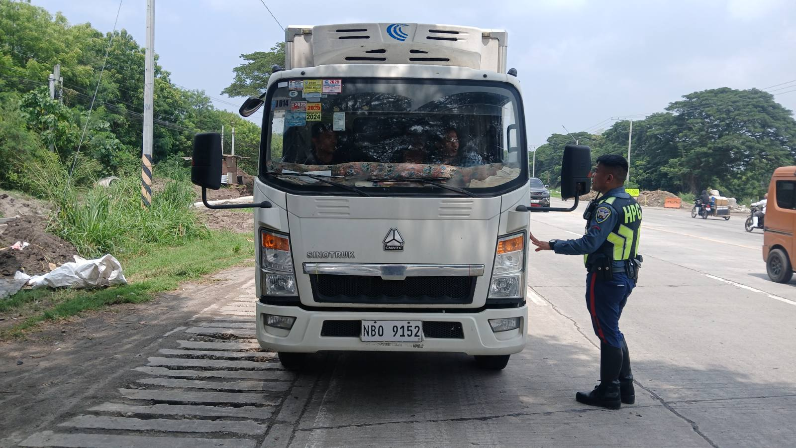 | October 15, 2026 | GSCHPT | NBO9152 | AnCar, RA 4136 and Other related laws | NHW Apopong, General Santos City | OR/CR not carried "ATTA" | Impounded for verification
4 | 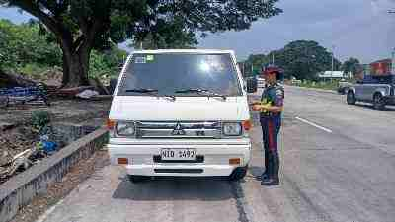 | October 15, 2026 | GSCHPT | NID1492 | AnCar, RA 4136 and Other related laws | NHW Apopong, General Santos City | OR/CR not carried "ATTA" | Impounded for verification

XXV. ACCOMPLISHMENT ON DOUBLE BARREL RELOAD:
Nr | Name of Suspects include picture | Date Arrested | Nature of Arrest | Unit Involved | Place of Arrest | Offense Charge with Docket # | Status of arrested person
1

XXVI. ACCOMPLISHMENT ON OTHER CRIMES:

Nr | Name of Suspects include picture | Date Arrested | Nature of Arrest | Unit Involved | Place of Arrest | Offense Charge with Docket # | Status of arrested person
1

Prepared by: Noted by:
Original signed Original signed

