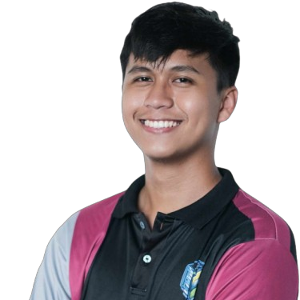
SYGNOREY JAZZE Q. AZUMA
Brgy. Dongalo, San Ildefonso, Ilocos Sur
sygnoreyjazze@gmail.com
09278016602

CAREER OBJECTIVES
Motivated Information Technology graduate seeking an entry-level position as a Junior Developer or IT Support Specialist. Eager to apply strong foundation in web development (PHP, JavaScript, Node.js) and database management (MySQL) to contribute to innovative projects and support organizational efficiency.

EDUCATIONAL BACKGROUND
Bachelor of Information Technology (Expected Graduation: 2026)
University of Northern Philippines (UNP), City of Vigan, Ilocos Sur
2022 – Present
Junior High School – Senior High School
Divine Word College of Vigan (DWCV), City of Vigan, Ilocos Sur
2016 – 2022
- With Honors (S.Y. 2021 – 2022)
Elementary
Sagsagat Elementary School, San Ildefonso, Ilocos Sur
2010 – 2016

TRAININGS AND SEMINARS ATTENDED
- DYCI ROBOTICS SEMINAR
Bocaue, Bulacan
April 23, 2025
- HYTECH POWER INC. SEMINAR
Quezon City, Metro Manila
April 23, 2025
- INTERNET OF THINGS
Quezon City, Metro Manila
April 24, 2025
- CYBER SECURITY SEMINAR
University of Makati, Taguig, Metro Manila
April 25, 2025
- DESIGN MADE EASY: A BEGINNER'S GUIDE TO CANVA
Online Seminar
May 24, 2025

SKILLS
TECHNICAL SKILLS:
- Programming Languages
C#, PHP, Java, VB.NET, JavaScript, Python
- Web Technologies
HTML5, CSS, Bootstrap5, SCSS, Node.js
- Databases
MySQL, XAMPP, HeidiSQL
- Tools & Platforms
Microsoft Office Suite, Git, Canva
SOFT SKILLS:
- Problem-solving & analytical thinking
- Communication & teamwork
- Adaptability & willingness to learn
- Creative design & graphic design
OTHER SKILLS:
- Internet of Things (IoT) – fundamentals and basic prototyping
- Cybersecurity basics – network scanning with Nmap using Kali Linux
- AI-assisted development (DeepSeek, Claude for code generation)

CHARACTER REFERENCE
Reina Regina S. Camus
[Position/Title]
[Contact Number] | [Email Address]
Brian James P. Asper
[Position/Title, e.g., IT Instructor]
[Contact Number] | [Email Address]
Michael Figares
[Position/Title]
[Contact Number] | [Email Address]

