

**E-retail factors for customer**

**activation and retention**

Submitted by:

**Sourav Chaudhury**

**ACKNOWLEDGMENT**

I would like to take this opportunity to show my gratitude to the resources mentioned below for helping me complete this project successfully.

* Flip Robo Technologies
* DataTrained Education
* TowardsDataScience
* AnalyticsVidya
* StackOverflow
* GitHub
* **Business Problem Framing**
* Customer satisfaction has emerged as one of the most important factors that guarantee the success of online store; it has been posited as a key stimulant of purchase, repurchase intentions and customer loyalty. A comprehensive review of the literature, theories and models have been carried out to propose the models for customer activation and customer retention. Five major factors that contributed to the success of an e-commerce store have been identified as: service quality, system quality, information quality, trust and net benefit. The research furthermore investigated the factors that influence the online customers repeat purchase intention. The combination of both utilitarian value and hedonistic values are needed to affect the repeat purchase intention (loyalty) positively. The data is collected from the Indian online shoppers. Results indicate the e-retail success factors, which are very much critical for customer satisfaction.
* **Conceptual Background of the Domain Problem**
* Large number of customers are getting attracted towards online retailing; this is because e-stores usually offer them a variety of services and products according to their preferences. Convenience, round the clock availability, flexible pricing, discounts as well as free door step delivery are some of the major benefits of shopping online. Presently, more number of online retailers are beginning to experience increase in demand for products and services. Indian online retail industry has been experiencing good times since the last six years; as a result of the constantly growing internet penetration, deployment of modern infrastructures, and a robust ecosystem for e-retail start-ups. Several e-commerce start-ups have commenced operation with innovative strategies, which differs from what was pioneered by first generation e-commerce companies.
* **Review of Literature**
* Customer satisfaction has emerged as one of the most important factors that guarantee the success of online store; it has been posited as a key stimulant of purchase, repurchase intentions and customer loyalty. A comprehensive review of the literature, theories and models have been carried out to propose the models for customer activation and customer retention. Five major factors that contributed to the success of an e-commerce store have been identified as: service quality, system quality, information quality, trust and net benefit. The research furthermore investigated the factors that influence the online customers repeat purchase intention on the basis of the Means End Chain theory (MEC) and Prospect theory.
* By hypothesising that a combination of both utilitarian value and hedonistic values are needed to affect the repeat purchase intention (loyalty) positively, Structural equation model has been presented on the primary data collected from the Indian online shoppers. Results indicate the e-retail success factors, which are very much critical for customer satisfaction. By increasing the utilitarian value and hedonistic values derived by the customers, customer satisfaction and hence the customers repeat purchase intention can be increased significantly.
* **Motivation for the Problem Undertaken**
* India’s B2C e-commerce revenue grew from €20 billion in 2017 to reach €25 billion in 2018 at a growth rate of 20%. The number of internet users in India has been growing at a CAGR of 35% since the year 2007 according to a report by IAMAI-IMRB (2017). Having grown from just over a 100 million internet users in 2010, India has since touched 500 million internet users in 2018. Online retail businesses are positioning themselves to be able to take advantage of the massive internet user base by turning them into online shoppers. Indian e-commerce market is poised to surpass that of the United States, making it the second largest in the world in less than twenty years from now. According to global payments firm Worldpay this rapid growth is driven by a host of e-commerce players comprising of small, medium and large firms in terms of revenue and assets. An amalgamation of factors contributed to India’s rapid increase in number of online retail shoppers, which includes; digital friendly policies of the Govt. Large investments made by the online retailers, growing internet and smartphone penetration, demographics distributions, emerging middle class and young population. With western markets getting saturated (matured) and China becoming more restrictive, India is becoming the main battleground for the e-tailers. The focus is attributed to the increased internet penetration, per capita income, rising middle class, urbanization and changes in consumer spending trends in India. Some foreign e-tailers like Amazon. com and Walmart (through Flipkart.com, Myntra.com, Jabong.com) are already playing with a good market share, while others like Alibaba.
* **Analytical Modelling of the Problem**
* Knowing how to maximise the repurchase intention of Indians online consumers’ is vital for an online retailer in India to achieve its business goals. This may further lead to develop a general reference model for successful online retail business. Success of an online retail website depends on its system quality and how much consumer motivator values are derived through shopping from it. System quality is the level of user satisfaction with the technical and functional aspects and is dependent on factors like: response time, usability, availability, reliability, and adaptability. On the other hand, motivational values are referred to as either utilitarian value (function or task oriented) or hedonic value (fantasy, multisensory or elements based on emotions). The present work has focused upon these values and attempted to see their role in the customer satisfaction and purchase decisions. The primary objective of this study is to propose and empirically test the online retail success model with emphasis on proving values to the customers. This work proposes two online retail success models and test them with the data collected from online retail customers in India. First model incorporates the factors necessary for user satisfaction, which in turns leads to purchase/repeat purchase intentions. While the second online business success model explains customers motivational values necessary for repurchase decision and loyalty, and most importantly how these values may differ from one customer to another.
* **Data Sources and their formats**

There were two datasets provided. Both were basically the questionnaire provided to the respondents and their answers recorded. Most of the questions were close ended and the respondents had to choose among options. One dataset was a descriptive in nature and the other was quantified. Below are the snapshots.

* **Encoded and Quantified Dataset**

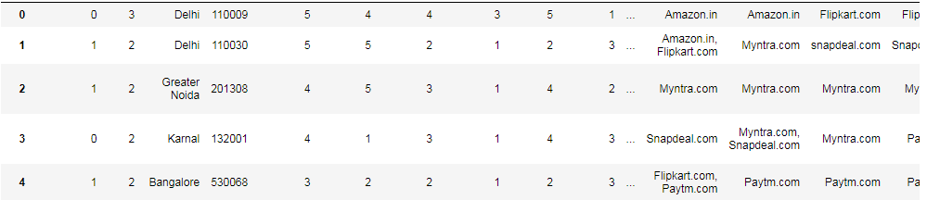

* **Descriptive Dataset**

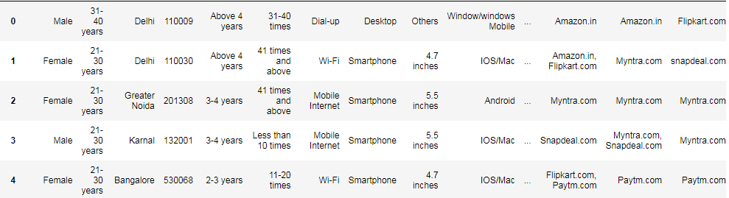

* **Data Preprocessing Done**

Both the files were in CSV format and a bit of data cleaning was required to make the data more comprehensible. Most of the data cleaning was in terms of removing the blank and trailing spaces from the variable names. Not performing this step might have produce value errors while performing the EDA steps as the data would not have being standardised.

* **Theoretical background**
* Several researchers have attempted to identify the factors necessary for online retail business success. Studies have mostly emphasized on: creating value for customer, managing the customers’ online , improvement of e-retail service quality , e-retail strategy, customer retention and website quality . Unfortunately, according to Wang researchers have not focused on integrating the entire online retail success factors into a comprehensive research model. Repeat customer purchase resulting from a long standing loyalty positively affects an e-retailer growth and profitability . Studies have considered “customer repurchase intention” as a reflection of loyalty and are being frequently used as a construct of e-retail success estimation instead of “intention to use”. Studies have suggested that past online shopping experience, perceived usefulness, and customer satisfaction are factors capable of influencing a customer’s repurchase intention. Website quality (e-store) and the usability of the e-store have also been proposed as being very vital for e-retail success by studies. In order to recommend a comprehensive model, the work adopted the Quality-Value-Satisfaction-Loyalty model; as the mechanism for which an online retailer may successful. The customer retention model illustrates that for a customer to become loyal to an online retail brand, there must be satisfaction, which arises when the e-tailer possesses a quality system backed-up by the proper mix of values. Shopping values refers to the evaluations of experience of shopping with an e-store; such as the extra convenience of shopping online. It focuses on the experience of purchasing the preferred product, instead of the product itself. In comparison to this, previous studies have used variables such as websites, internet performance, perceived profit, perceived risk, variables for website selection, and differences in lifestyle.
* **Online retail customers values**
* Value to the customer will determine the level of motivation to shop from an e-retail vendor psychologically categorised them into two broad categories: (a) Hedonistic (b) Utilitarian shopping values. Hedonistic values represent the excitement, and pleasurable experiences derived from shopping online . On the other hand, utilitarian shopping values are those related to the level of fulfilment as a result of being able to achieve the shopping goals. Hedonic shopping values are considered as the most vital factor for online customer satisfaction leading to customer retention. The utilitarian shopping values as a rational, goal oriented and effective decision based, which improves the customer satisfaction. Utilitarian e-retail customers concentrate mainly on functions related to specific task, for example: price comparison features, customer review before making a purchase. Arul Rajan (2020) investigated the effects on the online shopping channel in the City of Coimbatore of hedonic/utilitarian incentive on human aspects; factors, such as social media, marketing efforts, technology factors, shopping convenience were taken into account as variables that impact the motivation of shopping. This category of e-retail customer would be motivated to shop on an e-vendor with widely selection of products, informative, convenient, and fast websites . Both categories of shopping values have been presented in

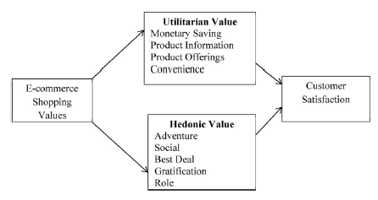

* **Proposed Hypothesis**
* **H1a**. Utilitarian shopping values are positively related to customer satisfaction.
* **H1b**. Utilitarian shopping values are positively related to customer repurchase intention.
* **H2a**. Hedonistic shopping values are positively related to customer satisfaction.
* **H2b**. Hedonistic shopping values are positively related to customer repurchase intention.
* **Proposed Research Model**
* The research model in this study is based on the Online Customer Lifecycle used in e-commerce, it tracks both the customer’s qualitative and quantitative journey in relation to a product . The model is based on statistical records of customer’s progression through the phases of the process; focusing on how to optimize the performance of several touch points and channels of interaction. Goal of every e-commerce company is to acquire customers ensuring that there is a continuously acceptable conversion rate. Along this, they need to focus on how to turn a visitor into a loyal customer, as well as to understand the shortest path through which a new customer becomes a loyal customer. Present work proposes two research models; the first model presents the factors necessary for the consumers’ purchase/re-purchase decision (Activation Model), while the other research model presents how motivational values can motivate customer loyalty towards an e-retailer. This research model accepts that “Use” and “User Satisfaction” jointly provide the “Net Benefits”; which is what the users get from shopping on an the e-retail website and contains the additional factor trust. The second model (customer retention) is derived from Means-End Chain theory (MEC) “the theory holds that consumer behaviour is value driven, so perceived values ultimately influence consumers’ choice patterns.

* **Customer Activation Model**
* The model adopts the three qualities (System Quality, Information Quality, Use, and Service Quality) and its impacts on User Satisfaction, thus, intention of the customer to use the e-retail website or application is also affected. In this research model, “User Satisfaction” represents one of the principal measurements of success of an online retail website. Wang et al. also stated that the measurement of “User Satisfaction” is an objective based attitude. It claimed that attitudes towards objects for example, website and Information Systems are not enough to predict customer behaviours like; intent to purchase or system usage. The importance of trust in online transactions has been widely discussed in many researches studies. The feeling of fairness can only be derived when there is a balance between input and outcome, which leads to the development of trust. Since E-retail websites becomes successful when customers buy its products, this model contains factors necessary for user satisfaction, while positing that user satisfaction, trust and net benefit are directly required for a purchase decision/re-purchase decision.
* **Customer Retention Model**
* This research study adopts the theory that an online customer’s repeat purchase intention (Retention) is influenced by utilitarian and hedonic values, which are further derived from net benefits. This study presents the second order composite latent variables in the customer retention model. The research models utilised in the research attempts to investigate why benefits are considered as the components of values; and to establish the link between goals and value. The customer retention model takes its root from the Means-End Chain theory (MEC) pay particular attentions to “consumers’ perceptive state after product or service consumption, it does not involve the risk concept. Prospect theory, therefore, is invoked to explore the role of risk in moderating the relationships between values and repeat purchase intention”. Correspondingly, the some research suggested that consumer behaviours are informed by utilitarian and hedonic values, which are the values derived from achieving online shopping goals. Seasoned online retail customers, mostly attach importance to conclusions drawn from previous purchase experiences, which expedite the process of attaining their shopping goals.
* **Visualizations, EDA and Findings**
* Two kinds of visualizations are used to display the findings from the study. These variables are mostly the respondents responses from the questionnaire pertaining to both the hedonistic and utilitarian values that a consumer derives. Beloware the visualizations.

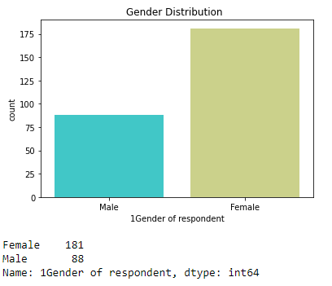

The above count plot shows the sex ratio of the respondents. The sample population has more females compared to males.

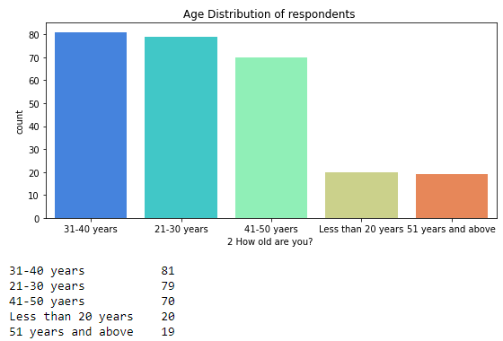

The above countplot shows the age distribution of the respondents. Majority of the respondents are in the age group of 31 to 40 years and the least being 51 years and above.

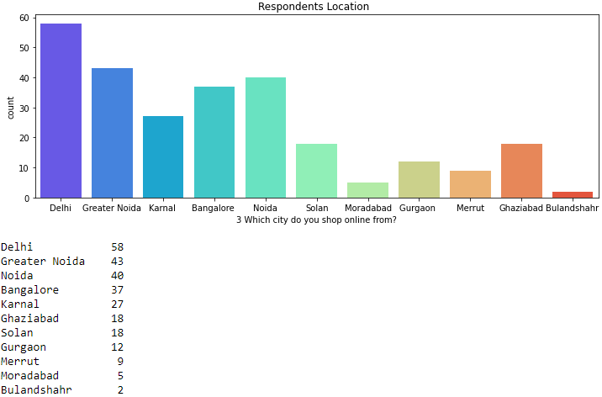

The above countplot shows the locations the respondents shops from. Most of the respondents are from Delhi and Noida area followed by Bangalore and Bulandshahr being the lowest.

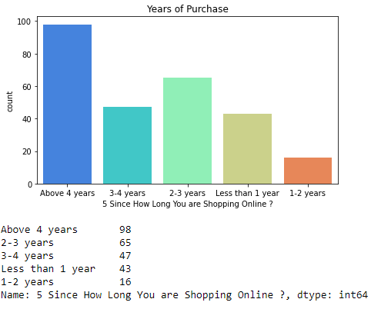

The above countplot shows the years since the respondents are purchasing from the online retailers. Most of the respondents are shopping for above 4 years and respondents shopping for last 1-2 years being the lowest. This means there are respondents who were repeat purchasers.

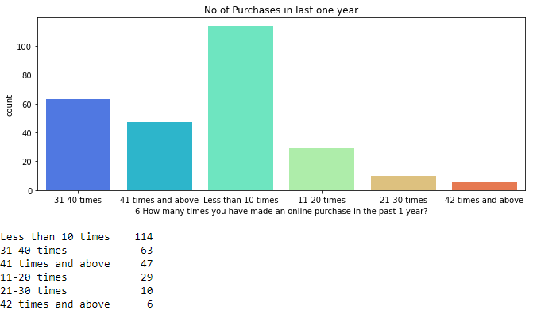

The above countplot shows the number of times the respondents have done a purchase in last one year. Most of the respondents have purchased less than 10 times from these websites and around 5 to 6 people have purchased more than 42 times.

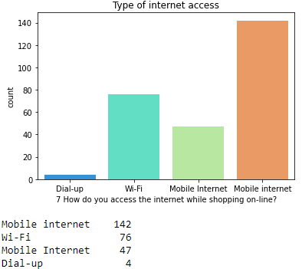

The above countplot shows the type of internet access the respondent is using. Most of the respondent is using Mobile Internet while Dial-up internet connection being the lowest.

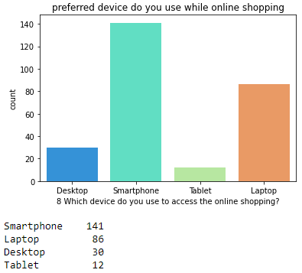

The above countplot shows the preferred device of the respondent while doing the online shopping. Most of the respondent uses smartphones while only some uses tablets.

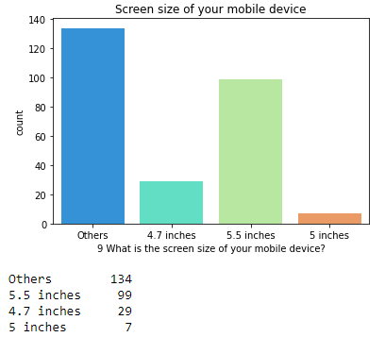

The above countplot shows the screen size of the respondents phone. Most of the respondents have screen size of 5.5 inches where as the least has 5 inches screen.

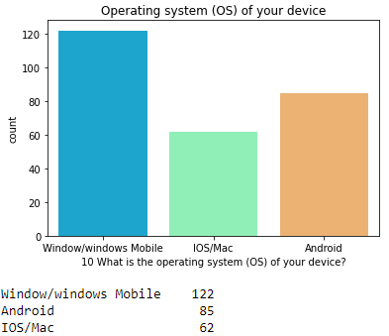

The above countplot shows the operating system of the respondents device. Most of the respondents have windows mobile while the least has Mac/IOS.

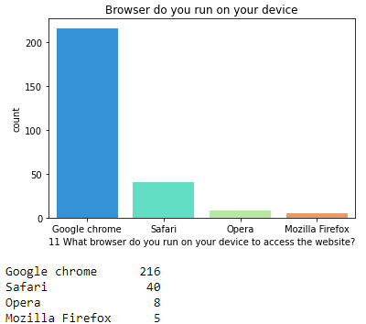

The above countplot shows the browsers of the respondents device. Most of the respondents have Google chrome while the least has Mozilla.

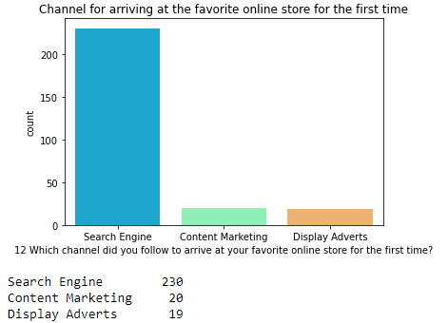

The above countplot shows the channel for arriving at the online store. Most of the respondents uses search engines while the least number used display advertisement.

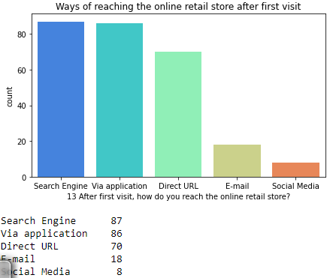

The above countplot shows the channel for arriving at the online store after first visit. Most of the respondents uses search engines while only some used social media.

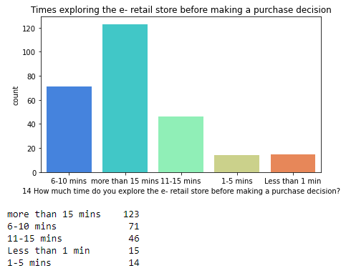

The above countplot shows the time respondents explore the retail store before making a purchase. Most of the respondents explore for more than 15 minutes while only some do it within 1 to 5 minutes.

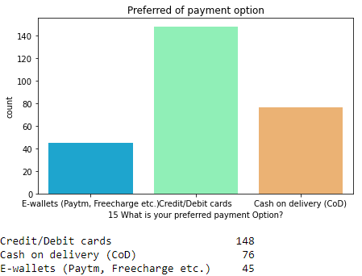

The above countplot shows preferred payment options of the respondents. Most of the respondents prefer online payment options like credit and debit cards followed by COD and the least prefers E-Wallets.

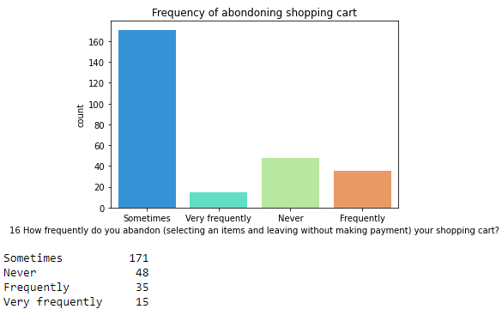

The above countplot shows the respondents frequency of abandoning the shopping cart. Most of the respondents sometimes abandons the shopping cart while least of them very frequently does it.

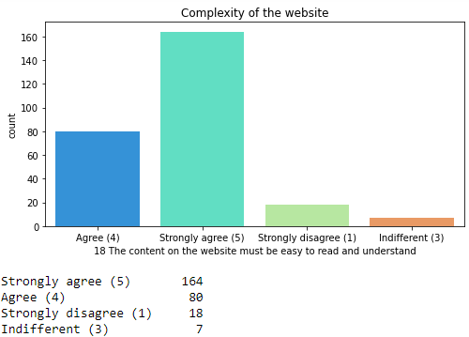

The above countplot describes the complexity of the website. Most of the respondents strongly agrees that the website should be easy to read and understand while very less number of respondents were indifferent to the context.

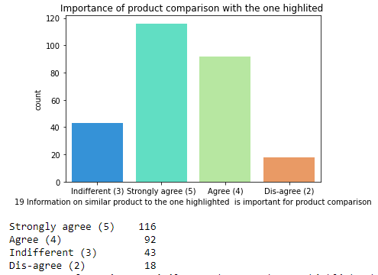

The above countplot shows whether information on similar product to the one highlighted is important for product comparison. Most of the respondents strongly agrees to it and less number of people disagree.

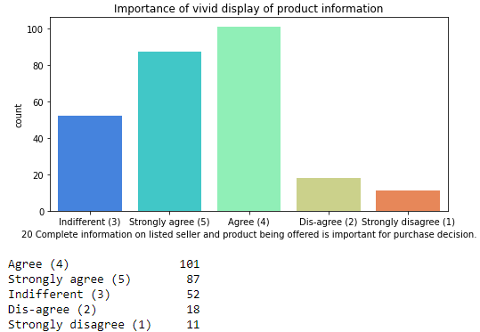

The above countplot shows importance of vivid display of product information on the website. Most of the respondents strongly agrees to the fact and a very less proportion of respondents disagree.

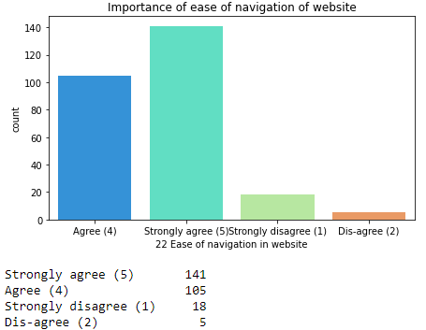

The above countplot shows importance of ease of navigation of websites. Most of the respondents strongly agrees to the fact with a very less number of respondents disagreeing to it.

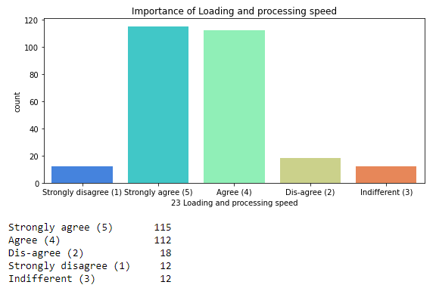

The above countplot shows importance of loading and processing speed of the website. Most of the respondents strongly agrees to the fact with a very less number of respondents being indifferent to it.

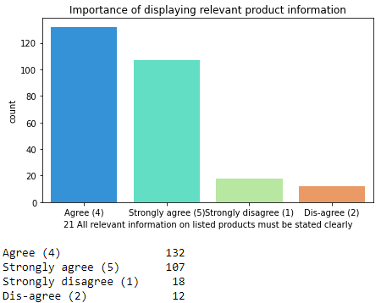

The above countplot shows importance of clearly displaying relevant product information. Most of the respondents strongly agrees to the fact with a very less number of respondents disagreeing to it.

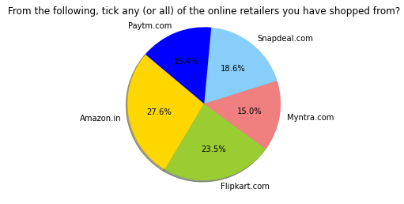

The above pie chart shows the different online retailers the respondents shops from. Most of the respondents shops from Amazon with respondents who shops from Myntra being the lowest.

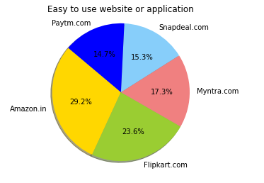

The above pie chart shows easiness of using the application of the different online retailers. Most of the respondents finds Amazon website and application easiest to use while they find Paytm to be the toughest.

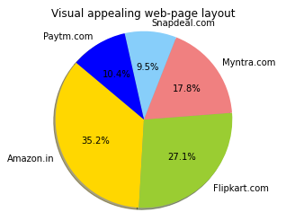

The above pie chart shows which website is visually more appealing to the respondents. Most of the respondents said Amazon is the most appealing website while Snapdeal being the least appealing.

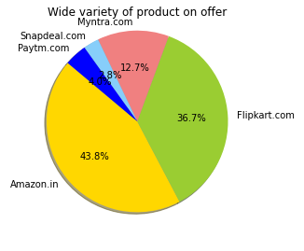

The above pie chart shows which website offers wide variety of product on offer. Most of the respondents said Amazon is the one with most variety of product on offer with Snapdeal with the least.

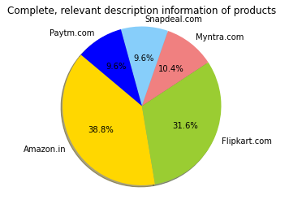

The above pie chart shows respondents answer to website which displays the most complete and relevant description of the product. Most of the respondents voted for Amazon and Paytm and Snapdeal being the lowest.

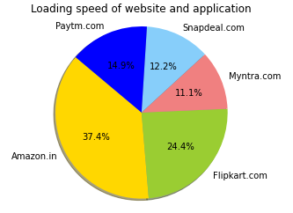

The above pie chart shows respondents' answer as to which e-commerce website and application has the highest loading speed. Most of the respondents voted for Amazon with Myntra being the lowest.

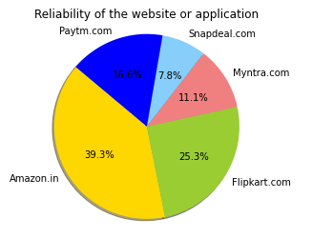

The above pie chart shows respondents answer as to which website is the most reliable. Most of the respondents voted for Amazon and the least people voted for Snapdeal.

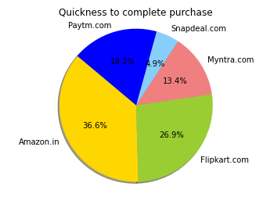

The above pie chart shows respondents answer as to which website is quick to complete a purchase. Most of the people voted for Amazon with Snapdeal being the lowest.

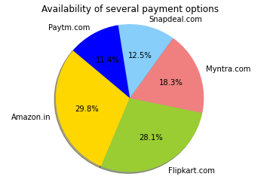

The above pie chart shows respondents answer as to which website has the most number of payment options. Most of the people voted for Amazon with Paytm being the lowest.

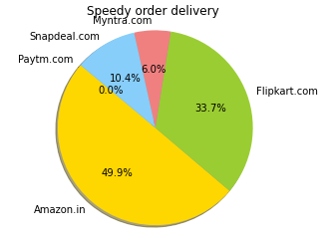

The above pie chart shows respondents answer as to which online retailer has the speediest order delivery. Most respondents voted for Amazon with the lesser votes for Myntra with no votes for Paytm.

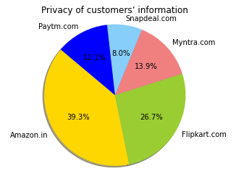

The above pie chart shows respondents answer as to which retailer provides the best privacy to customers information. Most of the respondents voted for Amazon while Snapdeal with the least votes.

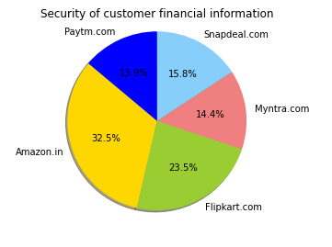

The above pie chart shows respondents answer as to which retailer provides the most security of customers financial data. Most of the respondents voted for Amazon while Paytm had the least votes.

**CONCLUSION**

* Key Findings and Conclusions of the Study
* For online retailers, marketers and retail website developers, the outcome of the study is of extreme importance to target a specific shopping segment(s). Various shopping values and web features influence the different groups of online shoppers. Some of the shoppers do e-shopping because of their convenience and usefulness, while many others rely on e-commerce to search products and offer information. Likewise, some segments are not interested to do online shopping to derive pleasure and fun. For example, information seekers are drawn to the web portals offering accurate product and service information and they may not be so interested in the entertainment value of online shopping. E-retailers targeting this community should concentrate their web elements on the theme ‘Reliability and Ease of Searching Products.’ Ensuring correct photos, product descriptions and ease of search for contextual cues can allow portals to attract this segment and gain loyalty. Students are a big part of the utility-seekers, as they actively concentrate on obtaining profit from online shopping. Portals targeting this category will concentrate on providing practical value to these shoppers either by increasing the use of portals or by reducing prices by providing promotional discounts. E-retail portals with a wide range of products to choose from would attract these shoppers and allow them to close their shopping trip in one case. Quality seekers are delighted by the monetary and practical advantages of online shopping as well as the fun they experience when browsing online portals. You can use portals that are fun to navigate and browse, and store the latest gadgets and trendiest items for heavy discounts. Increasing user experience and features such as built-in videos, the 3D view of items, chat mechanisms and customer-to - customer interactivity can help attract more users and increase segment patronisation. In general, core shoppers are not affected by either shopping or web variables. This segment must be targeted to traditional (offline) retailers, because they prefer to shop offline rather than online. Retailers should position their stores as offering an “experience” that cannot be offered via online platforms and that offers the customer a specific value proposal.
* To run a successful online retail store, emphasis must be given to the factors necessary for user satisfaction. However, these factors may differ among the customers as per their preferences. From the proposed and tested models: information, system and service qualities prove to be the well-established factors necessary for online business users’ satisfaction. Nevertheless, e-retailers are required to integrate other benefits as well to create value to the customer. Empirically tested models have shown the importance of the quality of system, information, accessibility, security, and ease of use are needed to appeal to the consumer’s utilitarian values. On the other hand, to appeal to the hedonistic values of the consumer, the e-store should incorporate elements that would offer value to the pleasure seeking behaviour of customers; for example: adventure, gratification, role shopping etc. As to what motivates a customer’s repurchase intention, the outcome of the study indicates that a combined approach designed to increase customer satisfaction, trust, and the overall net benefits of shopping on their e-store must be adopted to achieve their goals. Online retailers must focus on the information quality and system quality of the online retail websites to enhance customer satisfaction, which in turn will lead to repurchase decision. Both the utilitarian and hedonistic values led to customer satisfaction and considerably stimulate their repurchase intention, leading to loyalty. The result further suggests that customers’ perception of utilitarian and hedonic values will inform their preference for a particular online store. Hence, attention to the customer specific content is very much vital. The study recommends that the products and contents must be customers specific (personalised). The results of the study can help identify market segments for new e-retailers. Marketers can use the identified segments of online customers on the basis of their shopping values and decide accordingly on marketing strategies. Limitation of the study is the use of web-analytics in its classic form, which is to measure users’ interaction with the website. However web analytics is changing into digital analytics as a result of the multi-channel attribution like social media integration, social buying etc. Future studies may be conducted using the new digital analytics approach.